Military Modernization of China

by Biswas Sharma

Sponsor: Dr. James Robert Masterson, Asst. Professor of Government, Morehead State University

Literature Review

On 11 January 2007, a kinetic kill vehicle launched by a Chinese missile destroyed a Chinese weather satellite orbiting 500 miles above the earth. Exactly three years later China conducted a test on ground-based midcourse missile interception technology within its territory. The same day the following year, while the United States Secretary of Defense was visiting Beijing, the prototype J-20 stealth fighter made its first test flight. Back in March 2009, several Chinese government and civilian vessels and aircraft maneuvered in close proximity to two US Military Sealift Command ocean surveillance ships operating in international waters in the Yellow and South China Seas. (Blasko, 2012, p. 1) In December 2008, Chinese hackers associated with the web group hack4.com staged politically motivated web defacements on French Embassies in the US, United Kingdom, China, and Canada after French President Sarkozy’s visit with the Dalai Lama. (Krekel, 2009, p. 39)

Over the past decade, China’s military has benefitted from robust investment in modern hardware and technology. Many of its modern systems have reached maturity and others will become operational in the next few years. (ANNUAL REPORT TO CONGRESS: Military and Security Developments Involving the People's Republic of China, 2011, p. 1) China’s rise to a state of an Eastern superpower, and a possible rise as a direct competitor to the United States in the future, has been a topic of frequent discussions and speculations among analysts and military experts.

In his article China’s regional Military Posture, Michael D. Swaine assesses the current and future significance of China’s regional military posture. He interprets China’s defense policy objective, major features of China’s military capabilities and its engagement in Asia and analyzes its possible implications for Asian security. Swaine evaluates some fundamental defense objectives of the PLA in Asia. First, Chinese forces are deployed to deter or defeat possible threats or attacks directed against China’s heartland. Second, it is designated to deal with a range of possible “local war” conflict scenarios that might occur along its maritime periphery. Third, China’s military posture is also intended to support its foreign policy and increasing role in Asia.

Swaine evaluates the PLA’s status as being capable to pursue in-depth operations against any plausible effort to invade the Chinese territory, efficient to demonstrate power projection across land borders against smaller regional power to within 100 km of proximity and able to dislodge smaller regional powers from nearby disputed lands and/or maritime territories. Swaine argues, however, that PRC’s counterparts in Asia don’t see its ongoing modernization as an immediate threat to their sovereignty.

In his article Great Expectations: Interprating China’s Arrival, Avery Goldstein presents an analysis which (1) indicates that the then recent increases in China’s capabilities most important for international security, especially military power, have thus far been modest; (2) explains why expectations for great gains in the foreseeable future may well be exaggerated; and (3) acknowledges that although international relations theory provides persuasive reasons to expect China’s growing power to increase the frequency and intensity of international conflicts, it also suggests ways to manage such conflicts and, perhaps most important, suggests why grave scenarios involving major war are unnecessarily alarmist. Goldstein clarifies that the capability of the Chinese military should be seen in a relative, rather than absolute, perspective taking in account the simultaneous progresses being made by current superpowers – US in world scenario and Japan in the regional scenario. Goldstein points out that even a future filled with recurrent spirals of conflict between a dominant United States and an increasingly capable China should at worst result in manageable, if undesirable, cold war.

In the report Capability of the People’s Republic of China to Conduct Cyber Warfare and Computer Network Exploitation prepared for The US-China Economic and Security Review Commission, Bryan Krekel, on behalf of the Northrop Grumman Corporation, explains how the Chinese hacker community, that has been involved in numerous information exfiltration events worldwide, over a decade, is bound to be closely related to the Chinese government. He also describes the possible protocol of PLA cyber warfare tactics in course of war.

The Annual Report to Congress on Military and Security Developments Involving the People’s Republic of China published by the Office of the Secretary of Defense is among the most legitimate sources of this research. 2009, 2010 and 2011 reports all indicate that the pace and scope of China’s military modernization have increased over the past decade, enabling China’s armed forces to develop capabilities to contribute to the delivery of international public goods, as well as increase China’s options for using military force to gain diplomatic advantage or resolve disputes in its favor.

The 2011 report points out that “The pace and scope of China’s military development, combined with a relative lack of transparency, remains a point of concern in the United States and among [its] regional allies and partners. In recent years China has demonstrated occasional signs of assertiveness in Asia, particularly in the maritime domain. This trend has contributed to friction between China and some of its neighbors over disputed maritime territory in the East and South China Seas.”

The report concludes that as China’s regional and international interests expand, so too will China’s impetus for additional engagement, especially in the areas of peacekeeping operations, HA/DR and joint exercises, and in addition to furthering PLA modernization, these engagements will likely be geared toward building China’s political ties, assuaging fears about China’s rise, and expanding China’s international influence, particularly in Asia.

Most literature on this topic have the same recurring conclusion – that China is rising steadily and along with rising, spreading its influence in Asia, and gradually in the world scenario, but the rise of China as indicated by its military modernization, among many other indicators, is not too alarming at the moment.
Research
Introduction

The establishment of the People’s Liberation Army (PLA) of the People’s Republic of China (PRC) dates back to August 1, 1927 when the “Red Army” was created as the military arm of the Communist Party of China (CPC). (Blasko, 2012, pp. 2-7) The PLA has been involved in regional conflicts, sometimes resulting to war, ever since it was established in 1927. It has fought wars with Japan, Britain, Korea, India and Vietnam and has been involved in conflicts with Taiwan, Soviet Union, and even India and Vietnam on several occasions, and in due course it has undergone phases of modernization.
During the 1980s, China’s GDP doubled, and in the mid-1990s was doubling again. Over time, China transformed from a reluctant, small-scale international economic actor into an eager, large-scale participant playing the role other East Asian export-led growth economies had pioneered. (Glodstein, 7-8) The wave of modernization began in the 1980s after China changed its modernization strategy from being prepared for a big war to getting advanced in fighting “limited war under high-technology conditions” which resulted in spending on operations and maintenance rather than weapons procurement, and formation of amphibious elite units (whose efficiency still remained in question). (Goldstein, 1997-1998, pp. 10-11) This also brought about the shift from historic focus on land warfare to a holistic view of simultaneous operations in land, maritime, aerospace, electromagnetic, and cyber battle space dimensions. (Bergsten, 2008, p. 196)
The motivation for this was that a massive invasion by Russia was no longer seen as a major threat, and the new threats to China was seen to be a declaration of independence by Taiwan, possibly with assistance from the United States, or a confrontation over the Spratly Islands. (ANNUAL REPORT TO CONGRESS: Military and Security Developments Involving the People's Republic of China, 2011)
Throughout the mid‐1990s and the early 2000s, China acquired most of its complex modern weapons systems through imports from Russia and partly from Israel. At the same time, the 1991 Gulf War and the 1995-96 Taiwan Strait Crisis spurred Chinese development and testing of advanced weapons systems as a part of its military modernization program and its drive to develop greater capabilities to conduct a successful “active defense” strategy. By the mid‐2000s, China had begun to field indigenous weapons and hardware, aided in part by crossover knowledge from the Chinese civilian industry and the broader global economy. (Chang, 2012, p. 6)
China took the post-September 11 “war on terrorism” and the US invasion and occupation of Iraq as a “period of strategic opportunity” for the CCP to concentrate on its strategy for the stability and development in the first two decades of this century. (Wang, 2005, p. 20) With a complicated view of situations in the world, political preservation remained the top concern in the making of China’s foreign policy during the first decade of the 21st Century. (Wang, 2005, p. 25)

- Recent Modernization
Over the past 15 years, military spending in China has grown about 10 percent annually. The Chinese government's published 2011 military budget is about US$ 100 billion, the second largest in the world and up about 12.7 % from 2010 (US$ 87 billion) (but still only 1/7 of the U.S.'s). This figure meant that for 2011, China's military expenditure as a percentage of GDP was 1.4%. (ANNUAL REPORT TO CONGRESS: Military and Security Developments Involving the People's Republic of China, 2011) However, China’s actual defense-related expenditures are assumed to be much higher than this, with expenses related to research and development, strategic and paramilitary forces, and foreign arms procurement, among other items, all excluded from the formal budget. Organizations such as the Institute for International Strategic Studies (IISS), the RAND Corporation, the Stockholm International Peace Research Institute (SIPRI), and the IS DOD have each offered estimates of China’s actual annual defense expenditures based on various standsrds and models. DOD estimates are commonly the highest among them. (Bergsten, 2008, p. 192)
Such spending in the defense sector has led to the thorough modernization of all of its forces including the ground force, navy, air force, second artillery corps, and in the expansion of electronic warfare capabilities.

  - PLA Ground Force
Much, but not all, of the effort of modernization of the ground force has focused on units garrisoned nearest Taiwan. For example, a new amphibious assault vehicle has entered service in key units, improving the PLA’s capability to conduct amphibious attacks. Throughout the PLA, small numbers of modern main battle tanks, armored vehicles, self-propelled artillery, and air defense weapons have entered service in selected units. Concurrent with this modernization, PLA ground force training has begun to emphasize combined arms operations and long-range mobility.
While much of the PLA Ground Force was being reduced over the past few years, technology-intensive elements such as special operations forces (SOF), army aviation (helicopters), surface-to-air missiles (SAMs), and electronic warfare units have all been rapidly expanded.
The latest operational doctrine of the PLA ground forces highlights the importance of information technology, electronic and information warfare, and long-range precision strikes in future warfare. The older generation telephone/radio-based command, control, and communications (C3) systems are being replaced by an integrated battlefield information networks featuring local/wide-area networks (LAN/WAN), satellite communications, unmanned aerial vehicle (UAV)-based surveillance and reconnaissance systems, and mobile command and control centers. (ANNUAL REPORT TO CONGRESS: Military and Security Developments Involving the People's Republic of China, 2011)

  - PLA Navy
The PLA Navy has rapidly transformed from a large fleet of low-capability, single-mission platforms, to a leaner force equipped with more modern, multi-mission platforms, since the 1990s. The PLA has invested heavily in submarines. It is believed to be close to deploying the world’s first “carrier-killer” ballistic missile designed to sink aircraft carriers while they are maneuvering at sea up to 1,500km offshore. (BBC News, 2011) China continues to produce a new class of nuclear-powered ballistic missile submarine (SSBN). JIN-class (Type 094) SSBNs will eventually carry the JL-2 submarine-launched ballistic missile with an estimated range of some 7,400 km. The JIN and the JL-2 will give the PLA Navy its first credible sea-based nuclear capability. The Navy also utilizes the CJ-10 naval cruise missile system, which made its first public appearance during late 2009. (ANNUAL REPORT TO CONGRESS: Military and Security Developments Involving the People's Republic of China, 2011)
China is also focusing on the modernization of amphibious attack capabilities in the South China Sea region. The first large amphibious ship designed and built in China was the 4,100-ton Yukan-class LST (Landing Ship Tank) in 1979. A larger 20,000-ton Type 071 landing platform dock (LPD) under construction in Dalian since 2004 was launched in December 2007.
In the meantime, the PLAN marines corps, although under the PLAN, appears to be completely separate from the PLA or PLAN sailors. It has its own amphibious vessels, although they are observed frequently being used for logistics missions. This makes it difficult to say whether China has a credible amphibious force if the PLAN were to be ordered to invade Taiwan or any other coastline. Additionally, the recent production of additional large amphibious landing craft, like the Yuting IIIs and LPDs, could indicate plans for large and distant landings. (Bussert & Elleman, 2011, pp. 96-97)
China’s first aircraft carrier, a renovated build of the Soviet ex-VARYAG, began sea trials in August 2011. The possession of the aircraft carrier is seen by Chinese leaders as a “symbol of power”, and it is not expected to be functional in any major military operation any time soon. (BBC News, 2011) It is also likely to have defects such as the absence of arrestor wires as shown by satellite images. (Harding, 2011) This development, however, definitely indicates the focus of the PLA in expanding its reach beyond immediate maritime proximity.

  - PLA Air Force
In the PLA Air Force, the modernization effort has seen the steady introduction of new fighters, including Su-27s and Su-30s acquired from Russia, as well as the indigenously developed J-10. (Cheng, 2012, p. 3)
China is upgrading its B-6 bomber fleet (originally adapted from the Soviet Tu-16) with a new, longer-range variant that will be armed with a new long-range cruise missile. The PLA Air Force has continued expanding its inventory of long-range, advanced SAM (Surface to Air Missile) systems and now possesses one of the largest such forces in the world. Over the past five years, China has acquired multiple SA-20 PMU2 battalions, the most advanced SAM system Russia exports. It has also introduced the indigenously designed HQ-9 surface to air missile system. China’s aviation industry is also developing several types of airborne early warning and control system (AWACS) aircraft. These include the KJ-200, based on the Y-8 airframe, for AWACS as well as intelligence collection and maritime surveillance, and the KJ-2000, based on a modified Russian IL-76 airframe. (ANNUAL REPORT TO CONGRESS: Military and Security Developments Involving the People's Republic of China, 2011)
Despite government policies promoting domestic avionics, Chinese upgrade programs for military and civil aircraft have relied heavily on foreign imports. Avionic instruments imports include those from Russia, Italy, Britain and Israel. Nonetheless, it is starting to collaborate with the global avionics market to jointly produce equipment. (Bussert & Elleman, 2011, pp. 106-107)

  - PLA Second Artillery Corps
By December 2010, the PLA had deployed between 1,000 and 1,200 short-range ballistic missiles (SRBM) to units opposite Taiwan.
China is developing an anti-ship ballistic missile (ASBM) based on a variant of the CSS-5 medium-range ballistic missile (MRBM). Known as the DF-21D, this missile is intended to provide the PLA the capability to attack large ships, including aircraft carriers, in the western Pacific Ocean. The DF-21D has a range exceeding 1,500 km and is armed with a maneuverable warhead.
China is modernizing its nuclear forces by adding more survivable delivery systems. In recent years, the road mobile, solid propellant CSS-10 Mod 1 and CSS-10 Mod 2 (DF-31 and DF-31A) intercontinental-range ballistic missiles (ICBMs) have entered service. The CSS-10 Mod 2, with a range in excess of 11,200 km, can reach most locations within the continental United States.
China is also currently working on a range of technologies to attempt to counter U.S. and other countries’ ballistic missile defense systems, including maneuvering re-entry vehicles, multiple independently targetable re-entry vehicles (MIRVs), decoys, chaff, jamming, thermal shielding, and anti-satellite (ASAT) weapons. (ANNUAL REPORT TO CONGRESS: Military and Security Developments Involving the People's Republic of China, 2011)

Efforts have been made, nonetheless, to restrain the use of nuclear weapons through mutual understanding. After their first nuclear test (China claims minimal Soviet assistance before 1960) on 16 October 1964, China was the first state to pledge no-first-use of nuclear weapons. Likewise, President Clinton in 1998 took steps to bring into force the 1985 U.S.–China Agreement on Peaceful Nuclear Cooperation (CRS -3). (ANNUAL REPORT TO CONGRESS: Military and Security Developments Involving the People's Republic of China, 2007)

- Regional Analysis

In relation to historical conflicts and attention focused on by the ongoing modernization of its troops, PLA’s regional posture can be studied in two categories, Taiwan and beyond Taiwan.

  - Taiwan
China’s military activities, in most cases, have been revolving around the Taiwan issue.
Security in the Taiwan Strait is largely a function of dynamic interactions between and among mainland China, Taiwan, and the United States. Since the mid-to late 1990s, China’s military has been heavily oriented toward developing a credible threat of force and a range of coercive measures that could be directed toward the island, both to deter what is viewed as an increasingly separatist-minded Taiwan from achieving de jure independence and, if necessary, to prevail in a military confrontation with Taiwan and possibly the United States.
Even though the election of Taiwan President Ma Ying-jeou in March 2008 was followed by China and Taiwan having embarked on a period of improved economic and political ties, Beijing still seeks to deter Taiwan moves toward independence and achieve eventual unification.
The military component of China’s Taiwan strategy is likely intended to create an impression on Taiwan that accommodation with China is ultimately in the island’s best interest. This approach appears to include a heavy focus on amphibious operations, long range strike, and anti-access and area denial capabilities, which are intended to alter Taiwan’s threat calculus as well as that of any party considering intervention in a cross-Strait crisis. (ANNUAL REPORT TO CONGRESS: Military and Security Developments Involving the People's Republic of China, 2011)

  - Beyond Taiwan
China does not possess sufficient air and naval power projection capabilities to pose a major threat to Japanese forces or territory at present, nor will it in the foreseeable future. However, one notable exception is in the area of ballistic missiles. The PLA is deploying a growing number of increasingly accurate, mobile short- and medium-range ballistic missiles in South and Southeast China, many of them within range of Japan. Such weapons could be used to threaten or to attack Japanese targets or U.S. military bases located in the Japanese home islands, especially in the event of a serious crisis over Taiwan. This potential threat has added to Japan’s existing incentives – based primarily on the growing security threat posed by North Korean missiles – to expand its program of research on a ballistic missile defense system. (Swaine, 2005, p. 274)
China’s growing military capabilities have significant potential implications for South Korea, given Beijing’s close proximity to South Korea’s territorial borders, and China’s historically close political, economic, and security ties with North Korea. The security fears have declined greatly in recent years, however, in large part as a result of China’s opening to the outside world, its reduced support for the North Korean regime, and especially the improvement that has occurred in China’s relations with South Korea. (Swaine, 2005, p. 275)
Diplomatic ties with southern neighbor India have been strengthened with recent high level visits and dialogues. Nevertheless, to strengthen its deterrent posture relative to India, the PLA has replaced liquid-fueled, nuclear-capable CSS-2 IRBMs with more advanced and survivable solid-fueled CSS-5 MRBM systems. Beijing is also investing in road development along the Sino-Indian border with an apparent intention to increase trade links in the region, but this can also be seen as the development of infrastructure useful for sustainable military transportation in case of a future conflict.
On the other hand, Beijing continues to view Moscow as a useful international partner. (ANNUAL REPORT TO CONGRESS: Military and Security Developments Involving the People's Republic of China, 2011)
Tensions in the hotly disputed South China Sea region subsided after the-1990s, but signs of friction re-emerged in 2007, particularly between China and Vietnam. (ANNUAL REPORT TO CONGRESS: Military and Security Developments Involving the People's Republic of China, 2011) There are still occasional incidents of Chinese navy harassing Vietnamese fishermen.
Arguably, China’s ability to deploy a more robust strategic and conventional military presence off its southern coast is having a growing impact on regional rivalries and power dynamics.

- On ASAT and Cyber Warfare
In January 2007, China successfully tested a direct-ascent anti-satellite (ASAT) weapon against a PRC weather satellite, demonstrating its ability to attack satellites in low-Earth orbit. China continues to develop and refine this system, which is one component of a multi-dimensional program to limit or prevent the use of space-based assets by potential adversaries during times of crisis or conflict.
In addition to the direct-ascent ASAT program, China is developing other kinetic and directed-energy (e.g., lasers, high-powered microwave, and particle beam weapons) technologies for ASAT missions. Foreign and indigenous systems give China the capability to jam common satellite communications bands and GPS receivers.
Furthermore, in 2010, China conducted a national record 15 space launches and as the Space White Paper suggests, China is continually promoting its manned space project and is looking forward to launching a space laboratory. (The Central People's Government of the People's Republic of China, 2011)

Between 1999 and 2004, the Chinese hacker community was defined by its regular use of large scale, politically motivated attacks against foreign networks or websites. Chinese hackers traded Web defacements and distributed denial of service attacks with their counterparts in the United States, Japan, Taiwan, Indonesia, and South Korea and operated with relative immunity from Chinese law until strongly worded condemnations issued from Beijing eventually reigned in the attacks. Motivated by nationalist fervor, often resulting from a perceived insult to China by a foreign country, the leaders of hacker groups unified their members, identified targets, and often disseminated attack tools via their websites to ensure mass participation. The depth of resources necessary to sustain the scope of computer network exploitation targeting the US and many countries around the world coupled with the extremely focused targeting of defense engineering data, US military operational information, and China-related policy information is beyond the capabilities or profile of virtually all organized cybercriminal enterprises and is difficult at best without some type of state-sponsorship.
The PLA maintains a network of universities, including the National University of Defense Technology (NUDT), PLA University of Science and Engineering, PLA Information Engineering University, and research institutes that support information warfare related education either in specialized courses or more advanced degree granting programs.
Hitherto, China has not agreed with the U.S. position that existing mechanisms, such as International Humanitarian Law and the Law of Armed Conflict, apply in cyberspace. (Krekel, 2009)

- Arms Industry
China’s primary final assembly and rocket motor production facilities have received upgrades over the past few years, likely increasing production capacity.
China’s space launch vehicle industry is expanding to support satellite launch services and the manned space program. China’s shipbuilding capacity and capability are on the rise generating benefits for all types of military projects, including: submarines; surface combatants; naval aviation, including aircraft carriers; and lift assets. China continues relying on foreign suppliers for some propulsion units and to a much lesser degree, fire control systems, cruise missiles, surface-to-air missiles, torpedo systems, sensors, and other advanced electronics. China’s commercial and military aviation industries have advanced from producing direct copies of early Soviet models to developing and producing indigenous aircraft. China’s ability to surge military equipment production, however, will be limited by its reliance on foreign sourcing for technology, as well as the lack of skilled personnel and facilities. (ANNUAL REPORT TO CONGRESS: Military and Security Developments Involving the People's Republic of China, 2011)

- Why War is Not Imminent
While the military modernization of the People’s Republic of China is going at a remarkable pace, theories suggest that the likelihood of the country involving in any major conflict leading to a war in the near future is minimal.
Economic interdependence theory offers a comparatively sanguine outlook on the consequences of China’s growing capabilities. It identifies incentives for states to contain their international disputes when the costs of conflict are great (because one alienates valued economic partners) and the benefits from the use of force are small (because the foundations of modern economic and military power depend less on assets like labor and natural resources that conquerors can seize and more on knowledge and its technological fruits). Sharp reductions in international economic activity would seriously damage China’s ability to sustain the high rates of growth that are necessary, if not sufficient, for its emergence as a great power. Thus, because of the easily understood consequences of provoking sanctions among its most valued American, Japanese, and European economic partners, and not just because of possibly temporary limitations on the PLA’s capabilities, China’s leaders will continue to be constrained in their efforts to resolve international disputes. (Goldstein, 1997-1998)
The Nuclear Deterrence Theory, sometimes termed “nuclear peace theory”, provides the strongest reasons to expect that the dangers associated with China’s arrival as a full-fledged great power will be limited. Because nuclear powers cannot confidently eliminate the risk of unacceptable retaliation by their adversaries, they cannot engage one another in military battles that have a real potential to escalate to unrestrained warfare. Thus, in its purest form, nuclear peace theory argues that among the great powers the nuclear revolution has resulted in easily established relationships of mutual deterrence that provide not only a robust buffer against general war, but also a strong constraint on both limited war and crisis behavior.
As long as the constraints of the nuclear revolution prevail, the danger that China’s ascent will trigger great power war is small, but mismanaging the process may make it a more painful experience than necessary.

- Conclusion
The decade-long double-digit economic growth has definitely allowed People’s Republic of China to utilize financial, and the resulting technical, resources to evaluate its military prowess and transform its bulk force into a smaller, more efficient army. The world scenario following the 9-11 attacks and the consequent war on terrorism that acted as distraction to world superpowers, on the other hand, has provided China with an unprecedented opportunity to carry out a thorough modernization of its military force without having to care much about the associated international scrutiny and its possible impacts. China seems to have made proper use of these opportunities and has shown that it is capable to plan and then implement suitable strategies -- both in expansion and operation. Even though the PLA has achieved several milestones in due course of time, it still has some inherent defects, primarily its reliance on foreign technology, its inexperience in modern hi-tech warfare and its lagging behind in efficiency, as compared to its regional and international rivals, at the grass-root level. That said, PRC’s potential to rise to an even higher power echelon backed by its future growth in economy cannot be neglected. In any case, China still has a lot to achieve in order to get even close to the military prowess of the United States, and the process of its military modernization is unlikely to result to any major conflict with the potential to fuel a war.

Works Cited
(2011). ANNUAL REPORT TO CONGRESS: Military and Security Developments Involving the People's Republic of China. Washington, D.C.: Office of the Secretary of Defense.
China's first aircraft carrier 'starts sea trials'. (2011, 08 10). BBC News.
BBC News. (2011, 08 10). China's first aircraft carrier 'starts sea trials'. Retrieved from BBC: http://www.bbc.co.uk/news/mobile/world-asia-pacific-14470882
Bergsten, C. F. (2008). China's Rise: Challenges and Opportunities. Peterson Institute For International Economics.
Blasko, D. J. (2012). The Chinese Army Today: Tradition And Transformation For The 21st Century. New York: Routledge.
Branigan, T. (2011, 01 11). China confirms stealth fighter jet tests. The Guardian.
Bussert, J. C., & Elleman, B. A. (2011). People's Liberation Army Navy (PLAN): Combat Systems Technology, 1949-2010. Annapolis, MD: Naval Institute Press.
Chang, A. (2012). Indigenous Weapons Development in China's. In J. Dotson, U.S.‐China Economic and Security Review Commission Staff Research Report. U.S.‐China Economic and Security Review Commission.
Cheng, D. (2012). The Security Challenges Posed by the People's Republic of China. Washington, DC: The Heritage Foundation.
Goldstein, A. (1997-1998). Great Expectations: Interpreting China's Arrival. International Security.
Harding, T. (2011, 12 15). First satellite image of Chinese aircraft carrier reveals absence of key component. Retrieved from The Telegraph: http://www.telegraph.co.uk/news/worldnews/asia/china/8959279/First-satellite-image-of-Chinese-aircraft-carrier-reveals-absence-of-key-component.html
Krekel, B. (2009). Capability of the People's Republic of China to Conduct Cyber Warfare and Computer Network Exploitation. McLean, VA: Northrop Grumman Corporation Information Systems Sector.
Swaine, M. D. (2005). China's Regional Military Posture. In D. Shambaugh, Power Shift: China And Asia's New Dynamics. Berkeley, CA: University of California Press.
The Central People's Government of the People's Republic of China. (2011). China's Space Activities in 2011. PRC State Council Information Office.
Wang, F.-L. (2005). Beijing's Incentive Structure: The Pursuit to Preservation, Prosperity, and Power. In F.-L. Wang, & Y. Deng, China Rising: Power and Motivation in Chinese Foreign Policy. Oxford, UK: Rowman & Littlefield Publishers, Inc.

APPENDIX:

CHINA AND TAIWAN FORCES DATA

Taiwan Strait Military Balance, Ground Forces
China |  |  | Taiwan
Total |  | Taiwan Strait Area | Total
Personnel (Active) | 1.25 million | 400,000 | 130,000
Group Armies | 18 | 8 | 3
Infantry Divisions | 17 | 5 | 0
Infantry Brigades | 22 | 9 | 8
Mechanized Infantry Divisions | 6 | 2 | 0
Mechanized Infantry Brigades | 6 | 1 | 3
Armor Divisions | 9 | 4 | 0
Armor Brigades | 8 | 3 | 4
Artillery Divisions | 2 | 2 | 0
Artillery Brigades | 17 | 6 | 5
Airborne Divisions | 3 | 3 | 0
Amphibious Divisions | 2 | 2 | 0
Amphibious Brigades | 3 | 3 | 3
Tanks | 7,000 | 3,100 | 1,100
Artillery Pieces | 8,000 | 3,400 | 1,600
Note: PLA active ground forces are organized into Group Armies. Infantry, armor, and artillery units are organized into a combination of divisions and brigades deployed throughout the PLA’s seven MRs. A significant portion of these assets are deployed in the Taiwan Strait area, specifically the Nanjing, Guangzhou, and Jinan MRs. Taiwan has seven Defense Commands, three of which have Field Armies. Each Army contains an Artillery Command roughly equivalent to a brigade plus.

Major Ground Units 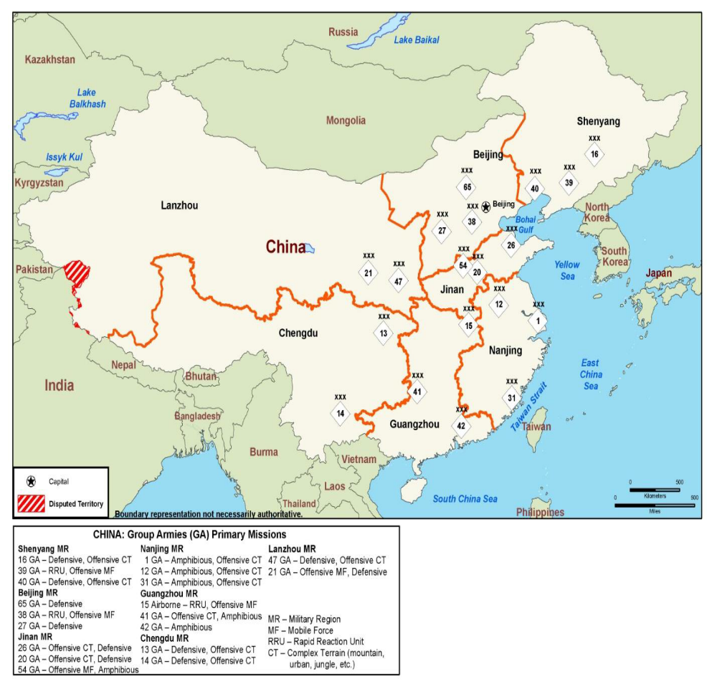

Taiwan Strait Military Balance, Naval Forces
China |  |  |  | Taiwan
Total |  | East and South Sea Fleets |  | Total
Destroyers | 26 | 16 | 4
Frigates | 53 | 44 | 22
Tank Landing Ships/ Amphibious Transport Dock | 27 | 25 | 12
Medium Landing Ships | 28 | 21 | 4
Diesel Attack Submarines | 49 | 33 | 4
Nuclear Attack Submarines | 5 | 2 | 0
Coastal Patrol (Missile) | 86 | 68 | 61
Note: The PLA Navy has the largest force of principal combatants, submarines, and amphibious warfare ships in Asia. After years of neglect, the force of missile-armed patrol craft is also growing. In the event of a major Taiwan conflict, the East and South Sea Fleets would be expected to participate in direct action against the Taiwan Navy. The North Sea Fleet would be responsible primarily for protecting Beijing and the northern coast, but could provide mission-critical assets to support other fleets.

Major Naval Units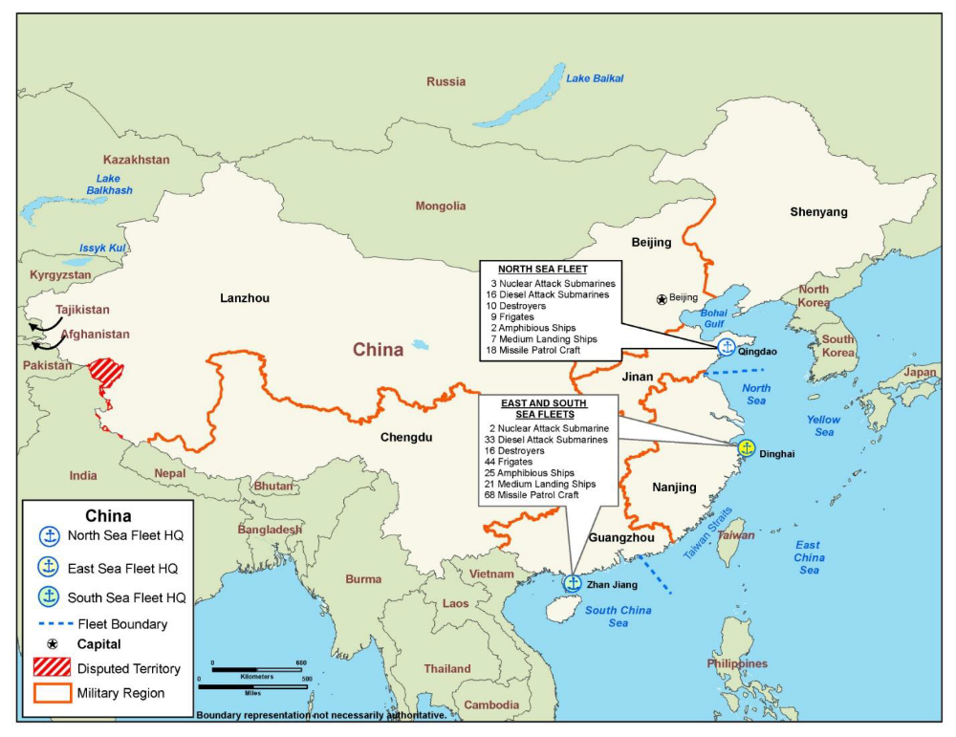

Taiwan Strait Military Balance, Air Forces
China |  |  | Taiwan
Aircraft | Total | Within range of Taiwan | Total
Fighters | 1,680 | 330 | 388
Bombers/Attack | 620 | 160 | 22
Transport | 450 | 40 | 21
Note: The PLAAF and the PLA Navy have approximately 2,300 operational combat aircraft. These consist of air defense and multi-role fighters, ground attack aircraft, fighter-bombers, and bombers. An additional 1,450 older fighters, bombers and trainers are employed for training and R&D. The two air arms also possess approximately 450 transports and over 100 surveillance and reconnaissance aircraft with intelligence, surface search, and airborne early warning capabilities. The majority of PLAAF and PLA Navy aircraft are based in the eastern half of the country. Currently, 490 aircraft could conduct combat operations against Taiwan without refueling. However, this number could be significantly increased through any combination of aircraft forward deployment, decreased ordnance loads, or altered mission profiles.

Major Air Units 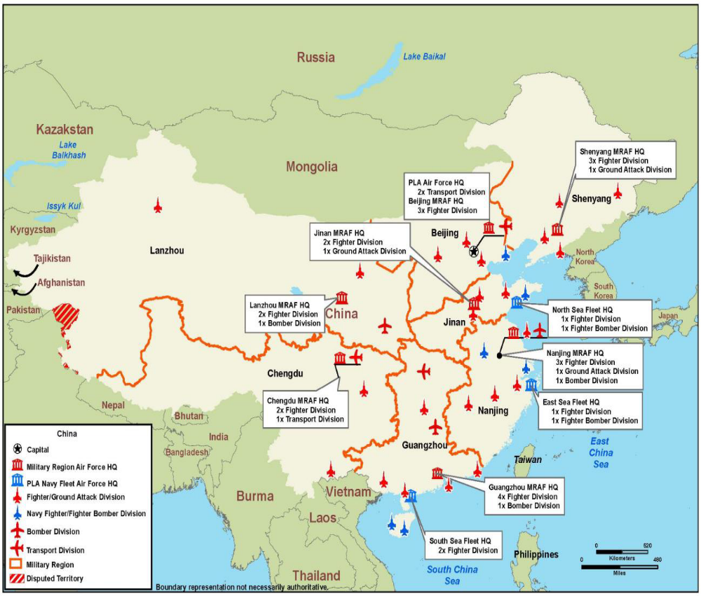

China’s Missile Force
System | Missiles | Launchers | Estimated Range
ICBM | 50-75 | 50-75 | 5,400-13,000+ km
IRBM | 5-20 | 5-20 | 3,000+ km
MRBM | 75-100 | 75-100 | 1,750+ km
SRBM | 1,000-1,200 | 200-250 | 300-600 km
GLCM | 200-500 | 40-55 | 1,500+ km

