Books Dataset — Data Cleaning & Data Insight
(Source: CSV dataset scraped from books.toscrape.com, 1000 books)

1. Introduction & Topic
For this lab task, a CSV dataset was created by web-scraping the site books.toscrape.com, containing information on 1000 books. For each book the following fields were collected: title, price, tax, availability (stock status), rating, number of reviews, product type, UPC, and product URL. This dataset was cleaned and then analyzed to extract meaningful insights.

2. Data Cleaning
On inspecting the raw CSV file, the following issues were identified and fixed:
- Encoding error: the price, price_excl_tax, price_incl_tax, and tax columns had the currency symbol '£' incorrectly encoded as 'Â£' and stored as text. These were cleaned and converted to numeric (float, GBP) values.
- The rating column was stored as text (One, Two, Three, Four, Five). A new numeric column, rating_numeric (1–5), was created to make analysis easier.
- Unnecessary whitespace was trimmed from all text columns.
- Checked for fully duplicate rows and missing/null values — none were found (0 missing values, 0 duplicate rows).
- One pair of duplicate titles was found ('The Star-Touched Queen'), but since they have different UPCs and prices, they were treated as two distinct catalogue entries and kept.
- The columns availability (all 'In stock'), product_type (all 'Books'), and number_of_reviews (all 0) are constant across the entire dataset — they add little analytical value, so this was noted explicitly.
After cleaning, the final cleaned CSV contains 1000 rows and 12 columns (including the new rating_numeric column), with no missing values.

3. Data Insight (Analysis)
- Average price: £35.07 | Minimum: £10.00 | Maximum: £59.99 | Median: £35.98
- The price distribution is fairly uniform — the number of books is roughly similar across different price ranges (see histogram below).
- Number of books by rating: One = 226, Three = 203, Five = 196, Two = 196, Four = 179 — rating 'One' is the most common.
- Average price does not vary much by rating (ranging from about £34.56 to £36.09), and the correlation between price and rating is only 0.028 — meaning there is essentially no relationship between a book's price and its rating.
- Most expensive book: 'The Perfect Play (Play by Play #1)' — £59.99. Cheapest book: 'An Abundance of Katherines' — £10.00.
- Books priced above £50: 198 (about 19.8% of all books). Books priced below £20: 196 (about 19.6%).
- All books are listed as 'In stock', and the number_of_reviews column is always 0 — since the source site (books.toscrape.com) is a demo/practice site, it does not expose real review data. This is a limitation of the dataset.

4. Visualization
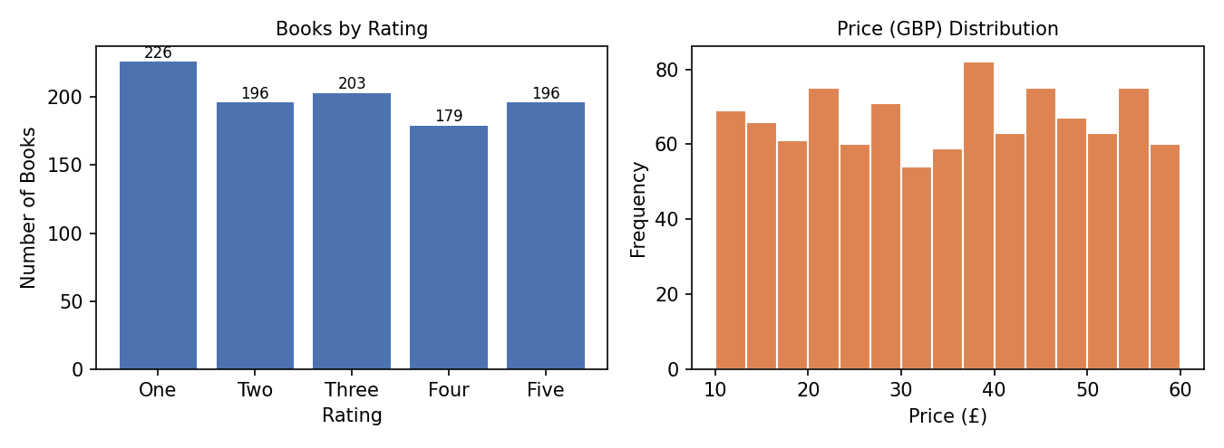

5. Conclusion
Starting from a 1000-book dataset scraped from books.toscrape.com, encoding and data-type issues were resolved to produce a clean CSV file. The analysis shows that book prices are spread fairly evenly between £10 and £60, and there is no significant relationship between price and rating. This cleaned dataset can be used for further analysis in the future, such as price prediction or building a recommendation system.

