**Project proposal on**

**Ningu wines**

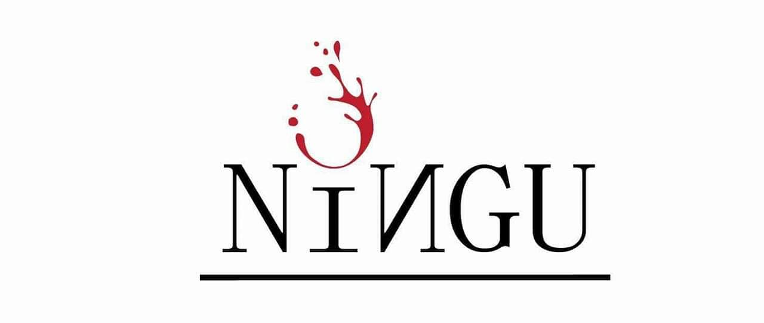

**Submitted by: Biswash Khadka Submitted to: Sudeep Bajimaya**

**ID: 00175071**

**Batch: 22C**

**Computing Project**

**Softwarica college of It and e-commerce**

Contents

**Chapter 1: Introduction** 3

**Introduction to project:** 4

**Background of the project:** 4

**Problem statement:** 4

**Description of the project:** 5

**Feature of the project:** 5

**Overview of the system:** 5

**Chapter 2: Scope of the project** 5

**Scope:** 5

**Limitation:** 6

**Aims:** 6

**Objective:** 6

**Overview of the scope:** 6

**Chapter 3: Development Methodology** 7

**Description of the methodology chosen:** 7

**Design pattern:** 9

**Architecture:** 10

**Chapter 4: Project Planning** 11

**WBS (work breakdown structure)** 11

**Milestones** 12

**Gantt chart:** 14

**Chapter 5: Risk management** 15

**Chapter 6: Configuration management** 18

**Chapter 7: Conclusion** 19

**Chapter 8: References and bibliography** 19

# Table of Figures

**Figure 1:-Phases of waterfall model** 8

**Figure 2: MVC (Model View Controller) design pattern.** 10

**Figure 3:3 tier architecture** 11

**Figure 4: Work breakdown structure** 12

**Figure 5: Gantt chart of Ningu wine project.** 14

# **Chapter 1: Introduction**

## **Introduction to project:**

Ningu wine is online wine shop with provides verities of kiwi wine and nursery of kiwi plants. It is a commercial website and I am going to develop it with the help of PHP and JavaScript. This website facilitates clients directly deal with the manufacture of wine. Online orders from customers is taken and provides delivery services through this website. But, also nursery of kiwi plants is delivered according to customers demand.

## **Background of the project:**

Talking about the background of this project, it is owned by Mr. Rangdan Tamang and is located in Ramechhap, Nepal. Previously, the production house only supplied the kiwi to various parts of Nepal but now they have planned to produce pure kiwi wine in the wine production house of Godawari and has thought of selling them through the online. That’s why, they have planned to computerized their business and develop a desktop-based application (Ningu Wines Website) and record their sales digitally which will bring good reputation for their business.

## **Problem statement:**

The main problem of this project is marketing. As the product is new in market, many people may not know about this which may cost loss in project at first. Next things are competition among the current wine production companies.

Doing advertisement will help the project to extend their business for clients. As the project is new on market, certain discount will be provided to the clients on online payment which promotes and motivates the client on using this e-commerce websites.

## **Description of the project:**

This project basically manages the wine and kiwi plant nursery. People can order wines through our online Ningu wine website and can pay through e-sewa payment application. Ningu wines have verities of test and flavors. Also, it is sugar free that is we use stevia plant (instant of sugar). So, we can say that it is a kind of healthy wine then others.

## **Feature of the project:**

Some of the features of Ningu wine website are discuss below:

* Owner itself will edit advertisement of products.
* Online payment and deliveries will be handled.
* Login system will be provided, so that the verification of client will be done and the duplication of data will be handled.
* To notify client and owner about the booking conformation.
* Adding, editing and updating features.
* Management of sales and purchase information.

## **Overview of the system:**

Overall, the project will be very help full for the wine production company and their clients. Simple design of the website will attract client as well as it will be easily accessible by them.

# **Chapter 2: Scope of the project**

## **Scope:**

Every project has its own scope. The scope for this project is people can order Ningu’s products online through the help of desktop-based application. And the owner can deliver the product after analyzing the records. Some people may have problem in finding the product in market. So, this project will help them to find the suitable product online.

## **Limitation:**

* Direct communication with the owner will not maintained.
* Products are of fixed price i.e. no bargaining system.
* Clients may not get regular update from the owner.

## **Aims:**

* To design the web-based application which is user friendly and cost minimizing.
* To improve customer satisfaction through better service.
* To grow the company bottom line and increase profitability.
* To support online delivery for their client and promotes their production house.

## **Objective:**

* Login and physical diagram maintained for database and programming part.
* Detailed information about the wine.
* Availability of product easy.
* Customer satisfaction through better service.
* Automation of workflow will reduce the cost.
* Validating and supporting sales item communication.

## **Overview of the scope:**

Ningu wine is a useful system for business purpose. It allows the company to expand their business all over the Nepal through online system. The existing paper-based work will be replaced by compromised system. It facilitates customers as well as the owner of the company. Almost every kinds of information will be provided in the website which makes easier to the clients. Hence, it plays a significant role in uplifting the economic growth of the company.

# **Chapter 3: Development Methodology**

## **Description of the methodology chosen:**

Here I have chosen agile methodology where the software developed incrementally. It is best technique to use because the requirement of client may change anytime. For this approach, we need a team but according to the requirement of our project we cannot do that. So, I prefer waterfall methodology to complete the project.

Waterfall methodology is the process or method where the process falls straight downwards through the various steps. And every step must be completed to move forward to another step.

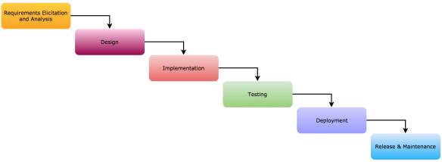

**Figure 1:-Phases of waterfall model**

Advantages of using waterfall methodology are discussed below:

* Easy to use and understand as every step is properly explained and developer won’t get confused while developing the system.
* Reduces the problematic issues.
* Scope will be high by using the waterfall methodology.
* Milestone of the project is defined well.
* Task remain stable as possible throughout the whole development process.

Object oriented methodology (OOM) is a system development approach which encourage and facilitate re-use of software components. With this methodology a computer system may evolved on element foundation which allows the effective re-use of present components and helps the sharing of its components via other structures. It supports the data abstraction, inheritance and encapsulation where abstraction helps to increase the efficiency and decreases the complexity. Encapsulation hides the data and permits the elements of class to be accessed from outside through interface provides by class.

## **Design pattern:**

MVC (model view controller) is an application design model composed of three interconnected parts. Those parts are model view and controller where model manages the app data and state. View present the model to user and allow user to manipulate. Controller act as an intermediate part between model and view.

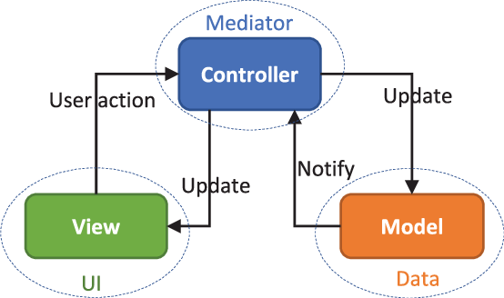

**Figure 2: MVC (Model View Controller) design pattern.**

In this project, I have used MVC pattern because of following reasons:

* Faster development process which supports rapid and parallel development.
* Helps to create multiple view for a model.
* Supports asynchronous technique, which helps developers to develop an application that loads faster.
* It returns data without applying any formatting so the same components can be used and called for use with any interface.

## **Architecture:**

A three-tier architecture is a client server architecture where functional process logic, data access, Computer data storage and user interface are developed and maintained. It is a well-established design pattern. User interface uses a graphical interface and implemented on pcs and laptops. Computer data storage is interlinked with relational database management system.

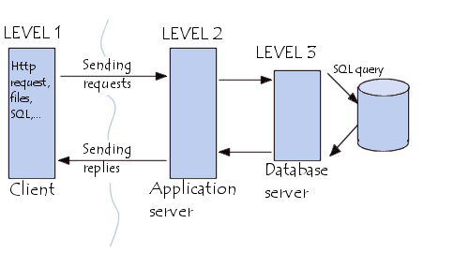

**Figure 3:3 tier architecture**

The three-tiers on three tier architecture are described below:

* **Presentation Tier:** It displays the data and information that are provided on websites.
* **Application Tier:** It control the functionality in application by performing detail processing.
* **Data Tier:** Here, the data are stored and are independent of application server.

# **Chapter 4: Project Planning**

## **WBS (work breakdown structure)**

Work breakdown structure organizes the teamwork into manageable sections. It visualizes the scope of project into small chunks, which makes teammate easier to understand.

Ningu Wines

Proposal

Proposal

Proposal

Proposal

System Analysis

System Analysis

System Analysis

System Analysis

System Design

System Design

System Design

System Design

Documentation

Documentation

Documentation

Documentation

Testing

Testing

Testing

Testing

Implementation

Implementation

Implementation

Implementation

Brainstorming

Brainstorming

Brainstorming

Brainstorming

WhiteBox and BlackBox Testing

WhiteBox and BlackBox Testing

WhiteBox and BlackBox Testing

WhiteBox and BlackBox Testing

Final Report

Final Report

Final Report

Final Report

Coding

Coding

Coding

Coding

Requirements Gathering

Requirements Gathering

Requirements Gathering

Requirements Gathering

User Interface

User Interface

User Interface

User Interface

Behavior Model

Behavior Model

Behavior Model

Behavior Model

Presentation

Presentation

Presentation

Presentation

Scoping

Scoping

Scoping

Scoping

Use Case

Use Case

Use Case

Use Case

Integration Testing

Integration Testing

Integration Testing

Integration Testing

Structural Model

Structural Model

Structural Model

Structural Model

Architecture

Architecture

Architecture

Architecture

Planning

Planning

Planning

Planning

**Figure 4: Work breakdown structure**

## **Milestones**

Milestones are tools used in project management to mark specific points along a project timeline. In a project management, milestone used to signify start and end of project.

|  |  |  |
| --- | --- | --- |
| Milestones | Start Date | Finish Date |
| Proposal   * Brainstorming * Scoping * Planning | 3/25/2019  3/25/2019  3/28/2019  4/4/2019 | 4/9/2019  3/27/2019  4/3/2019  4/9/2019 |
| Analysis   * Requirements Gathering * Use Case * Architecture | 4/10/2019  4/10/2019  4/20/2019  4/28/2019 | 5/8/2019  4/19/2019  4/27/2019  5/8/2019 |
| Design   * User Interface * Behavioral Model * Structural Model | 5/9/2019  5/9/2019  5/17/2019  5/26/2019 | 6/3/2019  5/16/2019  5/25/2019  6/3/2019 |
| Implementation   * Coding | 6/4/2019  6/4/2019 | 6/24/2019  6/24/2019 |
| Testing   * WhiteBox and BlackBox Testing * Integration Testing | 6/25/2019  6/25/2019  6/29/2019 | 7/1/2019  6/28/2019  7/1/2019 |
| Documentation   * Final Report * Presentation | 7/2/2019  7/2/2019  7/7/2019 | 7/12/2019  7/6/2019  7/12/2019 |

**Figure 4: Milestone.**

In above table, task and its deadline described. According to the milestone presented above the start, date for the project is 3rd march and the project will be completed in 12th of July.

The Milestone of project are discussed below:

* **Proposal:** In this phase,the planning and scoping of project is done which marks the milestone phase of SDLC. For this section I have separated 15 days. First 2 days I have used to brainstorm the ideas to develop project. For the scope of the project I have to consult with the owner so it takes 6 days for this section. And the remaining 5 days are utilized in planning of the project.
* **Analysis:** Beforedeveloping the application, requirements should me made clear. We cannot move back to previous step in this methodology so proper analysis should be done. So, we gathers the requirements here. Gathering information takes me 9 days as I have to visit the production house and collect the information.For use case 7 days are separated and remaining 10 days are separated for the architecture of web based application.
* **Design:** After analysis structural and behavioral design is designed. Activity diagram, Sequential diagram, Data Flow Diagram and Class diagram are designed before implementing the system. This marks the milestone of design phase. For this portion 23 days is separated.In which user interface takes 7 days, behavioral model 8 days and structural model takes 10 days.
* **Implementation:** Based on the design, system is implemented and coding is done using the concept of Object-Oriented model. This marks the milestone of implementation phase of SDLC. For the implementation of application and coding section 20 days are separated.
* **Testing:** Milestones marks this phase aftertesting is done to find the flaws in the system. Testing is done in 6 days where we will do black box and white box testing both.
* **Documentation:** In this final phase, the final report of the project is submitted after completing all above phases and being accepted by module supervision. In documentation we will do final report which consist 4 days.And the presentation will take 6 days. Where we will create some slides to give presentation of our project.

## **Gantt chart:**

Gantt chart provides graphical representation of a schedule that helps to plan, coordinate and track specific tasks in project.

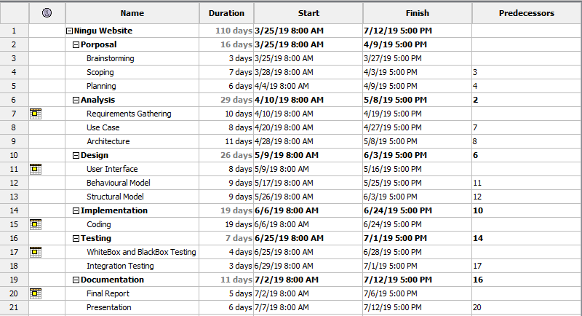

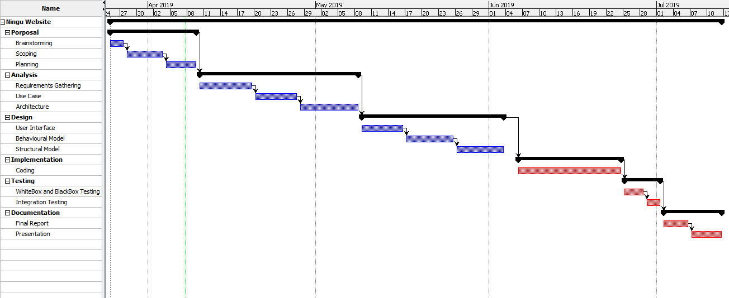

**Figure 5: Gantt chart of Ningu wine project.**

# **Chapter 5: Risk management**

The possibilities of any negation action that might took place due to external or internal factor and hamper the project is risk. All project has any kinds of risk. And the process of minimizing such kind of risk by analyzing, identifying and controlling is risk management.

The steps undertaken to manage such kind of risks are discuss below:

* **Identification:** Detection of risk that might prevent to achieve project goal.
* **Analysis:** After the identification of risk the consequences and likelihood of each risk is determined. Determines the most dangerous risk to the project.
* **Planning:** Here, we made the plan for most dangerous risk for our project.
* **Monitoring and control:** maintenance of project plan and continuously identification of risk.

To estimate the risk impact of project we use:

**Impact = Likelihood * Consequence**

|  |  |
| --- | --- |
| **Likelihood** | **Value** |
| Low | 1 |
| Medium | 2 |
| High | 3 |

**Table 1: Risk Likelihood and its value**

|  |  |
| --- | --- |
| **Likelihood** | **Value** |
| Very Low | 1 |
| Low | 2 |
| Medium | 3 |
| High | 4 |
| Very High | 5 |

**Table 2:Risk Consequences and its value.**

|  |  |  |  |  |  |  |
| --- | --- | --- | --- | --- | --- | --- |
| **S.N.** | **Risk** | **Likelihood** | **Consequence** | **Impact** | **Action** | **Remark** |
| 1 | Hard disk crash | 2 | 4 | 8 | Store in iCloud or google drive. |  |
| 2 | Unauthorized access | 3 | 4 | 12 | Strong and encrypted password must be used. |  |
| 3 | Time limitation | 2 | 4 | 8 | Proper planning and scheduling. |  |
| 4 | Unclear requirement (Ambiguous answer from client) | 3 | 3 | 9 | Proper communication with client. |  |
| 5 | Data loss | 2 | 4 | 8 | Proper backup system. |  |

**Table 3:Risk management sample table.**

# **Chapter 6: Configuration management**

Configuration management is a procedure this used to set up a product’s performance and additionally try to preserve that overall performance.

Key stages to project configuration management are:

* Planning and Managing.
* Configuration Identification.
* Configuration Reporting.
* Configuration accounting status.
* Auditing.

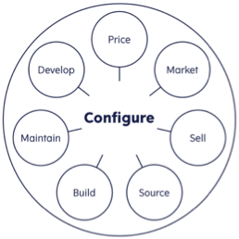

**Table 4:CM life Cycle.**

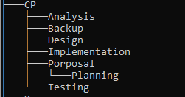

Figure 6: Configuration Management of project

Here, I have used GitHub ([biswash005@gmail.com](mailto:biswash005@gmail.com) ) as version controller of this project and has done regular backup through Google drive too.

# **Chapter 7: Conclusion**

Hence, the aims and objectives of the proposal will kept in mind while developing software. During design and implementation phases effective method will be used so that the software will, I made better. I have used waterfall model for my project because it is easy to use, maintain and the analysis is done briefly. Work breakdown structure, Gantt chart, Milestone are used which divides the project in small chunks and makes the work easier. In milestone I have provided the proper schedule for the project as shown in above diagram. In this way I have prepared the proposal for my web based application.

# **Chapter 8: References and bibliography**

Techopedia.com. (2019).Three-tier Architecture? Definition and Steps? [Online]. Available at:

(<https://www.techopedia.com/definition/24649/three-tier-architecture>) [Accessed on April 5. 2019].

Toolsqa.com. (2019). Process of Waterfall Model? [Online]. Available at:

(<https://www.toolsqa.com/software-testing/waterfall-model/> ) [Accessed on April 3. 2019].

Techrepublic.com. (2019). Lifecycle of Configuration Management? [Online]. Available at:

(<https://www.techrepublic.com/blog/tech-decision-maker/a-five-step-model-for-configuration-management/>) [Accessed on April 6. 2019].