# Chapter 2: Analysis

# 2.1 Introduction to analysis:

Analysis in the process of collecting information about the web-based application and the operation it will do in order to maintain the quality of the product. It starts with a brainstorm idea which will help in the development of the system. It is very important in breaking macro project into small chunks. It provides the basic framework, concept and methods. In this process all the functional and non-functional requirement of projects are made clear.

# 2.2 Analysis Methodology:

Analysis methodology is a way of analyzing the requirement of project. It includes functional requirement, non-functional requirement, and feasibility study. There are many analysis methodology like hard approach, soft approach, combined approach and many more. Among them, I have used soft system methodology for the analysis of the project because it is more people oriented analysis comparing to other approach of analysis. It helps to maintain the proper communication between user and developer which helps to meet the requirements. It facilitates joint problem solving and open discussion of problems. Moreover, it recognizes user interaction is more important than technical consideration. It uses the various techniques during the analysis phase like rich picture, root definition and conceptual model.

**Finding out:** Here, we finds out the problem and their solutions for the development of the system. Interview, Observations, Questionnaire, etc. is done to find the problem and their solution of existing system.

**Interview:**

It is the best way of gathering information. It is a communication in which one party asks the question and another one gives the answer of that question. Here, I have asked some question regarding to the Ningu wines website to owner and had received the information as much as needed like:

* What is the current situation of shop?
* How often is it easy to buy products in your shop?

**Observation:**

Observation is the act of closely observing or noticing something or someone. Here, I have observe all the working environment of shop and have identified the processes and problems of shop in current situation.

**Rich pictures:**

Rich picture is a drawing that illustrates the elements and relationships between the actor and system. It contains of picture, symbol and icons which helps in graphical representation of system. It illustrates the current situation and helps in better planning of the system. Here, I have drawn the rich picture of shop showing the working structure of shop owner and customers.

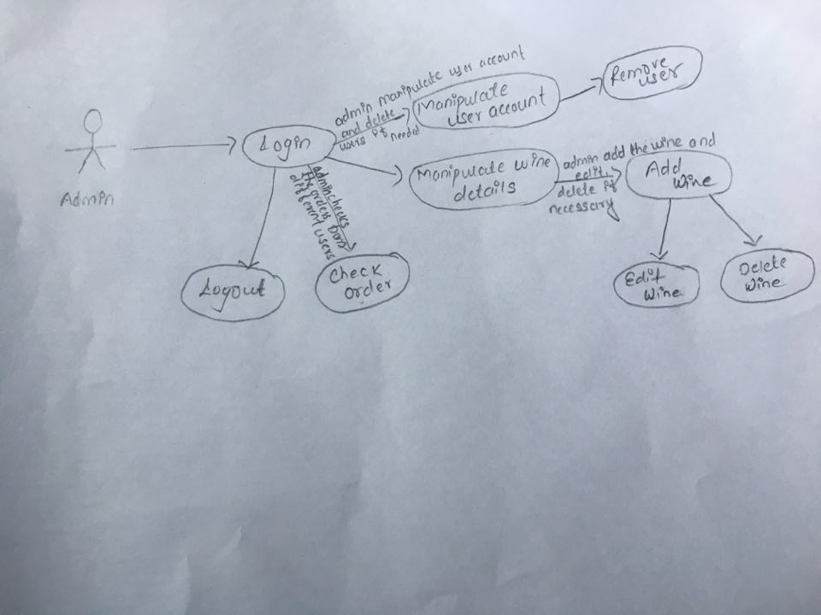

Figure 1: Rich picture for Owner

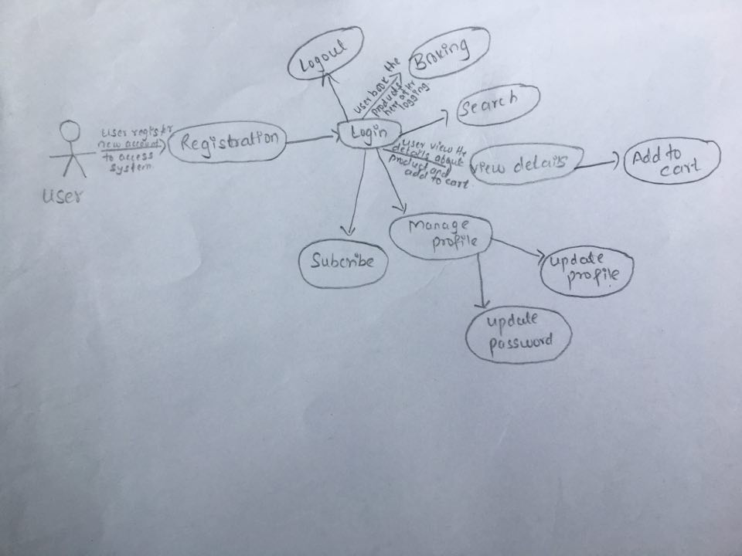

Figure 2: Rich picture for User

**Root definition:**

Structured description of a system is root definition. It represent the activities that have been undertaken and provides the clear statement of those activities. It help to clarify the problem statement and processes of the system. It also describes the aims and function of the system.

In root definition we clarifies the problem and process to overcome in an existing system. So here I have shown some of the processes and problems which mainly focuses on issues based root definition.

|  |  |
| --- | --- |
| **Processes** | **Problems** |
| Buying products | Customers need to go to shop and buy products manually, which takes more time and resources. |
| Recording information | Owner use to record all the information of sales, purchase and users in paper form, which makes difficult and is more time consuming. |
| Booking | Customers need to wait for long queue to book the products they want to buy. That consumes the more time, cost and resources. |

**Conceptual model:**

Conceptual model is a representation of a system which help users to know and understand the system the model represents. It’s a model of a system that uses concepts and ideas. It gives broad description of representative system. Well document of the system for future situation.

Here, the conceptual working model of admin and user is shown.

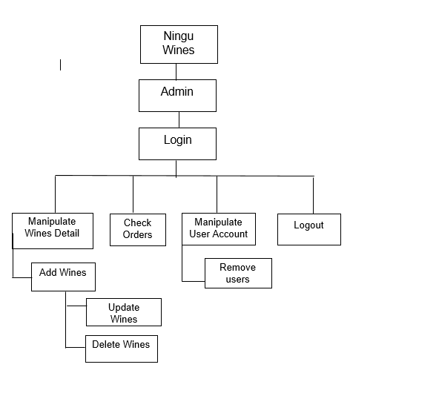

Figure : Conceptual model of Admin

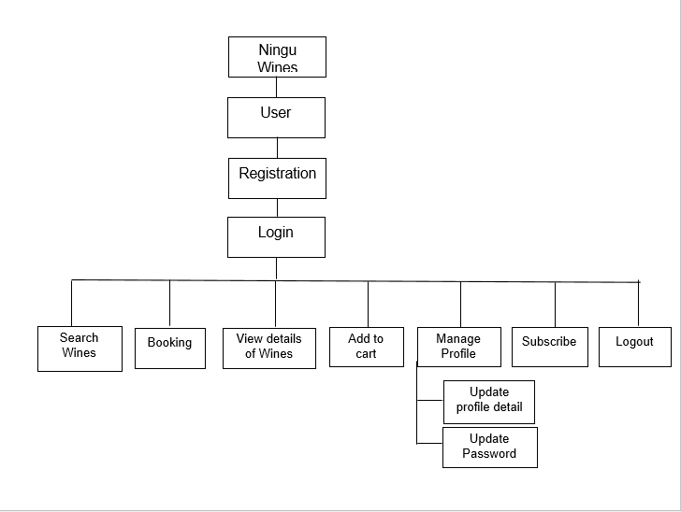

Figure : Conceptual model for User

**Comparison between rich picture and conceptual model:**

The comparison between rich picture and conceptual (real world) model is done here.

|  |  |
| --- | --- |
| **Rich Picture** | **Conceptual Model** |
| Buying products manually, which consumes more time and resources of users. | Buying products in digital form that safes the time and resources of users. |
| Recording information of purchases, sales and users in paper form which is time consuming process and has many risk while recording those data in paper. | Recording all information and data in digital form that makes feel safe. |
| Booking the products by waiting in queue that consumes the more time and resources of users. | Booking the products in digital form which is feasible to use and save the time and resources of users. |

# 2.3 Feasibility study:

A word feasible refers to state of being easy or reasonable. A feasibility study is an evaluation of project and its analysis or system that somebody has planned. It determine whether the system is technically and financially feasible or not. Simply feasibility study shows how easily and successfully we complete our project. Profitable and unprofitable will also be determine with the help of this study.

**Technical feasibility:**

Technical feasibility in terms of my project is complete study of how the input, output, process overflow. It should support the hardware and software requirement for our project. Suppose I have used **hp** notebook having ram 8 GB, processor 203GHz and graphics of 2 GB to complete my project.

**Social feasibility:**

Social feasibility refers to acceptance of our product by people after the launch of product. It consider whether the product is socially feasible or not. Sometimes the product may cause social issues so we have to take care of that situation and maintain our product regarding to all kind of culture and social issues.

**Legal feasibility:**

Legal feasibility consider the legal and ethical requirements that the product follows or not. Such study is usually done to provide an overview of threats that the company may faces.

**Economic feasibility:**

It determines the efficiency of project. It is also cost analysis. It provides profits against investments expected from the project.

# 2.4 Requirement analysis:

In requirement analysis, we mainly focus on the functional and non-functional requirements of the system. Functional and Non-functional requirements for the system has been done below with their description.

## 2.4.1 Functional requirements:

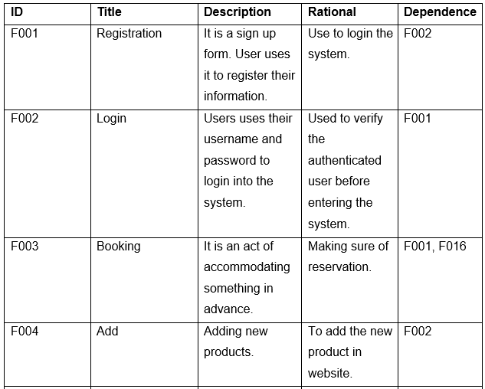

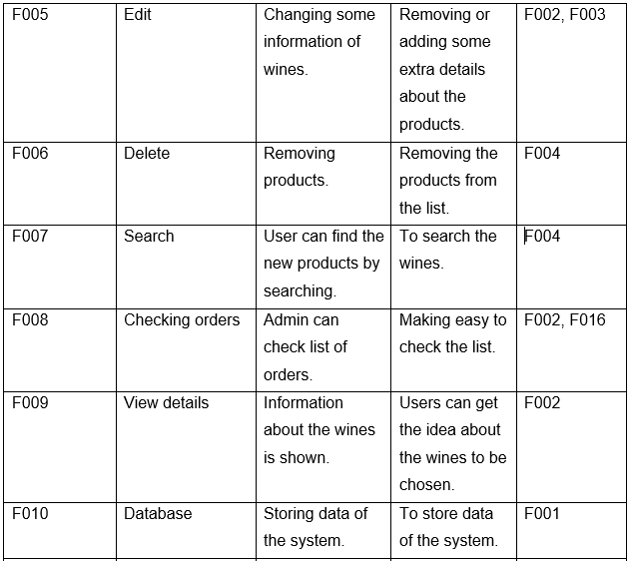

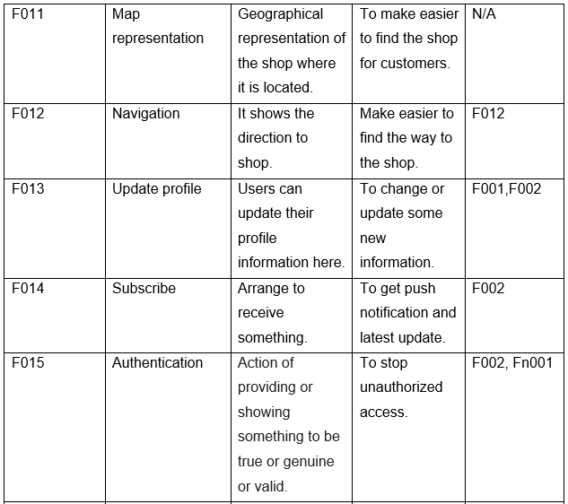

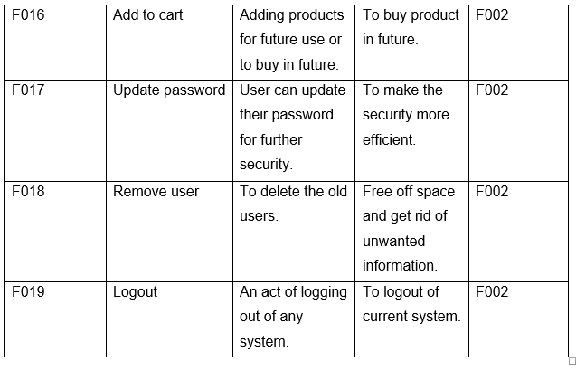

Table : Functional requirements table

## 2.4.2 Non-functional requirements:

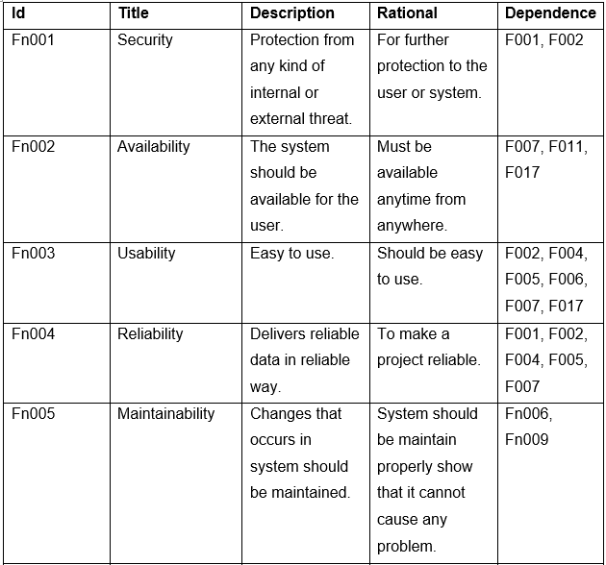

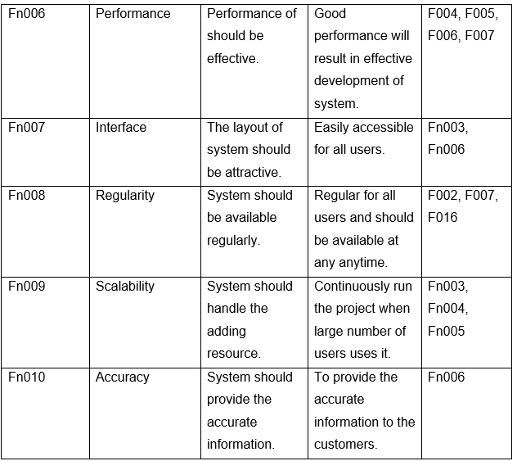

Table : Non-Functional requirements table

# 2.4.3 MoSCoW prioritization:

MoSCoW prioritization is a technique which helps to manage and understand the priorities. It helps developers to understand the requirements of customer and their priority. The MoSCoW prioritization categorized into four letters which are explained below:

**Must have:**

It represent the non-negotiable need for the projects. The minimum requirement of the project which the developer have promised to do must be guaranteed or delivered.

**Should have:**

Here, competitive solution for the project is given but not necessary to deliver it at a time. Without it the project will be good but not the best.

**Could have:**

This prioritization focuses in user desirable requirements that are less important i.e. less impact if left out.

**Would have:**

Here the requirements are prioritized for future use and are not delivered at the time. This will also shows the scope of the project. And the requirements will be considered for future use.

**Table1: MoSCoW prioritization for Functional requirements**

|  |  |  |
| --- | --- | --- |
| **ID** | **Title** | **MoSCoW** |
| F001 | Registration | Must have |
| F002 | Login | Must have |
| F003 | Booking | Should have |
| F004 | Add | Must have |
| F005 | Edit | Should have |
| F006 | Delete | Should have |
| F007 | Search | Should have |
| F008 | Checking orders | Should have |
| F009 | View details | Must have |
| F010 | Database | Must have |
| F011 | Map representation | Should have |
| F012 | Navigation | Won’t have |
| F013 | Update profile | Must have |
| F014 | Subscribe | Should have |
| F015 | Authentication | Must have |
| F016 | Add to cart | Must have |
| F017 | Update password | Must have |
| F018 | Remove user | Should have |
| F019 | Logout | Must have |

**Table2: MoSCoW prioritization for Non-Functional requirements**

|  |  |  |
| --- | --- | --- |
| **Id** | **Title** | **MoSCoW** |
| Fn001 | Security | Should have |
| Fn002 | Availability | Must have |
| Fn003 | Usability | Must have |
| Fn004 | Reliability | Must have |
| Fn005 | Maintainability | Must have |
| Fn006 | Performance | Must have |
| Fn007 | Interface | Must have |
| Fn008 | Regularity | Should have |
| Fn009 | Scalability | Must have |
| Fn010 | Accuracy | Must have |

# 2.4.4 SRH (Software Hardware Requirements):

A software hardware requirements is way to define the software system to be developed. It describe the feature and description of software application. It also defines functional and non-functional requirements that the software requires. Here, I have listed some of the software and hardware requirements needed for the system.

**Software Requirements:**

|  |  |  |
| --- | --- | --- |
| **S.N.** | **Software** | **Description** |
| 1. | Operating system | Windows 10 Home |
| 2. | Browser | Feasible to any browser like: Google chrome, Microsoft Edge, Mozilla Firefox, etc. |
| 3. | Server | XAMPP |
| 4. | Database | MySQL |

**Hardware Requirements:**

|  |  |  |
| --- | --- | --- |
| **S.N.** | **Hardware** | **Description** |
| 1. | Internet Connection | LAN or Wi-Fi |
| 2. | Device | Laptop, PC, Smartphone |
| 3. | Resolution | Any resolution is acceptable. |
| 4. | RAM and Processor | 2GB RAM and 2GHz processor is required. |

# 2.5 Use-case Diagram:

Use-case diagram is a graphical representation of all the elements of a system. It is a methodology which is used to identify, clarify and organize the system requirements. It is represented in UML. It shows the functionality of system by using actors and use cases.

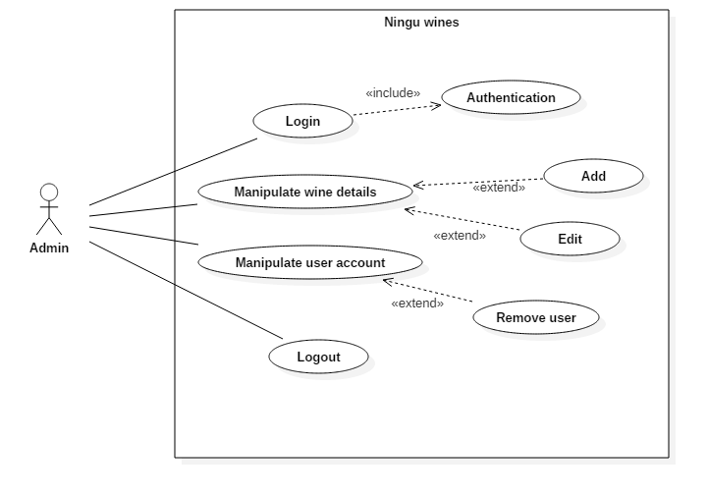

Figure : Use case diagram for Admin

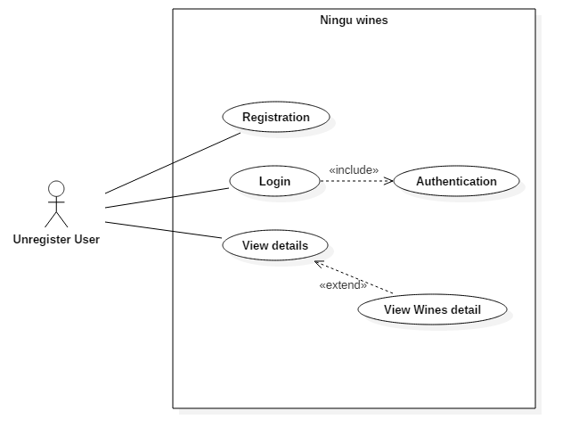

Figure : Use case diagram for unregistered user

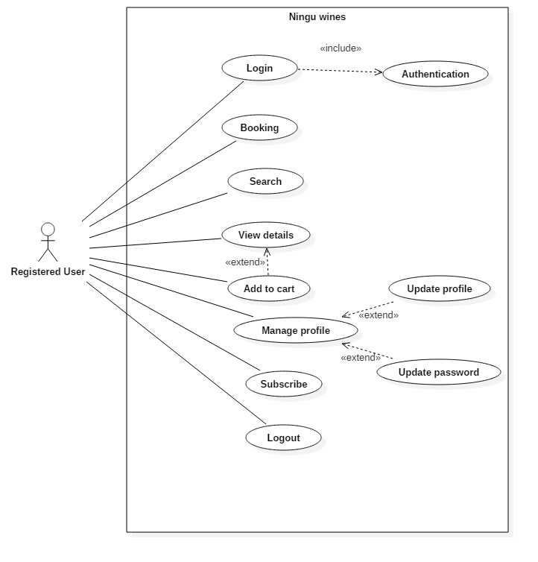

Figure : Use case diagram for registered user

In above use case diagram work that flows with system is shown. The actors of system are admin (manager/system manager), registered and unregistered user (owner or clients). User should have access to login the system using the unique email and password. Users can search the wines, add their details, edit their details and can remove the details of wines. They can also book the wine of their priority.

Now, the admin is who manages the system. All the users are manages by admin. Admin can manipulates the details provided by the users and can remove the unwanted details if arise. Also admin manipulates the user’s accounts details i.e. removes the user’s details which are fake or unnecessary to the system.

**Registration:**

Here, the user should provide their personal information to the system. The email address should be unique to login to the system.

**Login:**

It is a function provided to user and admin so that they can have access to system. By using email address and password they can login to the system and can have access to the function of the system.

**Booking:**

User can book verities of wine through booking.

**Search:**

User can find details of wines and other information.

**Add to cart:**

User can save/add their favorite product to buy whenever they want.

**Manage profile:**

User can add, update or edit their information. Also admin can update the product details according to need.

**Logout:**

User/Admin can sign-out from the system for further security.

# 2.6 NLA and Initial Class Diagram:

Ningu wine is online wine shop owned by Mr. Rangdan Tamang. It provides verities of kiwi wines and nursery of kiwi plants. It is a commercial website. Previously, the production only supplied the kiwi to various parts of Nepal but now they have planned to produce pure kiwi wine. For this, they have planned to computerized their business and develop desktop-based application, and record their sales digitally.

Here, the website should fulfill the minimum requirements. It include register page, which further include name, age. Gender, contact and more. Similarly, user have to do login to view the further information i.e. they can post their feedback and can edit, add or delete it. Also, user can register for wines. At last, they have to get logout of system after doing all the works for more security of their own.

**Candidate class, attributes and functionality:**

|  |  |  |
| --- | --- | --- |
| **Candidate class** | **Candidate Attributes** | **Candidate functionality** |
| User, Admin, Product | Id, Name, Password, Date, Contact number, Address, Username | Add, Edit, Delete, View, Register, Login, Search |

Initial class diagram:

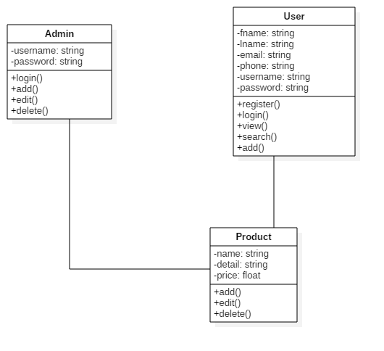

Figure : Initial class diagram