**CREATE TABLE: TED500**

INVESTORS:

CREATE TABLE INVESTORS (

investor_ID int PRIMARY KEY AUTO_INCREMENT,

f_Name varchar(20),

l_Name varchar(20),

street_No int,

street_Name varchar(40),

town_City varchar(30)

)

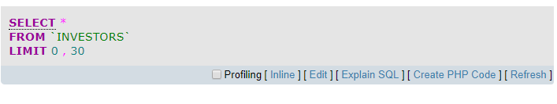

SHARES:

CREATE TABLE SHARES (

share_ID int PRIMARY KEY AUTO_INCREMENT,

share_Name varchar(20),

share_Price Double(8,2)

)

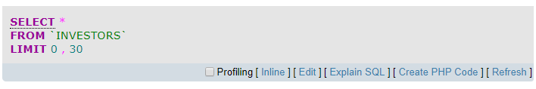

SHARE_DEALS:

CREATE TABLE SHARES_DEALS (

deal_ID int PRIMARY KEY AUTO_INCREMENT,

shares_Bought int,

deal_Date TIMESTAMP DEFAULT now(),

investor_ID int,

share_ID int,

FOREIGN KEY fk_investors_ID(investor_ID) REFERENCES INVESTORS(investor_ID),

FOREIGN KEY fk_share_ID(share_ID) REFERENCES SHARES(share_ID)

)

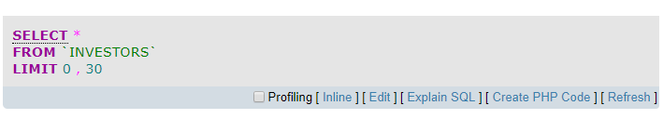

DATA

INVESTORS

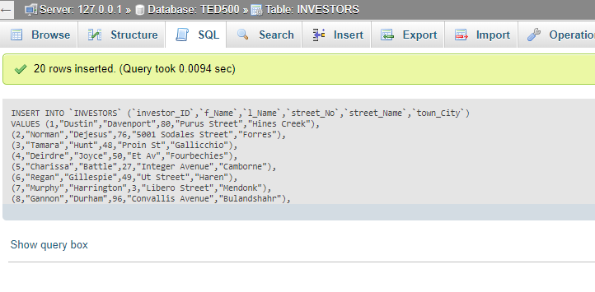

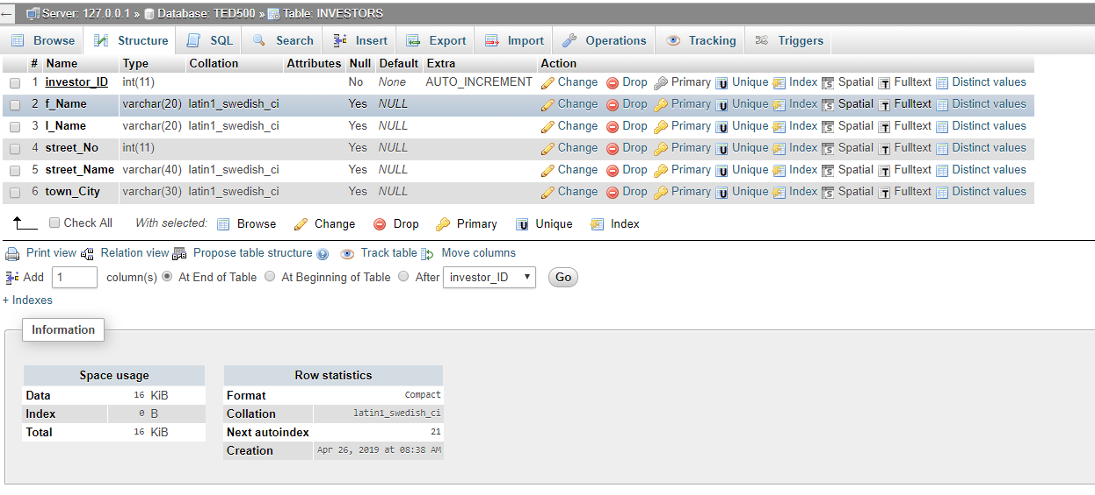

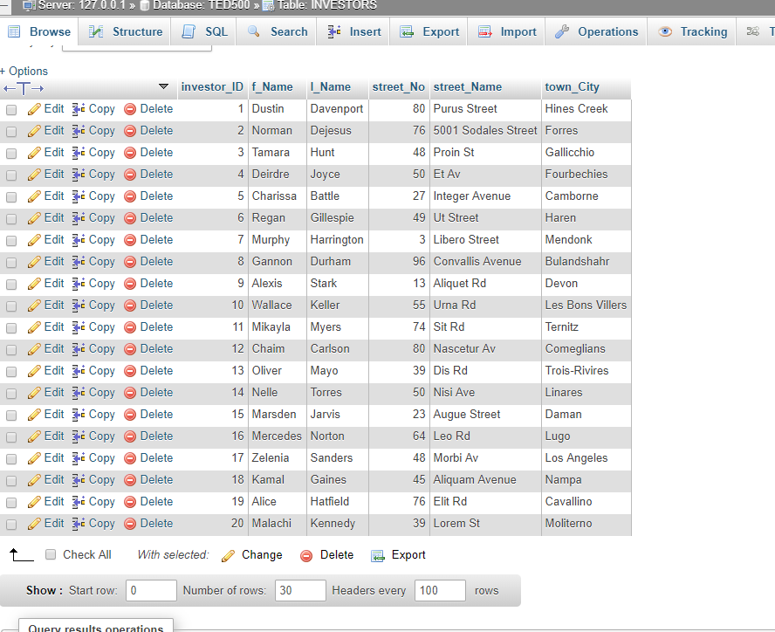

SHARES

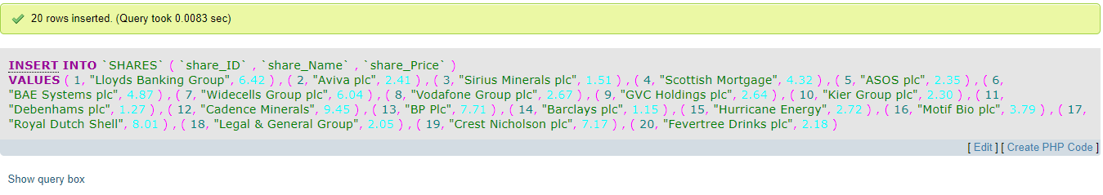

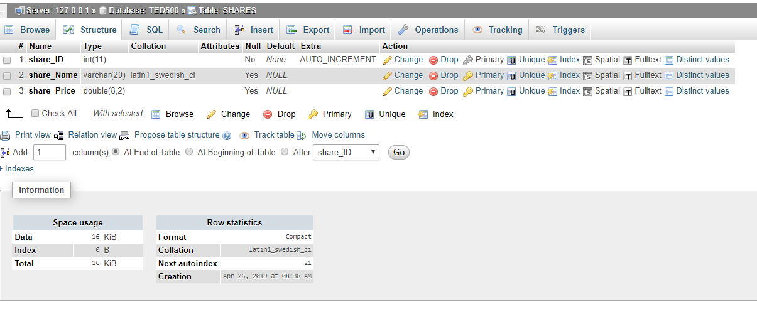

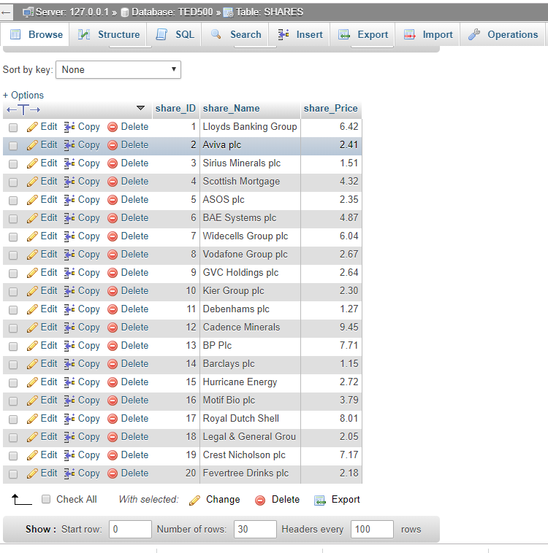

SHARES_DEALS

