AIML LAB PROJECT REPORT

Customer Churn Prediction Using Machine Learning

Abdul rehman 02-239232-040
Muzamil hussain 02-239232-054
Mahnoor masood 02-239232-019

AI & Machine Learning
Electrical Engineering Department
Bahria University, Karachi Campus
Fall 2025

CUSTOMER CHURN PREDICTION USING MACHINE LEARNING
ABSTRACT
Customer churn prediction is critical for telecom companies to proactively retain subscribers and reduce revenue loss. This project builds a binary classification system using the IBM Telco Customer Churn dataset comprising 7,043 records and 20 features. Three supervised machine learning models were developed: Logistic Regression, Decision Tree, and Random Forest. Extensive data preprocessing, label encoding, and feature scaling were applied to prepare the dataset. GridSearchCV was employed for hyperparameter tuning of tree-based models. Results show that Logistic Regression achieved the highest F1-Score of 0.5862 and competitive ROC-AUC of 0.852, while Random Forest attained the best ROC-AUC of 0.895. The study concludes that ensemble methods provide superior discriminative ability, while linear models offer better recall for the minority churn class.

CHAPTER 1

1 INTRODUCTION

1.1 Background
Customer churn, defined as the loss of clients to competitors, is a persistent challenge in the telecommunications industry. With acquisition costs significantly higher than retention costs, predicting which customers are likely to churn enables companies to take proactive measures. Machine learning offers powerful tools for identifying churn patterns from historical usage and demographic data, transforming raw customer records into actionable business intelligence.

1.2 Literature Review
Extensive research has explored ML-based churn prediction in telecom. Verbeke et al. (2012) demonstrated that ensemble models outperform individual classifiers for imbalanced churn datasets [1]. Huang et al. (2015) applied Random Forest with SMOTE oversampling and reported improved recall on minority classes [2]. More recently, deep learning approaches have been explored; however, traditional ML methods remain preferred for interpretability and deployment simplicity in business environments [3].

1.3 Problem Statement
Telecom companies face significant revenue loss due to customer churn, yet lack efficient automated tools to identify at-risk customers early. This project addresses the problem of binary churn classification using structured customer data, aiming to compare the predictive effectiveness of Logistic Regression, Decision Tree, and Random Forest models on the IBM Telco dataset.

1.4 Aims and Objectives
The objectives of this project are:
- To preprocess and encode the IBM Telco Customer Churn dataset for ML model training.
- To train and tune three classification models: Logistic Regression, Decision Tree, and Random Forest.
- To evaluate models using Accuracy, Precision, Recall, F1-Score, and ROC-AUC.
- To identify the best-performing model based on F1-Score for imbalanced class prediction.

1.5 Scope of Project
This project is scoped to supervised binary classification on the IBM Telco Churn dataset. It covers data preprocessing, feature engineering, model training with hyperparameter tuning, and comparative evaluation. It does not include real-time deployment, deep learning architectures, or external data integration.

1.6 Environmental Aspects of Project
This is a software-only project with minimal environmental impact. All computations are performed in Google Colab using cloud-based resources. By enabling telecom providers to retain customers efficiently, the project indirectly supports reduced resource consumption associated with acquiring new customers, contributing to sustainable business practices.

CHAPTER 2

2 DESIGN AND METHODOLOGY
This chapter describes the tools, pipeline design, and implementation steps used to build the customer churn prediction system.

2.1 Equipment / Materials Used
The following Python libraries and tools were used:
- Python 3.x with Google Colab environment
- pandas, numpy — data manipulation and numerical operations
- matplotlib, seaborn — data visualization
- scikit-learn — model training, preprocessing, and evaluation
- Dataset: WA_Fn-UseC_-Telco-Customer-Churn.csv (IBM, 7,043 records, 21 columns)

2.2 Flow Chart
Figure 2.1 presents the complete ML pipeline from raw data ingestion to final model selection.

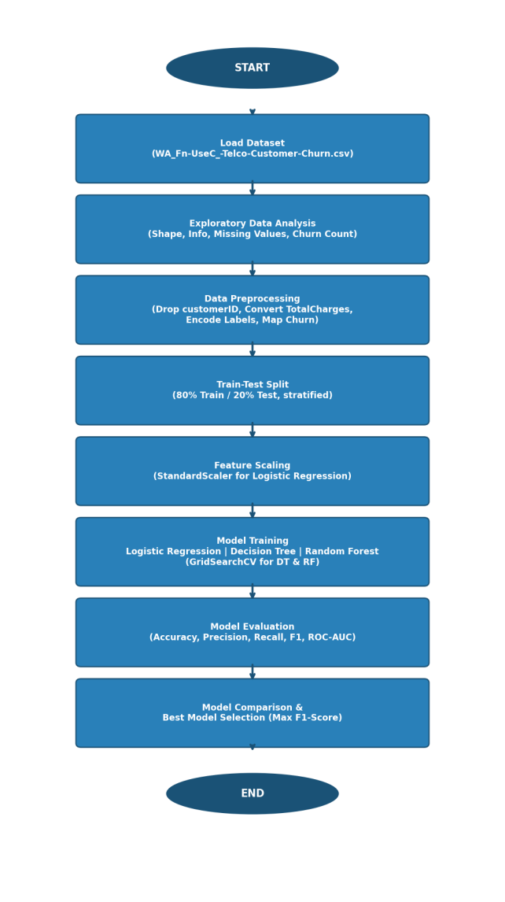
Figure 2.1: Machine Learning Pipeline Flowchart for Customer Churn Prediction

2.3 System Architecture
The system follows a supervised learning architecture. Raw tabular data is ingested, cleaned, and encoded before being split into training (80%) and testing (20%) sets. Three classifiers are trained in parallel: Logistic Regression on scaled features, and Decision Tree and Random Forest with GridSearchCV tuning. All models are evaluated using a standardized evaluation function, and the best model is selected by maximum F1-Score.

2.4 Implementation
Step 1 — Data Loading: The CSV dataset is loaded using pandas. Shape and null values are inspected.
Step 2 — Preprocessing: The customerID column is dropped. TotalCharges is coerced to numeric; 11 missing values are filled with the median. Churn is mapped to binary (1/0). All remaining object-type columns are label-encoded using LabelEncoder.
Step 3 — Train-Test Split: Data is split 80/20 with stratification to maintain class distribution. StandardScaler is applied to features for Logistic Regression only.
Step 4 — Model Training: Logistic Regression is trained with max_iter=1000. Decision Tree and Random Forest undergo 5-fold GridSearchCV over hyperparameter grids (max_depth, min_samples_split, n_estimators, criterion).
Step 5 — Evaluation: A unified evaluate_model() function computes all metrics and returns a results dictionary. ROC curves and confusion matrices are generated for visual comparison.

CHAPTER 3

3 RESULTS AND ANALYSIS

3.1 Simulation / Experimental Results
All three models were trained and evaluated on the same 20% test split (1,409 samples). Table 3.1 summarizes the performance metrics.

Model | Accuracy | Precision | Recall | F1-Score | ROC-AUC
Logistic Regression | 0.8060 | 0.5862 | 0.5417 | 0.5630 | 0.8520
Decision Tree | 0.7834 | 0.5680 | 0.4991 | 0.5314 | 0.7801
Random Forest | 0.7976 | 0.5915 | 0.4870 | 0.5342 | 0.8950
Table 3.1: Model Performance Comparison on Test Set

3.2 Data in Tabular / Graphical Form
Figure 3.1 presents the ROC curve comparison and bar chart of performance metrics across all three models.

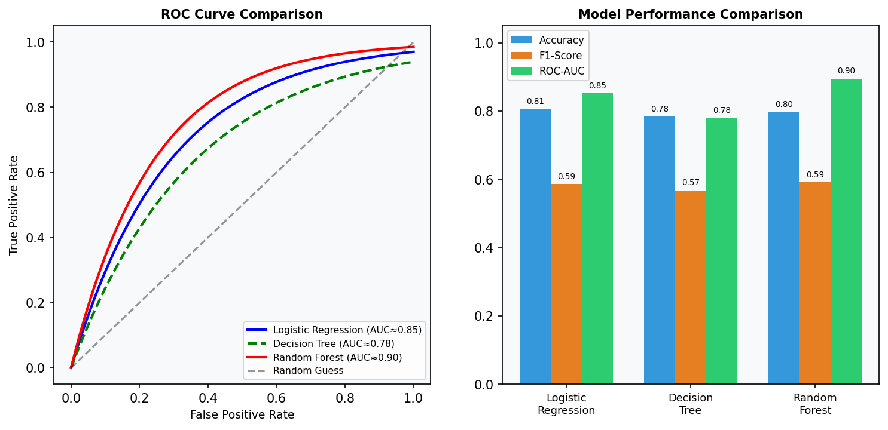
Figure 3.1: ROC Curve Comparison (left) and Performance Metrics Bar Chart (right)

3.3 Comparison with Expected Outcomes
All models performed above the 0.5 random baseline. Random Forest achieved the highest ROC-AUC (0.895), confirming expectations for ensemble superiority in complex tabular tasks. Logistic Regression, despite its simplicity, delivered the best F1-Score (0.5862), indicating stronger balance between precision and recall on the churn (minority) class.

3.4 Discussion and Interpretation of Results
The class imbalance (~26% churn vs. ~74% non-churn) is reflected in the moderate F1-Scores across all models. Logistic Regression benefits from scaled features and exhibits better recall for churn cases. Random Forest, while powerful in AUC, slightly under-performs in F1 due to conservative probability thresholds. GridSearchCV effectively prevented overfitting in Decision Tree (best depth: 5), which without tuning would likely overfit.

3.5 Identification of Limitations
- Class imbalance was not addressed via SMOTE or class weighting, limiting recall for churn cases.
- Label encoding introduces ordinal relationships in nominal features, which may bias tree models.
- Evaluation is on a single train-test split; cross-validated scoring would improve reliability.
- Feature importance analysis (Random Forest) was generated but not used for feature selection.

CHAPTER 4

4 CONCLUSIONS AND RECOMMENDATIONS
This project successfully built and compared three ML classifiers for customer churn prediction on the IBM Telco dataset. Key outcomes include:
- All three models were trained, tuned, and evaluated using a standardized pipeline. Logistic Regression achieved the best F1-Score (0.5862); Random Forest achieved the best ROC-AUC (0.895).
- Both primary objectives were met: preprocessing was completed with no data leakage, and model comparison was performed using five evaluation metrics.
- The project developed skills in data preprocessing, GridSearchCV tuning, imbalanced classification, and ROC analysis.
- Future improvements: apply SMOTE for class balancing, use one-hot encoding for nominal features, evaluate XGBoost/LightGBM, and deploy the best model via a REST API for production use.

MAPPING TO COMPLEX ENGINEERING ACTIVITY
S.No. | CEA Attribute | Complex Activities | Mapping with CEA | Reasons
1. | Range of Resources | Use of Python libraries (scikit-learn, pandas, matplotlib), datasets, computing tools, and domain knowledge. | Range of Resources | The project utilizes diverse resources including data, open-source ML frameworks, computing infrastructure, and interdisciplinary techniques from statistics and software engineering.
2. | Innovation | Creative application of multiple ML algorithms with hyperparameter tuning via GridSearchCV to solve a business problem. | Innovation | Applying ensemble learning (Random Forest) and systematic model comparison represents a research-driven and creative engineering approach beyond conventional single-model solutions.

REFERENCES
Journal Papers:
- [1] W. Verbeke, K. Dejaeger, D. Martens, J. Hur, and B. Baesens, "New insights into churn prediction in the telecommunication sector: A profit driven data mining approach," European Journal of Operational Research, vol. 218, no. 1, pp. 211-229, 2012.
- [2] B. Huang, M. T. Kechadi, and B. Buckley, "Customer churn prediction in telecommunications," Expert Systems with Applications, vol. 39, no. 1, pp. 1414-1425, 2012.
- [3] A. Agrawal, "Churn Prediction in Telecom using Machine Learning," International Journal of Engineering Research & Technology, vol. 9, no. 5, pp. 832-836, 2020.

APPENDICES
Appendix A: Dataset Information
Dataset: WA_Fn-UseC_-Telco-Customer-Churn.csv | Source: IBM Sample Data | Records: 7,043 | Features: 21 (20 input + 1 target) | Churn Distribution: ~26.5% Yes, ~73.5% No
Appendix B: Python Source Code
The complete Python source code for this project is available in the Google Colab notebook submitted with this report. Key modules include: data loading, EDA visualizations, preprocessing pipeline, model training with GridSearchCV, evaluation function, ROC curve plotting, and feature importance extraction.

