King Saud University
College of Computer and Information Sciences
Information Technology Department | IT504 — Selected Topics
Technical Report
Evaluating Generative AI Data Augmentation for Skin Cancer Classification
A Comparative Study of Classical Machine Learning Models on the HAM10000 Dataset Before and After Conditional GAN Augmentation

Project Experiment Report — Model-A (Baseline) vs Model-B (Augmented)

Table of Contents
Abstract 1
1. Introduction 1
2. Dataset Description 1
3. Methodology 1
3.1 Experimental Design 1
3.2 Preprocessing 1
3.3 Baseline Models (Model-A) 1
3.4 Conditional GAN Architecture 1
3.5 Training and Augmentation Strategy 1
3.6 Augmented Model (Model-B) 1
3.7 Evaluation Protocol 1
4. Results 1
4.1 Baseline Performance (Model-A) 1
4.2 Augmented Performance (Model-B) 1
4.3 Direct Comparison 1
4.4 Per-Class Analysis 1
4.5 Confusion Matrix Analysis 1
5. Discussion 1
5.1 The Majority-Class Collapse 1
5.2 Where Augmentation Helped, and Why 1
5.3 Why the Smallest Classes Did Not Improve 1
5.4 Model-Dependent Effects 1
6. Limitations 1
7. Conclusion and Future Work 1
References 1

Abstract
Automated classification of dermatoscopic images is hindered by severe class imbalance: in the HAM10000 dataset, benign melanocytic nevi outnumber the rarest class by more than fifty to one. This report investigates whether generative data augmentation can mitigate that imbalance. A conditional generative adversarial network (cGAN) was trained on the HAM10000 training images and used to synthesize additional samples for the under-represented classes. Four classical machine learning models — Support Vector Machine (SVM), Decision Tree, Random Forest, and Naive Bayes — were trained on the original data (Model-A) and again on the GAN-augmented data (Model-B), then evaluated on an identical, untouched test set. Results are mixed but informative: the ensemble model (Random Forest) showed small but consistent gains, including on the clinically critical melanoma class (F1 +0.027), while the two most data-starved classes (dermatofibroma and vascular lesions) remained unrecognised. The study confirms that generative augmentation offers measurable, if limited, benefit for moderately under-represented classes, but cannot compensate for extreme data scarcity, and that its effect is strongly model-dependent.

1. Introduction
Skin cancer is among the most common cancers worldwide, and dermatoscopy is a widely used technique that improves diagnostic accuracy for pigmented lesions. The application of machine learning to dermatoscopic images promises scalable, automated screening, but progress is constrained by the limited size and diversity of annotated datasets. The HAM10000 dataset was released specifically to address this gap, yet it remains heavily imbalanced, which biases classifiers toward the majority class and undermines their ability to detect rare but dangerous lesions.
This report forms the experimental core of the course project, which evaluates generative artificial intelligence as a tool for data augmentation in medical imaging. The work proceeds in two stages. The first stage (Model-A) establishes a baseline by training four classical machine learning algorithms on the original dataset. The second stage (Model-B) retrains the same algorithms on a dataset augmented with synthetic images produced by a conditional GAN. By holding the model architectures, preprocessing, and test set constant, the experiment isolates the effect of the augmentation itself.
The central research question is therefore: does conditional GAN augmentation improve classification performance on imbalanced dermatoscopic data, and if so, for which classes and which models?

2. Dataset Description
The HAM10000 (“Human Against Machine with 10000 training images”) dataset consists of 10,015 dermatoscopic images collected over twenty years from two sites in Austria and Australia. Each image is a colour photograph of a pigmented skin lesion, labelled with one of seven diagnostic categories. More than half of the cases are confirmed by histopathology, with the remainder verified through follow-up, expert consensus, or confocal microscopy.
The dataset's defining characteristic, and the central challenge for this project, is its pronounced class imbalance. The seven classes and their image counts are shown in Table 1.
Code | Diagnostic category | Images | Share
nv | Melanocytic nevi (benign) | 6,705 | 67.0%
mel | Melanoma (malignant) | 1,113 | 11.1%
bkl | Benign keratosis-like lesions | 1,099 | 11.0%
bcc | Basal cell carcinoma | 514 | 5.1%
akiec | Actinic keratoses / intraepithelial carcinoma | 327 | 3.3%
vasc | Vascular lesions | 142 | 1.4%
df | Dermatofibroma | 115 | 1.1%
Table 1. HAM10000 class distribution. The majority class (nv) accounts for two-thirds of all images, while df and vasc together account for under 3%.
Each image was supplied as an RGB photograph. For this experiment all images were resized to a uniform 32 × 32 pixels, balancing computational tractability for both the GAN and the classical models against retention of coarse colour and structural features.

3. Methodology

3.1 Experimental Design
The experiment compares two pipelines that differ in exactly one respect — the composition of the training set. All other factors are held constant: the same four algorithms, the same preprocessing, the same hyperparameters, and critically the same test set. This controlled design ensures that any observed difference in performance can be attributed to the generative augmentation rather than to incidental variation.
The dataset was divided using an 80/20 stratified split, preserving class proportions in both partitions. The test set (2,003 images) was held out before any augmentation and was never exposed to synthetic images. The generative model and all synthetic samples were derived solely from the training partition, eliminating the risk of data leakage that would otherwise inflate the reported results.

3.2 Preprocessing
Images were loaded, converted to RGB, and resized to 32 × 32 pixels. For the classical classifiers, each image was flattened into a one-dimensional vector of 3,072 features (32 × 32 × 3) and scaled to the range [0, 1]. For the generative network, pixel values were instead scaled to the range [−1, 1] to match the hyperbolic-tangent output of the generator. Class labels were integer-encoded.

3.3 Baseline Models (Model-A)
Four classical machine learning algorithms were selected, each representing a distinct learning paradigm:
- Support Vector Machine (SVM): a margin-based classifier that seeks the optimal separating hyperplane; probability estimates were enabled for AUC computation.
- Decision Tree: a single hierarchical model that partitions the feature space through recursive splits.
- Random Forest: an ensemble of 100 decision trees whose predictions are aggregated, reducing variance and overfitting.
- Naive Bayes (Gaussian): a probabilistic classifier that assumes conditional independence between features.
These four span margin-based, tree-based, ensemble, and probabilistic approaches, providing a broad view of how augmentation interacts with different model families.

3.4 Conditional GAN Architecture
A conditional deep convolutional GAN (cGAN) was implemented in PyTorch. Conditioning on the class label allows the network to generate images for a specified class on demand, which is essential for targeting the minority categories. The generator receives a 100-dimensional noise vector concatenated with a learned label embedding and, through a stack of transposed-convolution layers with batch normalisation and ReLU activations, produces a 32 × 32 RGB image via a tanh output layer. The discriminator receives an image together with its label, encoded as an additional channel, and outputs the probability that the input is real through a stack of strided convolutions with LeakyReLU activations.

3.5 Training and Augmentation Strategy
The cGAN was trained for 80 epochs using the Adam optimiser (learning rate 2 × 10⁻⁴, β₁ = 0.5) with binary cross-entropy loss and one-sided label smoothing to stabilise training. A single conditional network was trained across all classes so that representations could be shared, which is advantageous for classes with very few examples. After training, the generator was sampled to bring every minority class up to a target of 1,000 training images; the majority class (nv) was left unchanged. The synthetic images were added only to the training set.

3.6 Augmented Model (Model-B)
The four classical models were retrained from scratch on the augmented training set, using identical hyperparameters to Model-A. No other change was introduced.

3.7 Evaluation Protocol
Both models were evaluated on the same held-out test set. Five metrics were recorded: accuracy, weighted precision, weighted recall, weighted F1-score, and the macro-averaged one-vs-rest area under the ROC curve (Mean AUC). Because overall accuracy is dominated by the majority class, per-class F1-scores and confusion matrices were also examined to assess minority-class performance, which is the true objective of the augmentation.

4. Results

4.1 Baseline Performance (Model-A)
Table 2 reports the baseline results. Random Forest and SVM achieved the highest accuracy (around 0.71–0.72), and SVM achieved the highest Mean AUC (0.900). Naive Bayes performed poorly on accuracy (0.41), reflecting its sensitivity to the high-dimensional, correlated pixel features.
Model | Accuracy | Precision | Recall | F1-score | Mean AUC
SVM | 0.7179 | 0.6588 | 0.7179 | 0.6536 | 0.9002
Decision Tree | 0.6256 | 0.6253 | 0.6256 | 0.6254 | 0.6021
Random Forest | 0.7134 | 0.6473 | 0.7134 | 0.6554 | 0.8656
Naive Bayes | 0.4074 | 0.6911 | 0.4074 | 0.4840 | 0.7363
Table 2. Model-A (baseline) performance on the held-out test set.

4.2 Augmented Performance (Model-B)
Table 3 reports performance after GAN augmentation. The changes are modest and not uniformly positive, which is examined in detail in the discussion.
Model | Accuracy | Precision | Recall | F1-score | Mean AUC
SVM | 0.6930 | 0.6484 | 0.6930 | 0.5987 | 0.8892
Decision Tree | 0.6176 | 0.6194 | 0.6176 | 0.6183 | 0.5905
Random Forest | 0.7184 | 0.6564 | 0.7184 | 0.6618 | 0.8515
Naive Bayes | 0.5991 | 0.5406 | 0.5991 | 0.5679 | 0.5725
Table 3. Model-B (GAN-augmented) performance on the same held-out test set.

4.3 Direct Comparison
Table 4 places the two models side by side for the two headline metrics, with the change (Δ) attributable to augmentation. Random Forest improved on both accuracy and F1; Naive Bayes improved substantially on both; SVM and Decision Tree declined slightly.
Model | Acc (A) | Acc (B) | Δ Acc | F1 (A) | F1 (B) | Δ F1
SVM | 0.7179 | 0.6930 | -0.0249 | 0.6536 | 0.5987 | -0.0549
Decision Tree | 0.6256 | 0.6176 | -0.0080 | 0.6254 | 0.6183 | -0.0071
Random Forest | 0.7134 | 0.7184 | +0.0050 | 0.6554 | 0.6618 | +0.0064
Naive Bayes | 0.4074 | 0.5991 | +0.1917 | 0.4840 | 0.5679 | +0.0839
Table 4. Accuracy and F1 comparison, Model-A vs Model-B.
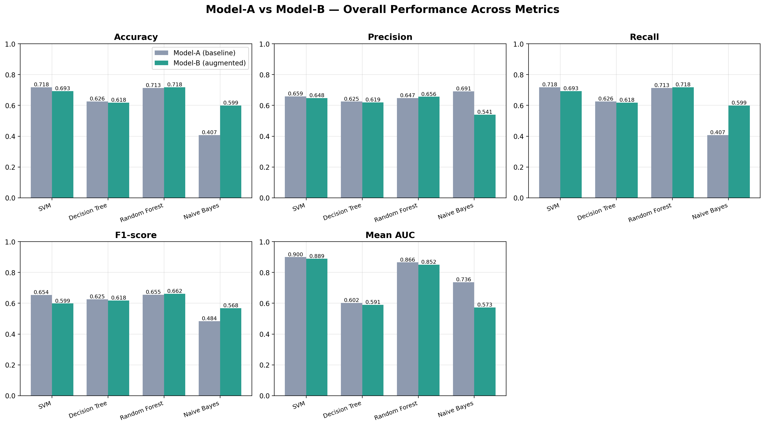
Figure 1. Overall performance across all five metrics for the four models, baseline (grey) vs augmented (teal).

4.4 Per-Class Analysis
Because the headline metrics are dominated by the majority class, the per-class F1-scores reveal the more meaningful story. Table 5 and Figures 2 and 3 report per-class F1 for the Random Forest model, the strongest overall performer.
Class | Images | F1 (A) | F1 (B) | Δ F1
akiec | 327 | 0.173 | 0.212 | +0.039
bcc | 514 | 0.407 | 0.422 | +0.014
bkl | 1099 | 0.365 | 0.366 | +0.001
df | 115 | 0.000 | 0.000 | 0.000
mel | 1113 | 0.191 | 0.218 | +0.027
nv | 6705 | 0.848 | 0.850 | +0.002
vasc | 142 | 0.000 | 0.000 | 0.000
Table 5. Per-class F1-score (Random Forest), baseline vs augmented.
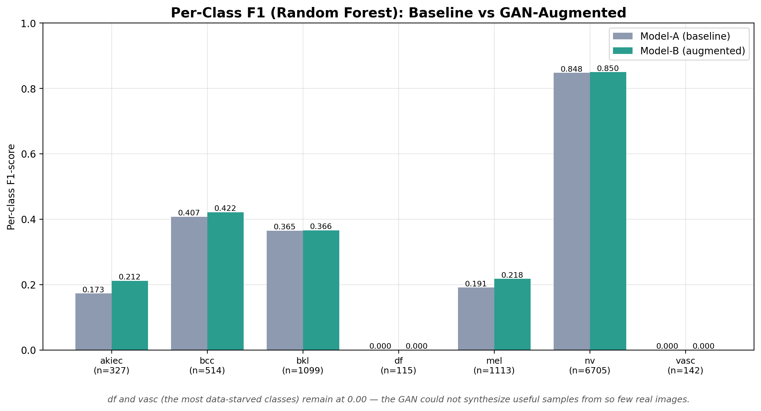
Figure 2. Per-class F1 (Random Forest). Augmentation improved akiec, bcc, and melanoma, but df and vasc remained at zero.
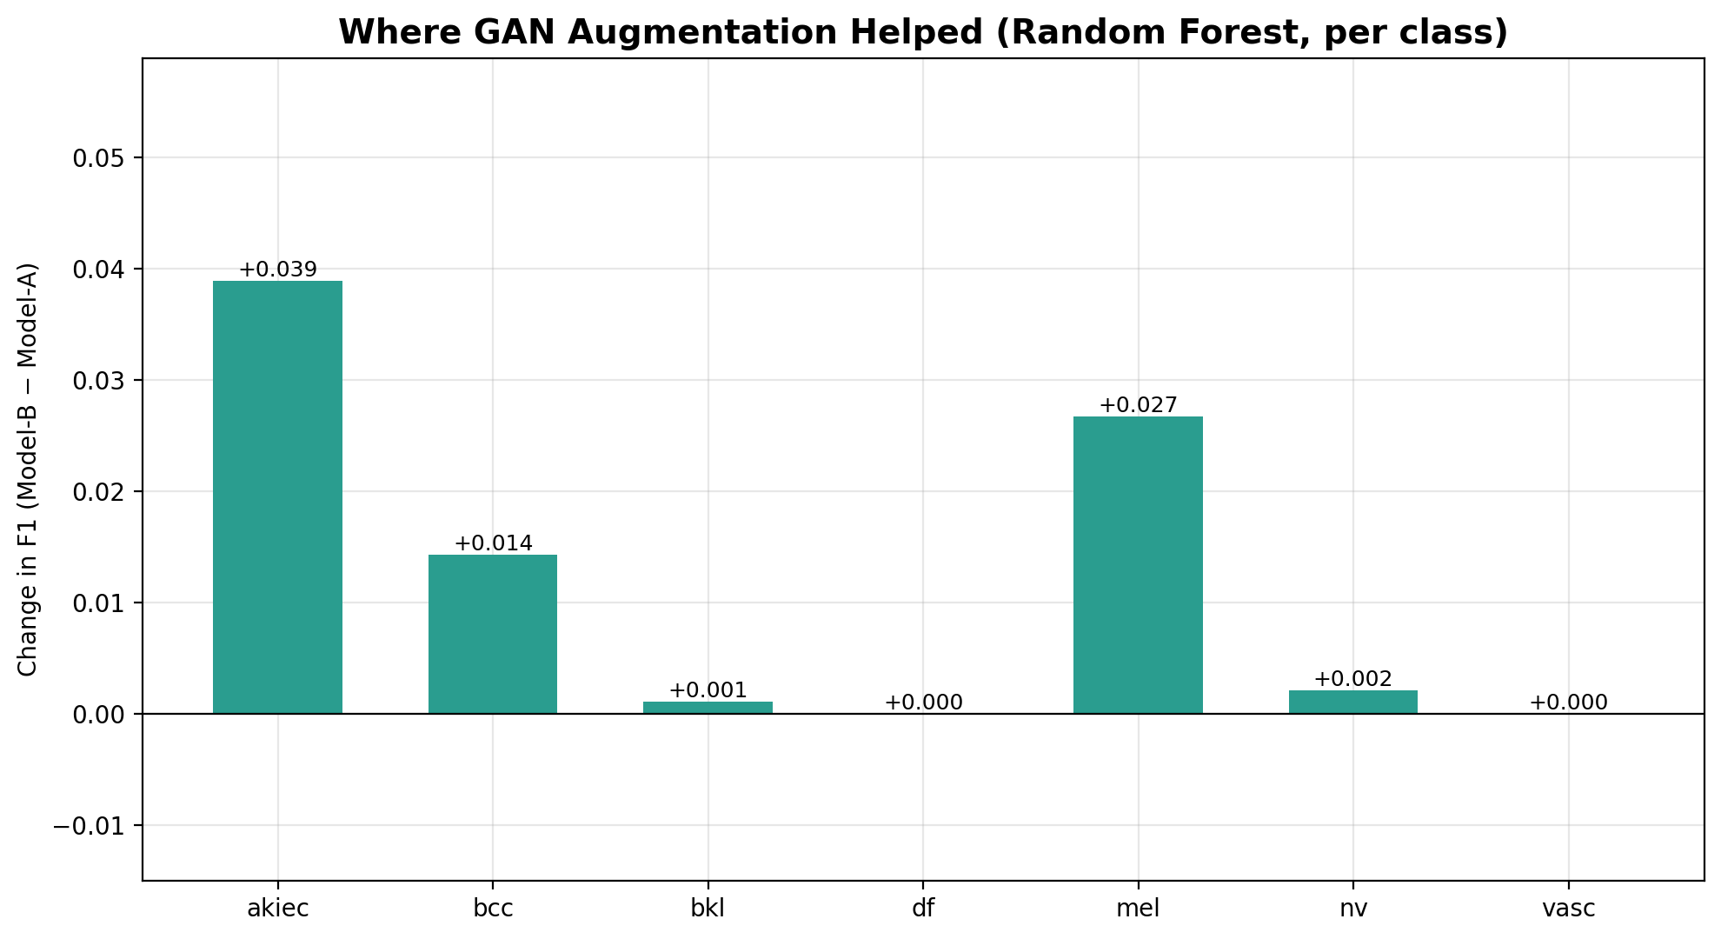
Figure 3. Change in per-class F1 after augmentation. Gains concentrate on moderately under-represented classes; the smallest classes are unaffected.

4.5 Confusion Matrix Analysis
The confusion matrices for Random Forest (Figure 4) expose the dominant failure mode of both models: minority classes are systematically misclassified as the majority class, nv. In the baseline, 164 of 223 melanoma cases were predicted as nv, and the df and vasc classes were almost entirely absorbed (16 of 23 and 26 of 28 cases respectively predicted as nv).
After augmentation, the model recovered a modest number of additional minority-class cases: correct melanoma predictions rose from 27 to 31, correct akiec from 7 to 9, and correct bcc from 33 to 35, while the majority class remained strong (nv correct: 1,293 to 1,297). However, the df and vasc columns still contain no correct predictions, confirming that augmentation shifted the decision boundary slightly in favour of moderately-sized minority classes without resolving the underlying bias toward nv.
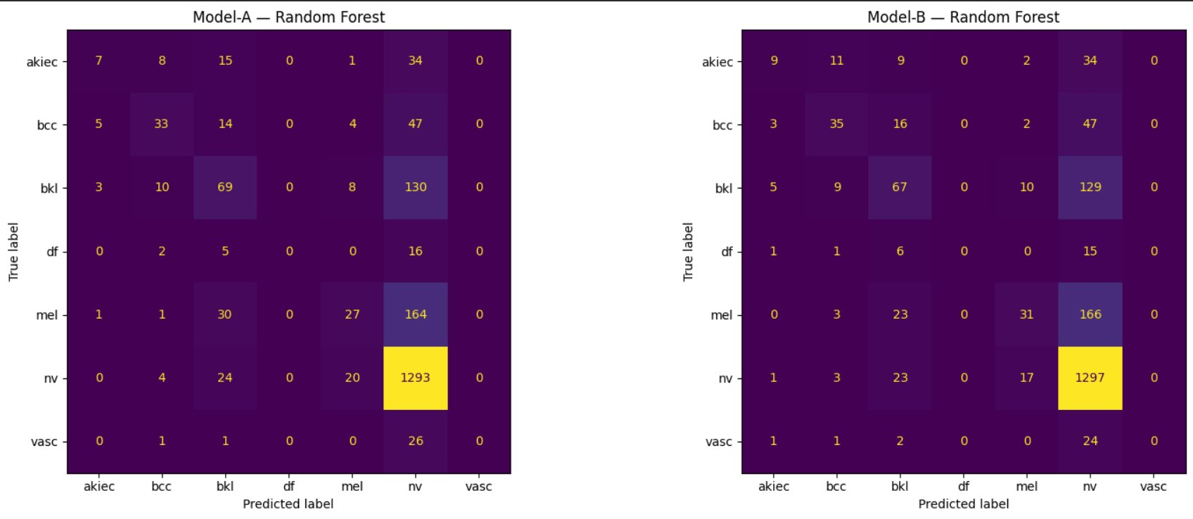
Figure 4. Confusion matrices for Random Forest: baseline (left) and augmented (right). The bright nv column reflects the majority-class collapse common to both models.

5. Discussion

5.1 The Majority-Class Collapse
The confusion matrices make clear that both pipelines suffer from majority-class collapse: when uncertain, the classifier defaults to nv, the class it has seen most often. This is the expected consequence of training on imbalanced data with classifiers that optimise overall accuracy. It also explains why accuracy is a misleading headline metric here — a model could achieve roughly 67% accuracy by predicting nv for every image.

5.2 Where Augmentation Helped, and Why
The clearest benefit appeared in the Random Forest model on the moderately under-represented classes. Actinic keratoses (akiec), basal cell carcinoma (bcc), and especially melanoma (mel) all saw F1 gains. The melanoma improvement (F1 +0.027, with four additional correct detections) is the most clinically significant outcome, since melanoma is the most dangerous class in the dataset. These gains are plausible because these classes had enough real images (300–1,100) for the conditional GAN to learn a usable representation, so the synthetic samples added genuine, if imperfect, signal.

5.3 Why the Smallest Classes Did Not Improve
Dermatofibroma (df) and vascular lesions (vasc), with only 115 and 142 images respectively, remained at zero F1 in both models. With so few real examples, the conditional GAN could not learn a faithful distribution for these classes, and the synthetic images it produced were too poor in quality or too unrepresentative to teach the classifier anything useful. This is a fundamental limitation: generative augmentation amplifies the information already present in the data, but it cannot create information that was never there. Extreme data scarcity therefore remains beyond its reach.

5.4 Model-Dependent Effects
The impact of augmentation varied sharply by model family. Random Forest, an ensemble that tolerates noisy features, benefited modestly. SVM declined, most likely because the imperfect synthetic samples distorted the class margins on which it depends. Naive Bayes showed a large accuracy increase (+0.19) but a simultaneous collapse in AUC (−0.16); the augmentation shifted its class priors toward more balanced predictions, raising raw accuracy while degrading the calibrated ranking that AUC measures, so the apparent improvement is largely an artefact rather than a genuine gain in discriminative power. This divergence underscores that the value of generative augmentation cannot be assessed by any single metric or model in isolation.

6. Limitations
- Image resolution was limited to 32 × 32 pixels, discarding fine dermatoscopic detail that may be diagnostically important; higher resolutions could improve both GAN fidelity and classifier performance.
- Classical models operate on flattened pixel vectors and cannot exploit spatial structure; a convolutional architecture would likely be more sensitive to the augmented data.
- A single conditional GAN trained for 80 epochs produced limited fidelity for the smallest classes; longer training or class-specific generative strategies might yield better synthetic samples.
- No quantitative evaluation of synthetic image quality (for example Frechet Inception Distance) was performed; quality was assessed only indirectly through downstream classification.

7. Conclusion and Future Work
This experiment evaluated conditional GAN augmentation as a remedy for class imbalance in dermatoscopic image classification. The evidence is nuanced. Generative augmentation produced small but real improvements for the ensemble model on moderately under-represented classes, including a meaningful gain on the clinically critical melanoma class. It did not, however, improve the most severely under-represented classes, and its effect was inconsistent across model families, in one case producing a misleading accuracy gain accompanied by degraded ranking quality.
The practical conclusion is that generative augmentation is a useful but bounded tool: it is most effective when a class has enough real examples to learn from, and it is best paired with models that tolerate imperfect synthetic data. Future work should explore higher-resolution generation, convolutional classifiers that can better exploit augmented data, more capable generative models such as diffusion models, and quantitative assessment of synthetic image quality. Combining generative augmentation with complementary techniques such as class-weighted loss functions or classical oversampling may also help address the extreme scarcity that augmentation alone could not overcome.

References
[1] Tschandl, P., Rosendahl, C. & Kittler, H. (2018). The HAM10000 dataset, a large collection of multi-source dermatoscopic images of common pigmented skin lesions. Scientific Data, 5, 180161.
[2] Goodfellow, I. et al. (2014). Generative Adversarial Networks. Advances in Neural Information Processing Systems.
[3] Mirza, M. & Osindero, S. (2014). Conditional Generative Adversarial Nets. arXiv:1411.1784.
[4] Radford, A., Metz, L. & Chintala, S. (2016). Unsupervised Representation Learning with Deep Convolutional Generative Adversarial Networks. arXiv:1511.06434.
[5] Pedregosa, F. et al. (2011). Scikit-learn: Machine Learning in Python. Journal of Machine Learning Research, 12, 2825–2830.

