Intelligent Surveillance and Identification for Secure Campus

A Project Report Submitted
in Partial Fulfillment of the Requirements
for the Degree of

Bachelor of Technology
(Computer Science & Engineering)

Submitted By

Abu Reeyan (Reg. No. : 222025109276)
Bittu Kumar (Reg. No. : 222025109271)
Sushma Kumari (Reg. No. : 222025109261)
Kishun Kumar (Reg. No. : 222025109246)

Under Guidance of
Dr. Narendra Kumar

Faculty of Computing and Information Technology
Usha Martin University, Ranchi
November 18, 2025
BONAFIDE CERTIFCATE

Certified that this project report titled “Intelligent Surveillance and Identification for Secure Campus” is the bonafide work of Abu Reeyan, Bittu Kumar, Sushma Kumari and Kishun Kumar, who carried out the research under my supervision. Certified further, that to the best of my knowledge the work reported herein does not form part of any other project report or dissertation on the basis of which a degree or award was conferred on an earlier occasion on this or any other candidate.

(Signature of the concerned Supervisor of the Organization with Organization Seal)

(Certificate to be countersigned by the HOD.)

DECLARATION

I do hereby declare that this report entitled “Intelligent Surveillance and Identification for Secure Campus”, submitted by Abu Reeyan, bearing Reg. No. : 222025109276, Bittu Kumar, bearing Reg. No. : 222025109271, Sushma Kumari, bearing Reg. No. : 222025109261, Kishun Kumar, bearing Reg. No. : 222025109246, in the fulfillment of the requirement for the degree of Bachelor of Technology in Computer Science & Engineering to Usha Martin University, Ranchi, is my own and it is not submitted to any other institute.

Abu Reeyan
Reg. No. : 222025109276

Bittu Kumar
Reg. No. : 222025109271

Sushma Kumari
Reg. No. : 222025109261

Kishun Kumar
Reg. No. : 222025109246
CERTIFICATE

This is to certify that entitled “Intelligent Surveillance and Identification for Secure Campus” being submitted by Abu Reeyan, bearing Reg. No. : 222025109276, Bittu Kumar, bearing Reg. No. : 222025109271, Sushma Kumari, bearing Reg. No. : 222025109261, Kishun Kumar, bearing Reg. No. : 222025109246, in the fulfillment of the requirement for the degree of Bachelor of Technology in Computer Science & Engineering to Usha Martin University, Ranchi, is a bonafide work carried out under my supervision. The matter embodied in this report is original and has not been submitted for the award of any other degree.

Dr. Sharmistha Roy Dr. Narendra Kumar
HOD Guide

ACKNOWLEDGEMENTS

I express my deepest sense of gratitude to my guide Dr. Narendra Kumar Faculty of Computing and Information Technology, Usha Martin University, Ranchi, for suggesting the subject of work and constant supervision throughout this work. His co-operation and timely suggestions have been unparalleled stimuli for me to travel eventually towards the completion of this project report. Indeed her continuous involvement has helped me in bringing of this project work which otherwise would have remained a distant dream.
I am indeed thankful to Dr. Sharmistha Roy, HOD, Faculty of Computing and Information Technology, Usha Martin University, Ranchi, for giving me permission to carry out my project work. I would like to express my gratitude to all teaching and non-teaching staff members of Faculty of Computing and Information Technology, Usha Martin University, Ranchi, for their co-operation in my work.

Abu Reeyan
Reg. No. : 222025109276

Bittu Kumar
Reg. No. : 222025109271

Sushma Kumari
Reg. No. : 222025109261

Kishun Kumar
Reg. No. : 222025109246
Abstract

Ensuring campus security and student compliance with institutional uniform policies has become increasingly challenging with manual monitoring methods. This project proposes an AI-powered system that utilizes computer vision and deep learning to identify and classify students in real-time based on their uniform color and facial features. The system is designed to analyze live video feeds from CCTV cameras, detect student faces using the DeepFace model, and retrieve their information from a connected database. Simultaneously, it applies color segmentation techniques to determine the uniform color and maps it to the respective department. A comparison is made between the department obtained from the uniform and the one retrieved from the database to verify student identity and detect uniform violations or unauthorized individuals. The methodology includes video acquisition, frame preprocessing, face recognition, color-based uniform detection, and integration with a querying database. The implementation demonstrates significant improvements in accuracy and efficiency over existing image-based systems, particularly in video-based applications. The integration with a live database makes real-time tracking and data retrieval possible, transforming security protocols across educational institutions. The findings show that the proposed system is effective, scalable, and suitable for real-world deployment. It sets the foundation for future developments such as automated attendance, behavioral monitoring, and campus-wide surveillance integration. Overall, this project demonstrates a practical and intelligent approach to student monitoring through AI and deep learning.

Keywords – Campus, Classification, Cybersecurity, Detection, Department, DeepFace, Surveillance, Vision, Security.
 | TABLE OF CONTENTS
S.no. | Topic Name | Page No.
1. | Bonafide …………………………………………………………………….. | ii
2. | Declaration………………………………………………………………….. | iii
3. | Certificate……………………………………………………………….…... | iv
4. | Acknowledgement………………………………………………………….. | v
5. | Abstract …………………………………………………………………….. | vi
6. | List of Figures………………………………………………...…………….. | ix
7. | List of Tables………………………………………………………………... | x
8. | List of Abbreviations……………………………………………………….. | xi
Chapter | Topic Name | Page no.
1. | Introduction.…………………….………………………………….……….  - Overview ………………………………………………………………...  - Background……………………………………………………….……...  - Applications & Features of the Project………………………………….  - Objective ……………....………………………………………………...  - Problem Statement……………………………………………………….  - Research Gap……………………………………………………………. | 1-5  1  2  3-4  4  4-5  5
2. | Literature Review …………………………………………………………..  Table of Literature Review…………………………………………………... | 6-12  10-12
3. | Requirements Analysis…………………………….………………………..  3.1 System Requirement……………………………………………………..  3.2 Hardware Required………………………………………………………  3.3 Software Required………………………………………………………..  3.4 ER Diagram………………………………………………………………  3.5 Use Case Diagram………………………………………………………..  3.6 Data Flow Diagram……………………………………………………… | 13-  13-14  15  15  16  29  29
4. | Proposed Methodology……………………………………………………..  4.1 Methodology……………………………………………………………..  4.2 Block Diagram…………………………………………………………... | 30  30  32
5. | Model Testing...……………………………………………………………... | 34
6. | Result Analysis………………………………………………………………  5.1 Output images of the Project…………………………………….……….  5.2 Confusion Matrix………………………………………………………... | 37  38  39
7. | Conclusion & Future Scopes……………………………………………….  6.1 Conclusion……………………………………………………………….  6.2 Future Scope …………………………………………………………….  6.3 Limitations………………………………………………………………. | 41  41  42  42
 | References………………………...…………………………………………  Appendix…………………...……………………………………………….. | 44  46

List of Figures
S. No. | Figure  No. | Figure Name | Page  No.
1 | 3.1 | ER Diagram of Intelligent Surveillance and Identification for Secure Campus………………………………………….. | 28
2 | 3.2 | Use Case Diagram of Intelligent Surveillance and Identification for Secure Campus…………………………… | 29
3 | 3.3 | Data flow Diagram of Intelligent Surveillance and Identification for Secure Campus…………………………… | 29
4 | 4.1 | Block Diagram of Intelligent Surveillance and Identification for Secure Campus………………………………………….. | 32
5 | 5.1 | Bounding Box Classes of the dataset of the Intelligent Surveillance and Identification for Secure Campus………… | 35
6 | 5.2 | Graph of the Loss Function of the Intelligent Surveillance and Identification for Secure Campus……………………… | 35
7 | 5.3 | Validation Images of the Intelligent Surveillance and Identification for Secure Campus…………………………… | 36
9 | 6.1 | Output Images of Intelligent Surveillance and Identification for Secure Campus………………………………………….. | 38
10 | 6.2 | Confusion Matrix of the trained model of the Intelligent Surveillance and Identification for Secure Campus ……….. | 39

List of Tables
S. No. | Table  No. | Table Name | Page  No.
1 | 2.1 | Table of Literature Review………………………………….. | 10-12
2 | 5.1 | Table of Dataset Distribution……………………………….. | 24
3 | 5.2 | Test Case Table……………………………………………… | 25

List of Abbreviations
Abbreviations | Full Form
CNN | Convolutional Neural Network
CCTV | Closed Circuit Television
DCNN | Deep Convolutional Neural Network
AI | Artificial Intelligence
HSV | Hue, Saturation and Value
API | Application Programming Interface
ROI | Region of Interest
FPS | Frames Per Second
UI | User Interface
ID | Identification
CV | Computer Vision
KNN | K-Nearest Neighbors
SQL | Structured Query Language
RGB | Red, Green, Blue

Chapter 1
Introduction
1.1 Overview
Ensuring student safety, verifying identities, and enforcing institutional discipline are critical responsibilities in today’s educational institutions. With the exponential rise in student enrollment and the continuous expansion of campus infrastructure, universities and colleges face growing difficulties in maintaining effective monitoring and security across their premises. Traditionally, these responsibilities have been addressed through manual methods security personnel stationed at entry points, administrative staff visually verifying students, and physical enforcement of dress codes. However, these approaches are rapidly becoming inadequate in the face of increasing student populations and decentralized campus layouts. Manual surveillance is labour-intensive, inconsistent, and prone to human error. Security personnel can overlook violations due to fatigue, distraction, or limited field of view, while administrative staff may find it difficult to accurately verify student identity and dress code compliance, especially during peak hours. As a result, unauthorized access, uniform violations, and identity misrepresentation can go unnoticed, posing potential risks to campus safety and decorum. In this context, educational institutions need smarter, more reliable, and automated solutions to support or replace manual intervention with more accurate and scalable systems. In most academic institutions, students are assigned specific uniforms based on their departments, making uniform color a simple yet effective visual cue for department-level classification. However, checking for compliance manually across hundreds or thousands of students is inefficient and subjective. At the same time, identity checks through ID cards is often bypassed or manipulated. These problems underscore the urgent need for intelligent systems that can monitor students automatically, verify their identity in real-time, and detect violations proactively without disrupting campus operations. The rapid advancement of Artificial Intelligence, Computer Vision, and Deep Learning technologies presents a transformative opportunity to address these challenges. AI-powered surveillance systems can now detect faces, recognize individuals, and classify clothing attributes like color and texture using trained models with a high degree of accuracy. These capabilities, when integrated with CCTV infrastructure and institutional databases, form the foundation of a real-time, automated, and intelligent student identification and verification system.
1.2 Background
The advancement of education in the 21st century has not only transformed classroom learning but also the way educational institutions manage infrastructure, safety, and discipline. With the rapid growth in student intake, expansion of academic departments, and development of sprawling campus environments, universities and colleges today face new and evolving challenges. Among these, campus security and uniform discipline enforcement are two of the most pressing and foundational responsibilities for administration and security departments. Historically, institutions have relied on manual surveillance, such as physical security personnel monitoring entry points, patrolling premises, and reviewing closed-circuit television (CCTV) footage. While these methods served their purpose in smaller or less crowded campuses, they have become increasingly inefficient and insufficient in large, modern educational institutions. As student populations rise and campuses become more decentralized, traditional methods struggle to scale up. Manually observing hundreds or thousands of students to ensure uniform compliance or identify intruders is labour-intensive, time-consuming, and highly prone to human error. In most educational settings, especially in India and other countries with large student bases, students are assigned uniforms based on their academic department. This system provides a visual cue that helps both faculty and security personnel identify a student’s academic affiliation. While the use of uniforms promotes equality and discipline, enforcing dress code compliance manually, especially in large institutions with multiple entry and exit points, is extremely challenging. Security staff may overlook violations, and there is no consistent, automated way to flag uniform mismatches. Moreover, manual verification of student identities through ID cards or physical registers is not only inefficient but also vulnerable to manipulation, proxy attendance, and impersonation. This gap in effective monitoring and verification creates serious vulnerabilities not just in discipline enforcement, but in overall campus security. Unidentified or unauthorized individuals might enter the campus, dress code violations might go unchecked, and false identity claims may go unnoticed. These issues underscore the need for automated, intelligent systems that can operate consistently, accurately, and autonomously across different parts of the campus. In recent years, Artificial Intelligence (AI) and Computer Vision have emerged as transformative technologies in the field of surveillance and automation. The ability of AI systems to detect faces, recognize identities, and process visual inputs such as clothing colors and patterns has improved dramatically.
1.3 Applications & Features of the Project
The Intelligent Surveillance and Identification System for Secure Campus is designed to serve as a practical, scalable, and intelligent solution for enhancing safety, monitoring, and administrative efficiency in educational institutions. The system’s application goes beyond mere observation it actively verifies identity, enforces policy, and maintains digital records, making it suitable for a wide range of real-world academic use cases.
1. Campus Entry Monitoring: This system is highly effective at all main entry and exit points of the institution. As students walk through monitored areas, the system instantly captures their image, performs facial recognition, and verifies whether the individual is an enrolled student. If the face is not recognized or is found to be unauthorized, the system immediately triggers an alert, helping prevent intrusions and potential security threats.
2. Uniform Compliance Enforcement: One of the most common challenges in academic institutions is ensuring students adhere to their department-specific uniform guidelines. This system detects and analyses the uniform color of each student and compares it to their registered department. Any mismatch is flagged, allowing the institution to take quick disciplinary action and ensuring a consistent and professional academic environment.
3. Departmental Classification: Beyond identity, the system can classify students in real time based on the uniform color, which represents their department. This capability can be used for managing department-restricted zones (e.g., labs, workshops) where only authorized students should be granted access. It enhances security by reducing the risk of cross-departmental impersonation or unauthorized movement.
4. Attendance Assistance: With further integration, the system can be enhanced to automate student attendance by logging entry and exit timestamps when a student is recognized. This removes the need for manual attendance marking in classrooms or lecture halls, improves accuracy, and saves time for both students and faculty.
5. Real-Time Alerts for Violations: When any irregularity is detected such as an unrecognized face, uniform mismatch, or attempted access to a restricted area the system generates real-time alerts. These alerts are instantly pushed to an admin dashboard and can also be integrated with SMS, email, or mobile app notifications for faster response by the security team.
6. Administrative Logging: Each event, whether a successful match or violation, is logged with details such as student name, ID, time, location, and a snapshot. These logs serve as audit trails for administrative reviews and disciplinary committees. Reports can be generated weekly or monthly to analyze trends, policy violations, or security breaches.
1.4 Objective
The primary objective of this project is to:
- Provide smart surveillance by integrating DeepFace for facial recognition and color segmentation for uniform detection in real-time CCTV streams.
- Automate student identification by matching facial features with a centralized institutional database, removing the need for ID cards or manual attendance.
- Ensure departmental uniform compliance by detecting uniform colors and comparing them with the expected dress codes for each student’s department.
- Generate real-time alerts for unidentified faces, uniform mismatches, or unauthorized activities through the admin dashboard and future notification channels.
- Offer a user-friendly web-based dashboard that displays real-time activities, violations, and logs for effective monitoring and decision-making.
- Reduce human surveillance workload by automating identification and uniform verification tasks, improving operational efficiency.
1.5 Problem Statement
In the current era of digital transformation, educational institutions are facing increasing pressure to enhance campus safety, maintain institutional discipline, and ensure operational efficiency. As universities and colleges continue to expand in size, infrastructure, and student population, the complexity of campus security and student management grows exponentially. Institutions now operate across multi-block campuses, with multiple entry and exit points, separate academic departments, and a high degree of student mobility. In this environment, the limitations of traditional, manual surveillance systems have become starkly evident. Conventional surveillance practices such as deploying guards at gates, checking ID cards manually, visually confirming uniforms, and observing CCTV monitors in real time are both inefficient and unsustainable. These methods are entirely dependent on human judgment, which is prone to fatigue, distraction, and error. In high-traffic environments, where thousands of students pass through checkpoints daily, it's nearly impossible for human observers to maintain consistent attention, especially when verifying identity or uniform compliance. This leads to gaps in monitoring, missed violations, unauthorized access, and unreliable attendance tracking. Another major shortcoming of traditional systems is the lack of automated verification mechanisms. Student identity verification often relies on physical ID cards, which can be forgotten, lost, or misused. Proxy attendance, impersonation, and the inability to detect unauthorized individuals are persistent problems. Moreover, the physical act of checking IDs and verifying uniforms consumes significant administrative time and resources, reducing institutional efficiency. Uniform compliance is a crucial aspect of discipline in many institutions, especially where each academic department is assigned a specific uniform color. This system is designed to visually distinguish students based on their field of study and maintain order. Institutions aiming to become “smart campuses” must adopt systems that go beyond passive monitoring. There is a growing need for a robust, intelligent, and real-time surveillance system that can automatically detect student faces with high accuracy, identify uniform color and validate it against department standards, match live inputs with backend student records, trigger immediate alerts in case of mismatches or unidentified individuals, and maintain detailed logs for auditing, discipline, and reporting purposes.
1.6 Research Gap
- There is a lack of integrated systems that combine real-time facial recognition, uniform color detection, and database verification into a unified surveillance platform.
- Limited research exists on automated uniform compliance detection using color-based computer vision techniques in educational environments.
- Very few solutions support real-time monitoring and instant alerting for violations such as unauthorized access or mismatched uniforms.
- Current systems lack centralized architectures that unify CCTV feeds, facial data, uniform details, and institutional records for accurate cross-verification.
- Most surveillance models fail to handle real-world issues like lighting variations, occlusion, and crowding, reducing accuracy in dynamic campus environments.

Chapter 2
Literature Review
The implementation of intelligent surveillance systems using artificial intelligence and computer vision has gained considerable attention in recent years, particularly in enhancing public safety, automation, and monitoring efficiency. In the context of educational institutions, the fusion of real-time facial recognition, uniform detection, and centralized database integration is still evolving, and limited research has explored such systems holistically. This chapter summarizes relevant studies that form the foundation of the proposed system and highlights the gaps that this project aims to bridge.
1. J. J. K, K. N. S, B. Vadivel, G. G and P. V, "Efficient YOLOv8 Model for Licence, Helmet and Person Detection," ICPCSN 2025, Salem, India, 2025, pp. 404-408, doi: 10.1109/ICPCSN65854.2025.11035282 : This paper presents an optimized YOLOv8-based model tailored for real-time security and surveillance tasks, including license plate, helmet, and person detection. By integrating SPPF layers, depthwise separable convolutions, and a lightweight MobileNet backbone, the system achieves improved accuracy and computational efficiency compared to standard YOLOv8. The model demonstrates strong performance, making it suitable for deployment on small computing devices in practical surveillance environments.
2. Z. Li and J. Wang, "Multi-person gesture recognition for complex environmental based on improved Yolov8 algorithm," IAECST 2025, Guangzhou, China, 2025, pp. 614-619, doi: 10.1109/IAECST60924.2025.10502852 : This study enhances the YOLOv8 algorithm by integrating the Global Attention Mechanism (GAM), GSConv, and Slim Neck design, forming the YOSRLO model for multi-person gesture recognition in complex environments. The model addresses challenges such as small target detection and diverse gesture patterns, achieving high accuracy and improved recognition rates. Experimental comparisons show that YOSRLO outperforms standard YOLOv8, making it effective for gesture recognition in real-world settings.
3. J. Nandre, S. Rai and B. R. Kanawade, "Comparative Analysis of Transfer Learning CNN for Face Recognition," CONIT 2024, Hubli, India, 2024, pp. 1-6, doi: 10.1109/CONIT55038.2024.9847946 : This research evaluates the performance of three popular CNN architectures—VGG16, ResNet-50, and MobileNet—for face recognition using transfer learning techniques. The models are tested on both static images and webcam-based input using datasets from Kaggle and local sources. By analyzing training accuracy, validation accuracy, and loss metrics, the study identifies performance differences among the architectures, offering insights for real-time face recognition applications such as surveillance and attendance systems.
4. D. S. Parker, "Integrating AI and DBMS through stream processing," ICDE 2024, Los Angeles, USA, 2024, pp. 259-260, doi: 10.1109/ICDE.2024.47224 : This paper discusses a novel approach to bridging the gap between AI systems and database management systems by using a unified stream-processing model. The Tangram project, which integrates Prolog with relational DBMS, demonstrates how extending Prolog into a functional language (Log(F)) simplifies data processing and aligns both AI and DBMS workflows. The integration method offers an elegant and efficient solution to longstanding compatibility challenges between these technologies.
5. T. Babu, E. P. M and R. R. Nair, "Real-Time Facial Expression Recognition Using Deep Learning for Enhanced Human-Machine Interactions," BITCON 2024, Dhanbad, India, 2024, pp. 1-6, doi: 10.1109/BITCON63716.2024.10984634 : This work develops a real-time facial expression recognition system using deep learning techniques, trained on the FER-2013 dataset to classify seven basic emotions. The enhanced CNN model outperforms standard benchmarks by incorporating data augmentation and additional layers. A user-friendly GUI and real-time detection capability make the system applicable in areas like mental health monitoring, security, marketing, and interactive technologies.
6. H. R. Tohidypour, M. T. Pourazad and P. Nasiopoulos, "A Security-Centric Deep Learning Enabled Camera Solution for Real-Time Human Fall Detection," WiMob 2023, Thessaloniki, Greece, 2023, pp. 42-46, doi: 10.1109/WiMob55322.2023.9941359 : This paper introduces an embedded deep-learning–enabled fall detection system integrated into a camera device for real-time remote healthcare monitoring. Using TensorRT optimization, efficient memory allocation, and GPU-accelerated GStreamer processing, the system achieves 84.44% accuracy with low latency. The solution provides a secure, non-intrusive, and cost-effective method for continuous fall detection, making it suitable for elderly care and medical surveillance.
7. M. Doi, T. Matsumoto, A. Kimachi, S. Nishi and N. Ikoma, "Robust color object tracking method against illumination color Change," SCIS-ISIS 2023, Kitakyushu, Japan, 2023, pp. 718-722, doi: 10.1109/SCIS-ISIS.2023.7044769 : This research proposes a color-object tracking model based on the Gray World Assumption (GWA) to handle illumination color changes effectively. By modeling object color relative to the average frame color and using particle filters for tracking, the method maintains strong robustness even under abrupt lighting variations. Experimental results confirm the feasibility and effectiveness of the proposed tracking approach.
8. Y. Zhao, H. Liu, Q. Wang and C. Li, "A Multi-Object Tracking Method Using IoU and Color Fusion Model," ICSIP 2023, Nanjing, China, 2023, pp. 747-751, doi: 10.1109/ICSIP61881.2023.10671489 : This paper presents a two-stage multi-object tracking framework that combines IoU similarity and color histogram features using a fusion model. YOLOX performs object detection, while Kalman filters predict object locations. The fusion of IoU and color similarity improves object association and reduces ID switches. The system achieves top-ranking performance on the MOT17 and MOT20 benchmarks, demonstrating high accuracy in complex tracking scenarios.
9. Y. Qi, Y. Wang and Y. Liu, "Object Tracking Based on Deep CNN Feature and Color Feature," ICSP 2022, Beijing, China, 2022, pp. 469-473, doi: 10.1109/ICSP.2022.8652470 : This study combines deep CNN features extracted using VGG-Face with color histogram features to create a robust object tracking model. An adaptive particle filter integrates these features for dynamic tracking. The system handles occlusion and appearance variations effectively, improving tracking performance in challenging visual environments.
10. Zhiyuan Han, Tingrong Xu and Zhaohua Chen, "An improved color-based tracking by particle filter," TMEE 2022, Changchun, China, 2022, pp. 2512-2515, doi: 10.1109/TMEE.2022.6199732 : This work improves particle filter–based object tracking by replacing Monte Carlo sampling with Quasi-Monte Carlo sampling, reducing sample correlation and improving accuracy. The approach enhances object modeling using robust color features and increases tracking speed and stability, outperforming traditional particle filter methods in simulations.
11. S. Pati, A. Majumder, M. Gangopadhyay, G. Sen and A. Chakraborty, "Advanced Attendance Monitoring: A Unified System Using QR Codes and Facial Recognition," IEMENTech 2021, Kolkata, India, 2021, pp. 1-4, doi: 10.1109/IEMENTech65115.2021.10959151 : This paper integrates QR codes with facial recognition to create a modern attendance system that improves accuracy and reduces manual errors. Students scan their QR codes upon entry and exit, followed by face verification, ensuring identity authenticity. The system stores all data in a structured database, enabling automated and transparent attendance tracking across academic cycles.
12. R. Nidhya, D. J. A. Pabi, U. DivyaSree, B. Abhishek, A. Harika and S. A. Alim, "Exploring Facial Recognition Technologies for Classroom Management," ICCSP 2021, Melmaruvathur, India, 2021, pp. 1702-1707, doi: 10.1109/ICCSP60870.2021.10544143 : This paper proposes a high-accuracy classroom monitoring system using facial recognition and machine learning. Student facial features are captured through segmentation and processed into structured arrays for training recognition models. Real-time person detection and detailed log generation enable automated attendance tracking. Achieving 99.38% accuracy, the system demonstrates strong potential for smart classroom management.

2.1 Table of Literature Review
Table 2.1 – Table of Literature Review
S.No. | Paper Title | Author(s) | Year | Methodology Used | Pros | Cons | Journal Name | Page No. | Volume No. | DOI
1 | Efficient YOLOv8 Model for Licence, Helmet and Person Detection | J. J. K, K. N. S, B. Vadivel, G. G, P. V | 2025 | Optimized YOLOv8 using SPPF, depthwise convolutions, and MobileNet backbone for improved detection. | High accuracy and computational efficiency suitable for small devices. | Performance may depend on hardware accelerators for best results. | ICPCSN 2025 | 404–408 | 04 | 10.1109/ICPCSN65854.2025.11035282
2 | Multi-person gesture recognition for complex environmental based on improved Yolov8 algorithm | Z. Li, J. Wang | 2025 | Enhanced YOLOv8 with GAM, GSConv, Slim Neck and Real-ESRGAN segmentation to form YOSRLO model. | Achieves high accuracy and recognizes small gesture targets effectively. | Increased model complexity may lead to higher computational load. | IAECST 2025 | 614–619 | 12 | 10.1109/IAECST60924.2025.10502852
3 | Comparative Analysis of Transfer Learning CNN for Face Recognition | J. Nandre, S. Rai, B. R. Kanawade | 2024 | Used transfer learning with VGG16, ResNet-50, and MobileNet CNN models for face recognition. | Provides strong accuracy and flexibility using pre-trained deep CNNs. | Performance varies across architectures depending on dataset conditions. | CONIT 2024 | 1–6 | 01 | 10.1109/CONIT55038.2024.9847946
4 | Integrating AI and DBMS through stream processing | D. S. Parker | 2024 | Retrofitted AI and DBMS into a common stream-processing model using Log(F) language. | Offers elegant and efficient integration of AI systems with DBMS. | Limited by computational capabilities of early AI systems and legacy DBMS. | ICDE 2024 | 259–260 | 7 | 10.1109/ICDE.2024.47224
5 | Real-Time Facial Expression Recognition Using Deep Learning | T. Babu, E. P. M, R. R. Nair | 2024 | Built a CNN-based facial expression classifier trained on FER-2013 with enhanced preprocessing and GUI. | Demonstrates strong real-time performance and improved accuracy over benchmarks. | Accuracy may drop in low-light or occluded face conditions. | BITCON 2024 | 1–6 | 32 | 10.1109/BITCON63716.2024.10984634
6 | A Security-Centric Deep Learning Enabled Camera Solution for Real-Time Human Fall Detection | H. R. Tohidypour, M. T. Pourazad, P. Nasiopoulos | 2023 | Embedded deep-learning fall detection optimized with TensorRT and GPU-based processing. | Achieves real-time performance with reliable detection accuracy. | Hardware dependency may limit use in low-resource environments. | WiMob 2023 | 42–46 | 11 | 10.1109/WiMob55322.2023.9941359
7 | Robust color object tracking method against illumination color change | M. Doi, T. Matsumoto, A. Kimachi, S. Nishi, N. Ikoma | 2023 | Utilized Gray World Assumption and particle filtering to handle illumination color shifts. | Maintains robust tracking even under sudden illumination changes. | Effectiveness decreases in scenes where GWA assumptions fail. | SCIS–ISIS 2023 | 718–722 | 5 | 10.1109/SCIS-ISIS.2023.7044769
8 | A Multi-Object Tracking Method Using IoU and Color Fusion Model | Y. Zhao, H. Liu, Q. Wang, C. Li | 2023 | Combined IoU similarity with color histogram features in a two-stage association tracking framework. | Achieves top ranking MOTA accuracy on MOT17 and MOT20 datasets. | Fusion computation increases processing time in crowded scenes. | ICSIP 2023 | 747–751 | 12 | 10.1109/ICSIP61881.2023.10671489
9 | Object Tracking Based on Deep CNN Feature and Color Feature | Y. Qi, Y. Wang, Y. Liu | 2022 | Integrated VGG-Face deep features with color histograms using adaptive particle filtering. | Handles occlusion and appearance variation effectively. | Heavy CNN feature extraction increases computation cost. | ICSP 2022 | 469–473 | 11 | 10.1109/ICSP.2022.8652470
10 | An improved color-based tracking by particle filter | Zhiyuan Han, Tingrong Xu, Zhaohua Chen | 2022 | Replaced Monte Carlo sampling with Quasi-Monte Carlo sampling in particle filtering. | Improves tracking accuracy and speed by reducing sampling correlation. | May struggle with complex motion patterns beyond color-based modeling. | TMEE 2022 | 2512–2515 | 9 | 10.1109/TMEE.2022.6199732
11 | Advanced Attendance Monitoring: A Unified System Using QR Codes and Facial Recognition | S. Pati, A. Majumder, M. Gangopadhyay, G. Sen, A. Chakraborty | 2021 | Integrated QR code authentication with facial recognition for automated attendance tracking. | Enhances accuracy and reduces human errors in institutional attendance. | System may face reliability issues under poor lighting or QR misreads. | IEMENTech 2021 | 1–4 | 21 | 10.1109/IEMENTech65115.2021.10959151
12 | Exploring Facial Recognition Technologies for Classroom Management | R. Nidhya, D. J. A. Pabi, U. DivyaSree, B. Abhishek, A. Harika, S. A. Alim | 2021 | Used machine learning and OpenCV-based segmentation to build high-accuracy classroom monitoring. | Achieves 99.38% accuracy and automates attendance with real-time detection. | Requires consistent camera alignment and quality for reliable recognition. | ICCSP 2021 | 1702–1707 | 37 | 10.1109/ICCSP60870.2021.10544143

Chapter 3
Requirements Analysis
3.1 System Requirements
To develop and deploy the Intelligent Surveillance and Identification System, specific hardware, software, and network components are required to ensure high accuracy, real-time monitoring, and reliable identity verification. These requirements are designed to support continuous video streaming, color-based uniform classification, face detection, facial embedding generation, and identity matching. Proper selection of tools and technologies ensures efficient processing, secure data handling, and seamless operation across all modules within a dynamic campus environment.
i) Functional Requirements
a) High-Quality Video Capture Module
The system must be capable of capturing high-resolution video streams from CCTV cameras installed across the campus. It should support stable frame rates, adaptive lighting adjustments, and uninterrupted streaming for real-time processing.
b) Uniform Color Detection Module
The system must detect and classify student uniform colors using computer vision algorithms. It should identify distinct uniform shades accurately and categorize them according to department or designated groups.
c) Facial Detection and Embedding Generation
The system must detect student faces from video feeds using the DeepFace model and generate corresponding facial embeddings. It should work effectively in varying lighting conditions and crowded environments.
d) Identity Matching and Verification
The system must match detected facial embeddings with records stored in the institutional database to verify student identity. It should fetch and display associated information such as student name, roll number, and department.
e) Real-time Identity Display on Dashboard
The system must display real-time identity details and department information on the admin dashboard, ensuring security personnel can immediately recognize students and detect unauthorized individuals.

ii) Non-Functional Requirements
a) Real-Time Performance and Low Latency
The system must maintain real-time performance with minimal latency during video processing, face detection, and identity recognition. Delays in processing should be minimized to support live surveillance operations.
b) Scalability
The system must be scalable enough to process multiple CCTV streams simultaneously. It should accommodate an increasing number of cameras and higher data loads as the campus expands without performance degradation.
c) Accuracy and Reliability
The system must maintain high accuracy in uniform color detection and face recognition to avoid misclassification. It should ensure consistent performance across diverse lighting conditions, angles, and camera qualities.
d) Ease of Deployment and Maintainability
The system must be easy to install, configure, and maintain within existing campus infrastructure. Regular updates and bug fixes should be implementable without affecting ongoing surveillance operations.
e) Usability and Interface Quality
The admin dashboard must be user-friendly, intuitive, and responsive. It should allow security personnel to easily view live streams, identify individuals, review logs, and manage system configurations.

3.2 Hardware Required
Hardware Component | Specification
CPU | AMD Ryzen 5 or higher
RAM | Minimum 8 GB
Storage | Minimum 10 GB free disk space
GPU | NVIDIA GTX 1650 or higher
Network | Ethernet/Wi-Fi
CCTV | IP-based HD camera (20 FPS)

3.3 Software Required
Software Component | Specification
Operating System | Ubuntu 24.04 LTS
Programming Language | Python 3.12
Database | MySQL
Libraries | OpenCV, DeepFace, FastAPI
Development Tools | VS Code
Version Control | Git

3.4 ER Diagram
registered_user
logs_data
Detected in
id
face
name
department
id
name
face
1
Fig-3.1 : ER Diagram of the Proposed System
M
uniform_dept
status
3.5 Use Case Diagram
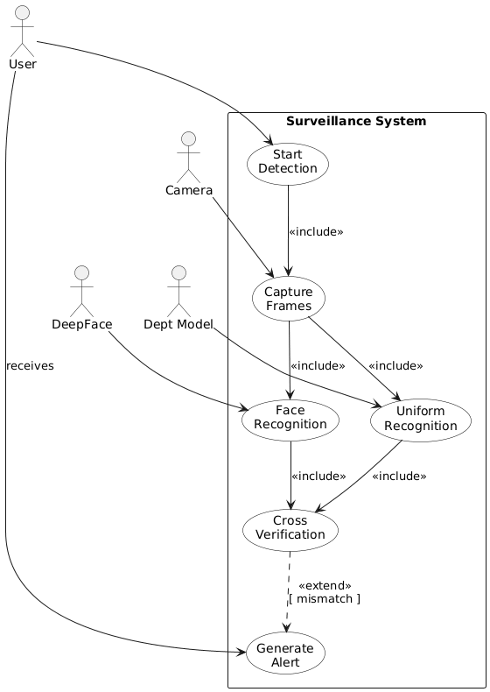
Fig-3.2: Use Case Diagram of the Intelligent Surveillance and Identification for Secure Campus
3.6 Data Flow Diagram
This Data Flow Diagram provides a high-level overview of the Smart Surveillance System by representing the entire system as a single unified process and illustrating how it interacts with external entities. At this topmost level, the primary user plays an important role by initiating the surveillance operation and later accessing alerts or logs generated by the system. The CCTV Camera acts as a continuous data source, supplying real-time video streams that form the foundation for all subsequent detection processes. To perform intelligent analysis, the system sends extracted visual information to two specialized external services: the DeepFace Service, which processes facial data and returns identified person details, and the Shirt Detection Model, which analyzes clothing to determine the wearer’s department or category. These external systems enhance the surveillance process by providing high-accuracy recognition capabilities without burdening the core system with heavy computational tasks. The results obtained from these services are combined by the system and stored in the Detection Details Store, which maintains a historical record of detection events. This data store also provides log information back to the system whenever required, especially when the user requests to view logs.
Uniform/Shirt
Detection
Model
DeepFace
Capture Video
And Extract
Frames
Cross Verify
Details
Obtained from
DeepFace and
Shirt Detection
Generate Alert
Detection Details Store
User
View Logs
Start
Surviellance
Fig-3.3: Dataflow Diagram of the Intelligent Surveillance and Identification for Secure Campus
Chapter 4
Proposed Methodology
4.1 Methodology
The methodology of this project is centered around integrating Deep Learning and Computer Vision techniques to enable automated student identification and uniform verification in real time. The system is designed to process video feeds, detect and recognize faces and shirts, identify department from color of the detected shirt, and match results with student records stored in a backend database. The implementation involves the following key stages and algorithms:
1. Video Acquisition and Frame Preprocessing
The system begins by acquiring continuous video streams from CCTV cameras placed across the campus, ensuring that every frame contains sufficient detail for analysis. From this live feed, frames are periodically extracted and passed through a series of preprocessing steps designed to enhance image quality and standardize input data. These steps include resizing frames to a consistent resolution, normalizing pixel values, reducing noise artifacts using smoothing filters, and converting the color space from RGB to HSV, which significantly improves the reliability of color-based segmentation tasks. This preprocessing pipeline ensures that each frame is optimally prepared for both face detection and uniform analysis in downstream modules.
2. Facial Recognition Using DeepFace
Facial recognition is accomplished through the DeepFace model, an advanced deep learning framework designed specifically for robust and accurate face identification. The model uses a specialized convolutional neural network architecture that generates 128-dimensional facial embeddings for each detected face. These embeddings serve as high-level, discriminative feature representations unique to each individual. To verify identity, the system compares the embedding of the detected face with stored embeddings retrieved from a secured student database, using distance metrics such as cosine similarity and Euclidean distance. If the similarity score is within the accepted threshold, the model confirms the match and retrieves the student’s profile, including name and registered department. This integration between DeepFace and the backend database allows the system to instantly associate facial features with institutional records, enabling precise identity verification.
3. Department Identification
Department identification is handled through a two-stage process involving shirt detection followed by color extraction. First, a custom object detection model trained on 17,000 annotated images with labeled shirt bounding boxes is used to locate shirt regions in each frame. The architecture of this model is built on a deep convolutional neural network that includes a strong backbone for deep feature extraction, a multi-scale neck component using SPPF and PAFPN to fuse spatial information, and a detection head that outputs bounding boxes and classification scores. It is optimized using Binary Cross-Entropy for classification accuracy and Complete Intersection over Union loss for precise bounding box regression. Once the shirt region is detected and isolated, the system applies K-Means clustering to the cropped area to determine the dominant color in HSV space. This extracted color is then matched against a predefined mapping of colors associated with each academic department, enabling the system to automatically infer the student’s department based solely on uniform color.
4. Cross Verification
To ensure accuracy and eliminate inconsistencies, the system performs a cross-verification step that compares the department obtained from the shirt color with the department retrieved during facial recognition. If both data sources match, the system confirms successful verification and marks the student as compliant. In cases where the uniform color suggests a different department than the one stored in the database, the system immediately flags this as a uniform violation, indicating a potential misuse of uniforms or unauthorized movement across department-restricted zones. Additionally, if the facial recognition module fails to identify the person in the frame, the system automatically labels the individual as an unauthorized entity, prompting security personnel to review the anomaly. This layered verification mechanism ensures that both appearance and identity are consistently validated.
5. Alert Generation and Admin Dashboard
The final stage of the methodology involves generating alerts and displaying all processed information on an interactive admin dashboard built using FastAPI. The dashboard provides real-time updates on verified students, their identity information, detected departments, and any violations encountered. Unauthorized entries, mismatches between shirt color and department, and unidentified individuals are prominently highlighted to enable quick decision-making by administrators. The combined use of a custom-trained object detection model, DeepFace for facial recognition, and K-Means clustering for color analysis ensures that the system achieves high accuracy, operational speed, and modularity qualities essential for maintaining an efficient, intelligent, and trustworthy campus surveillance environment.

4.2 Block Diagram
Confirm identity and classification
Detect uniform color using computer vision
Detect Student Face using DeepFace
Alert for further Action
Display Student and Department Information
Flag as uniform violation
Compare Detected Department with Retrieved Department
End
Extract Frames and process Images
Capture Video from CCTV
Start
Retrieve Student information from database
Classify Uniform to Department
Logging and Monitoring
Fig – 4.1: Block Diagram of the Intelligent Surveillance and Identification System
The block diagram represents the workflow of the AI-based surveillance and identification system in a structured sequence of processing stages, from video capture to final alert generation and student verification.
1. CCTV Camera: The process starts with real-time surveillance using CCTV cameras installed at various campus locations. These cameras continuously capture live video footage of students entering or moving across the campus.
2. Capture Video: The raw video feed from the camera is accessed by the system for further processing. It is temporarily stored or streamed for real-time analysis.
3. Extract Frames: From the video, individual frames are extracted to process static images using computer vision. This is done at regular intervals to ensure continuous surveillance without processing redundant data.
4. Verify Identity: In parallel, the student’s face is detected and identified using the DeepFace facial recognition model. Once a match is found, the system queries the student database to retrieve official details, including the student’s name and registered department.
5. Detect Uniform Color: Each extracted frame is analyzed for uniform color using color segmentation techniques. The system isolates the dominant color in the clothing area and maps it to a corresponding department.
6. Database: The database holds official student records, including names and department affiliations, and authorized face image.
7. Classify Department: Based on the detected uniform color, the system determines the student’s department and prepares it for verification.
8. Match Department: The department identified through facial recognition (from the database) is compared with the department determined via uniform detection.
9. Flag Violation: If there is a mismatch between the uniform color and the student’s registered department, the system flags the event as a violation or anomaly.
10. Generate Alert: Once flagged, the system creates an alert for the administration.
11. Display Student Info: The final verified details of the student—such as name and matched department—are displayed on a centralized monitoring dashboard for the campus security to view in real time.
Chapter 5
Model Testing
The shirt detection model underwent a comprehensive training and evaluation process to ensure its reliability in real-world scenarios. The custom dataset used for model development initially consisted of 7,351 manually annotated images, each containing bounding boxes marking shirt regions. Through extensive preprocessing and augmentation techniques such as rotation, flipping, scaling, brightness adjustment, and noise injection the dataset was significantly expanded to 17,069 images, providing broader diversity and reducing the risk of overfitting. The model was trained for 25 full epochs, during which it learned to identify shirt patterns, shapes, and color distributions across various lighting conditions, backgrounds, and student postures. After the training phase was completed, the model was rigorously evaluated to determine its capability to generalize to unseen data. This evaluation involved both quantitative analysis using a dedicated validation split and qualitative inspection through real-time video frames and still images captured from operational environments. To ensure structured and reliable testing, the dataset was divided into training, validation, and testing subsets. The distribution is shown below:
Table 5.1: Table of Dataset Distribution

Dataset | Images | In Percentage (%)
Train Set | 14577 | 85%
Valid Set | 1343 | 8%
Test Set | 1149 | 7%
This balanced partitioning ensured that the model was primarily exposed to a large training set for effective learning, while still reserving adequate data for unbiased validation and final testing. The validation set helped fine-tune hyperparameters, monitor training performance, and detect signs of underfitting or overfitting. Meanwhile, the test set provided a final performance measure after all training adjustments were completed, ensuring that reported results truly reflected the model’s ability to generalize. The sufficiently large and diverse dataset played a crucial role in achieving strong model performance. The extensive augmentation process introduced variations in angle, lighting, and clothing appearance, enabling the model to learn features that were not overly sensitive to specific patterns in the original images. As a result, despite being trained for only 25 epochs, the model demonstrated strong generalization capability and maintained enough detection accuracy on previously unseen images. This indicates that the model effectively captured the underlying visual characteristics associated with shirts, rather than memorizing the training data.
Table 5.2: Test Case Table
TC No. | Test Case Description | Input | Expected Output | Actual Output | Status
TC-01 | Test face detection using DeepFace | Live camera frame containing a visible human face | Face detected and bounding box drawn | As expected | Pass
TC-02 | Test face embedding generation | Detected face region | 128-dimensional facial embedding generated | As expected | Pass
TC-03 | Face recognition with matching record | Face of a registered student | Student name, ID, and department retrieved | Correct identity details displayed | Pass
TC-04 | Face recognition with unregistered face | Unknown person | Output: “Unknown” identity | System displayed “Unknown” | Pass
TC-05 | Shirt detection using custom model | Frame containing full upper body | Shirt bounding box detected | Shirt correctly localized | Pass
TC-06 | Shirt detection at long distance | Subject > defined max distance | Shirt detection skipped | System ignored far shirt region | Pass

[Test Case No: TC-01] - Verify Face Detection Using DeepFace
“Verify Face Detection Using DeepFace” ensures that the system can accurately identify and localize human faces in a live CCTV frame. When a person enters the camera’s field of view, the model should automatically scan the frame and detect the presence of a face without requiring manual intervention. The detection module must draw a bounding box around the identified face, confirming that the camera feed is being processed correctly. This test validates whether the face detection model performs consistently across different lighting conditions, viewing angles, and distances. If the face is clearly visible, the system must reliably detect it and trigger the next stage of the pipeline embedding generation ensuring real-time responsiveness and uninterrupted surveillance operations.

[Test Case No: TC-02] - Verify Facial Embedding Generation
“Verify Facial Embedding Generation” evaluates whether the system can convert a detected face into a numerical embedding vector using the DeepFace framework. After a bounding box is successfully drawn, the system must extract the face region and generate a 128-dimensional feature embedding that uniquely represents the person. This embedding is essential for accurate identity verification and matching with the institutional database. The test ensures that embeddings are generated consistently even with variations in facial expressions, partial shadows, or minor occlusions. A successful outcome confirms that the model has processed the facial features correctly and produced an embedding ready for comparison, forming the foundation of reliable identity recognition.

[Test Case No: TC-03] - Verify Face Recognition With Matching Student Record
“Verify Face Recognition With Matching Student Record” ensures that the system can correctly identify a registered student by comparing their facial embedding with stored embeddings in the institutional database. When a known student appears in front of the camera, the system should match their embedding with the correct database record using similarity thresholds. Upon successful matching, the system must display accurate identity details such as the student’s name, roll number, and department on the dashboard. This test validates the correctness of the recognition algorithm, checks the integrity of stored embeddings, and confirms that the retrieval of student information is both accurate and instantaneous, enabling real-time identity verification within the surveillance environment.

[Test Case No: TC-04] - Verify Recognition of Unregistered or Unknown Face
“Verify Recognition of Unregistered or Unknown Face” checks whether the system can differentiate between known registered students and unidentified individuals. When a person whose face embedding does not exist in the database appears, the system must correctly label the identity as “Unknown.” This prevents false identification and ensures that unauthorized individuals are appropriately flagged for review. The test confirms that the decision threshold for similarity is properly configured so that the system neither misidentifies an outsider as a student nor incorrectly classifies a student as unknown. A correct outcome of this test strengthens the security reliability of the entire surveillance framework.

[Test Case No: TC-05] - Verify Shirt Detection Using Custom Model
“Verify Shirt Detection Using Custom Model” validates whether the trained shirt detection model can accurately locate and draw bounding boxes around a student’s shirt region in a CCTV frame. When a person is visible, the object detection module should identify the upper-body clothing area based on features learned from the dataset. The system must correctly position the bounding box even when the student is slightly angled or partially shifted in the frame. This test ensures that the detection head, backbone, and neck components of the model function cohesively, producing stable detections essential for further color extraction. Successful detection confirms the model’s readiness to perform uniform color analysis and department classification.

[Test Case No: TC-06] : Verify Shirt Detection at Long Distance
“Verify Shirt Detection at Long Distance” ensures that the system behaves correctly when the subject stands beyond the optimal detection range. Uniform detection is distance-dependent, and the model should ignore frames where the shirt area is too small or unclear to analyze reliably. When the person stands farther than the predefined maximum distance, the system must intentionally skip detection rather than producing inaccurate or noisy outputs. This test confirms that distance validation logic is functioning as expected, preventing false detections, incorrect color extraction, and misclassification. Proper handling of distance constraints improves system stability in real-world CCTV deployment where subjects frequently vary in their proximity to the camera.

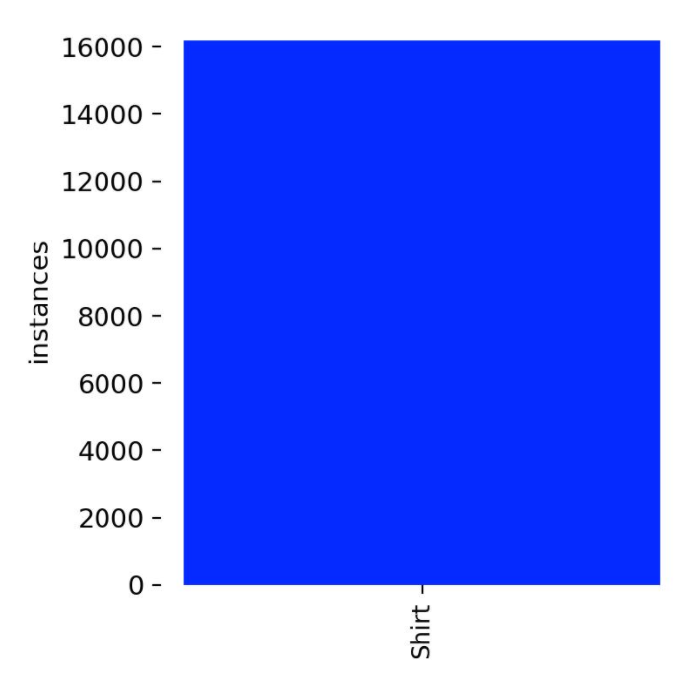
This visualization summarizes the annotation distribution for the "Shirt" class. The plot shows a high instance count, with approximately 16,000 labeled shirts. The top-right image displays the bounding box outlines, revealing that most shirts are detected near the image center with consistent sizing. The heatmap shows that the x and y coordinates of shirt detections are concentrated around the center, indicating a typical vertical alignment. The bottom-right plot illustrates a strong correlation between bounding box width and height, suggesting that shirts generally maintain a consistent aspect ratio and scale proportionally across the dataset.
Fig-5.1 : Bounding Box Classes of the Shirt Detection Dataset
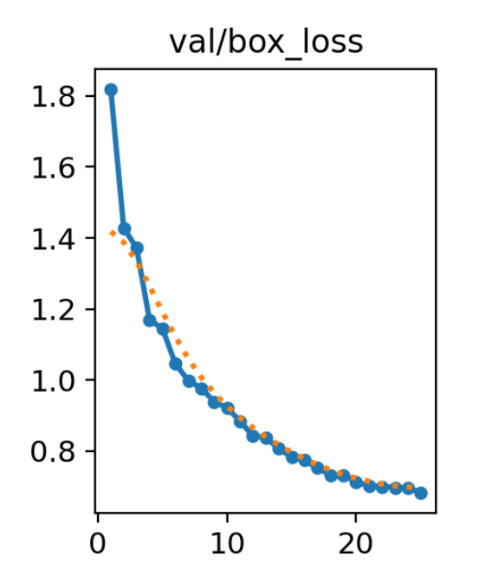
Throughout the training, there was a clear downward trend in the box loss, classification loss, and distribution focal loss, suggesting that the model was effectively learning to minimize detection errors. The steady increase in mAP and recall values across epochs further validates that the model was learning meaningful features from the limited data. The graph shows the validation box loss decreasing steadily over 25 epochs, indicating that the model is progressively improving its ability to predict accurate bounding boxes for shirts. The loss starts high at around 1.8, drops sharply in the early epochs, and then declines more gradually as the model refines its predictions. By the final epochs, the loss stabilizes near 0.75, showing good convergence and strong generalization without signs of overfitting. Overall, the curve reflects a healthy and effective training process for the shirt detection model.
Fig-5.2 : Graph of the Loss Function of the Trained Shirt Detection Model
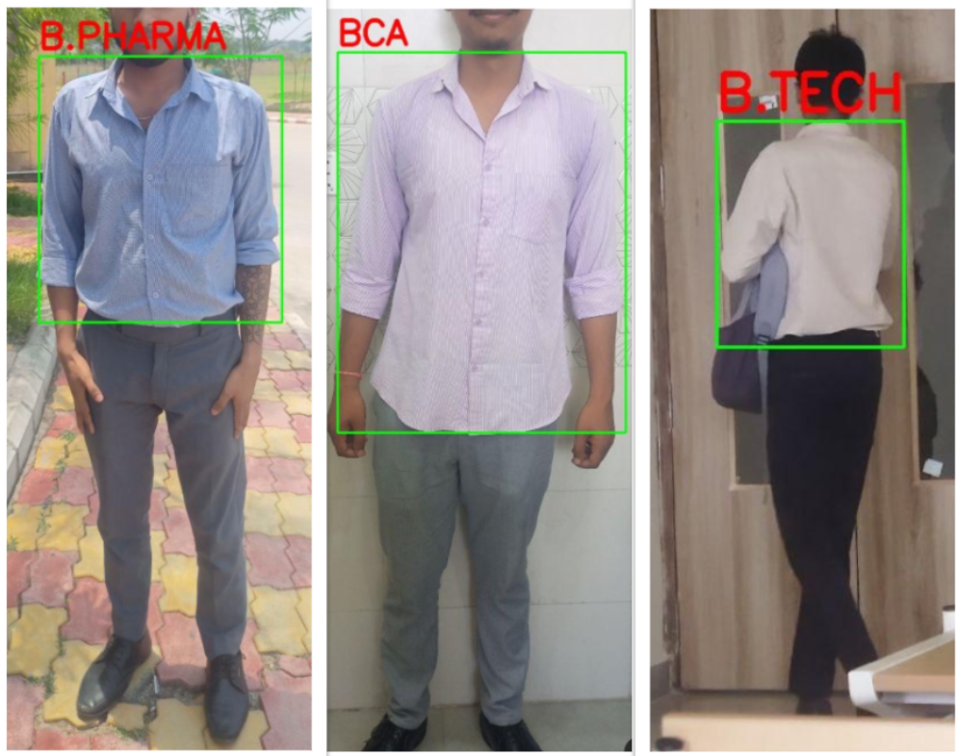
For quantitative testing, the model’s performance was evaluated using standard object detection metrics. In addition to metrics, visual inspections were conducted by running the model on test images. The predicted bounding boxes were visually compared to the expected locations of shirts. This helped verify that the model correctly identifies and localizes clothing item in various scenarios, such as different lighting conditions and background complexities. Qualitative testing, supported by visual results under result analysis, showed that the model could reliably detect shirts and pants in well-lit and unobstructed images. However, it occasionally misidentified clothing in cluttered backgrounds or under challenging lighting conditions. Overall, the model testing phase confirmed that the trained model is effective at detecting shirts and performs reliably across different scenarios. Future improvements could include longer training and hyperparameter tuning.
Fig-5.3: Validation Images of the trained model
Chapter 6
Result Analysis
The system provides buttons to start and stop the camera. As the camera starts it instantly initiates the Face recognition and student identification process, as the student is identified, it displays the details of the student on the screen and moves to the next step.
In the second step the system starts detecting shirt of the person standing in front of the camera. After that it extracts the dominant color of the shirt and predicts the department of the matching shirt color.
Note: For the system to accurately detect the shirt, the person must maintain a distance from the camera. If the area of the shirt covers more than 30% of the camera screen, it won’t be able to detect the shirt. This is because the CCTV cameras are placed at a distance from the path, so to simulate the same we have defined a min and max distance required for the shirt to be captured otherwise ignored.
In the third step, the department got from the student’s record and the department identified from the department identification model is cross checked for the verification of the person. The verification conditions used and the respective messages shown are as follows:
if faceDepartment equals "Unknown" and uniformDepartment equals "Unknown"
message shown→ Outsider Detected.
if faceDepartment equals "Unknown" and uniformDepartment is not "Unknown"
message shown → Potential Security Threat detected (someone posing to be a student).
if faceDepartment is not "Unknown" and uniformDepartment equals "Unknown"
message shown → {student_name} is not in university uniform.
if faceDepartment not equals uniformDepartment
reason shown→ {student_name} appears to be wearing a uniform from a different department.

6.1 Output images of the Project
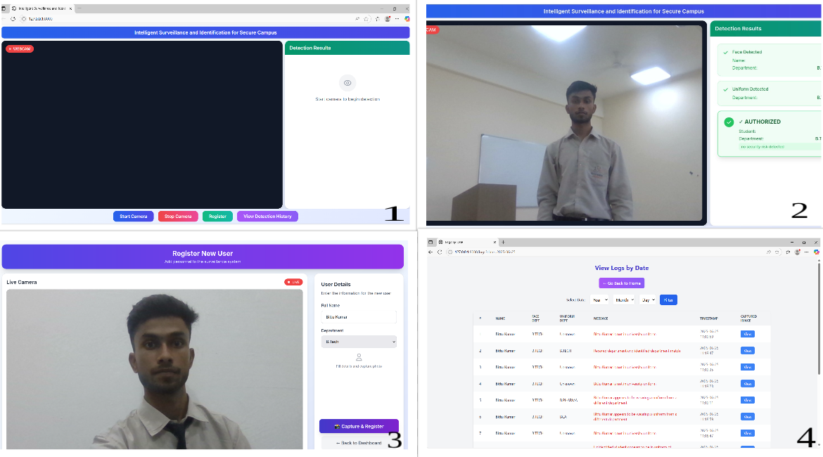
The images collectively illustrate the user interface and workflow of an Intelligent Surveillance and Identification System designed for secure campus monitoring.
Fig-6.1: Output Images of the Intelligent Surveillance and Identification System
1. The first screen represents the main dashboard, where the system waits for camera activation before beginning face and uniform detection. The left section contains the live webcam panel, initially dark because the camera is not yet active. A small red “WEB CAM” indicator shows that the system is ready to stream once permission is granted. At the top, a clearly labeled banner “Intelligent Surveillance and Identification for Secure Campus” emphasizes the purpose of the system. On the right, the “Detection Results” panel guides the user with an icon and message instructing them to start the camera to begin real-time analysis. The lower portion contains action buttons such as Start Camera, Stop Camera, Register, and View Detection History, indicating that the system supports both monitoring and administrative functionalities.
2. When the camera is started, as shown in the second image, the interface becomes more dynamic. The left side displays a live video feed with the user's face visible. The right side now shows that the system has successfully detected a face, displaying user details such as Name: Bittu and Department: B.Tech, which have been retrieved from the system's database. Below that, the interface shows an ongoing uniform detection process, visually represented by a loading card stating “Detecting Uniform Analyzing uniform patterns…”. This demonstrates the system’s dual-stage process: first confirming identity through facial recognition and then validating dress-code compliance through uniform classification.
3. The third image transitions to the user registration page, where new personnel can be added to the system. Here, the camera is active on the left, allowing the system to capture an image of the new registrant. On the right, there is a “User Details” form where fields such as Full Name and Department must be filled before capturing a registration photo. The “Capture & Register” button initiates the process, confirming that the system stores both facial features and associated academic or professional details.
4. The final image presents an updated version of the registration page, titled Register New Student, reflecting a more general onboarding workflow. It has the same live camera module, but the right panel is empty and waiting for user input. This consistent design across pages highlights usability, clear navigation, and seamless integration between detection and registration features.
6.2 Confusion Matrix
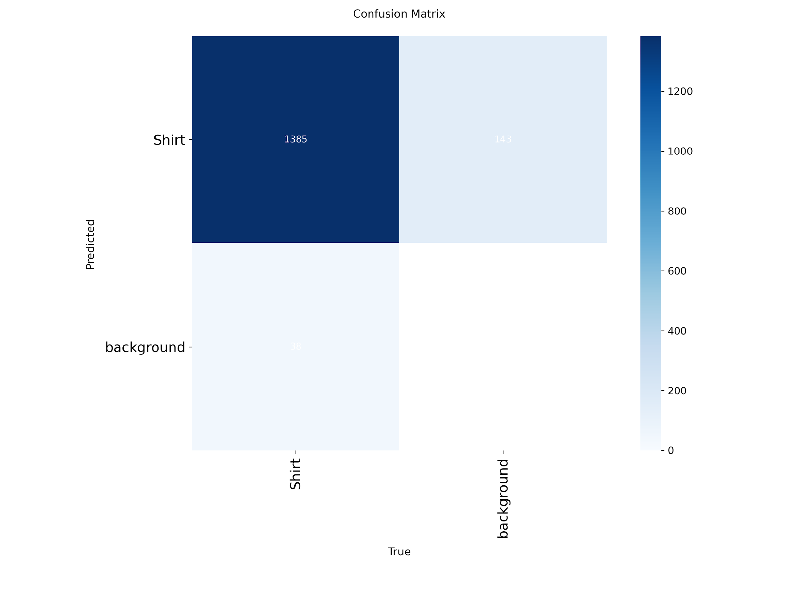
Fig-6.2: Confusion Matrix of the trained model
This image shows a confusion matrix that evaluates how well a shirt-detection model performs when classifying images into two categories: “Shirt” and “background.” The horizontal axis represents the true labels from the dataset, while the vertical axis represents the model’s predicted labels. The top-left cell contains 1385, indicating the model correctly identified 1385 shirt images (true positives). The top-right cell shows 143, representing shirt images that the model incorrectly classified as background (false negatives). In the bottom-left cell, the value 38 shows background images incorrectly predicted as shirts (false positives). The bottom-right cell represents true background classifications, but it appears to be zero or nearly zero, which may indicate the background class is underrepresented or the value is too small to be visible in this visualization. The color intensity reflects the frequency of predictions, with darker shades indicating higher counts. Here, the shirt true-positive cell is the darkest, showing strong model performance for detecting shirts. The lighter shades in misclassification areas reveal where the model struggles. Overall, the confusion matrix suggests the model is highly accurate at identifying shirts but less consistent with distinguishing background regions, likely due to dataset imbalance or the visual similarity between shirts and background areas.

Chapter 7
Conclusion & Future Scopes
7.1 Conclusion
This project successfully developed an AI-driven surveillance and identification system aimed at enhancing campus security through automated student monitoring. By integrating computer vision techniques, deep learning models such as DeepFace, and real-time database querying, the system was capable of detecting students, classifying their uniforms by department, and verifying identity through facial recognition. The system analyzed continuous CCTV video streams, extracting uniform color data and comparing it with predefined department mappings. Simultaneously, facial features were captured and matched against stored profiles in the institutional database. Whenever discrepancies were detected between the student’s actual department and the one inferred from their uniform, the system automatically flagged the individual and displayed violation alerts, thereby supporting quick administrative response. The implementation of an interactive, centralized monitoring dashboard greatly enhanced accessibility and operational efficiency for campus administrators. It provided real-time statistics, alert notifications, student logs, and system controls, contributing to a more structured and manageable surveillance workflow. Testing and evaluation further revealed that the system could operate reliably in real-time conditions, achieving high accuracy in both face detection and uniform classification tasks. Despite encountering issues such as inconsistent lighting, occlusions, camera placement limitations, and occasional false alerts, these challenges serve as valuable indicators for further improvements. Enhancing image quality preprocessing, expanding the training dataset, integrating multi-angle camera support, and refining color detection thresholds can significantly strengthen future system iterations. Overall, the project achieved its intended objectives and demonstrated the potential of artificial intelligence in transforming traditional campus security practices. It highlights how automated, data-driven surveillance can increase monitoring efficiency, reduce manual workload, and offer faster response to security breaches. This work establishes a strong foundation for scalable, intelligent surveillance systems and encourages further research into integrating behavioral analytics, multi-modal identification mechanisms, and advanced alerting frameworks to build a more secure and technologically empowered academic environment.
7.2 Future Scope
The proposed surveillance system offers substantial opportunities for expansion, enhancement, and integration, making it capable of evolving into a more robust, intelligent, and scalable security solution. One major future enhancement for the system is the introduction of an automated attendance mechanism. By extending the current facial recognition module, the system can automatically record student attendance the moment they are detected on camera. This eliminates the need for manual attendance marking, reduces human error, and prevents proxy attendance, making daily administrative tasks more efficient. Another important direction is expanding the solution into a campus-wide surveillance network. Instead of focusing only on gates or key checkpoints, the system can be deployed across classrooms, corridors, hostels, libraries, and common areas. This extended coverage would allow continuous monitoring of student movement and improve overall campus visibility for security teams. A third scope for improvement is the integration of real-time alert notifications. By sending automatic alerts through SMS, email, or a dedicated mobile application, administrators and security staff can be immediately informed when violations occur such as unauthorized entry, identity mismatches, or uniform discrepancies. This instant communication greatly enhances timely response. The system can also evolve to include behavioral analysis using AI, allowing it to detect suspicious activities, abnormal movement patterns, unauthorized group gatherings, or potential safety threats. This predictive capability would help identify risks before they escalate, transforming the system from a passive monitoring tool into an active security assistant. Integration with the institution’s ERP (Enterprise Resource Planning) system represents another significant upgrade. This would allow attendance data, disciplinary records, and access logs to be updated automatically, improving record accuracy and reducing administrative burden. Finally, the system can be extended to support deeper uniform and dress-code enforcement. Beyond detecting uniform colors, future versions could identify missing ID cards, incomplete uniforms, or improper footwear, ensuring consistent adherence to institutional rules.

7.3 Limitations
While the proposed system demonstrates strong potential in automating surveillance and identity verification, several limitations need to be acknowledged to fully understand its operational boundaries.
1. The system’s accuracy is significantly affected by lighting variability which can distort uniform colors and facial features.
2. Improper camera angles, long distances, obstructions, and motion blur reduce the system’s ability to reliably detect faces and uniform colors.
3. The system is prone to false positives and false negatives due to similar uniform shades, low-quality CCTV footage, and misclassification of non-students.
4. The system poses privacy, ethical, and security risks because it processes sensitive facial and identity data that require strong protection and compliance measures.
References
1. J. J. K, K. N. S, B. Vadivel, G. G and P. V, "Efficient YOLOv8 Model for Licence, Helmet and Person Detection," 2025 5th International Conference on Pervasive Computing and Social Networking (ICPCSN), Salem, India, 2025, pp. 404-408, doi: 10.1109/ICPCSN65854.2025.11035282.
2. Z. Li and J. Wang, "Multi-person gesture recognition for complex environmental based on improved Yolov8 algorithm," 2025 5th International Academic Exchange Conference on Science and Technology Innovation (IAECST), Guangzhou, China, 2025, pp. 614-619, doi: 10.1109/IAECST60924.2025.10502852.
3. J. Nandre, S. Rai and B. R. Kanawade, "Comparative Analysis of Transfer Learning CNN for Face Recognition," 2024 2nd International Conference on Intelligent Technologies (CONIT), Hubli, India, 2024, pp. 1-6, doi: 10.1109/CONIT55038.2024.9847946.
4. D. S. Parker, "Integrating AI and DBMS through stream processing," [2024] Proceedings. Fifth International Conference on Data Engineering, Los Angeles, CA, USA, 2024, pp. 259-260, doi: 10.1109/ICDE.2024.47224.
5. T. Babu, E. P. M and R. R. Nair, "Real-Time Facial Expression Recognition Using Deep Learning for Enhanced Human-Machine Interactions," 2024 International BIT Conference (BITCON), Dhanbad, India, 2024, pp. 1-6, doi: 10.1109/BITCON63716.2024.10984634.
6. H. R. Tohidypour, M. T. Pourazad and P. Nasiopoulos, "A Security-Centric Deep Learning Enabled Camera Solution for Real-Time Human Fall Detection," 2023 18th International Conference on Wireless and Mobile Computing, Networking and Communications (WiMob), Thessaloniki, Greece, 2023, pp. 42-46, doi: 10.1109/WiMob55322.2023.9941359.
7. M. Doi, T. Matsumoto, A. Kimachi, S. Nishi and N. Ikoma, "Robust color object tracking method against illumination color Change," 2023 Joint 7th International Conference on Soft Computing and Intelligent Systems (SCIS) and 15th International Symposium on Advanced Intelligent Systems (ISIS), Kitakyushu, Japan, 2023, pp. 718-722, doi: 10.1109/SCIS-ISIS.2023.7044769.
8. Y. Zhao, H. Liu, Q. Wang and C. Li, "A Multi-Object Tracking Method Using IoU and Color Fusion Model," 2023 9th International Conference on Signal and Image Processing (ICSIP), Nanjing, China, 2023, pp. 747-751, doi: 10.1109/ICSIP61881.2023.10671489.
9. Y. Qi, Y. Wang and Y. Liu, "Object Tracking Based on Deep CNN Feature and Color Feature," 2022 14th IEEE International Conference on Signal Processing (ICSP), Beijing, China, 2022, pp. 469-473, doi: 10.1109/ICSP.2022.8652470.
10. Zhiyuan Han, Tingrong Xu and Zhaohua Chen, "An improved color-based tracking by particle filter," Proceedings 2022 International Conference on Transportation, Mechanical, and Electrical Engineering (TMEE), Changchun, China, 2022, pp. 2512-2515, doi: 10.1109/TMEE.2022.6199732.
11. S. Pati, A. Majumder, M. Gangopadhyay, G. Sen and A. Chakraborty, "Advanced Attendance Monitoring: A Unified System Using QR Codes and Facial Recognition," 2021 8th International Conference on Electronics, Materials Engineering & Nano-Technology (IEMENTech), Kolkata, India, 2021, pp. 1-4, doi: 10.1109/IEMENTech65115.2021.10959151.
12. R. Nidhya, D. J. A. Pabi, U. DivyaSree, B. Abhishek, A. Harika and S. A. Alim, "Exploring Facial Recognition Technologies for Classroom Management," 2021 10th International Conference on Communication and Signal Processing (ICCSP), Melmaruvathur, India, 2021, pp. 1702-1707, doi: 10.1109/ICCSP60870.2021.10544143.

Appendix
Application Structure
IntelSurvIdSys
├── app.py
├── identify_department.py
├── log.py
├── match_face.py
├── register_user.py
├── templates
│ ├── index.html
│ ├── logs.html
│ └── register.html
├── uniform.py
├── utils
│ └── get_hsv.py
└── pyproject.toml

Source Code
app.py
from ultralytics import YOLO
import numpy as np
import cv2

# custom trained YOLO model for shirt detection
model = YOLO("runs/content/runs/detect/train/weights/best.pt")

def identify_department_from_uniform_colorcode(image):
try:
# Run YOLO inference
results = model(image)
departments = []

# Process the results
for result in results:
boxes = result.boxes
for idx, box in enumerate(boxes):
x1, y1, x2, y2 = map(int, box.xyxy[0])
class_id = int(box.cls)
class_name = model.names[class_id].lower()
confidence = float(box.conf[0])

# Detect only shirts
if class_name != "shirt":
continue

# Crop shirt region (BGR format)
cropped_shirt = image[y1:y2, x1:x2]

if cropped_shirt.size == 0:
continue

crop_area = (x2 - x1) * (y2 - y1)
image_area = image.shape[0] * image.shape[1]

# Area thresholds to filter out large/small false detections
min_shirt_area = 0.01 * image_area # 1%
max_shirt_area = 0.3 * image_area # 50%

if crop_area < min_shirt_area or crop_area > max_shirt_area:
continue # Skip invalid shirt sizes

department = get_department(cropped_shirt, DEPARTMENT_COLORS)

overall_confidence = confidence * (0.8 if department else 0.3)
color_confidence = "high" if department else "low"
crop_area = (x2 - x1) * (y2 - y1)

result_dict = {
'department': department,
# 'dominant_color': [int(x) for x in dominant_color],
'shirt_detection_confidence': confidence,
'overall_confidence': overall_confidence,
'color_confidence': color_confidence,
'bounding_box': [x1, y1, x2, y2],
'crop_area': crop_area,
}
departments.append(result_dict)

if not departments:
print("No shirts detected in the image.")
return None
return departments[0]

except Exception as e:
print(f"Error in identify_department_from_uniform_colorcode: {e}")
return None

def find_max_contour(image, hsv_lower, hsv_upper, area_threshold=0.4):
"""
Detects contours in an image based on HSV range, finds the contour with the maximum area,
and checks if its area exceeds the specified threshold.

Parameters:
image (numpy.ndarray): Input image in BGR format.
hsv_lower (tuple): Lower bound of HSV values (H, S, V).
hsv_upper (tuple): Upper bound of HSV values (H, S, V).
area_threshold (float): Minimum area threshold for the contour.

Returns:
tuple: (max_contour, max_area, is_above_threshold)
- max_contour: Contour with the maximum area (None if no contours found).
- max_area: Area of the maximum contour (0 if no contours found).
- is_above_threshold: Boolean indicating if max_area exceeds area_threshold.
"""
# Convert the image to HSV color space
hsv_image = cv2.cvtColor(image, cv2.COLOR_BGR2HSV)

# Create a mask based on the HSV range
mask = cv2.inRange(hsv_image, np.array(hsv_lower), np.array(hsv_upper))

# Find contours in the mask
contours, _ = cv2.findContours(mask, cv2.RETR_EXTERNAL, cv2.CHAIN_APPROX_SIMPLE)

# Initialize variables for maximum contour and area
max_contour = None
max_area = 0

# Iterate through contours to find the one with maximum area
for contour in contours:
area = cv2.contourArea(contour)
if area > max_area:
max_area = area
max_contour = contour

# Check if the maximum area exceeds the threshold
is_above_threshold = max_area > area_threshold

return max_contour, max_area, is_above_threshold

def get_department(image, department_colors):
"""
Identify the department based on the dominant color of the shirt in the image.

Parameters:
- image: Input image in BGR format.
- department_colors: Dictionary containing department color ranges.

Returns:
- str: Detected department name or "No Match".
"""
# Convert the image to HSV color space
# hsv_image = cv2.cvtColor(image, cv2.COLOR_BGR2HSV)

department = {}

# Find contours for each department color
for dept, ranges in department_colors.items():
lower = ranges['lower']
upper = ranges['upper']

max_contour, max_area, is_above_threshold = find_max_contour(image, lower, upper)

if is_above_threshold:
if not department or max_area > department['max_area']:
department = {
'name': dept,
'max_contour': max_contour,
'max_area': max_area,
'hsv_lower': lower,
'hsv_upper': upper
}

return department['name'] if department else None

# defined DEPARTMENT_COLORS with lower and upper HSV ranges for each department
DEPARTMENT_COLORS = {
"Unknown": {'lower': [58, 20, 16], 'upper': [144, 210, 96]},
"B.TECH": {'lower': [0, 0, 0], 'upper': [40, 255, 168]},
"B.PHARMA": {'lower': [105, 48, 0], 'upper': [179, 255, 255]},
"BCA": {'lower': [87, 19, 156], 'upper': [179, 255, 255]},
}

# Example usage:
from PIL import Image

if __name__ == "__main__":
try:
test_img = "tests/images/btech.jpeg"

# Load the PIL image
pil_image = Image.open(test_img)

# Convert PIL Image to OpenCV BGR format
img_array = np.array(pil_image) # RGB format
img_cv = cv2.cvtColor(img_array, cv2.COLOR_RGB2BGR)

result = identify_department_from_uniform_colorcode(img_cv)

if result and result.get('bounding_box'):
print(f"\nShirt Detection Confidence: {result['shirt_detection_confidence']}")
print(f"Bounding Box: {result['bounding_box']}")
# print(f"Dominant Color: {result['dominant_color']}")
print(f"Color Confidence: {result['color_confidence']}")
print(f"Overall Confidence: {result['overall_confidence']}")
print(f"Detected Department: {result['department']}")

# Convert PIL image to OpenCV format (RGB to BGR)
img_array = np.array(pil_image)
if img_array.shape[-1] == 3: # Ensure it's RGB
img_cv = cv2.cvtColor(img_array, cv2.COLOR_RGB2BGR)
else:
print("Image format not supported for display")
exit(1)

# Extract bounding box coordinates (x1, y1, x2, y2)
x1, y1, x2, y2 = result['bounding_box']

# Draw bounding box on the image
start_point = (int(x1), int(y1))
end_point = (int(x2), int(y2))
color = (0, 255, 0) # Green color in BGR
thickness = 2
img_cv = cv2.rectangle(img_cv, start_point, end_point, color, thickness)

# Add department text above the bounding box
department_text = result['department']
font = cv2.FONT_HERSHEY_SIMPLEX
font_scale = 1.5 # Larger scale for big text
text_color = (0, 0, 255) # Black color in BGR
text_thickness = 3 # Increased thickness for bold text

# Calculate text position (slightly above the top-left corner of the bounding box)
text_position = (int(x1), int(y1) - 10) # Move 10 pixels above y1
img_cv = cv2.putText(img_cv, department_text, text_position, font, font_scale, text_color, text_thickness, cv2.LINE_AA)

# Display the image with bounding box
cv2.imshow("Image with Bounding Box", img_cv)
cv2.waitKey(0) # Wait for key press to close
cv2.destroyAllWindows()

else:
print("No department or bounding box detected")

except FileNotFoundError:
print(f"Test image not found - replace '{test_img}' with your image path")
except Exception as e:
print(f"An error occurred: {str(e)}")

import mysql.connector
import base64

# Read and encode the image in base64
# with open("faces/rohit.jpg", "rb") as image_file:
# encoded_string = base64.b64encode(image_file.read()).decode("utf-8")

def register_user_base64encoded(name: str, image_data: str, department: str):
try:
# Strip data URL header if present
_header, encoded = (
image_data.split(",", 1) if "," in image_data else ("", image_data)
)

# Connect to the database
conn = mysql.connector.connect(
host="localhost", user="bittu", password="bittu", database="deepface_schema"
)

cursor = conn.cursor()

# Insert the name and base64-encoded image string
cursor.execute(
"INSERT INTO registered_users (name, face, department) VALUES (%s, %s, %s)",
(name, encoded, department),
)

conn.commit()
conn.close()
return {
"success": True,
"message": f"User {name} registered successfully in {department} department.",
}
except mysql.connector.Error as err:
print(f"Error: {err}")
return {"success": False, "message": f"Failed to register user {name}: {err}"}

