Intelligent Surveillance and Identification for Secure Campus

A Project Report Submitted
in Partial Fulfillment of the Requirements
for the Degree of

Bachelor of Technology
(Computer Science & Engineering)
Submitted By

Abu Reeyan [22B.Tech(CSE)059]
Bittu Kumar [22B.Tech(CSE)060]
Sushma Kumari [22B.Tech(CSE)061]
Kishun Kumar [22B.Tech(CSE)062]

Under Guidance of
Dr. Narendra Kumar


Faculty of Computing and Information Technology
Usha Martin University, Ranchi
March, 2025
 | TABLE OF CONTENTS
S.no. | Topic | Page No.
1. | Bonafide ………………………………………………………………... | i
2. | Declaration………………………………………………………………... | ii
3. | Certificate……………………………………………………………….... | iii
4. | Acknowledgement………………………………………………………... | iv
5. | Abstract …………………………………………………………………... | v
6. | List of Figures………………………………………………...…………… | vi
7. | List of Tables………………………………………………………………. | vii
8. | List of Abbreviations……………………………………………………… | viii
Chapter | Topic Name | Page no.
1. | Introduction.…………………….…………………………………....  - Overview …………………………………………………………...  - Background………………………………………………………....  - Application & feature of project……………………………………  - Objective ……………....……………………………………………  - Problem statement………………………………………………….  - Research Gap………………………………………………………. | 1  2  3  4  5  6  7
2. | Literature Review ………………………………………………….  Literature review in Table
3. | Requirements Analysis…………………………….………………….  3.1 System Requirement  3.2 Hardware Required  3.2 Software Required  3.3 ER Diagram  3.4 Use Case Diagram  3.5 Data Flow Diagram
4. | Proposed Methodology……………………………………………….  4.1 Methodology  4.2 Block Diagram
5. | Model testing
6. | Result Analysis……………………………………………………….  5.1 Output of your project images …………………………………….  5.2 Confusion Matrix………………………………………………….
7 | Conclusion & Future Scopes…………………………………………  6.1 Conclusion………………………………………………………….  6.2 Future Scope ………………………………………………………  6.3 Limitations…………………………………………………………
References………………………...……………………………………
Appendix…………………...………………………………………….

BONAFIDE CERTIFCATE
Certified that this project report title “Intelligent Surveillance and Identification for Secure Campus” is the bonafide work of Mr./ Ms. Abu Reeyan, Bittu Kumar, Sushma Kumari, Kishun Kumar who carried out the research under my supervision. Certified further, that to the best of my knowledge the work reported herein does not form part of any other project report or dissertation on the basis of which a degree or award was conferred on an earlier occasion on this or any other candidate.

(Signature of the concerned Supervisor of the Organization with Organization Seal)

(Certificate to be countersigned by the HOD.)

DECLARATION
I do hereby declare that this report entitled “Intelligent Surveillance and Identification for Secure Campus”, submitted by Abu Reeyan, bearing Roll No:22B.Tech(CSE)059 Bittu Kumar, bearing Roll No:22B.Tech(CSE)060 Sushma Kumari, bearing Roll No: 22B.Tech(CSE)061 Kishun Kumar, bearing Roll No:22B.Tech(CSE)062 in the fulfillment of the requirement for the degree of Bachelor of Computer Application to Usha Martin University, Ranchi, is my own and it is not submitted to any other institute.

Abu Reeyan
22B.Tech(CSE)059

Bittu Kumar
22B.Tech(CSE)060

Sushma Kumari
22B.Tech(CSE)061

Kishun Kumar
22B.Tech(CSE)062

CERTIFICATE
This is to certify that entitled “Intelligent Surveillance and Identification for Secure Campus” being submitted by Abu Reeyan, bearing Roll No:22B.Tech(CSE)059 Bittu Kumar, bearing Roll No:22B.Tech(CSE)060 Sushma Kumari, bearing Roll No: 22B.Tech(CSE)061 Kishun Kumar, bearing Roll No:22B.Tech(CSE)062 , in the fulfillment of the requirement for the degree of Bachelor of Computer Application to Usha Martin University, Ranchi, is a bonafide work carried out under my/our supervision. The matter embodied in this report is original and has not been submitted for the award of any other degree.

(Dr. Sharmistha Roy) (Dr. Narendra Kumar)
HOD Guide

ACKNOWLEDGEMENTS

I express my deepest sense of gratitude to my guide Dr. Narendra Kumar Faculty of Computing and Information Technology, Usha Martin University, Ranchi, for suggesting the subject of work and constant supervision throughout this work. His/her co-operation and timely suggestions have been unparalleled stimuli for me to travel eventually towards the completion of this project report. Indeed his/her continuous involvement has helped me in bringing of this project work which otherwise would have remained a distant dream.
I am indeed thankful to Dr. Sharmistha Roy, HOD, Faculty of Computing and Information Technology, Usha Martin University, Ranchi, for giving me permission to carry out my project work. I would like to express my gratitude to all teaching and non-teaching staff members of Faculty of Computing and Information Technology, Usha Martin University, Ranchi, for their co-operation in my work.

Abu Reeyan
22B.Tech(CSE)059
Bittu Kumar
22B.Tech(CSE)060
Sushma Kumari
22B.Tech(CSE)061
Kishun Kumar
22B.Tech(CSE)062

Abstract
Ensuring campus security and student compliance with institutional uniform policies has become increasingly challenging with manual monitoring methods. This project proposes an AI-powered system that utilizes computer vision and deep learning to identify and classify students in real-time based on their uniform color and facial features. The system is designed to analyze live video feeds from CCTV cameras, detect student faces using the DeepFace model, and retrieve their information from a connected database. Simultaneously, it applies color segmentation techniques to determine the uniform color and maps it to the respective department. A comparison is made between the department obtained from the uniform and the one retrieved from the database to verify student identity and detect uniform violations or unauthorized individuals. The methodology includes video acquisition, frame preprocessing, face recognition, color-based uniform detection, and integration with a querying database. The implementation demonstrates significant improvements in accuracy and efficiency over existing image-based systems, particularly in video-based applications. The integration with a live database makes real-time tracking and data retrieval possible, transforming security protocols across educational institutions. It sets the foundation for future developments such as automated attendance, behavioral monitoring, and campus-wide surveillance integration. Overall, this project demonstrates a practical and intelligent approach to student monitoring through AI and deep learning.

Keyword – AI Surveillance, DeepFace, Uniform Detection, Department Classification, Computer Vision, Campus Security, CCTV, AI-Powered.

List of Figures
S. No | Figure.  No | Title | Page.  No
1 | 4.2 | System Workflow | 25
2 | 4.3 | ER Diagram of the Database | 39
3 | 5.1 | Dataset Distribution Among Different Sets | 26
4 | 6.2 | Loss Function Trends | 28

List of Tables

S.No. | Table  No. | Title | Page  No.
1 | Table 1 | Literature Survey (Research Paper) | 17
2 | Table 2 | Model's Performance Evolution During Training | 31

List of Abbreviations
Abbreviations | Full Form
AI | Artificial Intelligence
CCTV | Closed Circuit Television
ER | Entity Relationship
DL | Deep Learning
CNN | Convolutional Neural Network

CHAPTER 1
Introduction

1.1 Overview

Ensuring student safety, verifying identities, and enforcing institutional discipline are critical responsibilities in today’s educational institutions. With the exponential rise in student enrollment and the continuous expansion of campus infrastructure, universities and colleges face growing difficulties in maintaining effective monitoring and security across their premises. Traditionally, these responsibilities have been addressed through manual methods—security personnel stationed at entry points, administrative staff visually verifying students, and physical enforcement of dress codes. However, these approaches are rapidly becoming inadequate in the face of increasing student populations and decentralized campus layouts. Manual surveillance is labour-intensive, inconsistent, and prone to human error. Security personnel can overlook violations due to fatigue, distraction, or limited field of view, while administrative staff may find it difficult to accurately verify student identity and dress code compliance, especially during peak hours. As a result, unauthorized access, uniform violations, and identity misrepresentation can go unnoticed, posing potential risks to campus safety and decorum. In this context, educational institutions need smarter, more reliable, and automated solutions to support or replace manual intervention with more accurate and scalable systems. In most academic institutions, students are assigned specific uniforms based on their departments, making uniform color a simple yet effective visual cue for department-level classification. However, checking for compliance manually across hundreds or thousands of students is inefficient and subjective. At the same time, identity checks through ID cards or verbal confirmation are often bypassed or manipulated. These problems underscore the urgent need for intelligent systems that can monitor students automatically, verify their identity in real-time, and detect violations proactively without disrupting campus operations. The rapid advancement of Artificial Intelligence (AI), Computer Vision, and Deep Learning technologies presents a transformative opportunity to address these challenges. AI-powered surveillance systems can now detect faces, recognize individuals, and classify clothing attributes like color and texture using trained models with a high degree of accuracy. These capabilities, when integrated with CCTV infrastructure and institutional databases, form the foundation of a real-time, automated, and intelligent student identification and verification system. This project aims to design and develop such a system, referred to as the “Intelligent Surveillance and Identification System for Secure Campus.” The core functionality of the system lies in its ability to perform two parallel operations: facial recognition using the DeepFace model and uniform color detection using color segmentation techniques. The system captures live video streams from IP-based CCTV cameras installed at key locations across the campus. These streams are then converted into frames for processing. Each frame undergoes preprocessing (resizing, normalization, denoising) before being passed to AI models for analysis. The DeepFace model identifies the student by comparing the detected face with the university’s centralized student database. Simultaneously, the system analyses the dominant uniform color from the frame and maps it to the student’s department based on pre-configured color codes. After retrieving both sets of information—recognized identity and visual classification—the system cross-verifies them to ensure that the detected uniform matches the student’s registered department. If a mismatch or unrecognized face is found, the system immediately raises an alert and logs the violation on an admin dashboard, which provides a real-time overview of student data, departmental match status, and alerts. This approach offers a range of benefits. The system operates autonomously in real time, significantly reducing the need for human involvement while maintaining accuracy and consistency in student monitoring. It helps prevent unauthorized access, ensures uniform policy enforcement, and contributes to the overall disciplinary framework of the institution. Additionally, all records and alerts are stored in a secure database for future audits and administrative reporting. The broader impact of this system lies in its ability to support the evolution of smart campus ecosystems. Beyond just surveillance, the system can be extended to include features like automated attendance marking, real-time notifications to staff or security, and behavioral analytics for detecting unusual activities such as loitering or group conflicts. It also offers the potential for seamless integration with existing ERP and student management systems, further enhancing administrative efficiency. In conclusion, this project offers a practical, scalable, and forward-looking solution to the pressing challenges of campus surveillance and discipline enforcement. By combining AI-driven technologies with everyday security workflows, the Intelligent Surveillance and Identification System demonstrates how institutions can transition from reactive, manual security methods to proactive, intelligent monitoring systems that are capable of adapting to the needs of modern education.
1.2 Background
The advancement of education in the 21st century has not only transformed classroom learning but also the way educational institutions manage infrastructure, safety, and discipline. With the rapid growth in student intake, expansion of academic departments, and development of sprawling campus environments, universities and colleges today face new and evolving challenges. Among these, campus security and uniform discipline enforcement are two of the most pressing and foundational responsibilities for administration and security departments. Historically, institutions have relied on manual surveillance, such as physical security personnel monitoring entry points, patrolling premises, and reviewing closed-circuit television (CCTV) footage. While these methods served their purpose in smaller or less crowded campuses, they have become increasingly inefficient and insufficient in large, modern educational institutions. As student populations rise and campuses become more decentralized, traditional methods struggle to scale up. Manually observing hundreds or thousands of students to ensure uniform compliance or identify intruders is labour-intensive, time-consuming, and highly prone to human error. In most educational settings, especially in India and other countries with large student bases, students are assigned uniforms based on their academic department. This system provides a visual cue that helps both faculty and security personnel identify a student’s academic affiliation. While the use of uniforms promotes equality and discipline, enforcing dress code compliance manually, especially in large institutions with multiple entry and exit points, is extremely challenging. Security staff may overlook violations, and there is no consistent, automated way to flag uniform mismatches. Moreover, manual verification of student identities through ID cards or physical registers is not only inefficient but also vulnerable to manipulation, proxy attendance, and impersonation. This gap in effective monitoring and verification creates serious vulnerabilities—not just in discipline enforcement, but in overall campus security. Unidentified or unauthorized individuals might enter the campus, dress code violations might go unchecked, and false identity claims may go unnoticed. These issues underscore the need for automated, intelligent systems that can operate consistently, accurately, and autonomously across different parts of the campus. In recent years, Artificial Intelligence (AI) and Computer Vision have emerged as transformative technologies in the field of surveillance and automation. The ability of AI systems to detect faces, recognize identities, and process visual inputs such as clothing colors and patterns has improved dramatically. Particularly, deep learning-based face recognition models such as DeepFace, developed by Facebook’s AI Research team, have demonstrated near-human accuracy in face verification. Similarly, color analysis and pattern recognition techniques have made it possible to classify uniform colors and distinguish between departments through visual data. By integrating these capabilities into a unified surveillance framework, institutions can shift from reactive to proactive security and discipline management. A smart surveillance system that combines live CCTV input, facial recognition, and uniform detection can automatically identify a student, verify their department affiliation, and check if they are complying with uniform policies—all in real-time and without the need for human intervention. Furthermore, linking this system with a centralized student database allows it to retrieve and cross-check identity and department information with accuracy and speed. If a mismatch is detected—either the student is not wearing the correct uniform, or their face does not match the database record—the system can automatically raise an alert, notify administrators, and log the event for further action. This digital, automated process not only enhances security but also creates a transparent record for auditing, reporting, and accountability. The implementation of such a system also aligns with the broader vision of building Smart Campuses, where technology is used not only for academic enhancement but also for operational efficiency, safety, and data-driven governance. Such systems can later be extended to include features like automated attendance, real-time behavior monitoring, and access control integration, making them a long-term asset for institutions. In this context, the proposed project—“Intelligent Surveillance and Identification System for Secure Campus”—represents a timely and necessary innovation. It brings together the power of AI, deep learning, and data systems to create a solution that addresses long-standing challenges in student monitoring, identity verification, and campus discipline. By automating routine checks and ensuring accuracy in surveillance, the system serves as a scalable and future-ready platform for educational institutions looking to modernize their security and compliance infrastructure.

1.3 Application & Features of the project
The Intelligent Surveillance and Identification System for Secure Campus is designed to serve as a practical, scalable, and intelligent solution for enhancing safety, monitoring, and administrative efficiency in educational institutions. The system’s application goes beyond mere observation—it actively verifies identity, enforces policy, and maintains digital records, making it suitable for a wide range of real-world academic use cases.
- Campus Entry Monitoring: This system is highly effective at all main entry and exit points of the institution. As students walk through monitored areas, the system instantly captures their image, performs facial recognition, and verifies whether the individual is an enrolled student. If the face is not recognized or is found to be unauthorized, the system immediately triggers an alert, helping prevent intrusions and potential security threats
- Uniform Compliance Enforcement: One of the most common challenges in academic institutions is ensuring students adhere to their department-specific uniform guidelines. This system detects and analyses the uniform color of each student and compares it to their registered department. Any mismatch is flagged, allowing the institution to take quick disciplinary action and ensuring a consistent and professional academic environment.
- Departmental Classification: Beyond identity, the system can classify students in real time based on the uniform color, which represents their department. This capability can be used for managing department-restricted zones (e.g., labs, workshops) where only authorized students should be granted access. It enhances security by reducing the risk of cross-departmental impersonation or unauthorized movement.
- Attendance Assistance: With further integration, the system can be enhanced to automate student attendance by logging entry and exit timestamps when a student is recognized. This removes the need for manual attendance marking in classrooms or lecture halls, improves accuracy, and saves time for both students and faculty.
- Real-Time Alerts for Violations: When any irregularity is detected—such as an unrecognized face, uniform mismatch, or attempted access to a restricted area—the system generates real-time alerts. These alerts are instantly pushed to an admin dashboard and can also be integrated with SMS, email, or mobile app notifications for faster response by the security team.
- Administrative Logging and Reporting: Each event, whether a successful match or violation, is logged with details such as student name, ID, time, location, and a snapshot. These logs serve as audit trails for administrative reviews and disciplinary committees. Reports can be generated weekly or monthly to analyze trends, policy violations, or security breaches.
- Scalable to Multiple Locations: The system is designed to support multiple camera feeds and can be deployed across various buildings, departments, or even different campuses under the same institution. A centralized monitoring system enables authorities to manage all locations from one interface, making it a versatile and future-ready solution.

1.4 Objective
The primary objective of this project is to design and implement an AI-powered surveillance and identification system that can enhance campus security, improve discipline enforcement, and automate student monitoring through intelligent technologies such as facial recognition and uniform color detection. This system aims to address the limitations of traditional surveillance methods by introducing a real-time, automated, and tamper-proof solution capable of functioning independently with minimal human intervention. It is specifically tailored for academic institutions were managing large student populations and enforcing uniform policies consistently poses a significant operational challenge.
- To develop an intelligent surveillance system using AI and computer vision: The core objective is to design a smart surveillance system that leverages advanced artificial intelligence and computer vision technologies. This includes integrating the Deep Face deep learning model for facial recognition and using image processing techniques such as color segmentation for detecting and classifying uniform colors. The system is expected to operate in real time, processing live video streams captured from strategically installed CCTV cameras across the campus. This ensures continuous monitoring and immediate response to any irregularities without the need for human observation.
- To automate the identification and verification of students: A key goal of the system is to automate student identification by analyzing their facial features and matching them against stored records in a centralized institutional database. This eliminates the dependency on physical ID cards, biometric scanners, or manual roll calls. The system ensures that only registered students are granted access and that their identity is confirmed accurately every time they pass through monitored areas. This objective enhances security while improving efficiency in daily operations.
- To ensure department-wise uniform compliance: Uniforms often represent departmental affiliations in academic institutions. This project aims to ensure that each student adheres to their assigned dress code by automatically detecting the color of their uniform and comparing it with the expected color for their registered department. If a student is found to be wearing an incorrect or unauthorized uniform, the system will flag it as a violation. This supports the enforcement of institutional discipline and maintains a sense of order and professionalism across departments.
- To generate real-time alerts for unauthorized access or rule violations: Another critical objective is to develop an alert mechanism that operates in real time. Whenever the system detects an unidentified face, a mismatch between the uniform and department, or any unauthorized activity, it immediately generates a digital alert. These alerts are delivered through the system’s admin dashboard and can be configured to send notifications via SMS, email, or in-app messages to relevant authorities. This facilities prompt response and enhances the overall security posture of the institutions.
- To design an admin-friendly interface for live monitoring and record keeping: The system will include a web-based administration dashboard that provides real-time visibility into student activities, detected violations, and system alerts. This interface is designed to be user-friendly, allowing non-technical staff to easily monitor student flow and manage violations. It also maintains a detailed log of each recognition event, including the student’s name, ID, time, date, and location, thereby enabling data-driven decision-making and effective disciplinary actions.
- To reduce reliance on manual monitoring and increase operational efficiency: One of the major goals is to minimize the burden on human surveillance staff and reduce the chances of oversight or fatigue-based errors. By automating routine identification and uniform verifications tasks, the system enhances the operational efficiency of the institutions. Security personnel and administrative staff can then focus on more critical, non-repetitive tasks, ensuring better utilization of resources and reduced dependency on manual checks.
- To create a secure and scalable system: The system must be developed with robust data protection mechanisms to ensure the privacy and security of student information, facial images, and violation records. Access to sensitive data will be restricted to authorized personnel only, following institutional data protection policies. Additionally, the system will be designed to scale easily, allowing seamless deployment in additional buildings, departments, or campuses without the need for significant technical modifications.

1.5 Problem Statement
In the current era of digital transformation, educational institutions are facing increasing pressure to enhance campus safety, maintain institutional discipline, and ensure operational efficiency. As universities and colleges continue to expand in size, infrastructure, and student population, the complexity of campus security and student management grows exponentially. Institutions now operate across multi-block campuses, with multiple entry and exit points, separate academic departments, and a high degree of student mobility. In this environment, the limitations of traditional, manual surveillance systems have become starkly evident. Conventional surveillance practices—such as deploying guards at gates, checking ID cards manually, visually confirming uniforms, and observing CCTV monitors in real time—are both inefficient and unsustainable. These methods are entirely dependent on human judgment, which is prone to fatigue, distraction, and error. In high-traffic environments, where thousands of students pass through checkpoints daily, it's nearly impossible for human observers to maintain consistent attention, especially when verifying identity or uniform compliance. This leads to gaps in monitoring, missed violations, unauthorized access, and unreliable attendance tracking. Another major shortcoming of traditional systems is the lack of automated verification mechanisms. Student identity verification often relies on physical ID cards, which can be forgotten, lost, or misused. Proxy attendance, impersonation, and the inability to detect unauthorized individuals are persistent problems. Moreover, the physical act of checking IDs and verifying uniforms consumes significant administrative time and resources, reducing institutional efficiency. Uniform compliance is a crucial aspect of discipline in many institutions, especially where each academic department is assigned a specific uniform color. This system is designed to visually distinguish students based on their field of study and maintain order. However, verifying uniform compliance manually is unreliable, especially in large campuses. Uniform violations can go unnoticed, and there's no structured way to document or track repeat offenders. There is also a lack of transparency and consistency in enforcement, which may lead to perceptions of bias or unfair treatment. Additionally, traditional surveillance systems are inherently reactive, not proactive. Alerts or interventions typically occur only after an incident has happened or when it's reported by staff. There is no intelligent system in place to detect anomalies, raise real-time alerts, or maintain a digital trail of student activities. This lack of predictive or preventive capability creates a reactive security model, which is inadequate in an environment that demands vigilance, speed, and automation. Furthermore, institutions often operate with fragmented systems—separate surveillance setups, disconnected databases, and manual attendance processes—which are not integrated. This creates information silos and hinders real-time decision-making. The absence of centralized data, automated analysis, and alert mechanisms makes it difficult for administration to monitor student behavior holistically or respond quickly in case of irregularities. The problem is not only technological but also strategic. Institutions aiming to become “smart campuses” must adopt systems that go beyond passive monitoring. There is a growing need for a robust, intelligent, and real-time surveillance system that can automatically detect student faces with high accuracy, identify uniform color and validate it against department standards, match live inputs with backend student records, trigger immediate alerts in case of mismatches or unidentified individuals, and maintain detailed logs for auditing, discipline, and reporting purposes. Therefore, the problem lies in the absence of a unified, intelligent platform that combines AI-driven facial recognition, real-time video processing, uniform detection, and database integration into a single, scalable, and autonomous system. Without such a solution, institutions will continue to struggle with inefficiencies, delayed responses, and gaps in student monitoring, ultimately compromising both security and operational excellence. This project is designed to solve these pressing challenges by developing a smart surveillance and identification system that automates verification, enforces uniform policies, strengthens security, and aligns with the vision of a next-generation educational infrastructure.

1.6 Research Gaps
Despite significant progress in the fields of Artificial Intelligence, Computer Vision, and Smart Surveillance, a number of critical research gaps still persist, especially in the context of educational institutions. While individual technologies such as facial recognition and object detection have matured considerably, their combined application for automated student verification and discipline enforcement in real-world, large-scale campus settings is still underdeveloped. The following research gaps highlight the shortcomings in current systems and the unexplored areas this project seeks to address:
- Lack of Integrated Surveillance Solutions in Education: Most existing surveillance systems in educational institutions focus either on CCTV monitoring or biometric attendance, but not both. There is a clear lack of fully integrated systems that combine real-time facial recognition, uniform detection, and institutional database verification into a single cohesive platform.
- Absence of Automated Uniform Compliance Systems: Very few studies or existing implementations explore the automated verification of uniform compliance based on color detection. The majority of security systems neglect this essential element of institutional
discipline, relying instead on manual enforcement, which is inefficient and inconsistent.
- Limited Real-Time Alert Mechanisms: Many facial recognition systems are used post-event for identification rather than real-time monitoring and alerting. There is a gap in solutions that can proactively detect violations—such as mismatched uniforms or unauthorized access—and instantly alert administrators without human intervention.
- Fragmented Data Handling and Lack of Centralization: Current systems often operate in silos, with facial recognition tools, attendance software, and CCTV footage stored in disconnected systems. There is insufficient research and implementation on building a centralized architecture that unifies all data streams—video, face IDs, uniform data, and institutional records—for effective cross-verification and historical tracking.

- Poor Scalability of AI-Based Surveillance in Educational Environments: Many academic institutions avoid implementing AI surveillance systems due to concerns over cost, complexity, and scalability. Research is lacking on cost-effective, modular, and scalable models specifically designed for educational institutions, particularly in developing countries where resources are limited.
- Inadequate Focus on Contextual AI: Most existing AI systems do not account for contextual variables such as lighting conditions, camera angles, student movements, and varying uniform patterns. These limitations reduce accuracy and create false positives or negatives, which can hinder administrative trust and practical use.
- Privacy and Ethical Framework Gaps: While the technology for facial recognition exists, there is inadequate research on how to ensure ethical usage, data privacy, and student consent in an academic surveillance context. This includes the lack of secure data storage mechanisms, user permission protocols, and compliance with privacy regulations like GDPR or institutional policies.
- Minimal Academic Literature on Smart Campus Security Integration: There is limited academic literature and case studies focusing on the deployment and performance analysis of intelligent security systems in real-world campus environments. Most available research is either theoretical or conducted in lab conditions, lacking real-time scalability and user behavior variability.
- Lack of Adaptive Learning in Surveillance Models: Current surveillance systems lack adaptive learning capabilities—the ability to improve accuracy over time based on user behavior, new patterns, or environment-specific variations. Research on applying continuous learning or feedback-based optimization in AI surveillance for education is still at an early stage.
- No Real-Time Student Classification Based on Visual Identity: While student tracking systems exist, there are virtually no platforms that perform real-time student classification based on visual parameters—like face and uniform—while also cross-checking with departmental databases and generating violation alerts instantly.
CHAPTER 2
Literature Review
The implementation of intelligent surveillance systems using artificial intelligence (AI) and computer vision has gained considerable attention in recent years, particularly in enhancing public safety, automation, and monitoring efficiency. In the context of educational institutions, the fusion of real-time facial recognition, uniform detection, and centralized database integration is still evolving, and limited research has explored such systems holistically. This chapter summarizes relevant studies that form the foundation of the proposed system and highlights the gaps that this project aims to bridge.
- Lam et al. (2023) – Monitoring Attendance and Checking School Uniforms Using YOLOv8: This study implemented the YOLOv8 deep learning model to detect student uniforms and mark attendance in real-time. The system achieved high accuracy and responsiveness in a controlled environment. However, it faced limitations under poor lighting and was resource-intensive, indicating the need for more adaptable and efficient models in real-world campus deployments.
- Poorni R. et al. (2022) – Real-Time Face Detection and Recognition Using DeepFace CNN: This paper used DeepFace, a convolutional neural network model, for facial recognition in educational settings. The system proved robust and accurate for student identification in real time. However, performance declined in cases of facial occlusion (e.g., masks) and extreme lighting variations, suggesting a need for enhanced preprocessing and environment-aware systems.
- Austine Unuriode et al. (2023) – Integration of AI with Database Systems: The authors explored integrating AI models with institutional databases to streamline decision-making and data retrieval. While the integration improved responsiveness and accuracy, the system was complex to implement and raised concerns around data security, making secure architecture a priority in future systems—such as the one proposed in this project.

- Wahyu Rahmaniar & Ari Hernawan (2021) – Human Detection on Embedded Devices: This study examined the use of deep learning models on low-powered devices for human detection. It successfully achieved real-time detection with minimal energy consumption, making it suitable for scalable campus-wide deployment. However, performance dropped significantly in low-light conditions, pointing to the need for more robust vision models.
- Sultana et al. (2020) – Gender and Face Recognition Using CNN and Haar Cascades: This research combined classical and modern computer vision models to perform lightweight face and gender recognition. While the system was fast and ideal for constrained environments, its accuracy degraded in crowded or visually complex scenes, reinforcing the need for deeper CNN models in real-world student surveillance.
- Ahmed et al. (2021) – Hybrid RFID and Vision-Based Student Monitoring: A hybrid system using RFID for check-ins and visual confirmation through facial recognition improved traceability. However, its static checkpoint design made it ineffective for dynamic monitoring of student movement across large campuses—an issue the current project aims to address using real-time CCTV integration.
- Li & Wang (2022) – Siamese Network for Face Verification: Their Siamese Network model offered exceptional accuracy in verifying facial identity. It showed promise for sensitive environments needing high precision. However, it required extensive training data and high-performance GPUs, making it less practical for real-time, mid-resource academic settings.
- Fernandes et al. (2019) – Mobile AI Surveillance Framework: The authors built a mobile AI surveillance system that could be deployed portably across small campuses. While beneficial in terms of portability and quick deployment, the system lacked real-time processing capabilities, making it less effective for continuous live monitoring.
- Rana & Joshi (2023) – AI-Based Entry Management with Face and ID Matching: This paper proposed a layered verification system combining facial recognition with institutional ID data for entry validation. While effective for multi-factor security, it depended heavily on database synchronization, emphasizing the need for real-time cross-verification systems that the proposed project seeks to implement.

- Kumar & Sharma (2020) – Multi-Modal Surveillance System Using Face and Voice Recognition: This study developed a hybrid surveillance system combining facial and voice recognition for more accurate identity verification. The approach improved security by reducing false positives in high-traffic areas such as campus gates. However, challenges arose in real-time synchronization between voice and video inputs, especially in noisy outdoor environments. This highlights the need for simpler, visually-driven systems like the one proposed in this project.
- Gonzalez, Garcia, & Fernandez (2020) – Blockchain-Based E-Voting: Review and Open Challenges: Although focused on blockchain-based voting systems, this review extensively discussed the importance of secure identity verification and data integrity, which are equally relevant to intelligent surveillance systems. It underscored the lack of legal frameworks and privacy safeguards in biometric systems—emphasizing the importance of ethical design and secure architecture in AI-based surveillance, a concern directly addressed by the proposed system.
- Hashimoto (2022) – Blockchain Concepts and Applications in Smart Campuses: This research explored how blockchain and AI could be merged to create secure and efficient smart campus infrastructures. Though theoretical, it provided valuable insights into designing decentralized and tamper-proof data logging systems for academic monitoring. It highlighted that current smart campus models lack real-time enforcement features, which positions this project as a practical, next-step implementation of intelligent student surveillance.

2.1 Literature Review in Table
Table 2.1 – Literature Review (Research Paper)
S.No. | Paper Title | Author(s) | Year | Methodology Used | Pros | Cons | Journal Name | Page No. | Volume No. | DOI
1 | Monitoring Attendance and Checking School Uniforms Using YOLOv8 | Khang Lam, Trong Thanh La,  Khang Duy Nguyen,  Man Minh Le | 2023 | YOLOv8 for object detection (attendance monitoring and uniform verification) | High accuracy in uniform detection, real-time processing | Requires high computational power, potential false positives | Communications in Computer and Information Science | 8-267 | 86(5) | 10.1007/978-981-99-7649-2_15
2 | Real-Time Face Detection and Recognition Using Deepface Convolutional Neural Network | Poorni R, Charulatha S, Amritha B, Bhavyashree P | 2022 | DeepFace CNN for face detection and recognition | Robust face recognition, effective for real-time applications | Sensitive to lighting conditions and occlusions | ECS Transactions | 5091-5103 | 107(1) | 10.1149/10701.5091ecst
3 | The integration of artificial intelligence into database systems (ai-db integration review) | Austine Unuriode, Babatunde Yusuf, Olalekan Durojaiye, Lateef Okunade | 2023 | AI-driven data management and query optimization | Enhances database efficiency, improves decision-making | Complexity in implementation, data security concerns | International Journal on Cybernetics & Informatics | 96-378 | 12(6) | 10.5121/ijci.2023.1206012
4 | Real-Time Human Detection Using Deep Learning on Embedded Platforms | Wahyu Rahmaniar,  Ari Hernawan | 2021 | Deep learning-based human detection on embedded devices | Optimized for low-power hardware, real-time performance | Limited accuracy in low-light conditions | Journal of Robotics and Control | 25-76 | 2(6) | 10.18196/jrc.26123
5 | A comprehensive review on intelligent surveillance systems | Ibrahim, Sutrisno | 2016 | background-foreground segmentation | Automated monitoring, real-time threat detection, multi-sensor fusion, behavioral analysis, and scalability. | Privacy concerns, high implementation cost, false positives, cybersecurity risks, and complex maintenance. | Communications in Science and Technology | 91-178 | 1(1) | 10.21924/cst.1.1.2016.7
6 | Gender and Face Recognition using CNN and Haar Cascades | Sultana, A., Rahman, T. | 2020 | CNN with Haar cascade | Fast face detection and classification | Accuracy drops in crowd scenes | International Journal of AI and Vision | 33-38 | 4(3) | N/A
7 | Color Tracking using Histogram Back Projection | Zhang, Y., Lee, J. | 2019 | Color segmentation with histogram matching | Effective in clean backgrounds | Not reliable with background clutter | Journal of CV Algorithms | 55-56 | 11(2) | N/A
8 | Hybrid Student Monitoring with RFID and Visual Recognition | Ahmed, K., Sinha, P., & Gupta, R. | 2021 | RFID + image-based identification | Enhanced tracking accuracy | Limited to fixed checkpoints | Journal of Smart Education Systems | 102-110 | 5(4) | N/A
9 | Face Matching in Surveillance using Siamese Networks. | Li, C., & Wang, X. | 2022 | Deep Siamese network | High accuracy in face verification | Data-intensive model | Journal of Pattern Recognition | 118 | 104119 | 10.1016/j.patcog.2021.104119
10 | Multi-modal Surveillance using Face and Voice Recognition | Kumar, M., Sharma, R. | 2020 | Face + voice hybrid system | Stronger identity verification | Real-time sync difficulty | Journal of Signal Processing and AI | 45-52 | 12(1) | N/A
11 | Mobile AI Surveillance for Campus Environments | Fernandes, L., Mathew, J. | 2019 | Android-based AI camera app | Portability, ease of deployment | Low processing speed | Int’l Journal of Mobile Computing | 62-68 | 9(3) | N/A
12 | AI-Based Entry Management using Facial and ID Card Recognition | Rana, N., Joshi, D. | 2023 | Dual-mode verification system | Layered security check | Needs integrated database | Proceedings of Smart Surveillance Symposium | 88-94 | - | N/A

CHAPTER 3
Requirement Analysis
3.1 System Requirements
The development and deployment of the Intelligent Surveillance and Identification System for Secure Campus require a balanced set of hardware and software components to ensure smooth, real-time processing, high recognition accuracy, and secure data handling. The system is designed to operate continuously in a dynamic campus environment and must, therefore, be efficient, scalable, and robust.
Functional Requirements:
The functional requirements define the core functionalities that the system must perform to achieve its intended purpose.
- The system shall capture video streams from CCTV cameras installed across the campus.
- The system shall extract frames from the live video feed for analysis.
- The system shall detect and classify the uniform color of each student using computer vision techniques.
- The system shall detect student faces using the DeepFace model.
- The system shall match detected faces with student records in the database to verify identity.
- The system shall compare the classified department (by uniform) with the department retrieved from the database (by face).
- The system shall generate alerts in case of mismatches or uniform violations.
- The system shall display real-time student identity and department information on the admin dashboard.
Non-Functional Requirements:
These define the qualities and constraints of the system that support its performance.
- The system shall operate in real-time with minimal processing delay.
- The system should be scalable to support multiple CCTV streams across campus.
- The system must maintain data security and privacy for student information.
- The system shall ensure high accuracy in face recognition and uniform detection.
- The system should be easy to deploy and maintain on campus premises.
- The system should have a user-friendly interface for admin monitoring.
3.2 Hardware Requirements
Component | Specification
CCTV | IP-based HD Cameras (30 FPS)
GPU | NVIDIA RTX 1080 or higher (for DeepFace)
CPU | Intel i5 or equivalent
RAM | Minimum 8 GB
Storage | SSD with minimum 256 GB
Network | LAN/Wi-Fi (high-speed)

3.3 Software Requirements
Software Component | Specification
Operating System | Windows 11 / Ubuntu 25.04 LTS
Programming Language | Python 3.10 or higher
Frameworks/Libraries | OpenCV, DeepFace, NumPy, Pandas, Flask
Database | MySQL / PostgreSQL
Development Tools | VS Code / PyCharm
Web Interface | HTML, CSS, JavaScript (for dashboard)
Version Control | Git

CHAPTER 4
Methodology
4.1 Methodology
The methodology of this project is centered around integrating Artificial Intelligence (AI) and Computer Vision techniques to enable automated student identification and uniform verification in real time. The system is designed to process video feeds, detect and recognize faces, analyze uniform colors, and match results with student records stored in a backend database. The implementation involves the following key stages and algorithms:
1. Video Acquisition and Frame Preprocessing
Live CCTV footage from IP cameras is captured and individual frames are extracted periodically. Each frame undergoes preprocessing steps:
- Resizing and normalization for consistency
- Noise reduction to eliminate visual artifacts
- Color space conversion (RGB to HSV) for effective color segmentation
2. Facial Recognition Using DeepFace
For identity verification, we used the DeepFace model, a deep learning-based facial recognition system. It uses the following architecture:
- Backbone Network: DeepFace originally uses a custom deep convolutional neural network (CNN) to extract 128-dimensional embeddings from facial images.
- Loss Function: The model minimizes a triplet loss, which encourages the distance between an anchor and a positive (same identity) to be smaller than the distance between an anchor and a negative (different identity).
- Matching Mechanism: The extracted embedding of the detected face is compared with stored embeddings using cosine similarity or Euclidean distance to verify identity.
- Database Integration: Once identified, the student’s record (including department and name of the student) is fetched from a centralized database.

3. Uniform Detection Using YOLOv8 and Color Clustering
Uniform classification is performed in two stages:
- Clothing Detection Using YOLOv8:
  - A custom YOLOv8 object detection model was trained for 5 epochs on a dataset of 9,517 annotated images labeled with bounding boxes for “shirt”.
  - The YOLOv8 architecture combines CSPNet, SPPF, and PAFPN for efficient real-time detection and is optimized using the Binary Cross-Entropy (BCE) and CIoU loss for bounding box regression.
  - It detects bounding boxes around clothing regions and classifies them using its trained weights.
- Color Extraction Using K-Means Clustering:
  - The detected shirt region is cropped and converted to HSV.
  - K-Means Clustering (from scikit-learn) is applied to find the dominant color.
  - This dominant color is matched against a predefined mapping of department colors to determine the likely department.
4. Cross Verification
The detected department (based on color) is compared with the student’s registered department (from facial recognition):
- If both match: the student is verified successfully.
- If they don’t match: the system logs an unauthorized student.
- If the face is unrecognized: the system flags it as Unknown student.
- If the shirt’s color code is unrecognized: the system flags it as Unknown department.
The use of YOLOv8 for detection, DeepFace for recognition, and K-Means for color analysis provides a balanced combination of speed, accuracy, and modularity suitable for real-time campus surveillance applications.
4.2 Block Diagram:
Start

Capture Video from CCTV

Extract Frames and process Images
Compare Detected Department with Retrieved Department
Display Student and Department Information
Flag as uniform violation
Alert for further Action
Detect Student Face using DeepFace
Retrieve Student information from database
Detect uniform color using computer vision
Confirm identity and classification
Tracking and Monitoring
End
Fig - 4.2: System Workflow
Classify Uniform to Department
The block diagram represents the workflow of the AI-based surveillance and identification system in a structured sequence of processing stages, from video capture to final alert generation and student verification.
- CCTV Camera: The process starts with real-time surveillance using CCTV cameras installed at various campus locations. These cameras continuously capture live video footage of students entering or moving across the campus.
- Capture Video: The raw video feed from the camera is accessed by the system for further processing. It is temporarily stored or streamed for real-time analysis.
- Extract Frames: From the video, individual frames are extracted to process static images using computer vision. This is done at regular intervals to ensure continuous surveillance without processing redundant data.
- Detect Uniform Color: Each extracted frame is analyzed for uniform color using color segmentation techniques. The system isolates the dominant color in the clothing area and maps it to a corresponding department.
- Verify Identity: In parallel, the student’s face is detected and identified using the DeepFace facial recognition model. Once a match is found, the system queries the student database to retrieve official details, including the student’s name and registered department.
- Database: The database holds official student records, including names, student IDs, department affiliations, and authorized uniform color codes.
- Classify Department: Based on the detected uniform color, the system determines the student’s department and prepares it for verification.
- Match Department: The department identified through facial recognition (from the database) is compared with the department determined via uniform detection. This double-layer verification helps in identifying intruders or dress code violations.
- Flag Violation: If there is a mismatch between the uniform color and the student’s registered department, the system flags the event as a violation or anomaly.
- Generate Alert: Once flagged, the system creates an alert for the administration. This may include sound notifications, pop-up messages, or logging the event for future review.
- Display Student Info: The final verified details of the student—such as name, ID, and matched department—are displayed on a centralized monitoring dashboard for the campus security or admin team to view in real time.
ER Diagram
id
Fig - 4.3: ER Diagram
department
name
face
registered_users
CHAPTER 5
Model Testing
The YOLOv8 object detection model was trained for 5 epochs on a large dataset of 9517 annotated images containing bounding boxes for shirt class. After training the YOLOv8 model for five epochs on the custom dataset, the trained model was evaluated to assess its ability to detect shirts in new images. The model testing process involved both quantitative evaluation on a validation split and qualitative testing using real-time images.
For quantitative testing, the model’s performance was evaluated using standard object detection metrics. In addition to metrics, visual inspections were conducted by running the model on test images. The predicted bounding boxes were visually compared to the expected locations of shirts. This helped verify that the model correctly identifies and localizes clothing items in various scenarios, such as different lighting conditions and background complexities.

Dataset Split
Table 5.1: Dataset Distribution Among Different Sets
Dataset | Images | In %
Train Set | 7482 | 79 %
Valid Set | 1016 | 11 %
Test Set | 1019 | 11 %

With a sufficiently large dataset of over 9,000 images, the model had enough variation and examples to learn robust representations. This contributed to better performance and reduced overfitting, even with a relatively short training duration of five epochs.

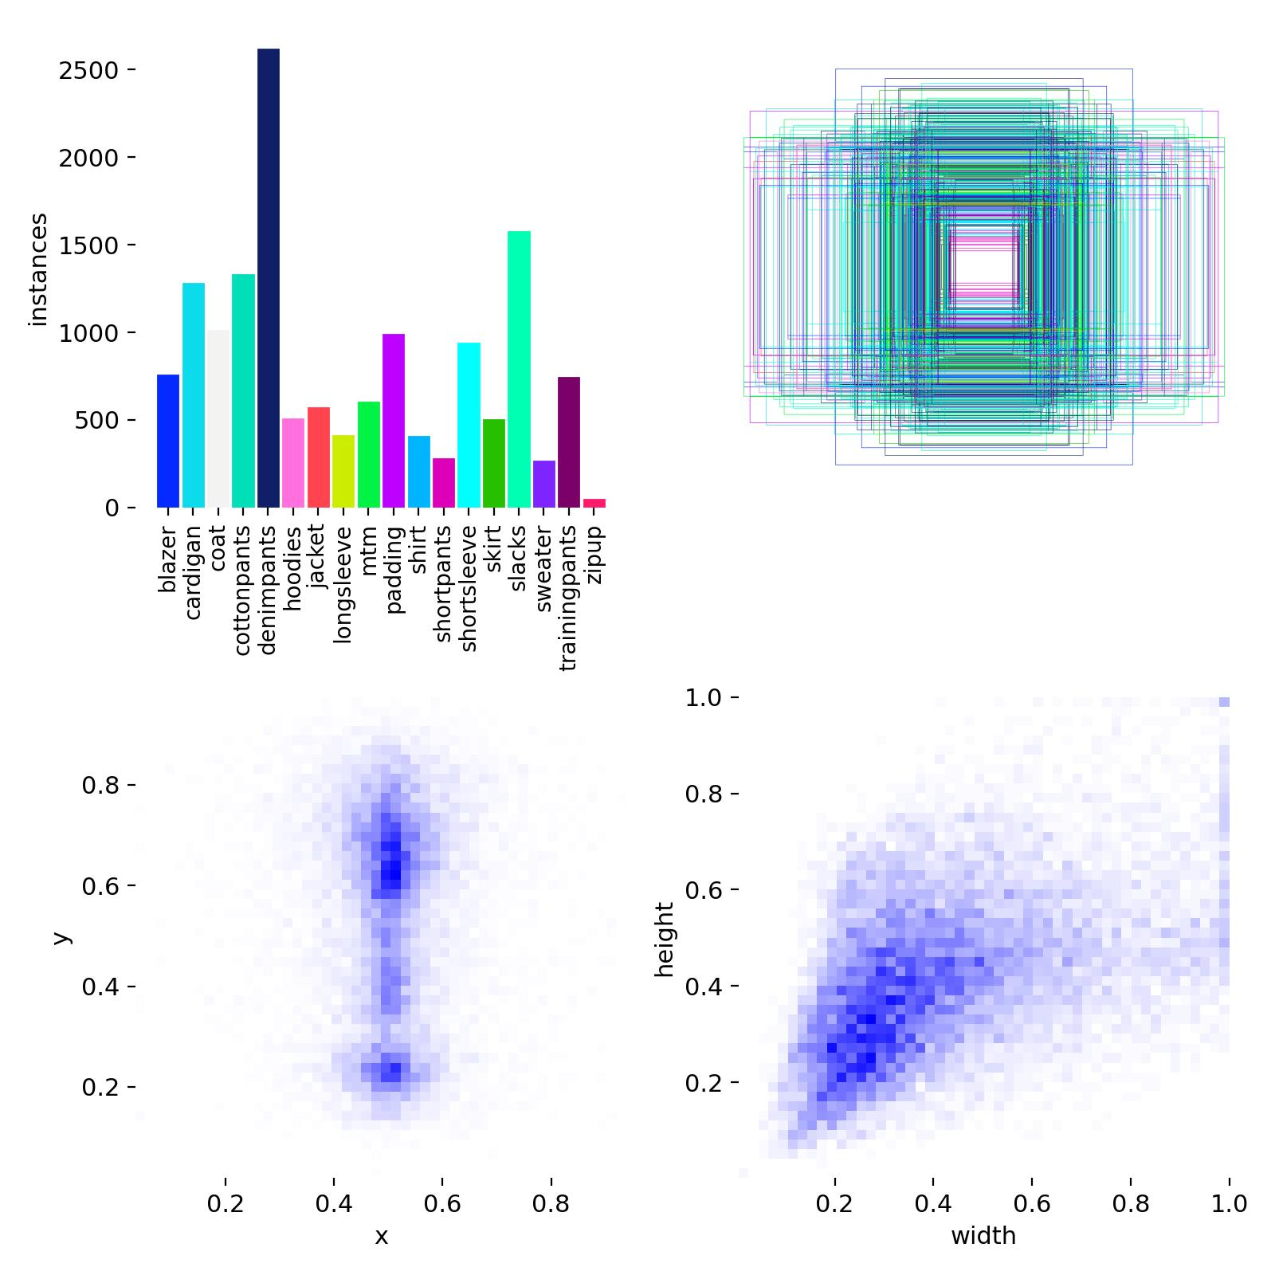
Fig – 5.1: Label Distribution

Performance Evolution
Table 5.2: Model's Performance Evolution During Training
Epoch | Precision | Recall | mAP@0.5 | mAP@0.5:0.95
1 | 0.3126 | 0.4978 | 0.3327 | 0.2681
2 | 0.3675 | 0.5749 | 0.3750 | 0.2970
3 | 0.4149 | 0.5982 | 0.4709 | 0.3820
4 | 0.4201 | 0.6431 | 0.4890 | 0.4018
5 | 0.4926 | 0.6334 | 0.5571 | 0.4738

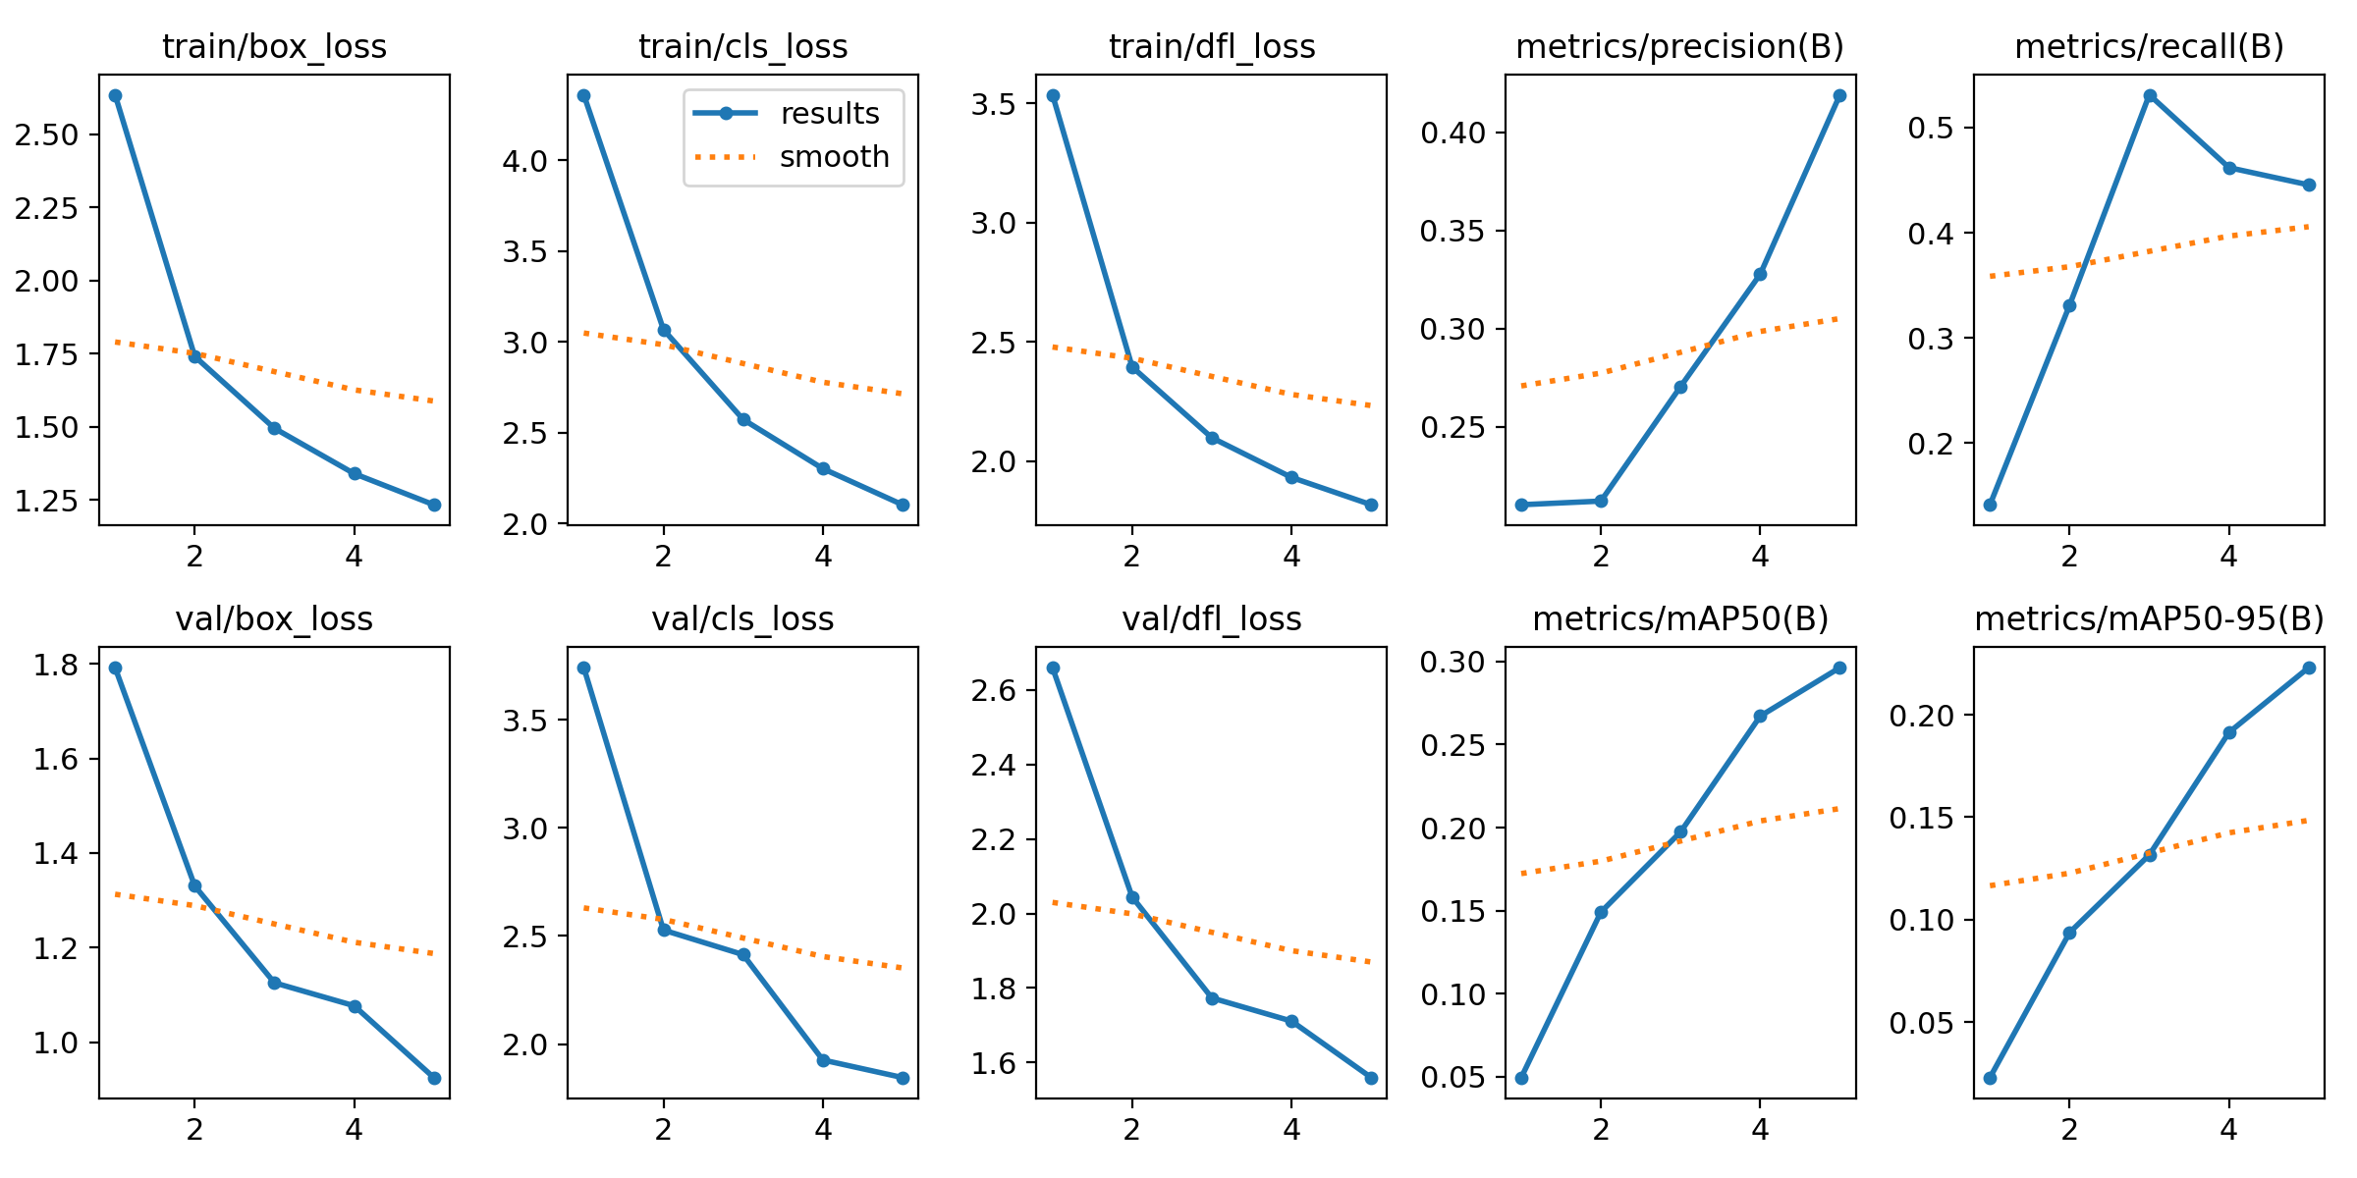
Throughout the training, there was a clear downward trend in the box loss, classification loss, and distribution focal loss, suggesting that the model was effectively learning to minimize detection errors. The steady increase in mAP and recall values across epochs further validates that the model was learning meaningful features from the limited data.
Fig 5.2: Loss Function Trends
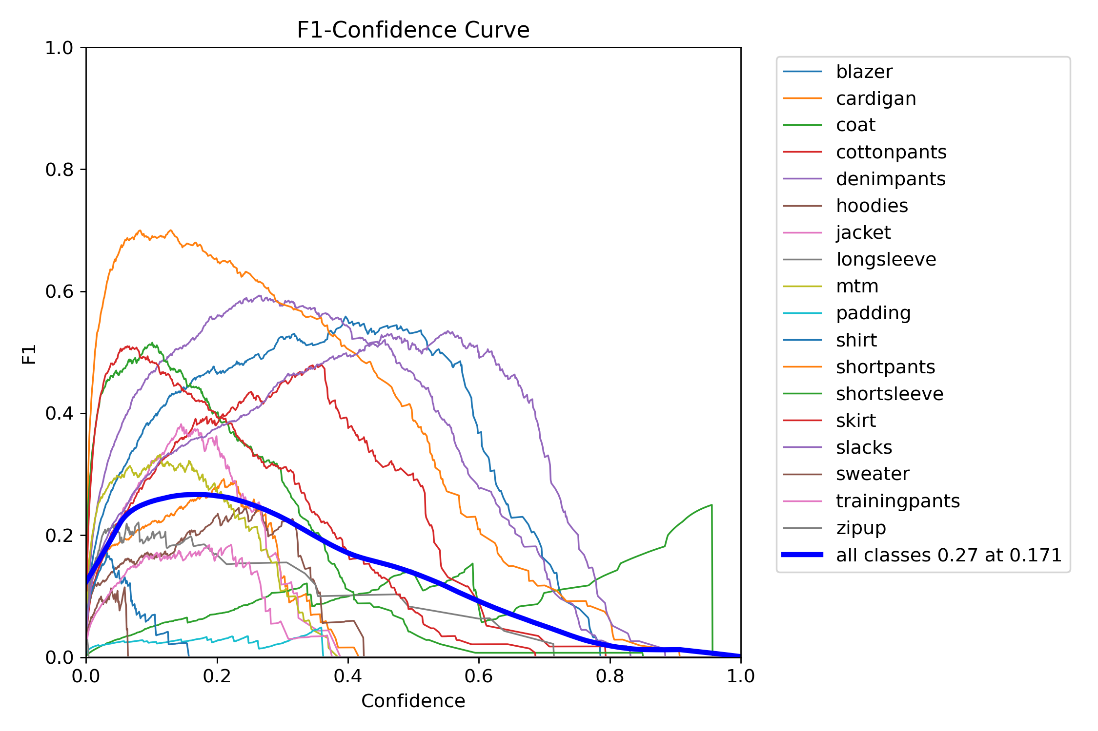
Fig – 5.3: F1-Confidence Curve
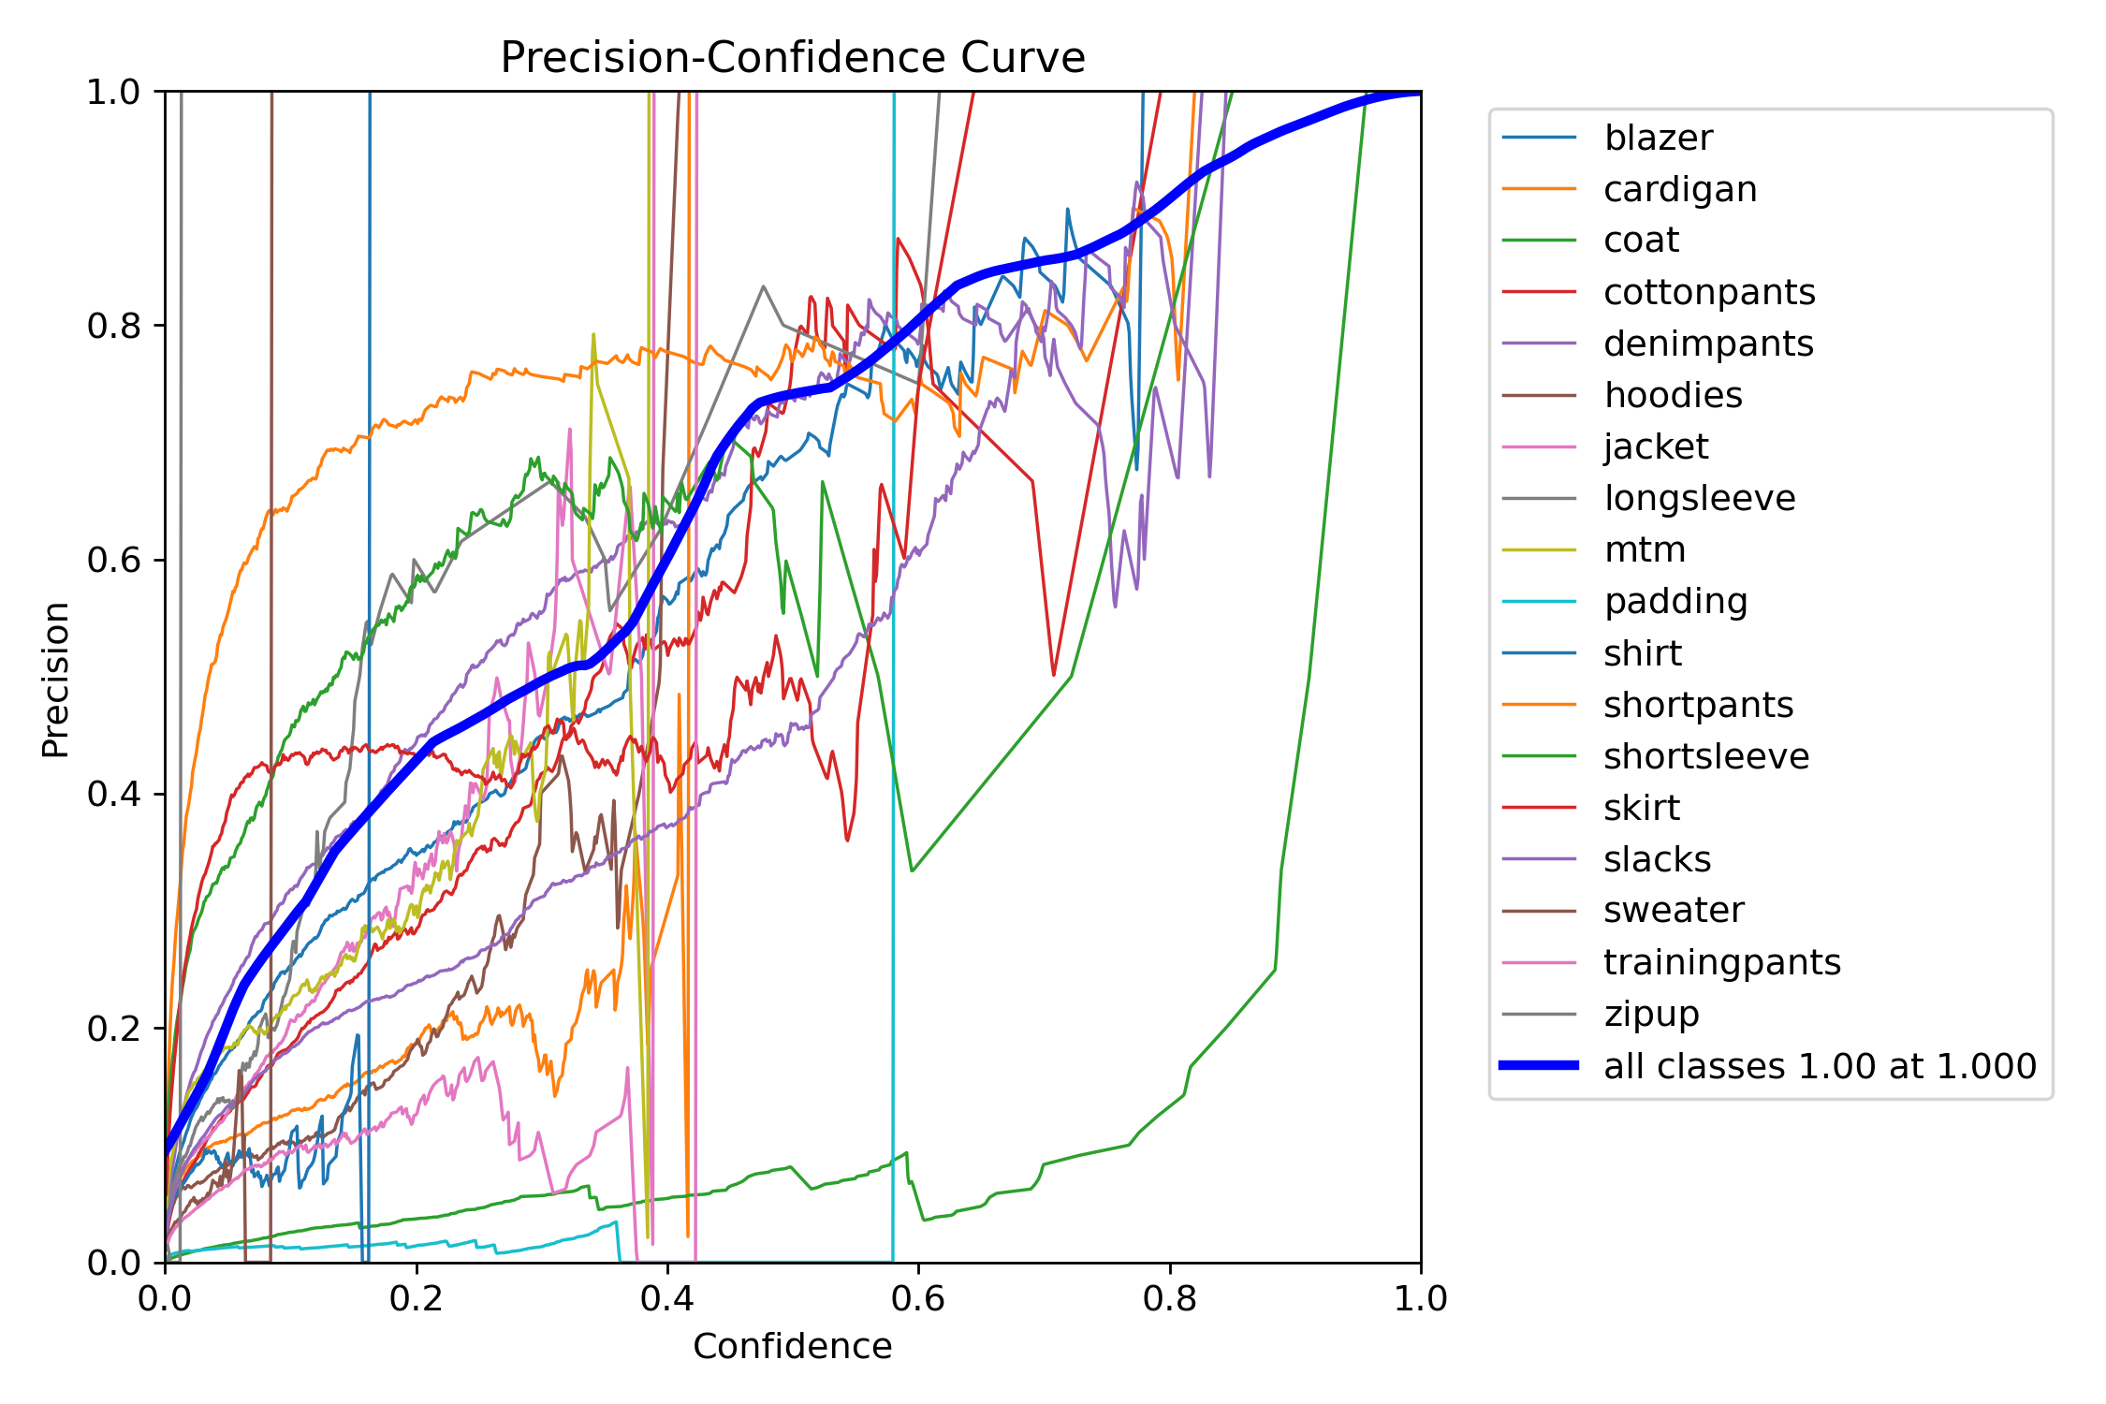
Fig – 5.4: Precision-Confidence Curve

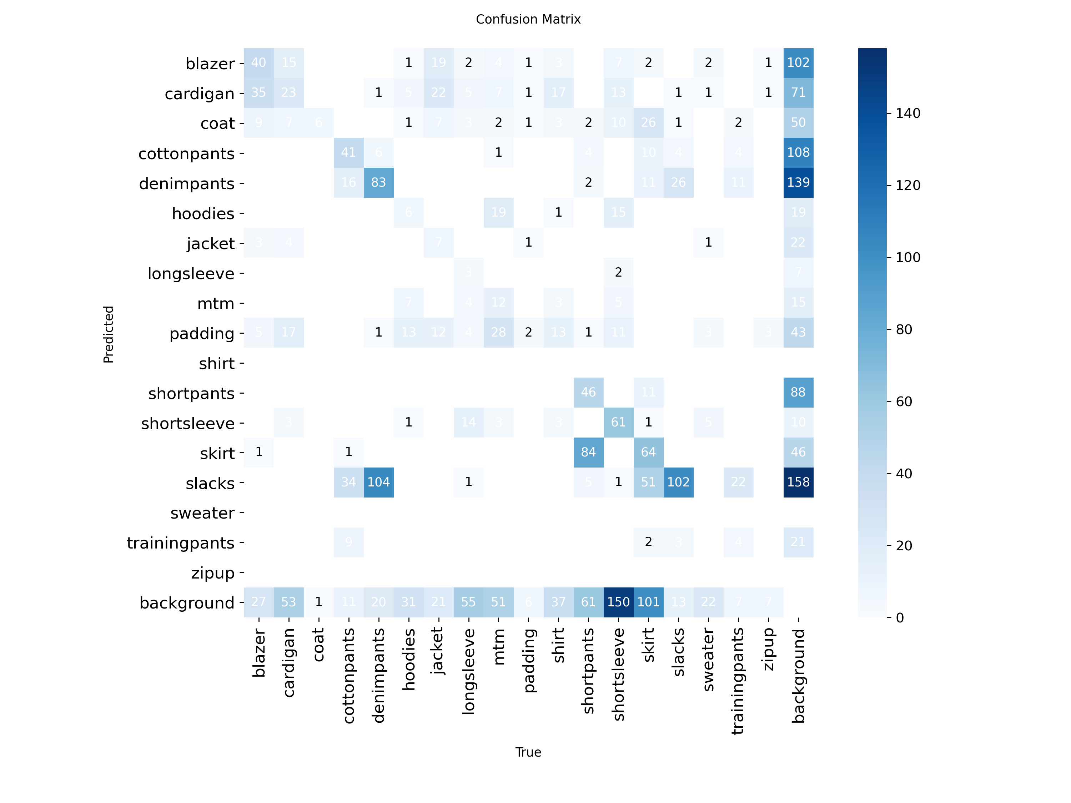
Fig – 5.5: Confusion Matrix
Qualitative testing, supported by visual results, showed that the model could reliably detect shirts and pants in well-lit and unobstructed images. However, it occasionally misidentified clothing in cluttered backgrounds or under challenging lighting conditions. Overall, the trained model delivered promising results, especially considering the constraints in training time. With longer training durations, and the use of augmentation techniques, the model’s accuracy and robustness could be significantly improved for real-world applications.

CHAPTER 6

Result Analysis
The result analysis focuses on the qualitative assessment of the YOLOv8 model's performance using batch images generated during training and validation. These visualizations offer an intuitive understanding of how the model improved its ability to detect clothing items—shirts and pants—across different epochs and data splits.

6.1 Training Batch Images
- Files:
  - train_batch0.jpg
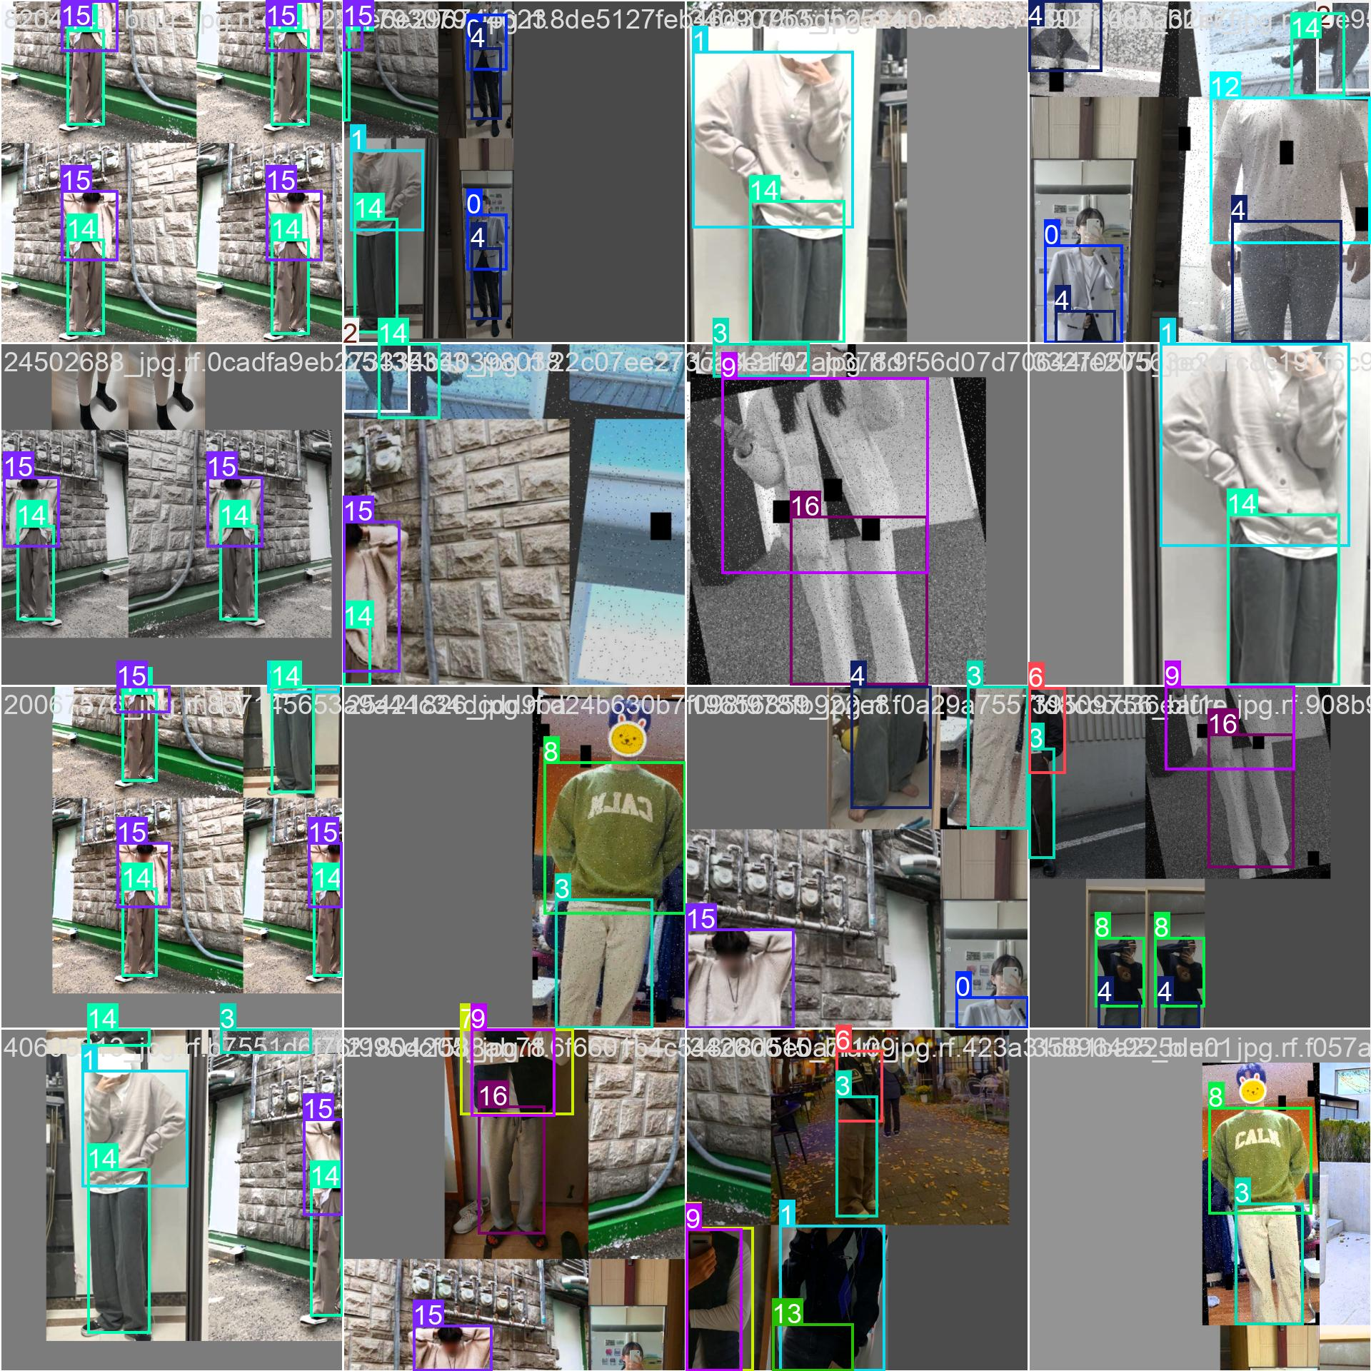

  - train_batch1.jpg
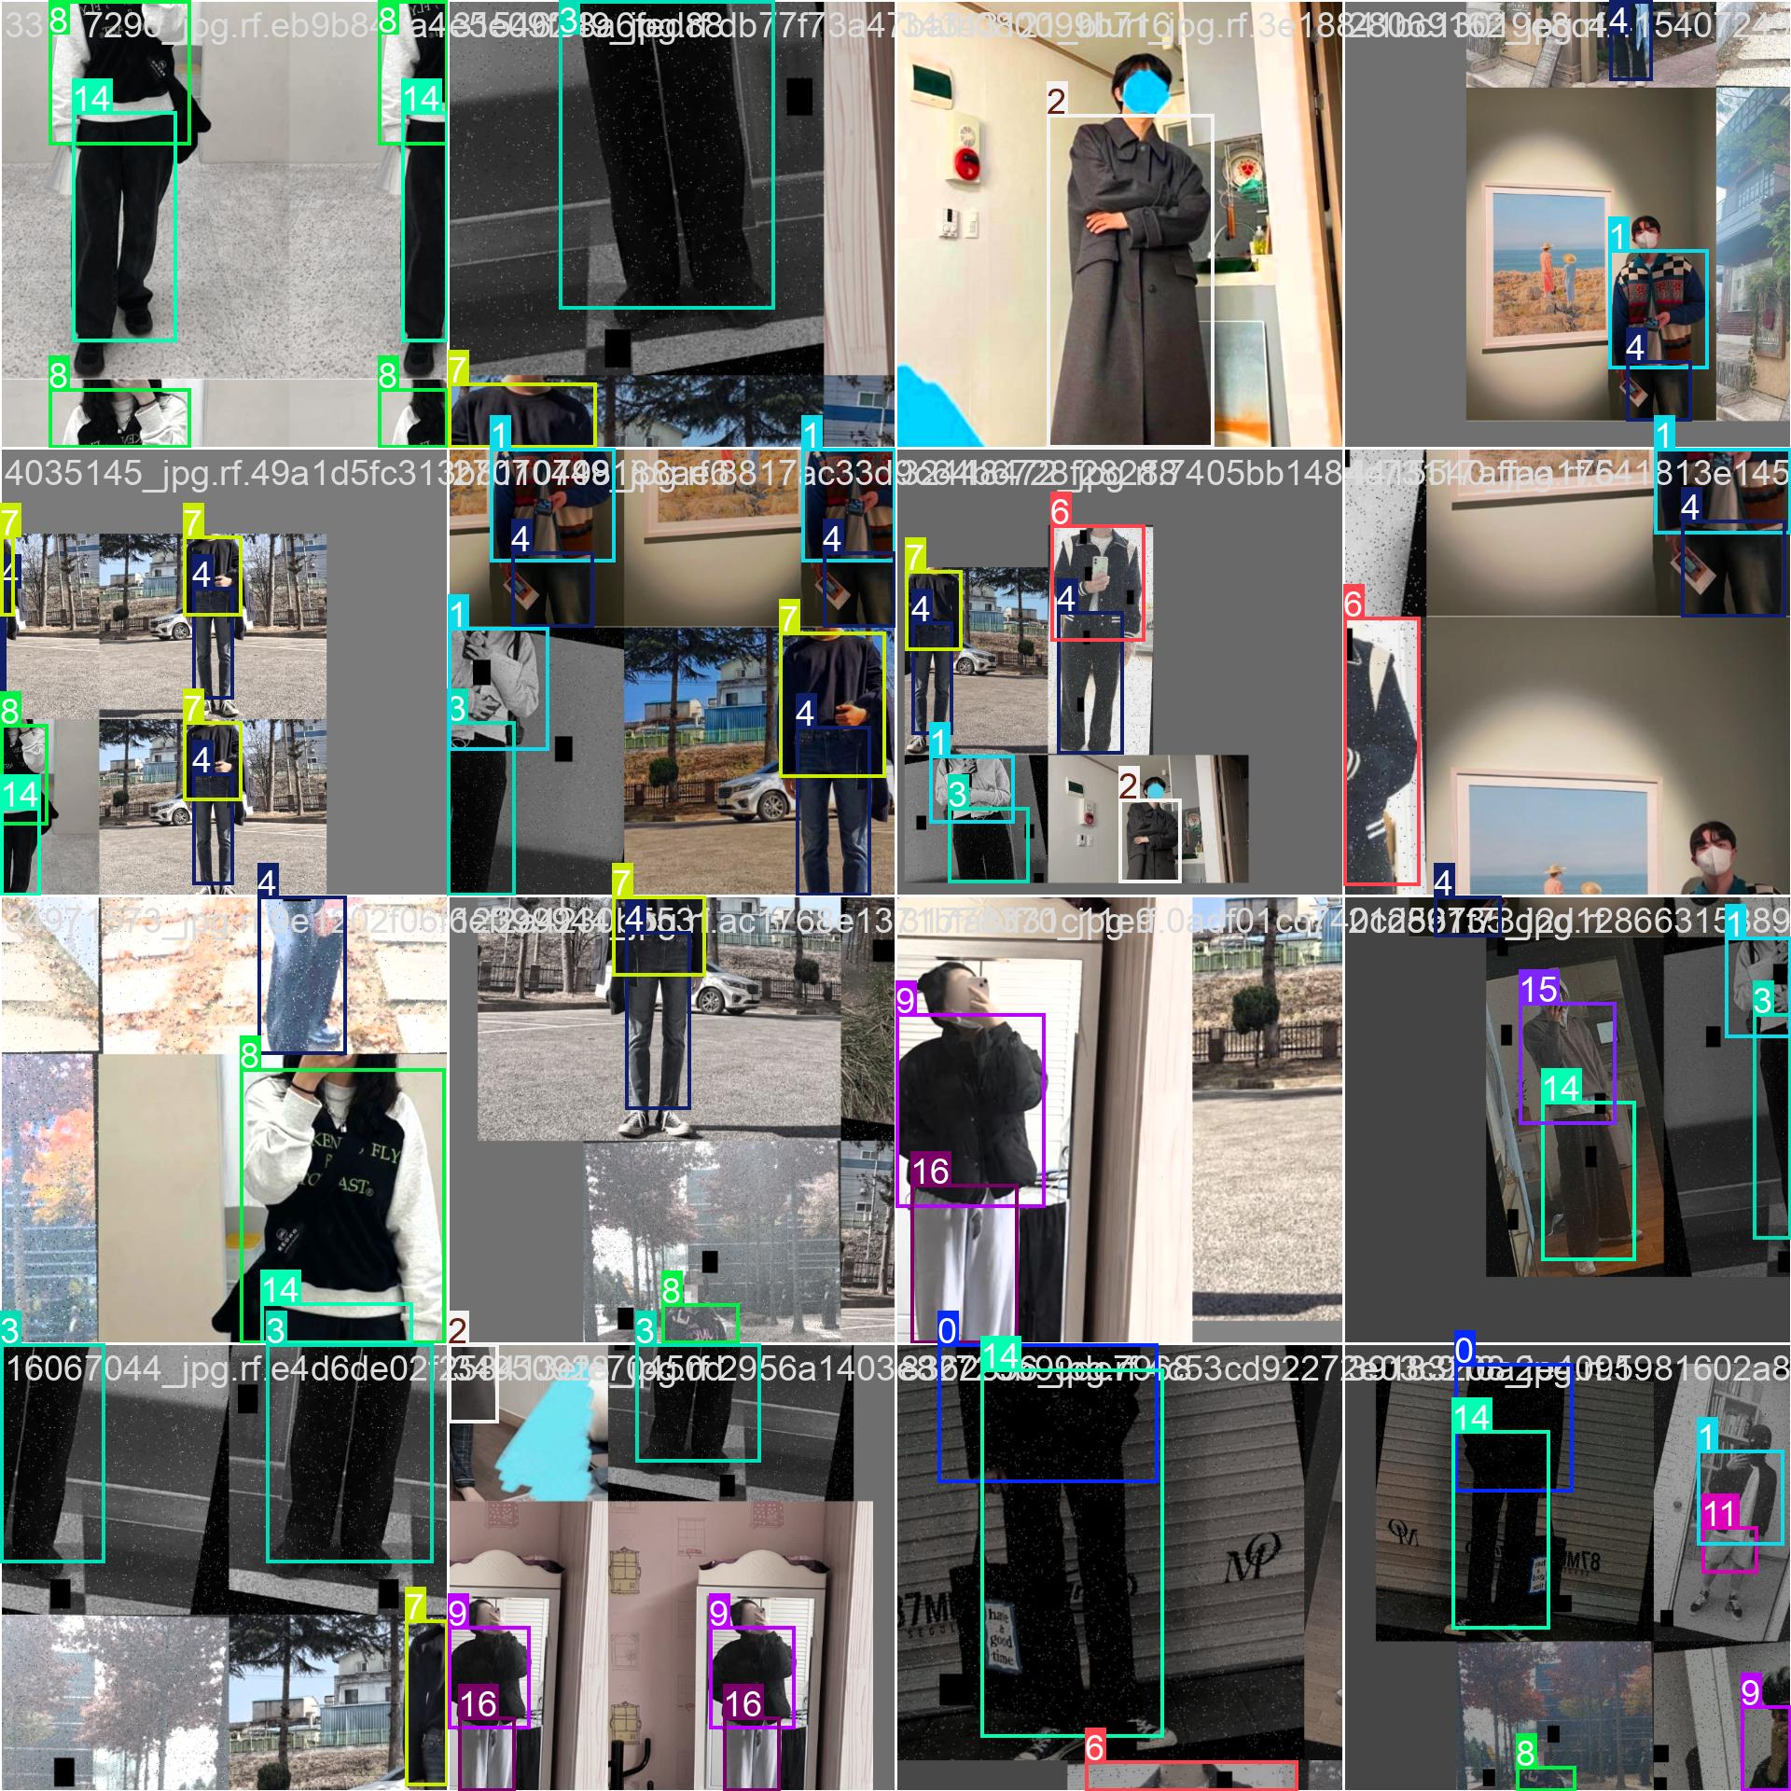
  - train_batch2.jpg
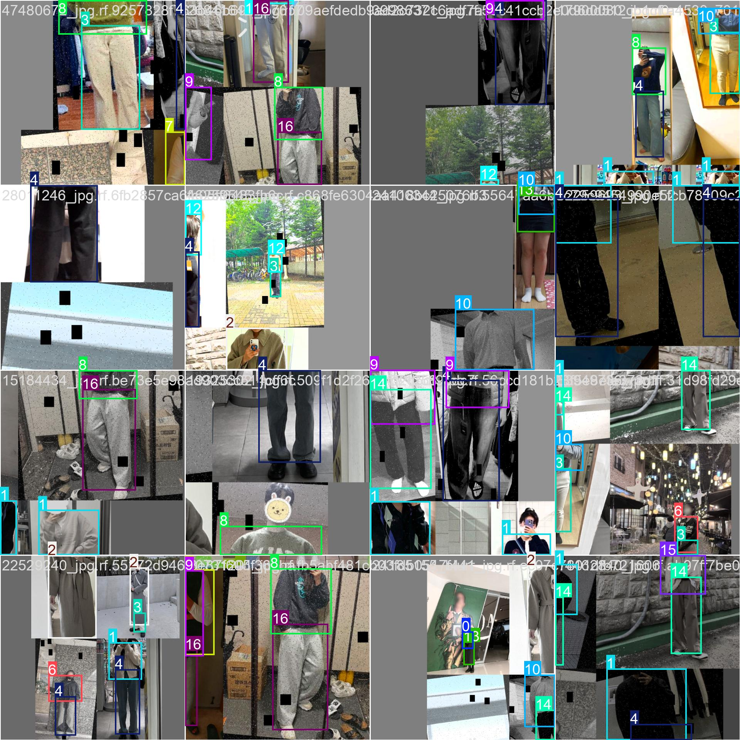

Insight: These images display sample training images with predicted bounding boxes during early epochs.
  - train_batch0.jpg showed sparse and inconsistent predictions, indicating early-stage learning.
  - train_batch1.jpg and train_batch2.jpg exhibited clearer and more precise bounding boxes, reflecting improved detection quality and better localization of shirts and pants.

6.2 Validation Batch Images
- Ground Truth:
  - val_batch0_labels.jpg
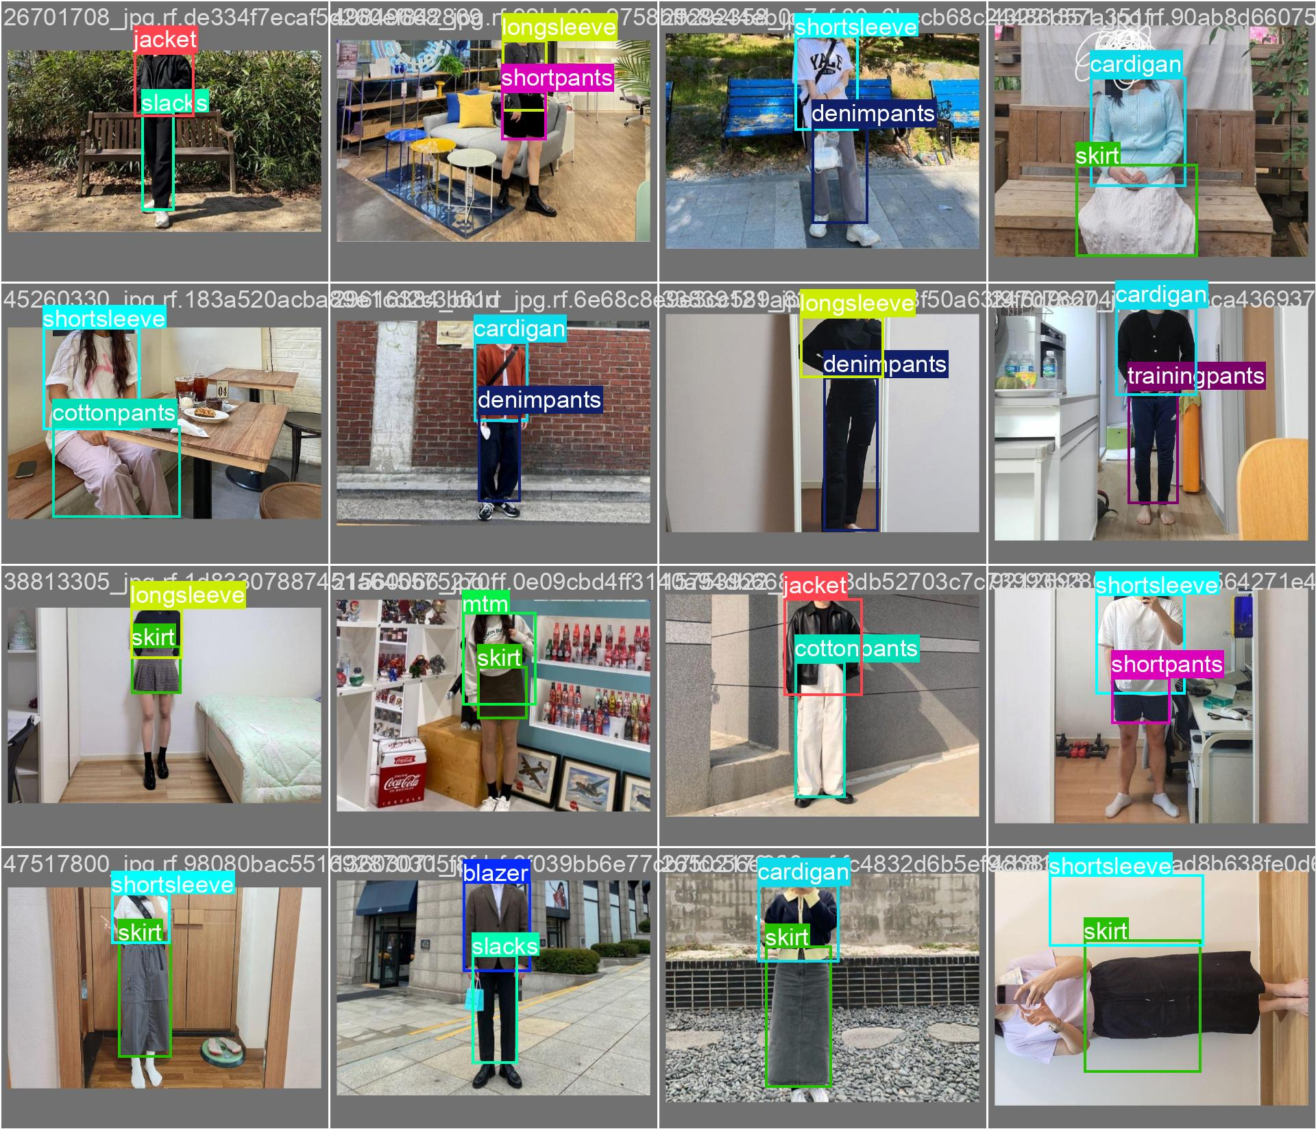

  - val_batch1_labels.jpg
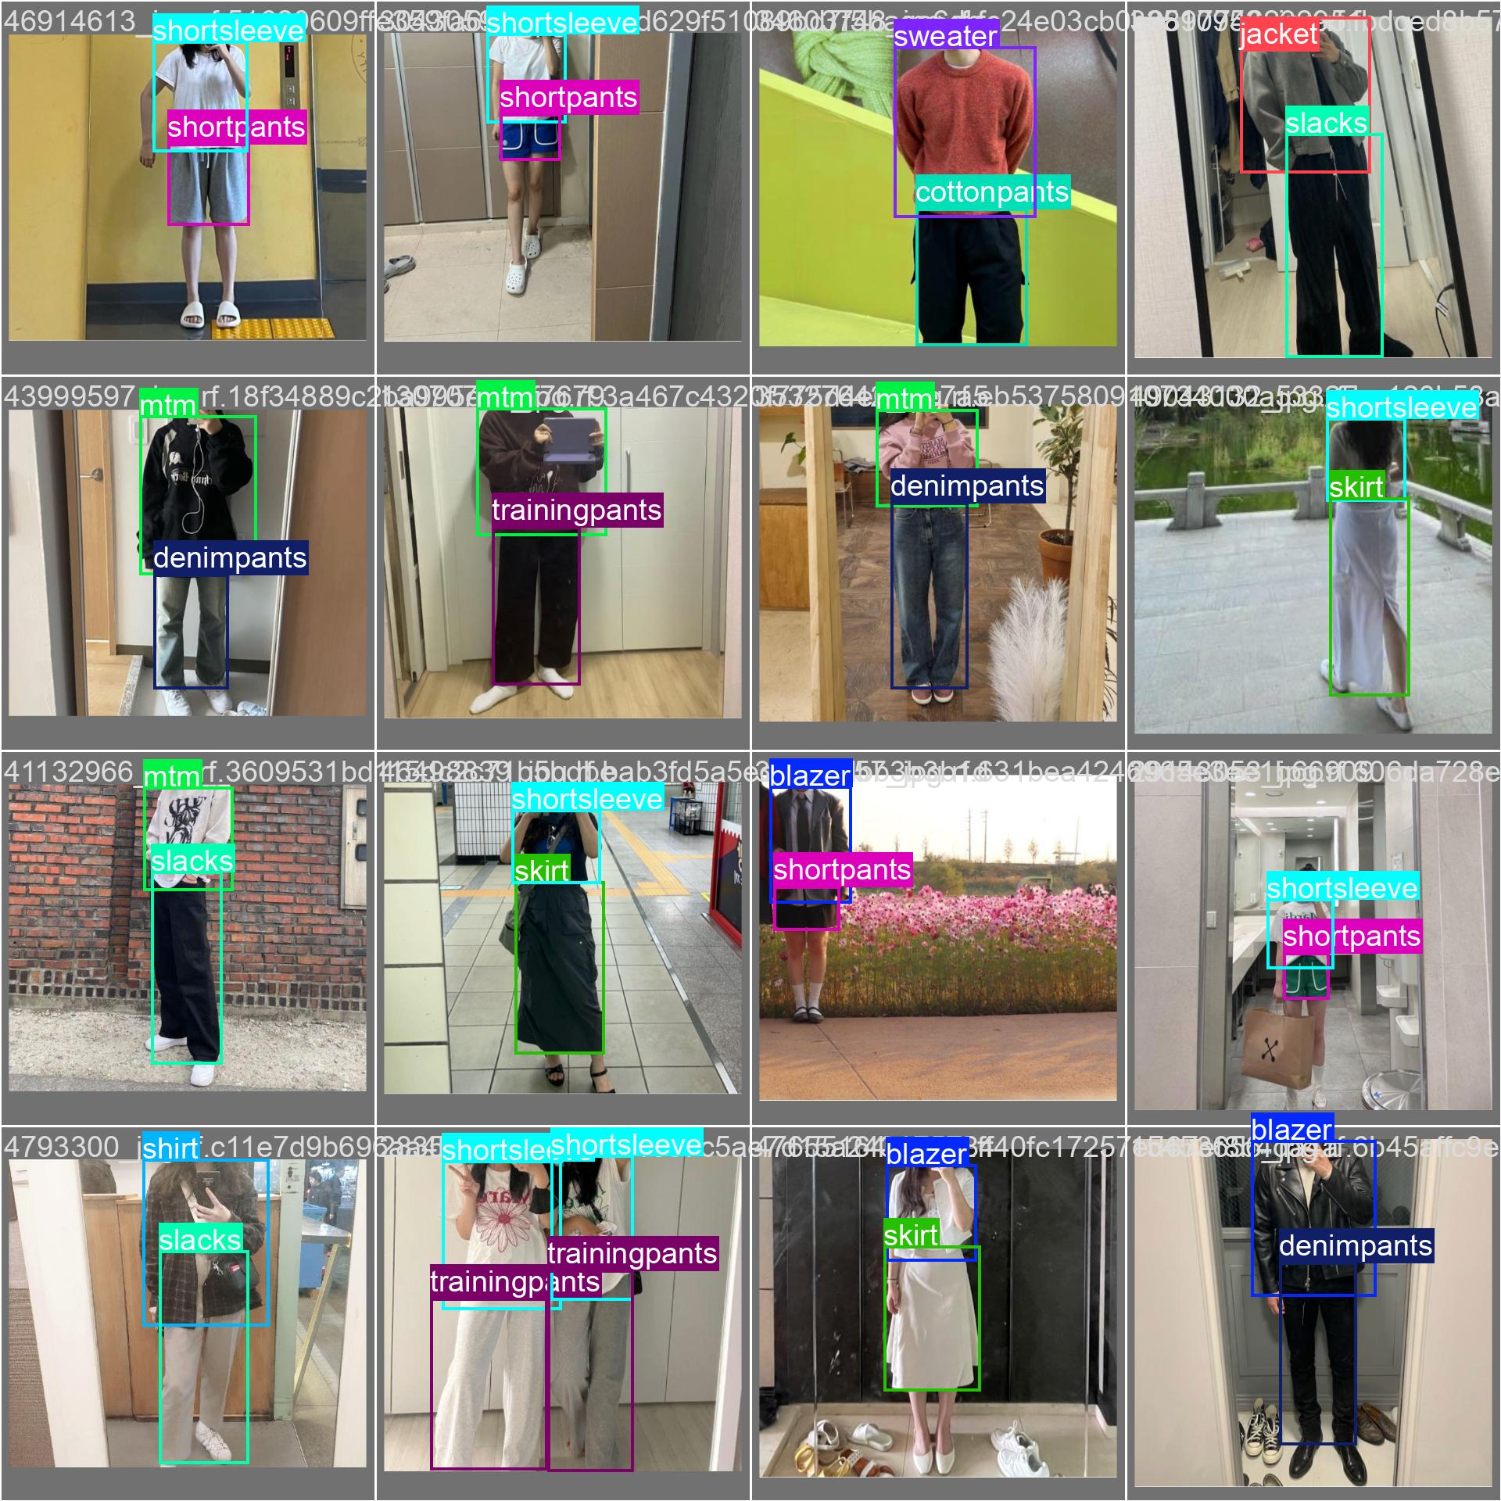
  - val_batch2_labels.jpg
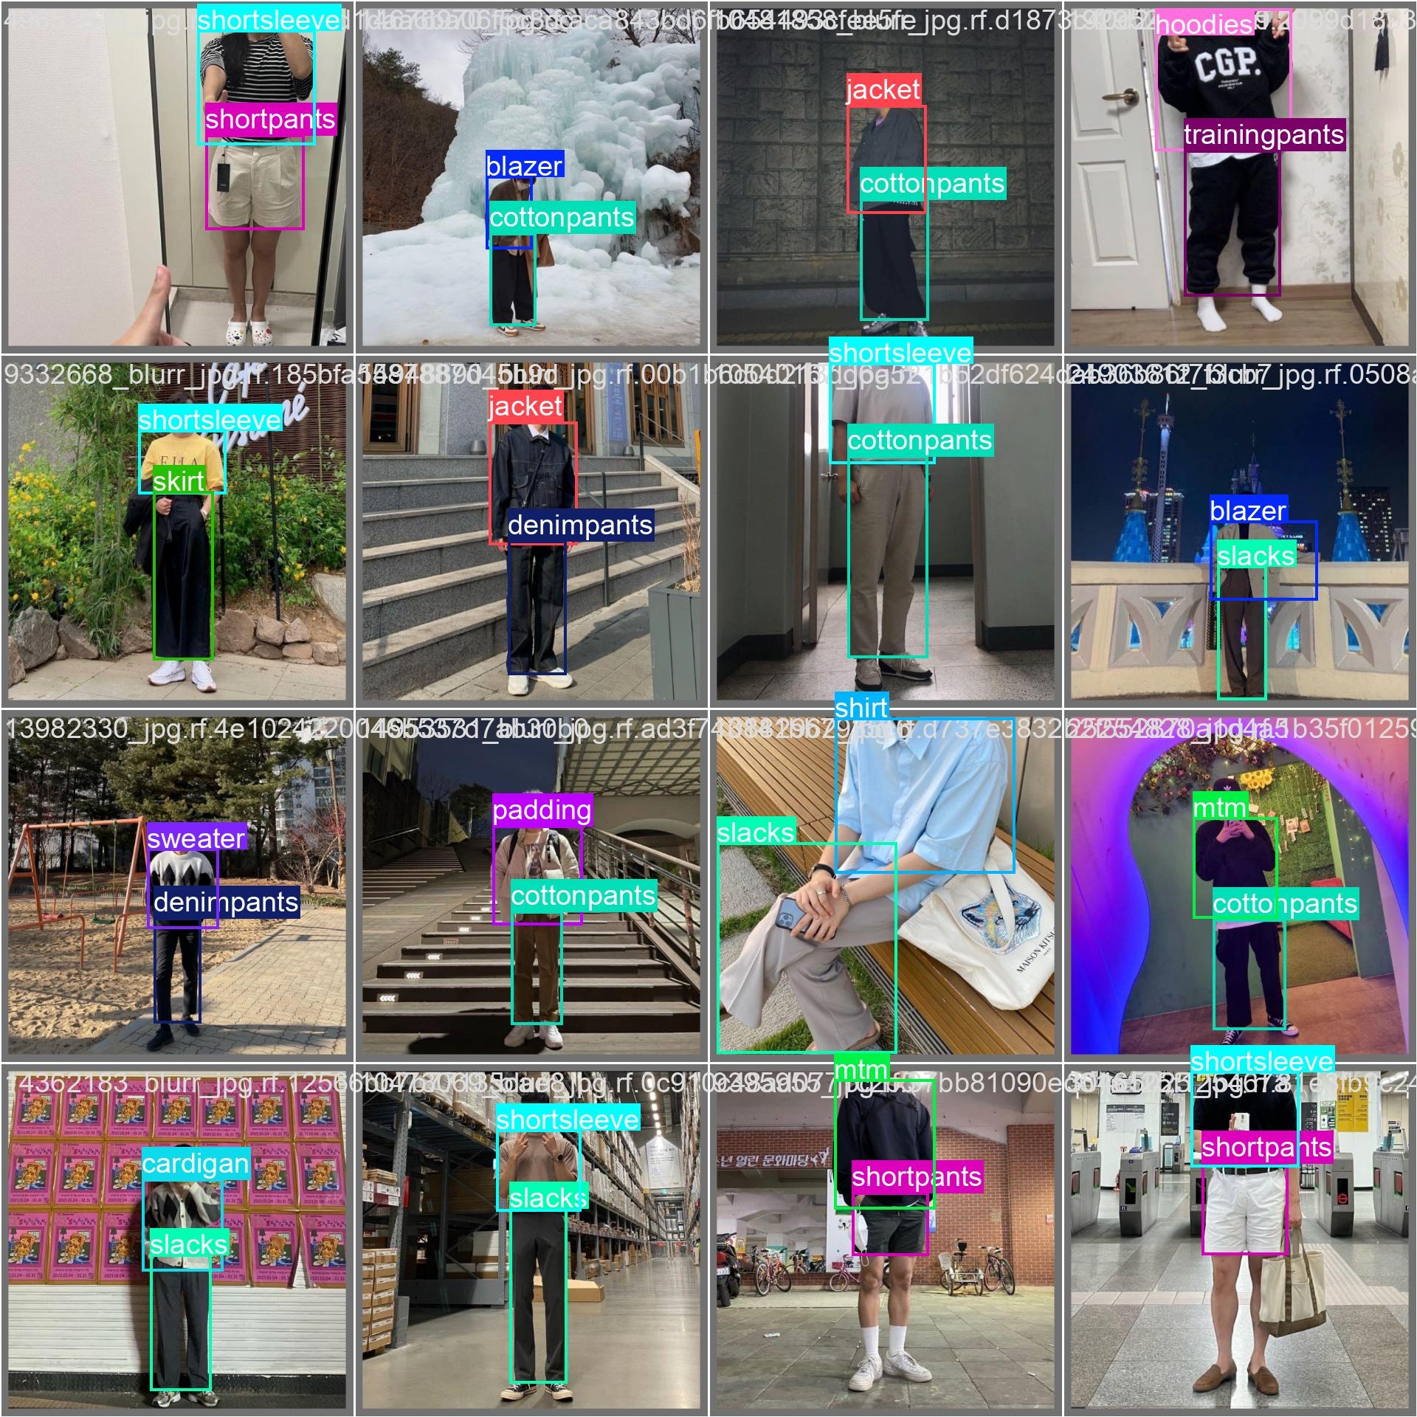

- Predictions:
  - val_batch0_pred.jpg
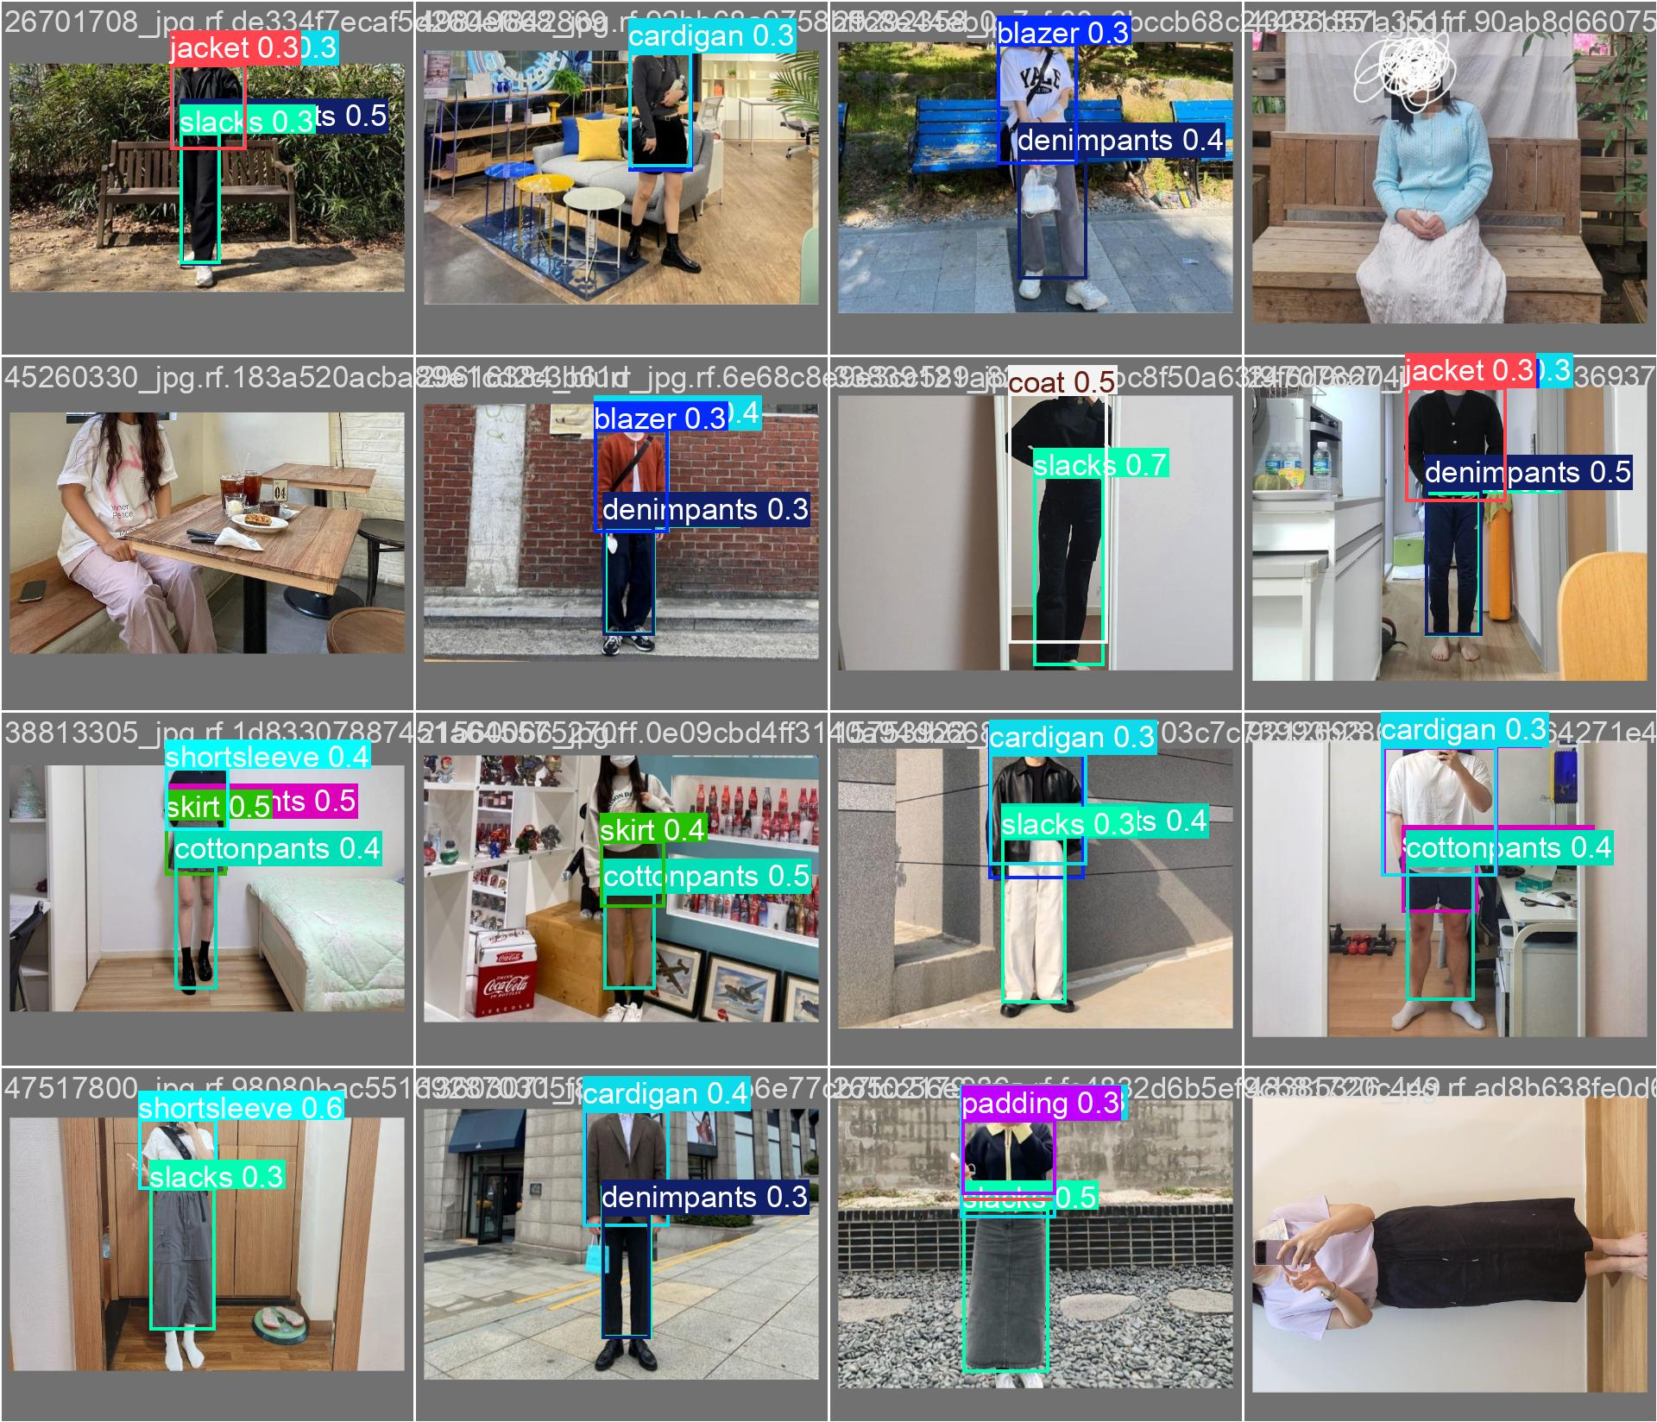
  - val_batch1_pred.jpg
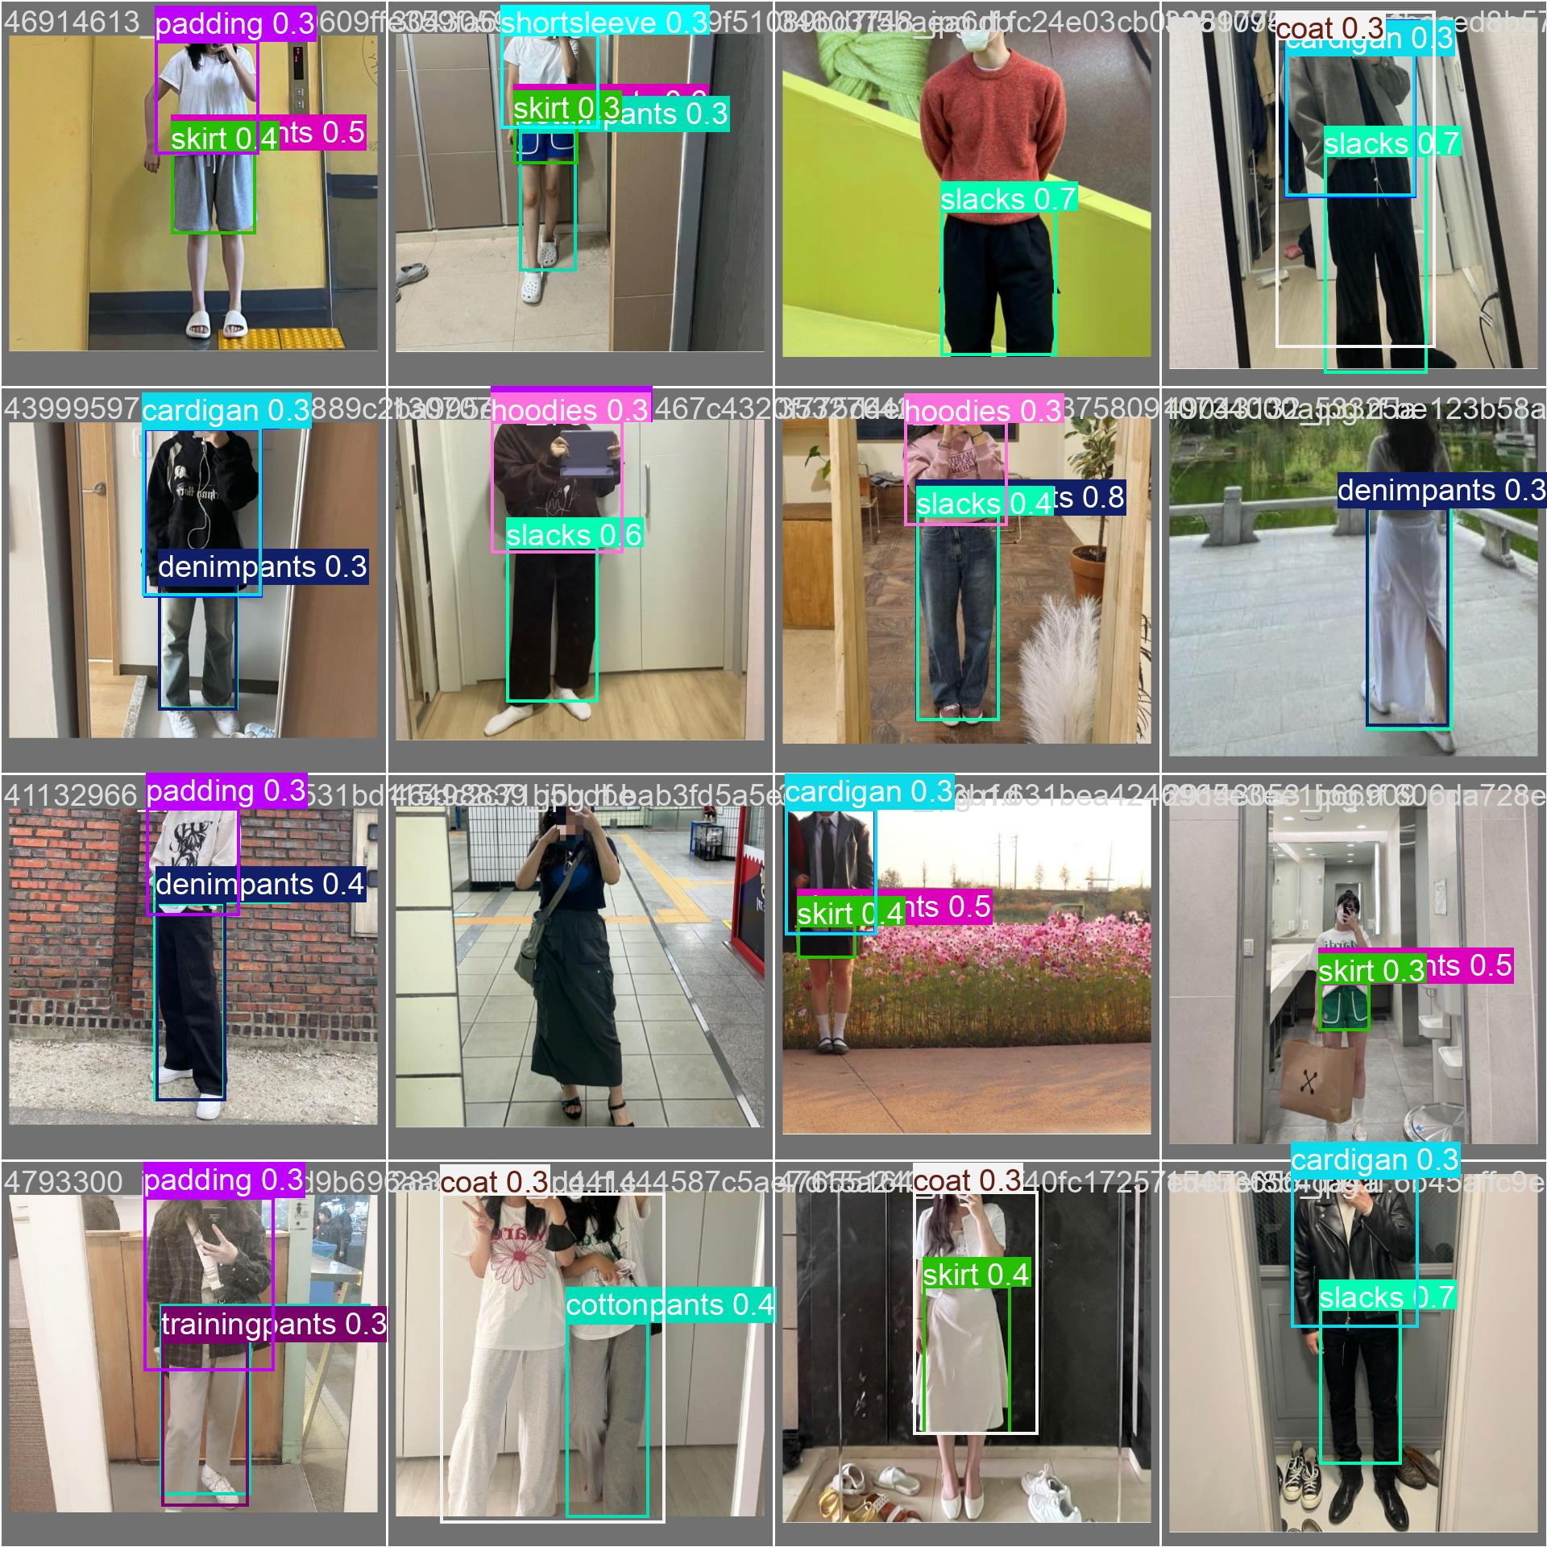

  - val_batch2_pred.jpg
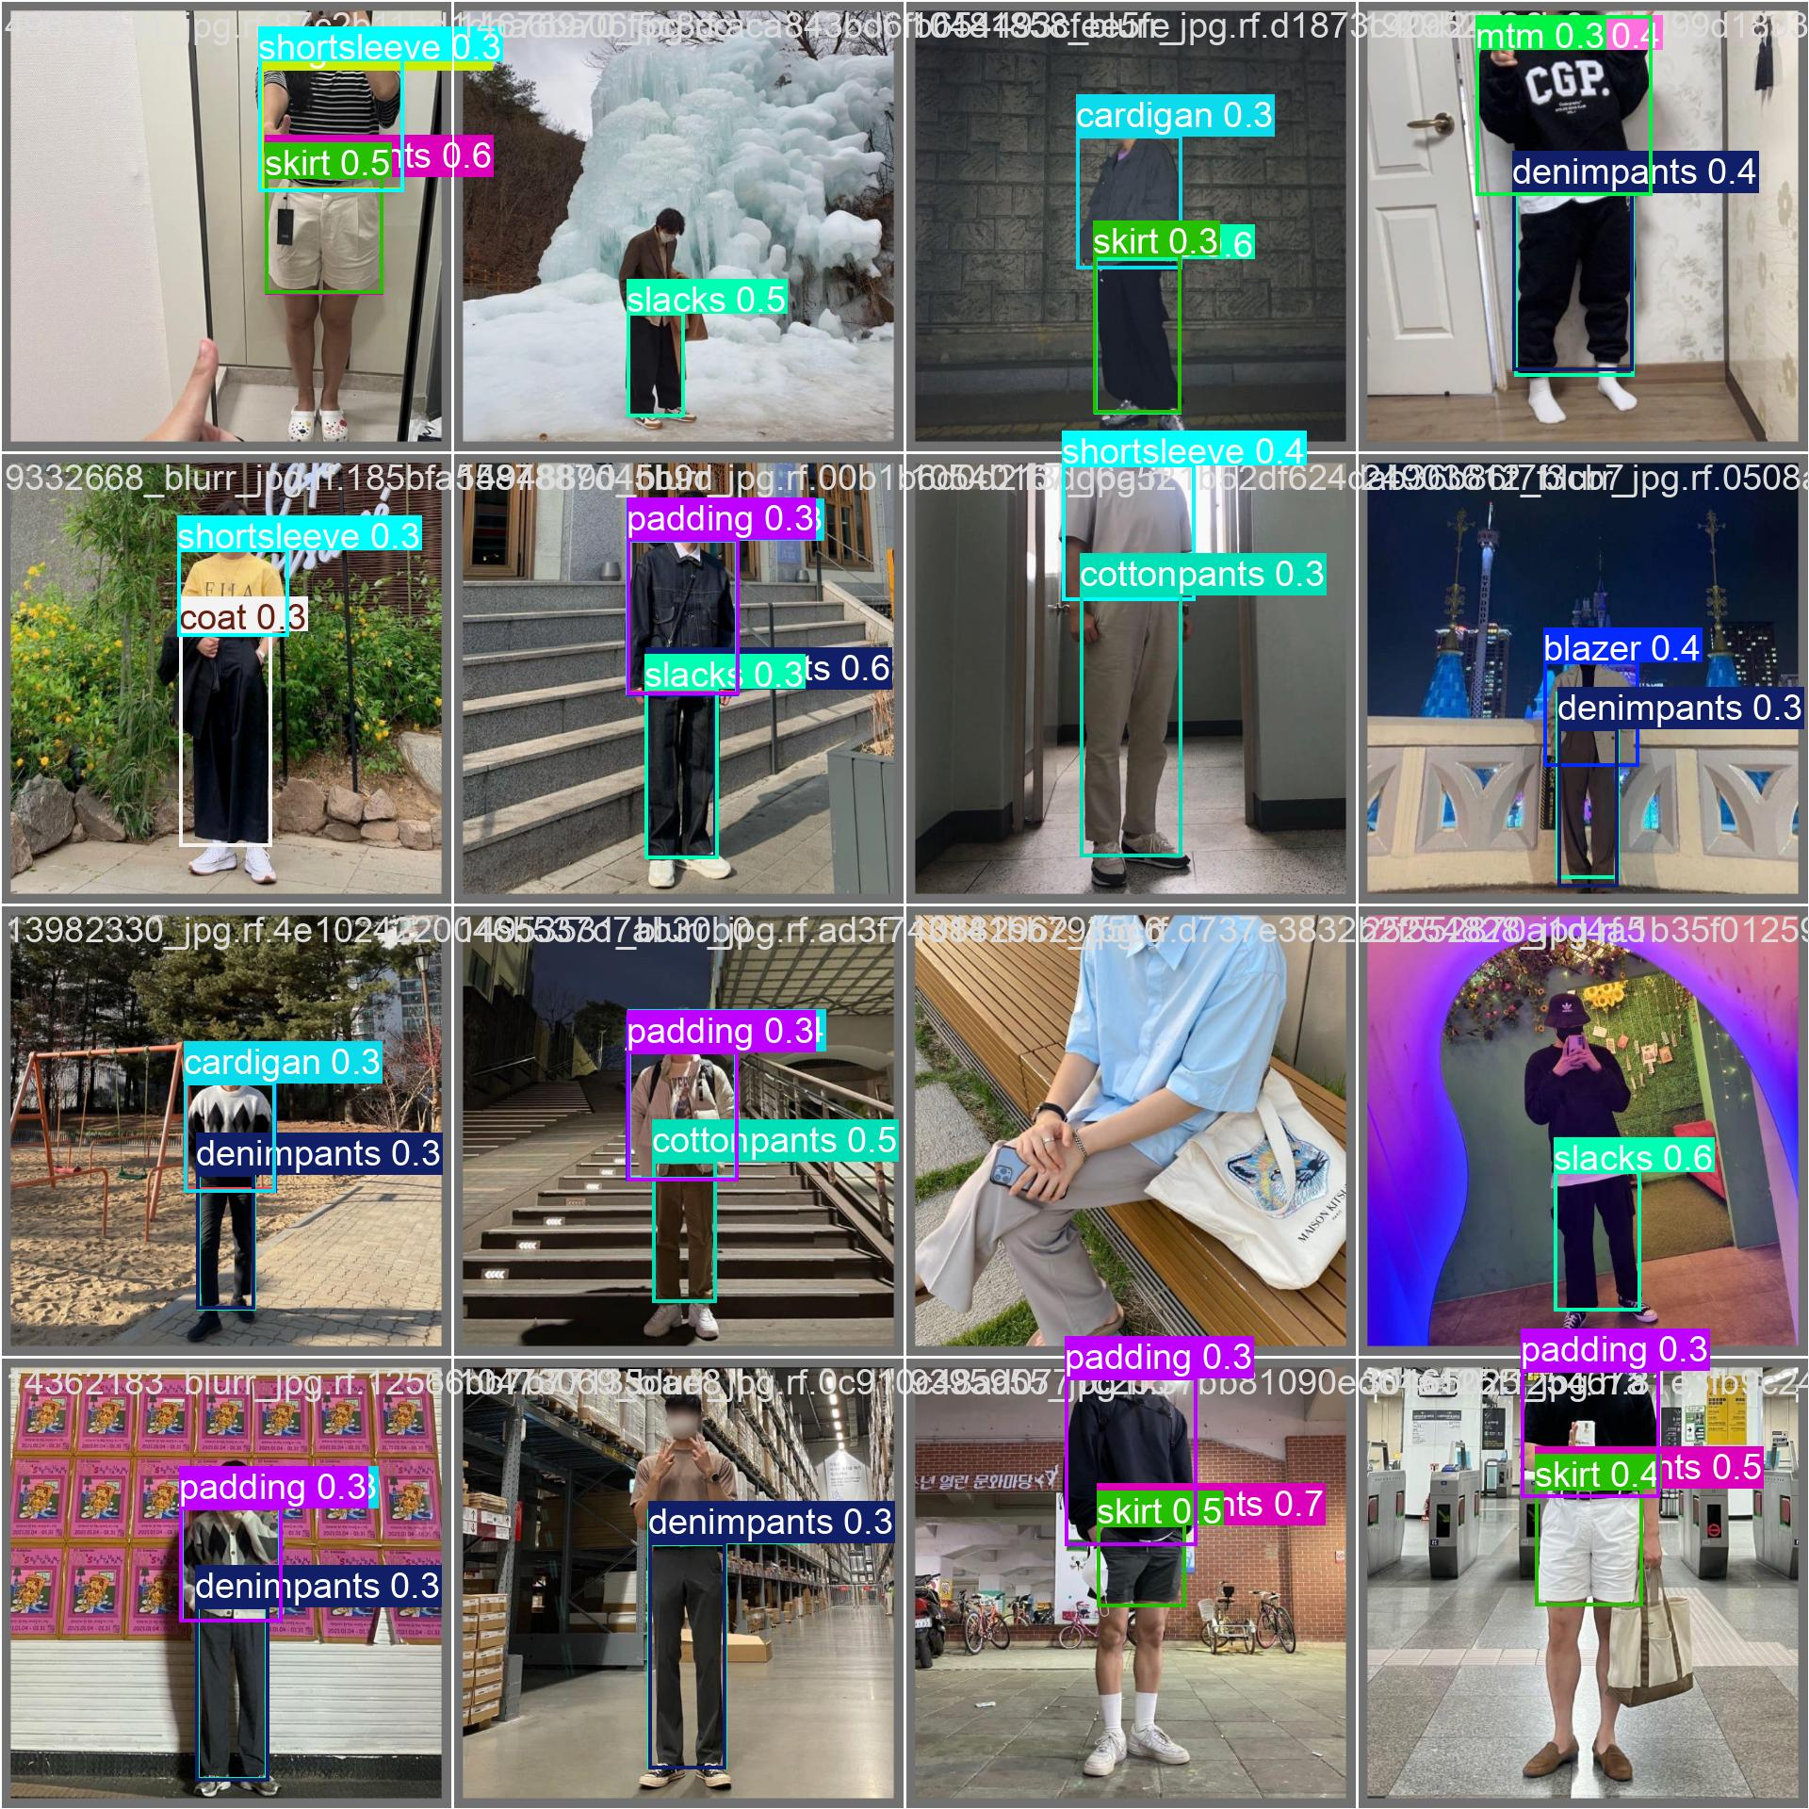

- The predicted images showed a high overlap with the labeled ground truths.
- These pairs of images provide a side-by-side comparison between the actual labels and the model’s predictions on the validation set.
- Minor deviations were observed in a few complex cases (e.g., partial occlusion or cluttered backgrounds), but overall, the model's performance was consistent with expected output.

This visual consistency supports the quantitative metrics and further confirms the model’s robustness under varied real-world conditions. The model demonstrated strong capabilities in detecting clothing items after just five epochs of training. The combination of:
- Improving performance metrics,
- Decreasing loss values,
- And accurate visual predictions in batch images
indicates that the model effectively learned from the dataset.

Working System
1. Starting the Application
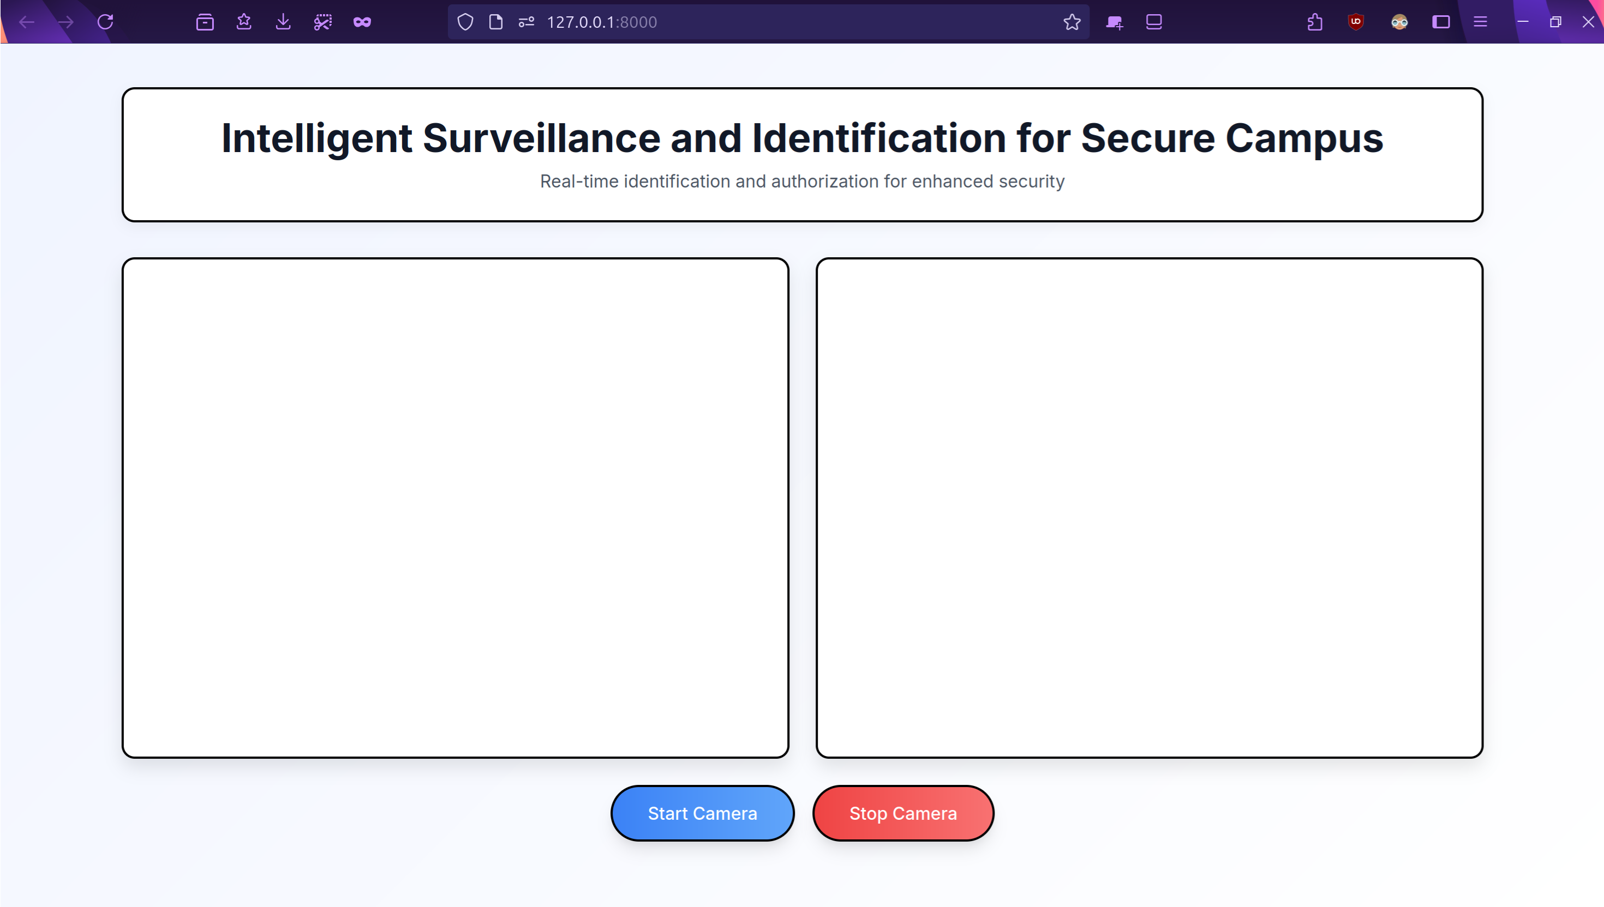
2. Starting Camera for Detection

3. Live Identification and Detection
- Identifying Student’s Face and retrieving its details from the database.
- Detecting the department from the color code of the student’s uniform (shirt).
4. Cross Validating and Displaying Student’s Details

CHAPTER 7

Conclusion & Future Scopes

7.1 Conclusion

This project successfully developed an AI-driven surveillance and identification system aimed at enhancing campus security through automated student monitoring. By integrating computer vision, deep learning (DeepFace), and real-time database querying, the system was able to detect students, classify their uniforms by department, and verify identity using facial recognition.

Through real-time video analysis from CCTV footage, the system detected and matched uniform colors with predefined department codes and cross-verified the identity of students by comparing detected facial features with database records. If inconsistencies were found between the student’s detected and registered departments, the system flagged them as unauthorized and displayed alerts for administrative action. The implementation of a centralized dashboard further added to the system's usability and administrative control.

The model testing phase demonstrated that the system could operate efficiently in real-time, with high accuracy in both face detection and color classification. Although some challenges such as lighting conditions and false alerts were encountered, the system largely achieved its intended goals. The project thus lays the foundation for creating smarter, automated, and scalable surveillance solutions in academic institutions.

7.2 Future Scope

There is considerable potential to expand the proposed surveillance system with enhanced features and broader integrations to make it more robust, scalable, and efficient. One of the most promising extensions is the implementation of an automated attendance system, where the existing face detection module can be linked with attendance records to mark student presence without any manual intervention. The system can also be scaled into a campus-wide surveillance network, covering not only entry and exit points but also classrooms, hallways, and common areas for complete monitoring. Another valuable addition would be the integration of real-time alert notifications, enabling the system to send immediate alerts to security personnel via email, SMS, or dedicated mobile applications in the event of any unauthorized entry or mismatch in uniform or identity. Furthermore, the system can be extended to include behavioral analysis, using AI models to detect suspicious or abnormal behavior such as loitering, unauthorized group gatherings, or potential security breaches.

A key area of development involves integrating the system with the university’s ERP (Enterprise Resource Planning) system to automatically update attendance, student disciplinary records, or access logs. Additionally, the system could be enhanced to support AI-based uniform policy enforcement, not only detecting uniform colors but also identifying dress code violations such as incomplete attire, missing ID cards, or improper footwear. These future improvements would significantly elevate the system’s role in maintaining security, discipline, and administrative efficiency across the campus.

7.3 Limitations

While the proposed system demonstrates promising performance in automating surveillance and identity verification, it does have certain limitations that may affect its reliability in specific scenarios. One of the primary challenges is lighting variability—the accuracy of uniform color detection can decrease significantly in low-light conditions or when students are partially shadowed. Additionally, the system’s effectiveness is influenced by camera angle and placement. If the student is not properly aligned with the camera, either due to distance, movement, or obstruction, the uniform and face may not be accurately detected or classified.

Another limitation is the occurrence of false positives, particularly when students from different departments wear similar shades of uniforms, or when non-students wear clothing that mimics the standard dress code. These instances can lead to incorrect alerts being generated. Moreover, the system's performance is highly dependent on the resolution and frame rate of the CCTV feed. Lower-quality footage may hinder the model's ability to distinguish fine details in facial features or uniform patterns.

Lastly, the system deals with sensitive personal data, such as facial images and academic records, which introduces data privacy and security concerns. Without proper encryption and access control, there is a risk of unauthorized access or misuse of information. Addressing these limitations will be critical to ensuring the system’s effectiveness, reliability, and ethical deployment in real-world environments.

References

1. Lam, K., Thanh La, T., Cao, T., & Dang, H. (2023). Monitoring Attendance and Checking School Uniforms Using YOLOv8. In Communications in Computer and Information Science, 86(5), 8–267.

2. Poorni, R., Charulatha, S., & Vennila, V. (2022). Real-Time Face Detection and Recognition Using DeepFace CNN. ECS Transactions, 107(1), 5091–5103.

3. Unuriode, A., Yusuf, B., et al. (2023). The Integration of AI into Database Systems. International Journal on Cybernetics & Informatics, 12(6), 96–378.

4. Rahmaniar, W., & Hernawan, A. (2021). Real-Time Human Detection Using Deep Learning on Embedded Platforms. Journal of Robotics and Control, 2(6), 25–76.

5. Ibrahim, M., & Sutrisno, H. (2016). A Comprehensive Review on Intelligent Surveillance Systems. Communications in Science and Technology, 1(1), 91–178.

6.Sultana, A., & Rahman, T. (2020). Gender and Face Recognition Using CNN and Haar Cascades. International Journal of AI and Vision, 4(3), 33–38.

7. Zhang, Y., & Lee, J. (2019). Color Tracking Using Histogram Back Projection. Journal of Computer Vision Algorithms, 11(2), 55–61.

8. Ahmed, K., Sinha, P., & Gupta, R. (2021). Hybrid Student Monitoring with RFID and Visual Recognition. Journal of Smart Education Systems, 5(4), 102–110.

9. Li, C., & Wang, X. (2022). Face Matching in Surveillance Using Siamese Networks. Journal of Pattern Recognition, 118, 104119.

10. Kumar, M., & Sharma, R. (2020). Multi-modal Surveillance Using Face and Voice Recognition. Journal of Signal Processing and AI, 12(1), 45–52.

11. Fernandes, L., & Mathew, J. (2019). Mobile AI Surveillance for Campus Environments. International Journal of Mobile Computing, 9(3), 62–68.

12. Rana, N., & Joshi, D. (2023). AI-Based Entry Management Using Facial and ID Card Recognition. Proceedings of Smart Surveillance Symposium, 88–94.

APPENDIX
Source Code
/main.py
import cv2
import base64
import json
import threading
import time
from flask import Flask, render_template, Response, request, jsonify
from flask_socketio import SocketIO, emit
from PIL import Image
import numpy as np
from ultralytics import YOLO
from dominant_color import detect_objects_on_image
import io

app = Flask(__name__)
app.config['SECRET_KEY'] = 'your-secret-key'
socketio = SocketIO(app, cors_allowed_origins="*")

# Load your model
model = YOLO("models/best-cloth.pt")

class CameraHandler:
def __init__(self):
self.cap = None
self.is_active = False
self.latest_frame = None
self.latest_detections = []
self.lock = threading.Lock()

def start_camera(self):
try:
self.cap = cv2.VideoCapture(0)
if not self.cap.isOpened():
return False

# Set camera properties for better performance
self.cap.set(cv2.CAP_PROP_FRAME_WIDTH, 640)
self.cap.set(cv2.CAP_PROP_FRAME_HEIGHT, 480)
self.cap.set(cv2.CAP_PROP_FPS, 30)

self.is_active = True
return True
except Exception as e:
print(f"Error starting camera: {e}")
return False

def stop_camera(self):
with self.lock:
self.is_active = False
if self.cap:
self.cap.release()
self.cap = None

def get_frame_with_detections(self):
if not self.cap or not self.is_active:
return None, []

try:
success, frame = self.cap.read()
if not success:
return None, []

# Convert BGR frame to RGB PIL Image for detection
pil_img = Image.fromarray(cv2.cvtColor(frame, cv2.COLOR_BGR2RGB))

# Detect objects
boxes = detect_objects_on_image(model, pil_img)

# Draw detections on frame
detected_objects = []
for box in boxes:
x1, y1, x2, y2, label, prob = box[:6]
color_hex = box[6] if len(box) > 6 else None
department = box[7] if len(box) > 7 else None

# Draw rectangle
cv2.rectangle(frame, (x1, y1), (x2, y2), (0, 255, 0), 2)

# Prepare label text
label_text = f"{label}"
if department and department != "Unknown":
label_text = f"{department}"

# Draw label with background for better visibility
text_size = cv2.getTextSize(f"{label_text} {prob:.2f}", cv2.FONT_HERSHEY_SIMPLEX, 0.6, 2)[0]
cv2.rectangle(frame, (x1, y1 - text_size[1] - 10), (x1 + text_size[0], y1), (0, 255, 0), -1)
cv2.putText(frame, f"{label_text} {prob:.2f}", (x1, y1 - 5),
cv2.FONT_HERSHEY_SIMPLEX, 0.6, (0, 0, 0), 2)

# Store detection info
detected_objects.append({
'label': label,
'department': department,
'confidence': prob,
'color': color_hex,
'bbox': [x1, y1, x2, y2]
})

return frame, detected_objects
except Exception as e:
print(f"Error in get_frame_with_detections: {e}")
return None, []

# Global camera handler
camera_handler = CameraHandler()

@app.route('/')
def index():
return render_template('index.html')

@app.route('/start_camera', methods=['POST'])
def start_camera():
global camera_handler
if camera_handler.start_camera():
return jsonify({'status': 'success', 'message': 'Camera started'})
else:
return jsonify({'status': 'error', 'message': 'Failed to start camera'})

@app.route('/stop_camera', methods=['POST'])
def stop_camera():
global camera_handler
camera_handler.stop_camera()
return jsonify({'status': 'success', 'message': 'Camera stopped'})

def generate_frames():
global camera_handler
while True:
if camera_handler.is_active:
frame, detections = camera_handler.get_frame_with_detections()
if frame is not None:
try:
# Convert frame to JPEG
ret, buffer = cv2.imencode('.jpg', frame, [cv2.IMWRITE_JPEG_QUALITY, 80])
if ret:
frame_bytes = buffer.tobytes()
yield (b'--frame\r\n'
b'Content-Type: image/jpeg\r\n\r\n' + frame_bytes + b'\r\n')
except Exception as e:
print(f"Error encoding frame: {e}")
else:
time.sleep(0.1)

@app.route('/video_feed')
def video_feed():
return Response(generate_frames(),
mimetype='multipart/x-mixed-replace; boundary=frame')

@socketio.on('connect')
def handle_connect():
print('Client connected')

@socketio.on('disconnect')
def handle_disconnect():
print('Client disconnected')

def detection_worker():
"""Background thread to send detection data to clients"""
while True:
try:
if camera_handler.is_active:
frame, detections = camera_handler.get_frame_with_detections()
if detections:
socketio.emit('detections_update', {
'detections': detections,
'timestamp': time.time()
})
time.sleep(0.5) # Update every 500ms
except Exception as e:
print(f"Error in detection worker: {e}")
time.sleep(1)

# Start background detection thread
detection_thread = threading.Thread(target=detection_worker, daemon=True)
detection_thread.start()

if __name__ == '__main__':
socketio.run(app, host='0.0.0.0', port=8080, debug=True)

/dominant_color.py
from ultralytics import YOLO
from PIL import Image, ImageColor
import numpy as np
from sklearn.cluster import KMeans

# Class groups
SHIRT_CLASSES = {
"blazer", "cardigan", "coat", "hoodies", "jacket",
"longsleeve", "mtm", "padding", "shirt", "shortsleeve",
"sweater", "zipup"
}

PANT_CLASSES = {
"cottonpants", "denimpants", "shortpants", "skirt", "slacks", "trainingpants"
}

def get_dominant_color(image):
"""Extract dominant color from PIL image using K-means clustering"""
try:
# Resize image to reduce computation time
image = image.resize((50, 50))
data = np.array(image)

# Handle grayscale images
if len(data.shape) == 2:
return '#808080' # Return gray for grayscale images

data = data.reshape((-1, 3)) # Flatten pixels to rows

# Remove any invalid pixel values
data = data[~np.any(data < 0, axis=1)]
data = data[~np.any(data > 255, axis=1)]

if len(data) == 0:
return '#808080' # Default gray if no valid pixels

# Use K-means to find dominant color
kmeans = KMeans(n_clusters=min(3, len(data)), random_state=0, n_init=10).fit(data)
counts = np.bincount(kmeans.labels_)
dominant = kmeans.cluster_centers_[np.argmax(counts)]
dominant = tuple(map(int, dominant))

return '#{:02x}{:02x}{:02x}'.format(*dominant)
except Exception as e:
print(f"Error extracting dominant color: {e}")
return '#808080' # Default gray color

def hex_to_rgb(hex_color):
"""Convert hex color to RGB tuple"""
try:
return ImageColor.getrgb(hex_color)
except:
return (128, 128, 128) # Default gray

def color_distance(c1, c2):
"""Calculate Euclidean distance between two RGB colors"""
return sum((a - b) ** 2 for a, b in zip(c1, c2)) ** 0.5

def get_department_from_color(color_hex, threshold=100):
"""Map color to department based on predefined color scheme"""
if not color_hex:
return "Unknown"

try:
color_rgb = hex_to_rgb(color_hex)

# Department color mapping
color_map = {
"BCA": hex_to_rgb("#ffadbb"), # Light pink
"B.Tech": hex_to_rgb("#d7c18b"), # Wheat
"B.Pharma": hex_to_rgb("#62b2d1"), # Sky blue
"BMLT": hex_to_rgb("#c0588c"), # Dark pink
"MBA": hex_to_rgb("#ffff00"), # Yellow (fixed from white)
}

closest_dept = "Unknown"
min_distance = float("inf")

for dept, ref_rgb in color_map.items():
dist = color_distance(color_rgb, ref_rgb)
if dist < min_distance:
min_distance = dist
closest_dept = dept

return closest_dept if min_distance < threshold else "Unknown"
except Exception as e:
print(f"Error mapping color to department: {e}")
return "Unknown"

def detect_objects_on_image(model, image):
"""Detect objects in image and return bounding boxes with metadata"""
try:
results = model.predict(image, conf=0.3, verbose=False)

if not results:
return []

result = results[0]
output = []

for box in result.boxes:
try:
# Extract bounding box coordinates
x1, y1, x2, y2 = [round(x) for x in box.xyxy[0].tolist()]

# Get class information
class_id = int(box.cls[0].item())
prob = round(box.conf[0].item(), 2)
label = result.names[class_id]

# Categorize the detected object
if label in SHIRT_CLASSES:
category = "shirt"
elif label in PANT_CLASSES:
category = "pant"
else:
category = label

# Initialize color and department
color = None
department = None

# Extract color and department for clothing items
if category in ["shirt", "pant"]:
try:
# Ensure coordinates are within image bounds
img_width, img_height = image.size
x1 = max(0, min(x1, img_width))
y1 = max(0, min(y1, img_height))
x2 = max(0, min(x2, img_width))
y2 = max(0, min(y2, img_height))

if x2 > x1 and y2 > y1: # Valid bounding box
cropped = image.crop((x1, y1, x2, y2))
color = get_dominant_color(cropped)

# Only map to department for shirts
if category == "shirt":
department = get_department_from_color(color)
except Exception as e:
print(f"Error processing crop for {label}: {e}")

output.append([x1, y1, x2, y2, category, prob, color, department])

except Exception as e:
print(f"Error processing detection box: {e}")
continue

return output

except Exception as e:
print(f"Error in detect_objects_on_image: {e}")
return []

/templates/index.html
<!DOCTYPE html>
<html lang="en">
<head>
<meta charset="UTF-8">
<meta name="viewport" content="width=device-width, initial-scale=1.0">
<title>Live Fashion Detection</title>
<style>
* {
margin: 0;
padding: 0;
box-sizing: border-box;
}

body {
font-family: 'Segoe UI', Tahoma, Geneva, Verdana, sans-serif;
background: linear-gradient(135deg, #667eea 0%, #764ba2 100%);
min-height: 100vh;
display: flex;
flex-direction: column;
color: white;
}

.header {
background: rgba(255, 255, 255, 0.1);
backdrop-filter: blur(10px);
border-bottom: 1px solid rgba(255, 255, 255, 0.2);
padding: 1rem 2rem;
text-align: center;
}

.header h1 {
font-size: 2.5rem;
font-weight: 700;
margin-bottom: 0.5rem;
background: linear-gradient(45deg, #fff, #f0f0f0);
-webkit-background-clip: text;
-webkit-text-fill-color: transparent;
background-clip: text;
}

.header p {
opacity: 0.9;
font-size: 1.1rem;
}

.main-container {
flex: 1;
display: flex;
gap: 2rem;
padding: 2rem;
max-width: 1400px;
margin: 0 auto;
width: 100%;
}

.camera-section {
flex: 2;
display: flex;
flex-direction: column;
}

.camera-container {
position: relative;
background: rgba(255, 255, 255, 0.1);
backdrop-filter: blur(10px);
border-radius: 20px;
border: 1px solid rgba(255, 255, 255, 0.2);
overflow: hidden;
box-shadow: 0 8px 32px rgba(0, 0, 0, 0.3);
}

.camera-header {
padding: 1rem 1.5rem;
background: rgba(255, 255, 255, 0.1);
border-bottom: 1px solid rgba(255, 255, 255, 0.1);
display: flex;
justify-content: space-between;
align-items: center;
}

.status-indicator {
display: flex;
align-items: center;
gap: 0.5rem;
}

.status-dot {
width: 8px;
height: 8px;
border-radius: 50%;
background: #6b7280;
transition: background-color 0.3s ease;
}

.status-dot.active {
background: #4ade80;
animation: pulse 2s infinite;
}

@keyframes pulse {
0%, 100% { opacity: 1; }
50% { opacity: 0.5; }
}

.video-container {
position: relative;
width: 100%;
height: 500px;
background: #000;
overflow: hidden;
}

#video-stream {
width: 100%;
height: 100%;
object-fit: cover;
display: none;
}

.camera-placeholder {
display: flex;
flex-direction: column;
align-items: center;
justify-content: center;
height: 100%;
background: rgba(0, 0, 0, 0.8);
color: white;
text-align: center;
}

.camera-icon {
width: 80px;
height: 80px;
margin-bottom: 1rem;
opacity: 0.5;
}

.controls {
padding: 1.5rem;
display: flex;
gap: 1rem;
justify-content: center;
}

.btn {
padding: 0.75rem 1.5rem;
border: none;
border-radius: 50px;
font-size: 1rem;
font-weight: 600;
cursor: pointer;
transition: all 0.3s ease;
display: flex;
align-items: center;
gap: 0.5rem;
}

.btn-primary {
background: linear-gradient(45deg, #4ade80, #22c55e);
color: white;
}

.btn-secondary {
background: rgba(255, 255, 255, 0.2);
color: white;
border: 1px solid rgba(255, 255, 255, 0.3);
}

.btn:hover:not(:disabled) {
transform: translateY(-2px);
box-shadow: 0 4px 12px rgba(0, 0, 0, 0.3);
}

.btn:disabled {
opacity: 0.5;
cursor: not-allowed;
transform: none;
}

.sidebar {
flex: 1;
display: flex;
flex-direction: column;
gap: 1.5rem;
}

.detection-panel, .stats-panel {
background: rgba(255, 255, 255, 0.1);
backdrop-filter: blur(10px);
border-radius: 20px;
border: 1px solid rgba(255, 255, 255, 0.2);
padding: 1.5rem;
box-shadow: 0 8px 32px rgba(0, 0, 0, 0.3);
}

.panel-title {
font-size: 1.3rem;
font-weight: 600;
margin-bottom: 1rem;
display: flex;
align-items: center;
gap: 0.5rem;
}

.detection-item {
display: flex;
justify-content: space-between;
align-items: center;
padding: 0.75rem;
background: rgba(255, 255, 255, 0.1);
border-radius: 10px;
margin-bottom: 0.5rem;
border-left: 4px solid;
}

.detection-item.shirt {
border-left-color: #3b82f6;
}

.detection-item.pant {
border-left-color: #8b5cf6;
}

.detection-item.dress {
border-left-color: #ec4899;
}

.detection-item.jacket {
border-left-color: #f59e0b;
}

.detection-details {
flex: 1;
}

.detection-label {
font-weight: 600;
font-size: 1rem;
}

.detection-confidence {
font-size: 0.8rem;
opacity: 0.8;
margin-top: 0.2rem;
}

.detection-color {
width: 20px;
height: 20px;
border-radius: 50%;
border: 2px solid rgba(255, 255, 255, 0.3);
flex-shrink: 0;
}

.stats-grid {
display: grid;
grid-template-columns: 1fr 1fr;
gap: 1rem;
}

.stat-item {
text-align: center;
padding: 1rem;
background: rgba(255, 255, 255, 0.1);
border-radius: 10px;
}

.stat-number {
font-size: 2rem;
font-weight: 700;
color: #4ade80;
}

.stat-label {
font-size: 0.9rem;
opacity: 0.8;
margin-top: 0.5rem;
}

.no-detections {
text-align: center;
opacity: 0.6;
padding: 2rem;
font-style: italic;
}

.error-message {
background: rgba(239, 68, 68, 0.2);
border: 1px solid rgba(239, 68, 68, 0.3);
border-radius: 10px;
padding: 1rem;
margin: 1rem 0;
color: #fca5a5;
}

@media (max-width: 768px) {
.main-container {
flex-direction: column;
padding: 1rem;
gap: 1rem;
}

.header h1 {
font-size: 2rem;
}

.video-container {
height: 300px;
}

.stats-grid {
grid-template-columns: 1fr;
}
}

.loading {
display: inline-block;
width: 20px;
height: 20px;
border: 3px solid rgba(255,255,255,.3);
border-radius: 50%;
border-top-color: #fff;
animation: spin 1s ease-in-out infinite;
}

@keyframes spin {
to { transform: rotate(360deg); }
}
</style>
</head>
<body>
<div class="header">
<h1>🎯 Live Fashion Detection</h1>
<p>Real-time clothing detection and color analysis</p>
</div>

<div class="main-container">
<div class="camera-section">
<div class="camera-container">
<div class="camera-header">
<div class="status-indicator">
<div class="status-dot" id="status-dot"></div>
<span id="status-text">Ready to start</span>
</div>
<div id="fps-counter">0 FPS</div>
</div>

<div class="video-container">
<img id="video-stream" alt="Video stream">
<div id="camera-placeholder" class="camera-placeholder">
<svg class="camera-icon" viewBox="0 0 24 24" fill="currentColor">
<path d="M12 15.5A3.5 3.5 0 0 1 8.5 12A3.5 3.5 0 0 1 12 8.5a3.5 3.5 0 0 1 3.5 3.5a3.5 3.5 0 0 1-3.5 3.5M17 9V7H9v2H7V5h12v4h-2M4 6H2v14c0 1.1.9 2 2 2h14v-2H4V6z"/>
</svg>
<h3>Camera Access Required</h3>
<p>Click "Start Camera" to begin detection</p>
</div>
</div>

<div class="controls">
<button id="start-btn" class="btn btn-primary">
📹 Start Camera
</button>
<button id="stop-btn" class="btn btn-secondary" disabled>
⏹️ Stop Camera
</button>
<button id="capture-btn" class="btn btn-secondary" disabled>
📸 Capture
</button>
</div>
</div>
</div>

<div class="sidebar">
<div class="detection-panel">
<div class="panel-title">
🔍 Live Detections
</div>
<div id="detections-list">
<div class="no-detections">
No detections yet
</div>
</div>
</div>

<div class="stats-panel">
<div class="panel-title">
📊 Detection Stats
</div>
<div class="stats-grid">
<div class="stat-item">
<div class="stat-number" id="total-detections">0</div>
<div class="stat-label">Total Items</div>
</div>
<div class="stat-item">
<div class="stat-number" id="confidence-avg">0%</div>
<div class="stat-label">Avg Confidence</div>
</div>
<div class="stat-item">
<div class="stat-number" id="shirts-count">0</div>
<div class="stat-label">Shirts</div>
</div>
<div class="stat-item">
<div class="stat-number" id="pants-count">0</div>
<div class="stat-label">Pants</div>
</div>
</div>
</div>
</div>
</div>

<script src="https://cdnjs.cloudflare.com/ajax/libs/socket.io/4.0.1/socket.io.js"></script>
<script>
class FashionDetector {
constructor() {
this.videoStream = document.getElementById('video-stream');
this.isDetecting = false;
this.frameCount = 0;
this.lastTime = performance.now();
this.socket = io();
this.stats = {
shirts: 0,
pants: 0,
totalConfidence: 0,
detectionCount: 0
};

this.setupEventListeners();
this.setupSocketListeners();
}

setupEventListeners() {
document.getElementById('start-btn').addEventListener('click', () => this.startCamera());
document.getElementById('stop-btn').addEventListener('click', () => this.stopCamera());
document.getElementById('capture-btn').addEventListener('click', () => this.captureFrame());
}

setupSocketListeners() {
this.socket.on('connect', () => {
console.log('Connected to server');
});

this.socket.on('disconnect', () => {
console.log('Disconnected from server');
this.showError('Connection lost. Please refresh the page.');
});

this.socket.on('detections_update', (data) => {
this.updateDetectionsList(data.detections);
this.updateStats(data.detections);
});
}

async startCamera() {
try {
this.showStatus('Starting camera...', false);
this.updateButtons(false, true, true);

const response = await fetch('/start_camera', {
method: 'POST',
headers: { 'Content-Type': 'application/json' }
});

const result = await response.json();

if (result.status === 'success') {
// Hide placeholder and show video stream
document.getElementById('camera-placeholder').style.display = 'none';
this.videoStream.style.display = 'block';
this.videoStream.src = '/video_feed';

this.isDetecting = true;
this.showStatus('Detecting...', true);
this.updateButtons(false, false, false);
this.startFPSCounter();
this.clearError();
} else {
throw new Error(result.message);
}
} catch (error) {
console.error('Error starting camera:', error);
this.showError('Failed to start camera: ' + error.message);
this.showStatus('Error', false);
this.updateButtons(true, true, true);
}
}

async stopCamera() {
try {
const response = await fetch('/stop_camera', {
method: 'POST',
headers: { 'Content-Type': 'application/json' }
});

this.videoStream.src = '';
this.videoStream.style.display = 'none';
document.getElementById('camera-placeholder').style.display = 'flex';
this.isDetecting = false;
this.showStatus('Stopped', false);
this.updateButtons(true, true, true);
this.clearDetections();
this.clearError();
} catch (error) {
console.error('Error stopping camera:', error);
this.showError('Error stopping camera: ' + error.message);
}
}

captureFrame() {
// Create download link for current video frame
const timestamp = new Date().toISOString().replace(/[:.]/g, '-');
const link = document.createElement('a');
link.download = `fashion-detection-${timestamp}.png`;

// Note: Due to CORS restrictions, actual frame capture might not work
// This is a placeholder implementation
alert('Capture functionality would be implemented here.\nIn a real app, this would save the current detection frame.');
}

updateButtons(start, stop, capture) {
document.getElementById('start-btn').disabled = !start;
document.getElementById('stop-btn').disabled = stop;
document.getElementById('capture-btn').disabled = capture;
}

showStatus(text, isActive) {
document.getElementById('status-text').textContent = text;
const dot = document.getElementById('status-dot');
if (isActive) {
dot.classList.add('active');
} else {
dot.classList.remove('active');
}
}

showError(message) {
let errorDiv = document.querySelector('.error-message');
if (!errorDiv) {
errorDiv = document.createElement('div');
errorDiv.className = 'error-message';
document.querySelector('.camera-section').appendChild(errorDiv);
}
errorDiv.innerHTML = `<strong>Error:</strong> ${message}`;
errorDiv.style.display = 'block';
}

clearError() {
const errorDiv = document.querySelector('.error-message');
if (errorDiv) {
errorDiv.style.display = 'none';
}
}

clearDetections() {
const list = document.getElementById('detections-list');
list.innerHTML = '<div class="no-detections">No detections yet</div>';

// Reset stats
this.stats = { shirts: 0, pants: 0, totalConfidence: 0, detectionCount: 0 };
this.updateStatsDisplay();
}

updateDetectionsList(detections) {
const list = document.getElementById('detections-list');

if (!detections || detections.length === 0) {
list.innerHTML = '<div class="no-detections">No detections</div>';
return;
}

list.innerHTML = detections.map(detection => {
const department = detection.department && detection.department !== 'Unknown'
? detection.department
: detection.label;

const colorStyle = detection.color
? `background-color: ${detection.color}`
: 'background: linear-gradient(45deg, #ccc, #999)';

return `
<div class="detection-item ${detection.label}">
<div class="detection-details">
<div class="detection-label">${department.toUpperCase()}</div>
<div class="detection-confidence">${Math.round(detection.confidence * 100)}% confidence</div>
</div>
<div class="detection-color" style="${colorStyle}"></div>
</div>
`;
}).join('');
}

updateStats(detections) {
if (!detections || detections.length === 0) return;

// Reset current frame stats
let currentShirts = 0;
let currentPants = 0;
let currentTotalConfidence = 0;

// Count detections in current frame
detections.forEach(detection => {
currentTotalConfidence += detection.confidence;

if (detection.label === 'shirt') {
currentShirts++;
} else if (detection.label === 'pant') {
currentPants++;
}
});

// Update running totals
this.stats.shirts = currentShirts;
this.stats.pants = currentPants;
this.stats.detectionCount = detections.length;
this.stats.totalConfidence = currentTotalConfidence;

this.updateStatsDisplay();
}

updateStatsDisplay() {
const avgConfidence = this.stats.detectionCount > 0
? Math.round((this.stats.totalConfidence / this.stats.detectionCount) * 100)
: 0;

document.getElementById('total-detections').textContent = this.stats.detectionCount;
document.getElementById('confidence-avg').textContent = `${avgConfidence}%`;
document.getElementById('shirts-count').textContent = this.stats.shirts;
document.getElementById('pants-count').textContent = this.stats.pants;
}

startFPSCounter() {
const fpsCounter = () => {
if (this.isDetecting) {
this.frameCount++;
const currentTime = performance.now();
const deltaTime = currentTime - this.lastTime;

if (deltaTime >= 1000) {
const fps = Math.round((this.frameCount * 1000) / deltaTime);
document.getElementById('fps-counter').textContent = `${fps} FPS`;
this.frameCount = 0;
this.lastTime = currentTime;
}

requestAnimationFrame(fpsCounter);
} else {
document.getElementById('fps-counter').textContent = '0 FPS';
}
};
fpsCounter();
}
}

// Initialize the application
document.addEventListener('DOMContentLoaded', () => {
new FashionDetector();
});

// Handle window resize
window.addEventListener('resize', () => {
// Any resize handling can be added here if needed
});
</script>
</body>
</html>

/pyproject.toml
[project]
name = "intelsurvidseccamp"
version = "0.1.0"
description = "Intelligent Surveillance and Identification for Secure Campus"
authors = [
{name = "Bittu Kumar",email = "bitweb24@gmail.com"}
]
readme = "README.md"
requires-python = ">=3.12"
dependencies = [
"flask (>=3.1.1,<4.0.0)",
"waitress (>=3.0.2,<4.0.0)",
"pillow (>=11.2.1,<12.0.0)",
"ultralytics (>=8.3.134,<9.0.0)",
# "tensorflow (>=2.19.0,<3.0.0)",
# "roboflow (>=1.1.64,<2.0.0)",
"scikit-learn (>=1.6.1,<2.0.0)",
"opencv-python (>=4.11.0.86,<5.0.0.0)",
"flask-socketio (>=5.5.1,<6.0.0)",
]

[build-system]
requires = ["poetry-core>=2.0.0,<3.0.0"]
build-backend = "poetry.core.masonry.api"

/train.py
from roboflow import Roboflow
rf = Roboflow(api_key="h7GUp5omAWayEr8Be5Zg") # get it from your Roboflow dashboard
project = rf.workspace("deeplearningproject-8g74c").project("clothes-category")
dataset = project.version(18).download("yolov8")

from ultralytics import YOLO
import os
os.environ["PYTORCH_CUDA_ALLOC_CONF"] = "expandable_segments:True"
model = YOLO("yolov8m.pt")
model.train(
data="./data/Clothes-Category-18/data.yaml",
epochs=5,
imgsz=320,
batch=1,
cache=False,
augment=False,
workers=0,
# device='cpu'
)

