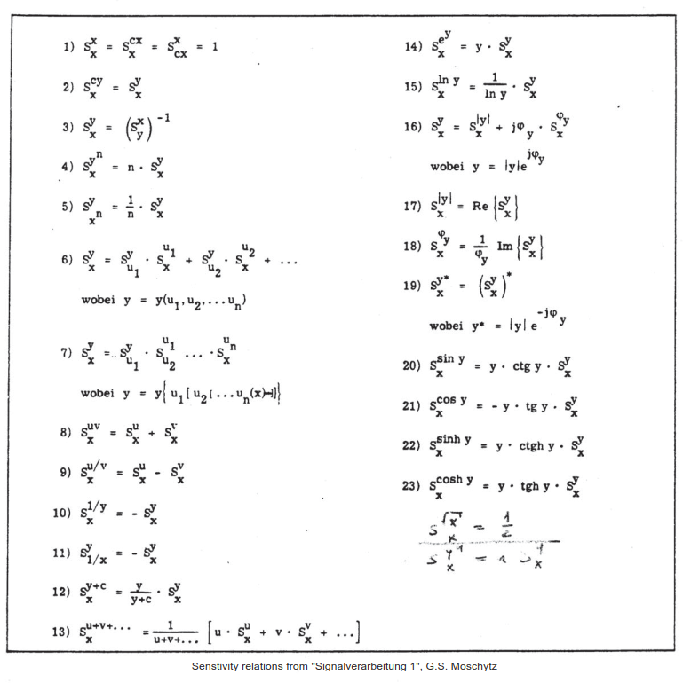**Sensitivity** / relative Sensitivity

Given $f_{(x)}$: how much does f change, if x changes by 10% ?

1. partial differentiation of $f_{(x)}$ by x
2. multiply with the inverse oft the function and x

**relative sensitivity** of f for changes in x:

${\frac{∆f}{f}=\frac{∆x}{x}⋅S}_{x}^{f}$ (in [%])

$$S_{x}^{f}=\frac{x}{f_{(x)}}⋅\frac{∂f}{∂x}$$