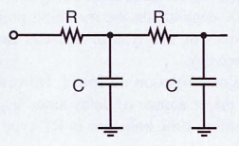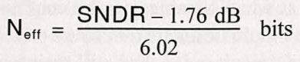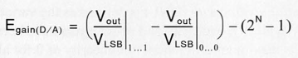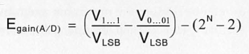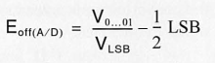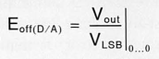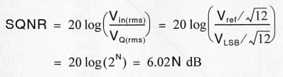

**settling time**

**ENOB**

relative $N_{eff}=\log_{2}\left(\frac{V_{ref}}{max(DNL [V])}\right)$

absolute $N_{eff}=\log_{2}\left(\frac{V_{ref}}{max({|V}_{ideal}-V_{code}|)}\right)$

$$offset-free, gain-free values = \frac{V_{[code]}}{V_{LSB}}-E_{off}± \frac{code}{2^{N}-1}⋅ E_{gain}=[LSB]$$

**INL / DNL**

zero code

all ones

⚠️ ADC vs. DAC !

**ADC**

**DAC**