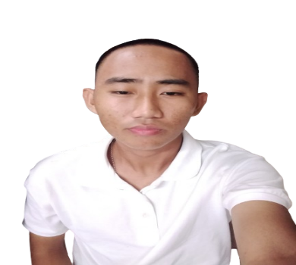**Mark Daniel M. Partoza 18**y/o

Purok 1 Brgy. Hamorawon Calbayog City, Samar 6710

Mobile No. 09639939159

Email Address: [partozamark2005@gmail.com](mailto:partozamark2005@gmail.com)

### ****QUALIFICATIONS & TECHNICAL SKILLS****

* Proficient in designing **algorithms and flowcharts** for logical problem-solving and program structure planning
* Skilled in **Web Development** using modern technologies and best practice hands-on experience with **Visual Studio Code** for front-end and back-end coding
* Knowledgeable in **Basic Mobile App Development** using tools like **Microsoft Visual Studio 2022**, **React Native**, and **Expo**
* Capable of developing **Graphical User Interface (GUI)** based applications
* Experienced in **C/C++ Programming** with a solid understanding of object-oriented and procedural programming principles

**EDUCATIONAL BACKGROUND:**

Tertiary Education : **Northwest Samar State University**

Rueda St. Calbayog City, Samar

Bachelor of Science and Computer Engineering

2023 – 2024

Secondary Education: **Calbayog City National High school**

Gomez Ext. Calbayog City, Samar

2017 – 2023

Primary Education : **Calbayog East Central Elementary School**

Gomez Ext. Balud, Calbayog City, Samar

2010 – 2017

**REFERENCES:**

**ENGR. RITCHIE MARIBOJOC**

Program Chairperson

College of Engineering and Architecture

Northwest Samar State University

Main Campus, Calbayog City

**BONIFACIO M. BADILLA**

CEA’s Secretary  
College of Engineering and Architecture

Gomez Ext., Calbayog City, Samar 6710

09082360352

*I hereby certify that the above information’s are true and correct to the best of my knowledge and belief.*

**MARK DANIEL M. PARTOZA**

Applicant