Entity-relationship diagram

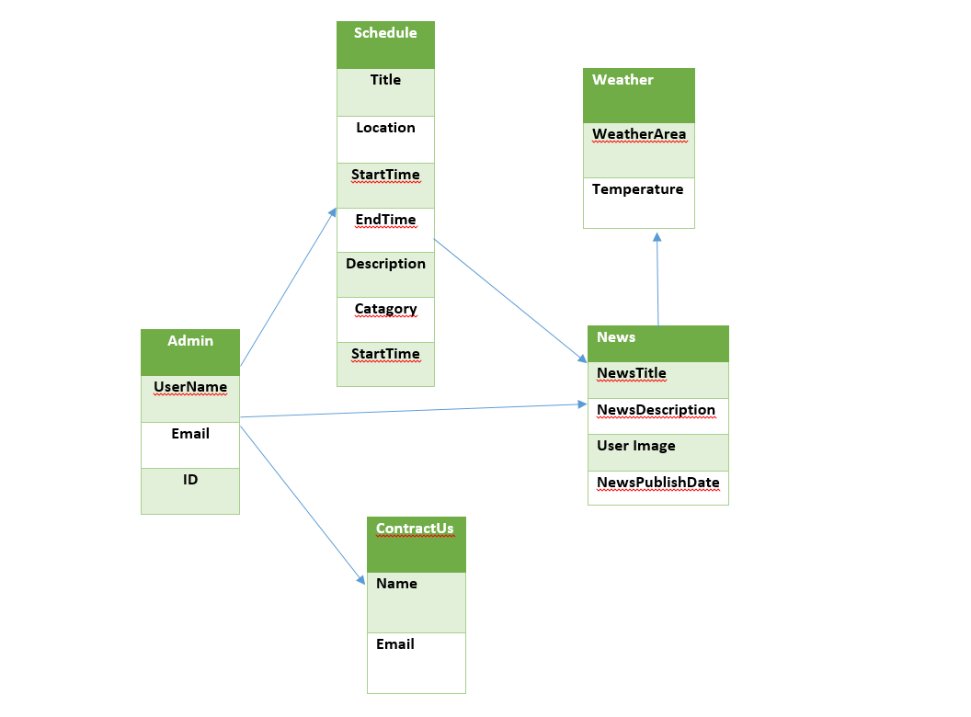

Figure 1: ERD