Our website is a database of computer science projects. Built for the Duke Tech Incubator, our project aims to prevent programming projects from dying out by connecting projects with mentors and people interested in working on the project.

Our database holds details on projects, including the project name, description, founder, members and activity status. On the website, users are able to search up different projects by name, tag, founder, mentor, status etc. They can click on the project to find out more information about the project.

Users are also able to login with a specific netID. Users have profiles that display the projects they are currently participating in and information such as their email, graduation year and major. They can also edit and update the details of existing projects.

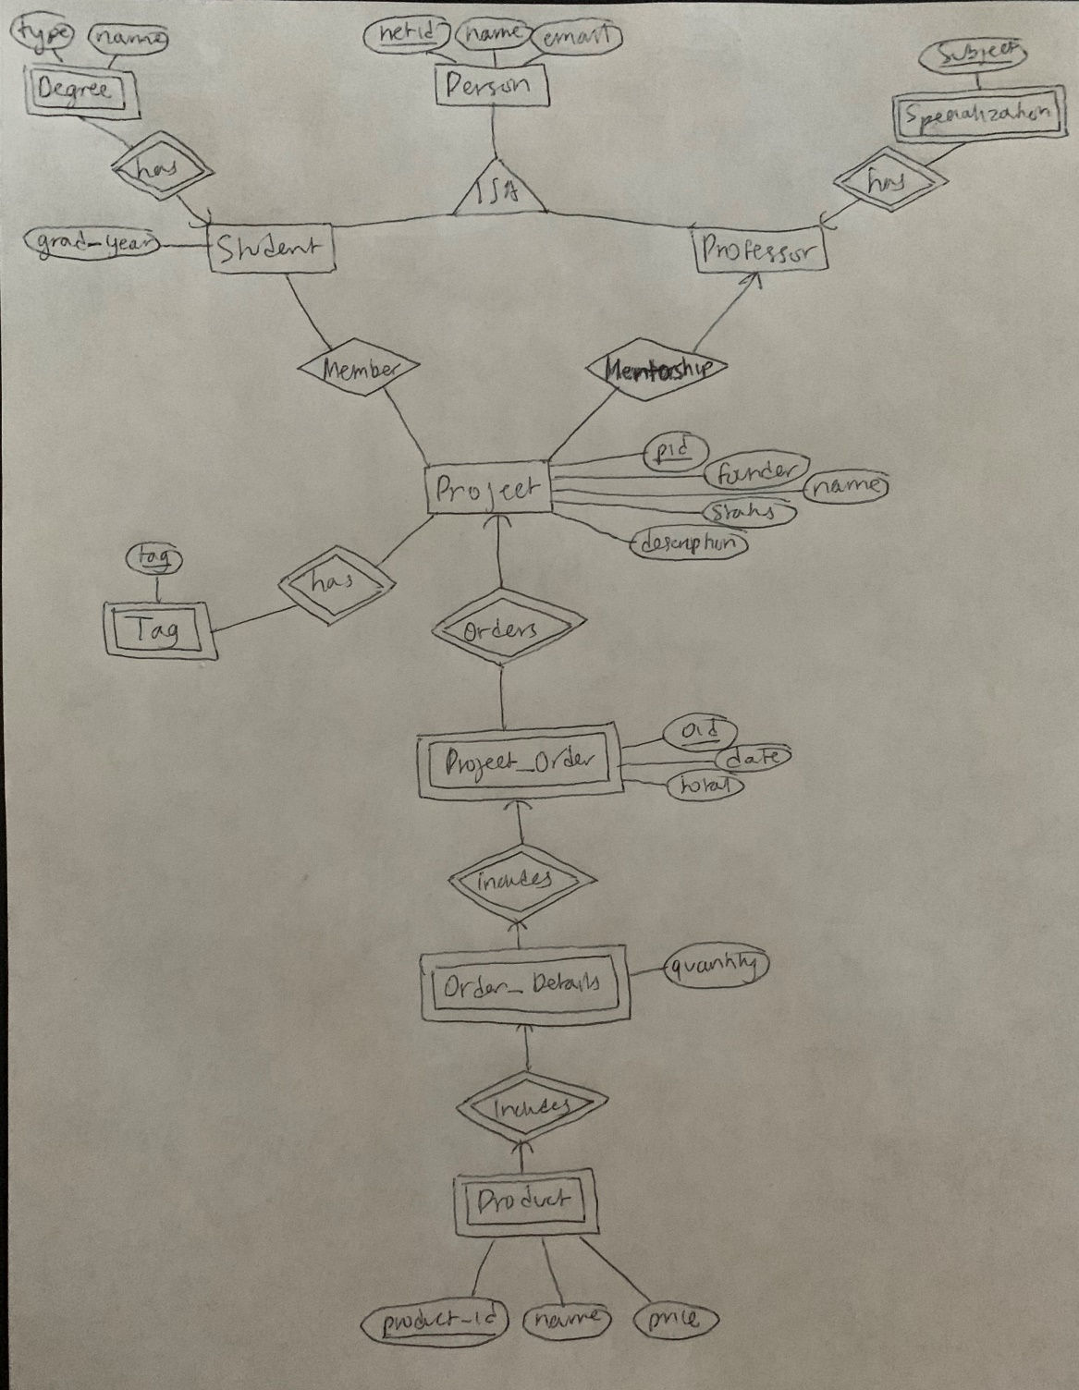

We assume that users (mentors and mentees) will enter their data through our website. The forms on the website are set up in a way that the data entered will be handled correctly.

List of database tables with descriptions:

* Person: holds netID, name and email of a person
* Student: a person + their graduation year
* Professor: netIDs of professors
* Project: list of projects to be mentored, including the name of the project, activity status, description of the project, founder name and project ID.
* Mentorship: contains relationships of mentorship. Mentor NetID and project ID
* Project Order: A list of orders that projects have made, detailing the date of the order and the total value of the order
* Order Details: specific order that was made, detailing which project requested it, the product names and quantities, with a primary key of (orderID, product_id).
* Product: A table of products with primary key product_id that contains each product's name and price.
* Tag: Tags describing the project that can be used to search for projects.
* Degree: details which students are pursuing what degrees. This information is displayed on user profiles
* Specialization: similar to degree but shows what are the specialties of professors.
* Member: shows relationships of what students are members of what projects using NetID and ProjectID.