**June 2019**



e

Table of Contents

Overview 3

Generate Key Pair 4

Configure Environment 6

Conclusion 17

# Overview

AWS Database Migration Service (DMS) helps you migrate databases to AWS easily and securely. The source database remains fully operational during the migration, minimizing downtime to applications that rely on the database. The AWS DMS can migrate your data to and from most widely used commercial and open-source databases. The service supports homogenous migrations such as SQL Server to SQL Server, as well as heterogeneous migrations between different database platforms, such as SQL Server to Amazon Aurora or Oracle to PostgreSQL. AWS DMS can also be used for continuous data replication with high-availability.

This document walks the user through configuring the environment necessary for executing this workshop.

# Generate Key Pair

In this step, you will generate an EC2 key pair for use in the Database Migration Workshop labs.

1. Go to <http://amzn.to/2kcoMQp> and click “Create Key Pair.”

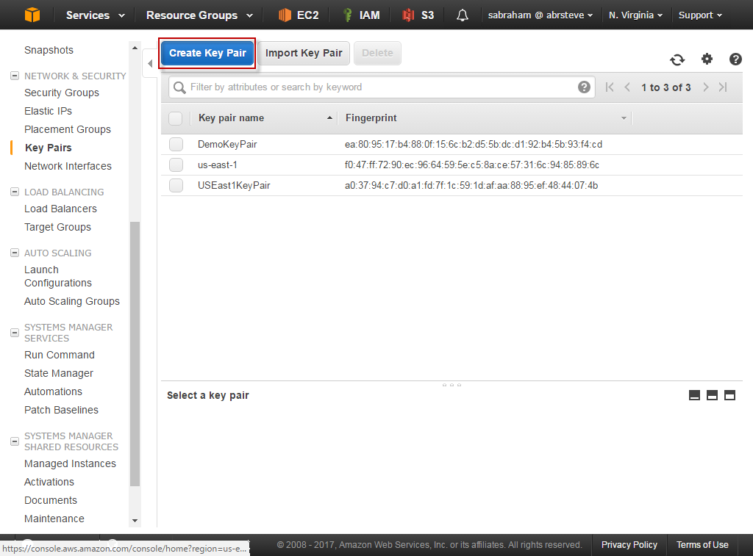

1. Name the key pair “DMSKeyPair” and then click “Create.” At this point, your browser will download a file named “DMSKeyPair.pem.” Save this file. You will need it to complete the labs.

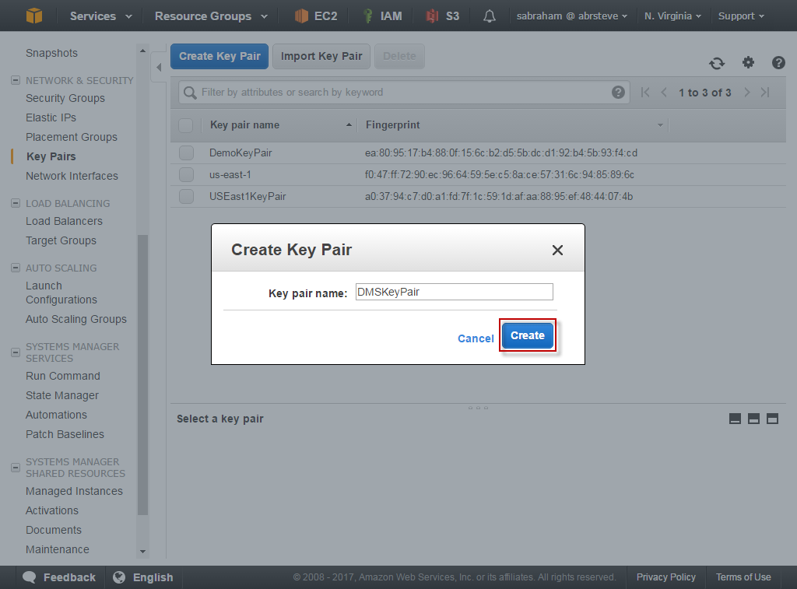

# Configure Environment

In this step, you will configure an environment consisting of:

* 1 SQL Server running on EC2 (Source)
* 1 RDS Aurora MySQL Database Cluster (Target)
* 1 RDS SQL Server (Target)
* 1 App Server running on EC2

The SQL Server running on EC2 will simulate an on-premises database server while the RDS Aurora MySQL cluster and RDS SQL Server instance will be your targets.

We’ll use the App Server for the CloudEndure lab.

1. Open the CloudFormation console at: <http://amzn.to/2lzMPpF>

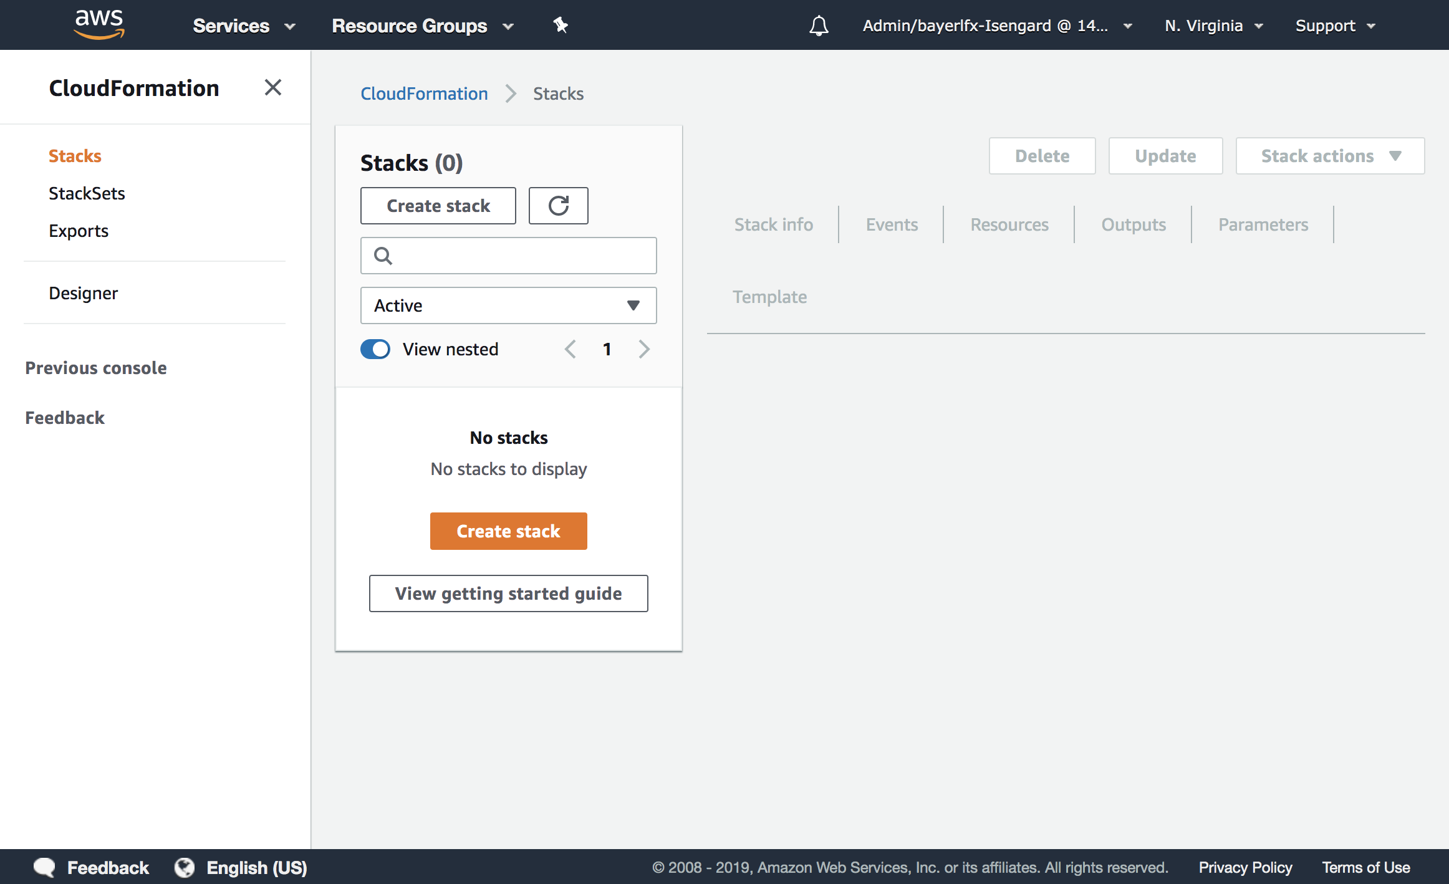

1. Change the current region in the drop down to “N. Virginia.”

***Important Note: In order for this lab to run, the region must be set to N. Virginia.***

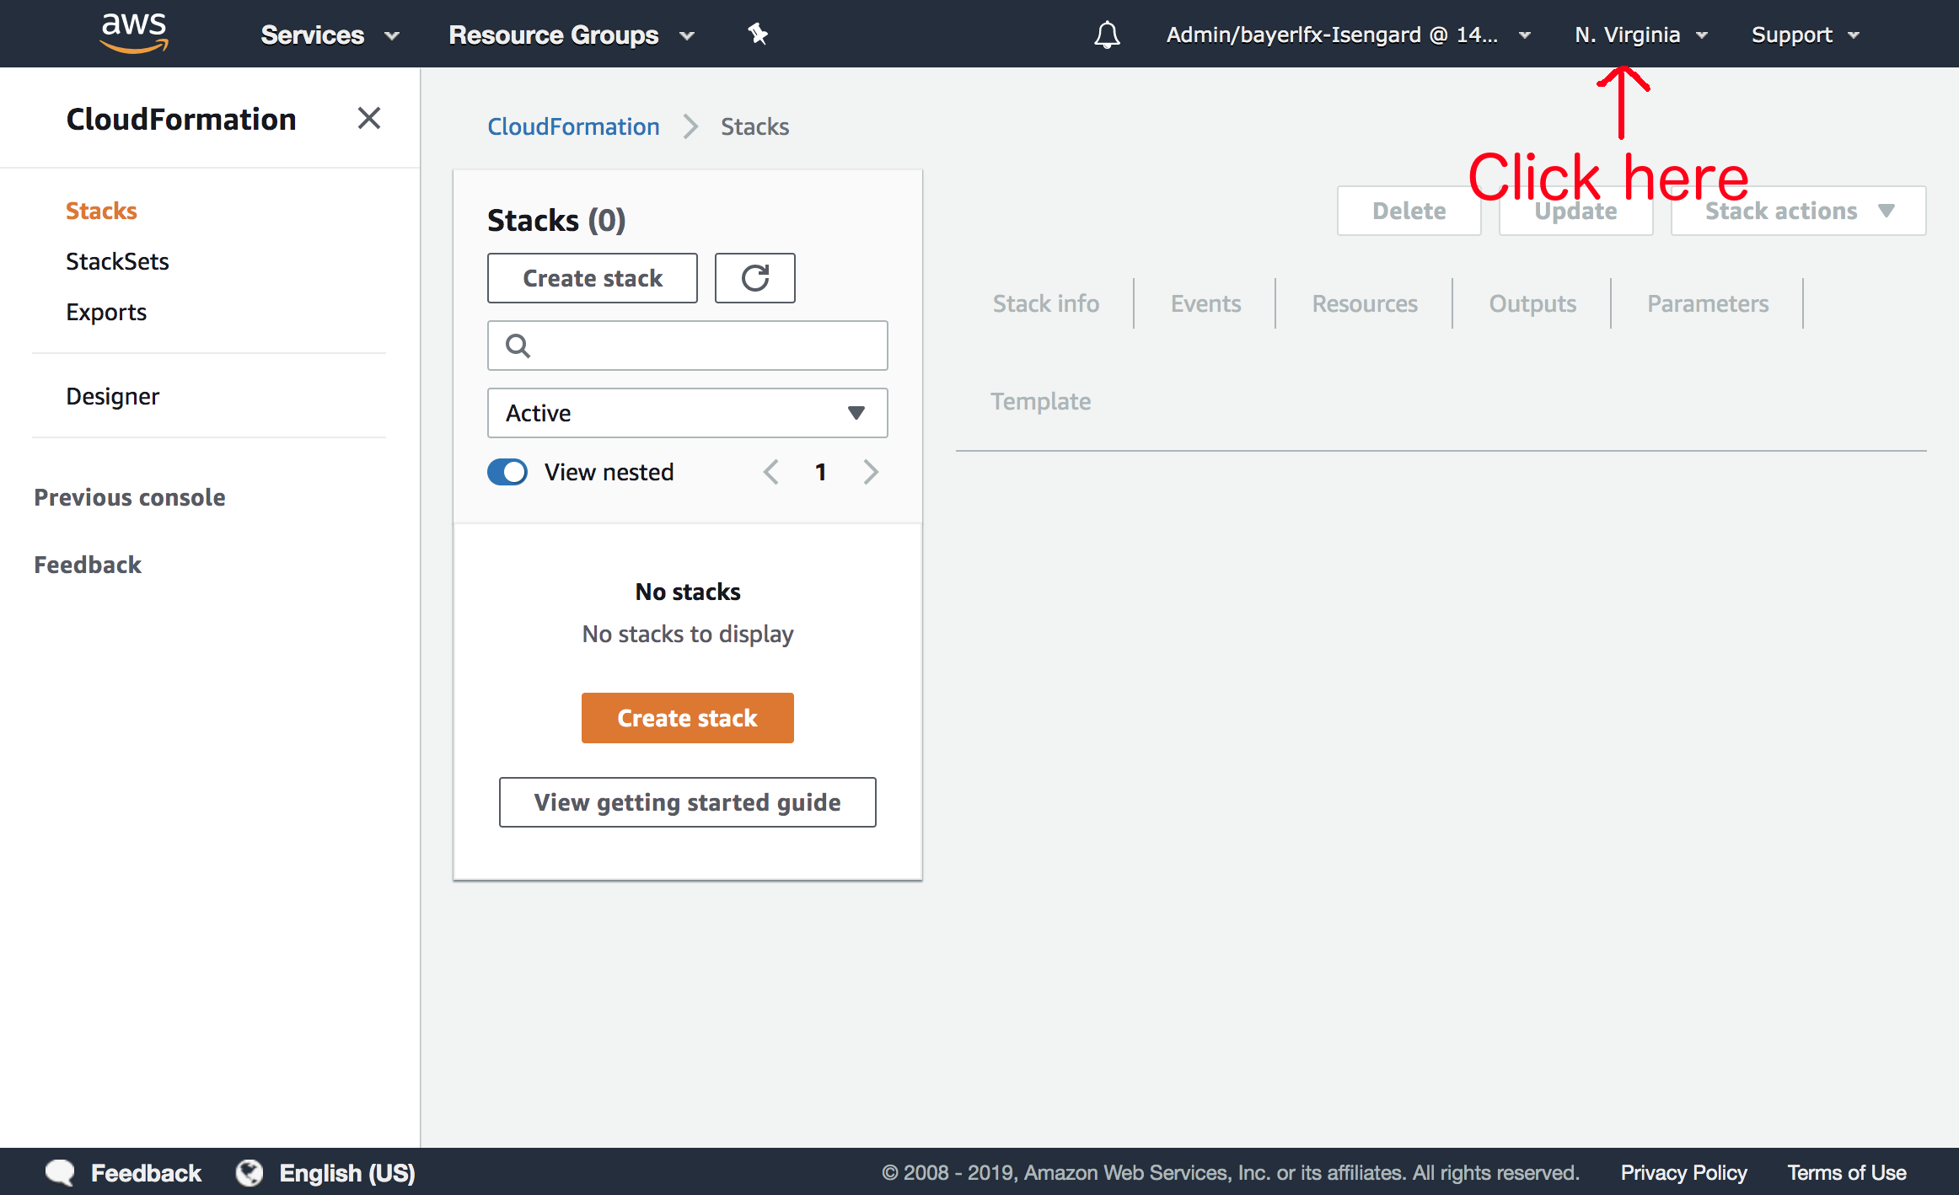

1. Click “Create Stack”

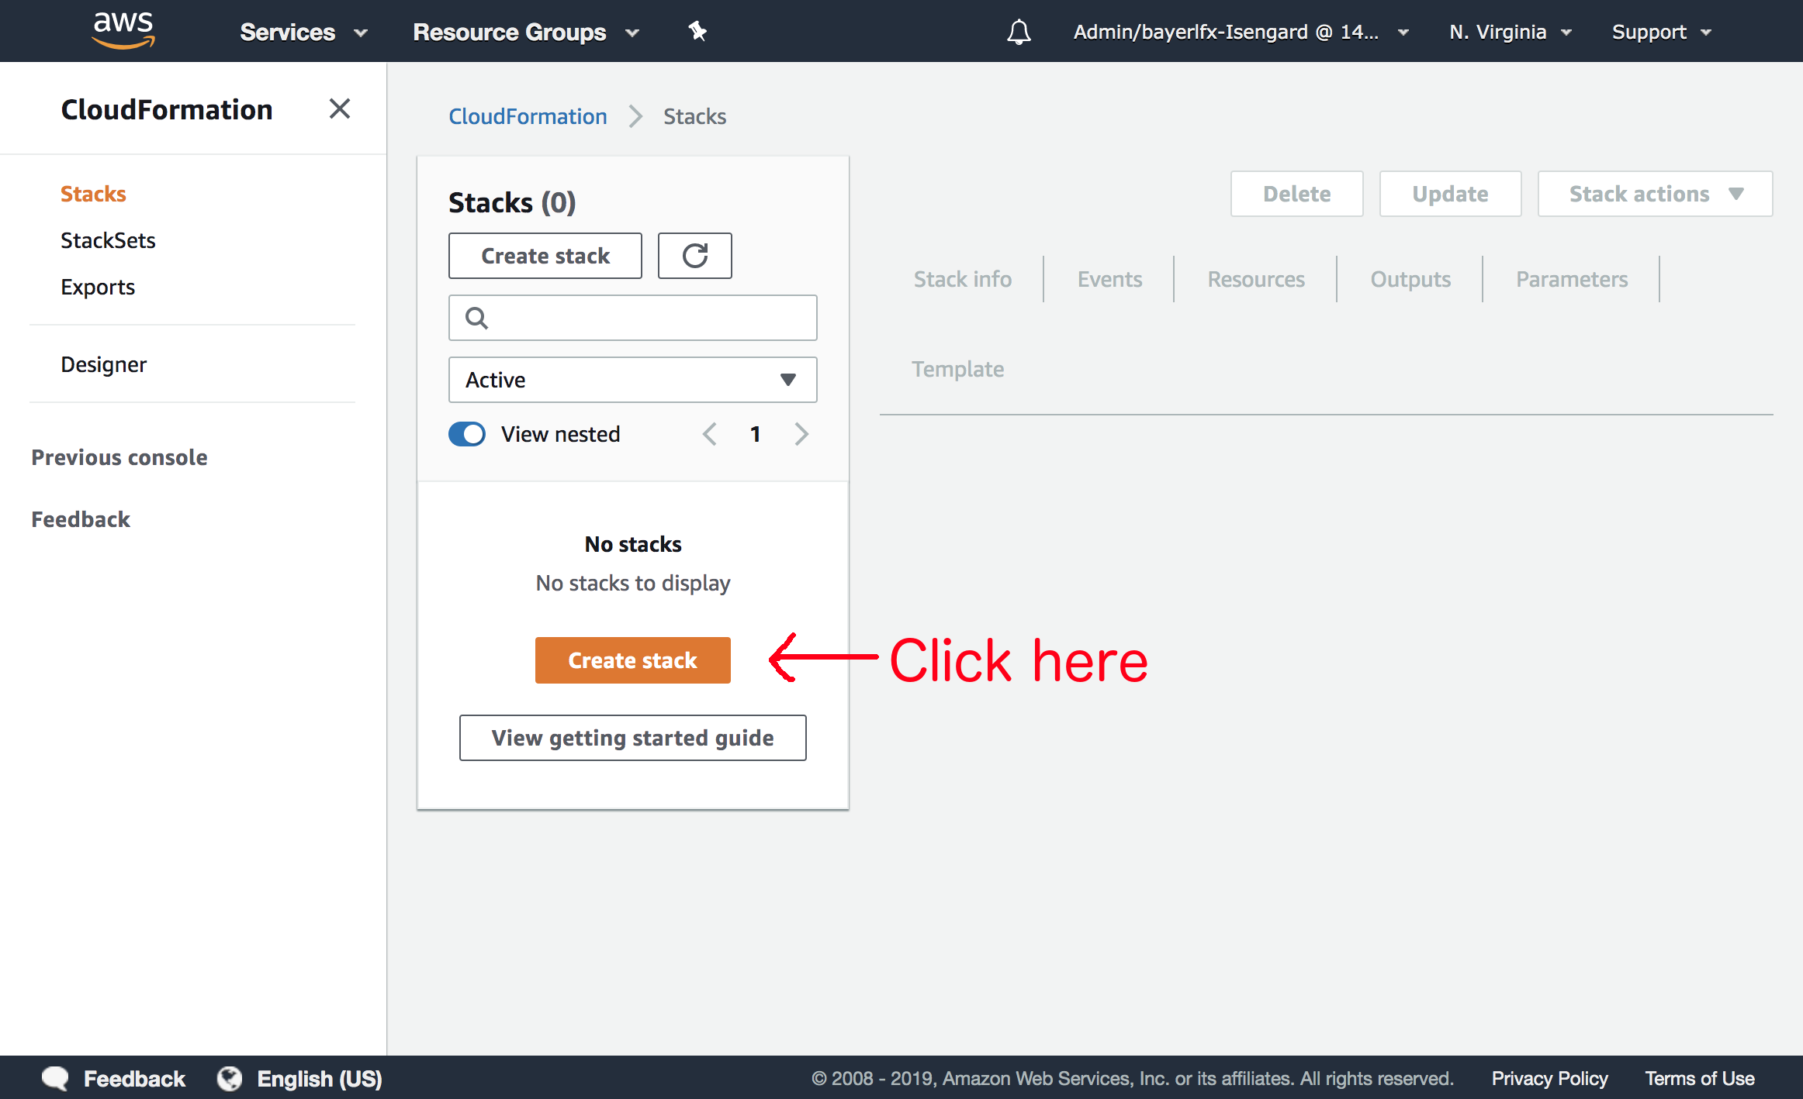

1. Click “Choose File” and select the file named “DatabaseMigrationWorkshop.json” and then click “Next.”

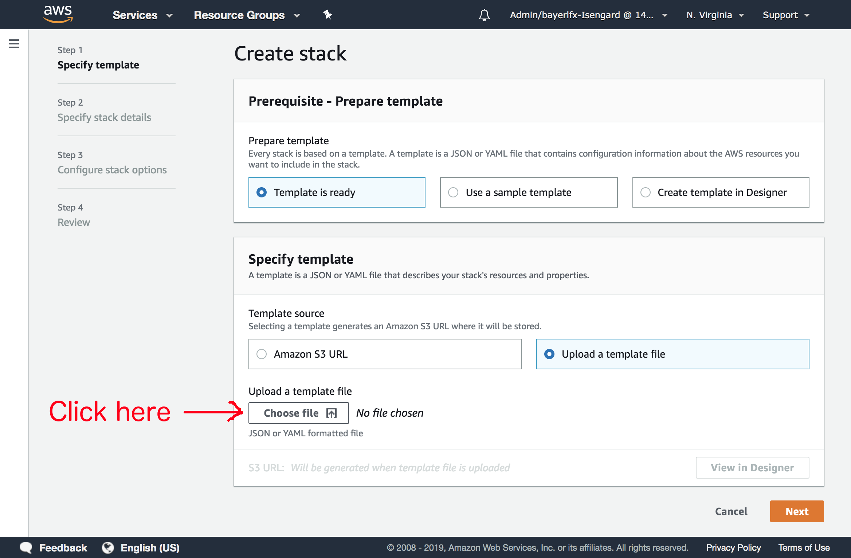

1. Populate the form as with the values specified below and then click “Next.”

|  |  |
| --- | --- |
| **Stack Name** | A unique identifier |
| **KeyName** | DMSKeyPair |

*Note: The resources that are created here will be prefixed with whatever value you specify in the Stack Name. Please specify a value that is unique to your account. For example your first and last name with no spaces.*

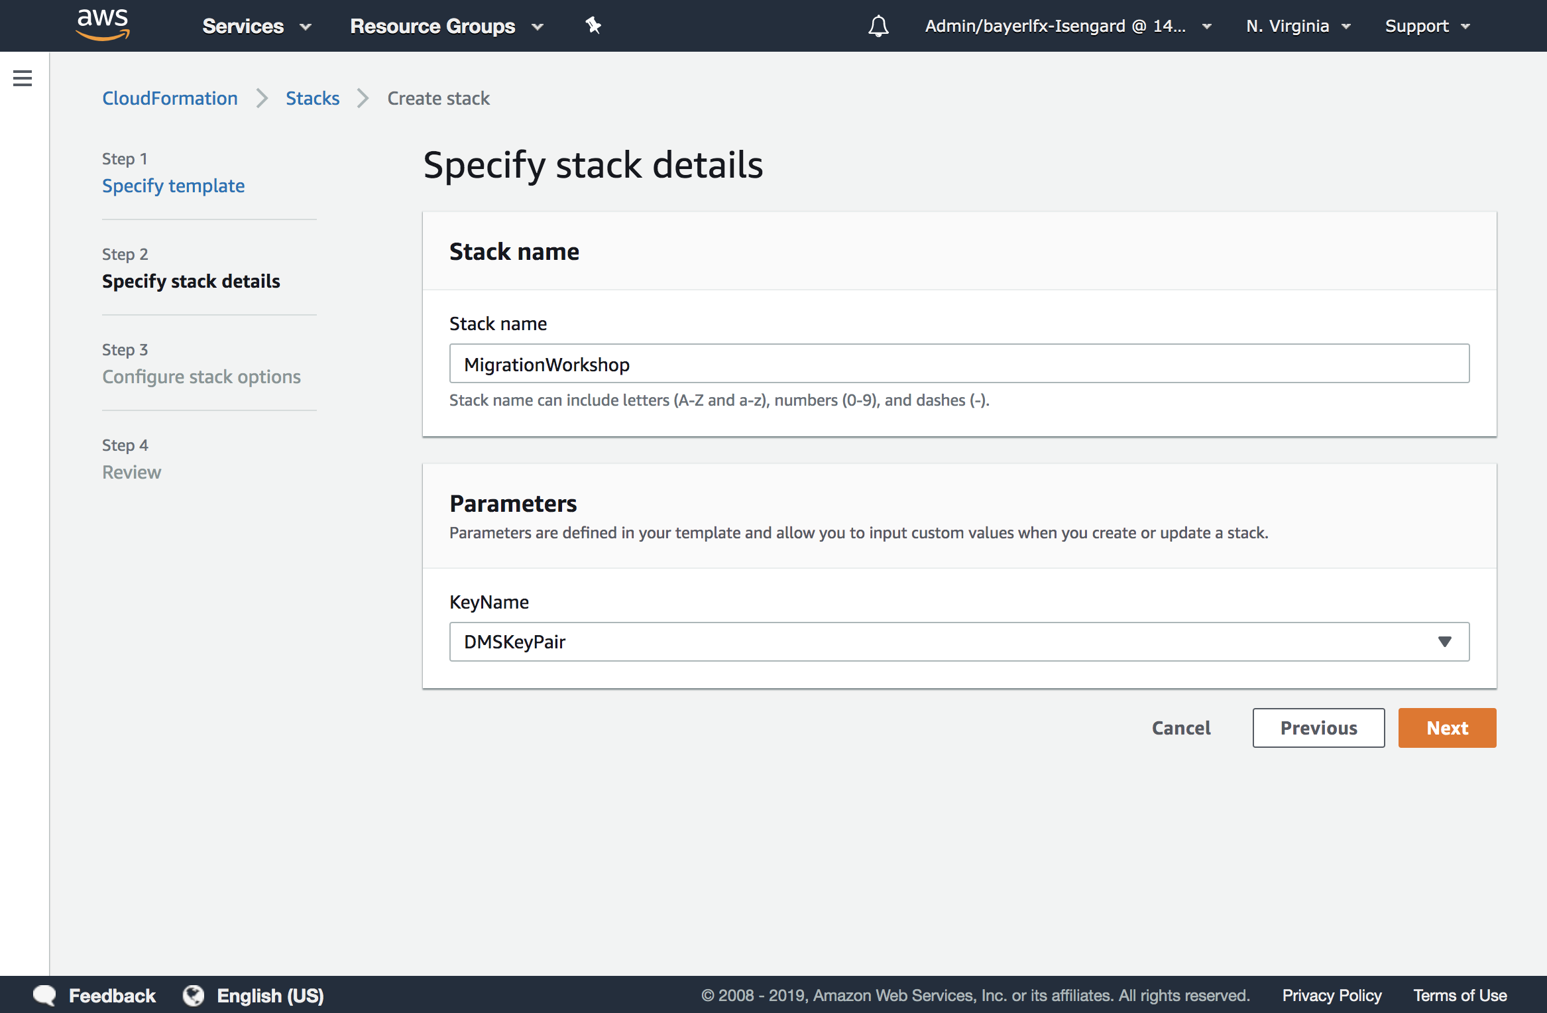

1. On the “Options” page, accept all of the defaults and click “Next.”

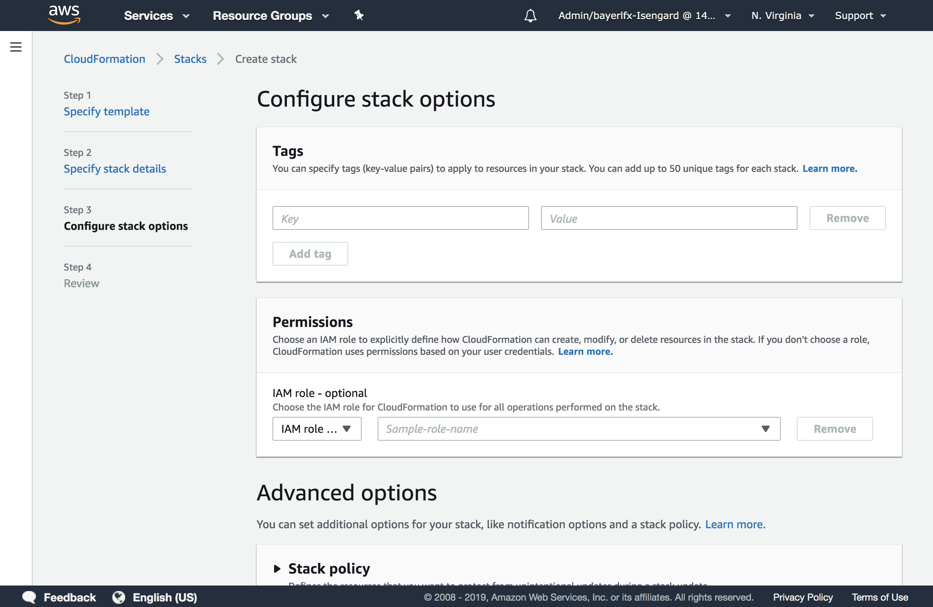

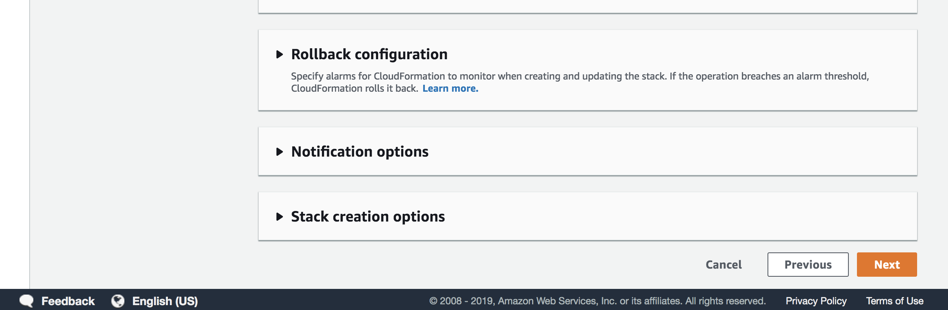

1. On the Review page, click “Create stack”

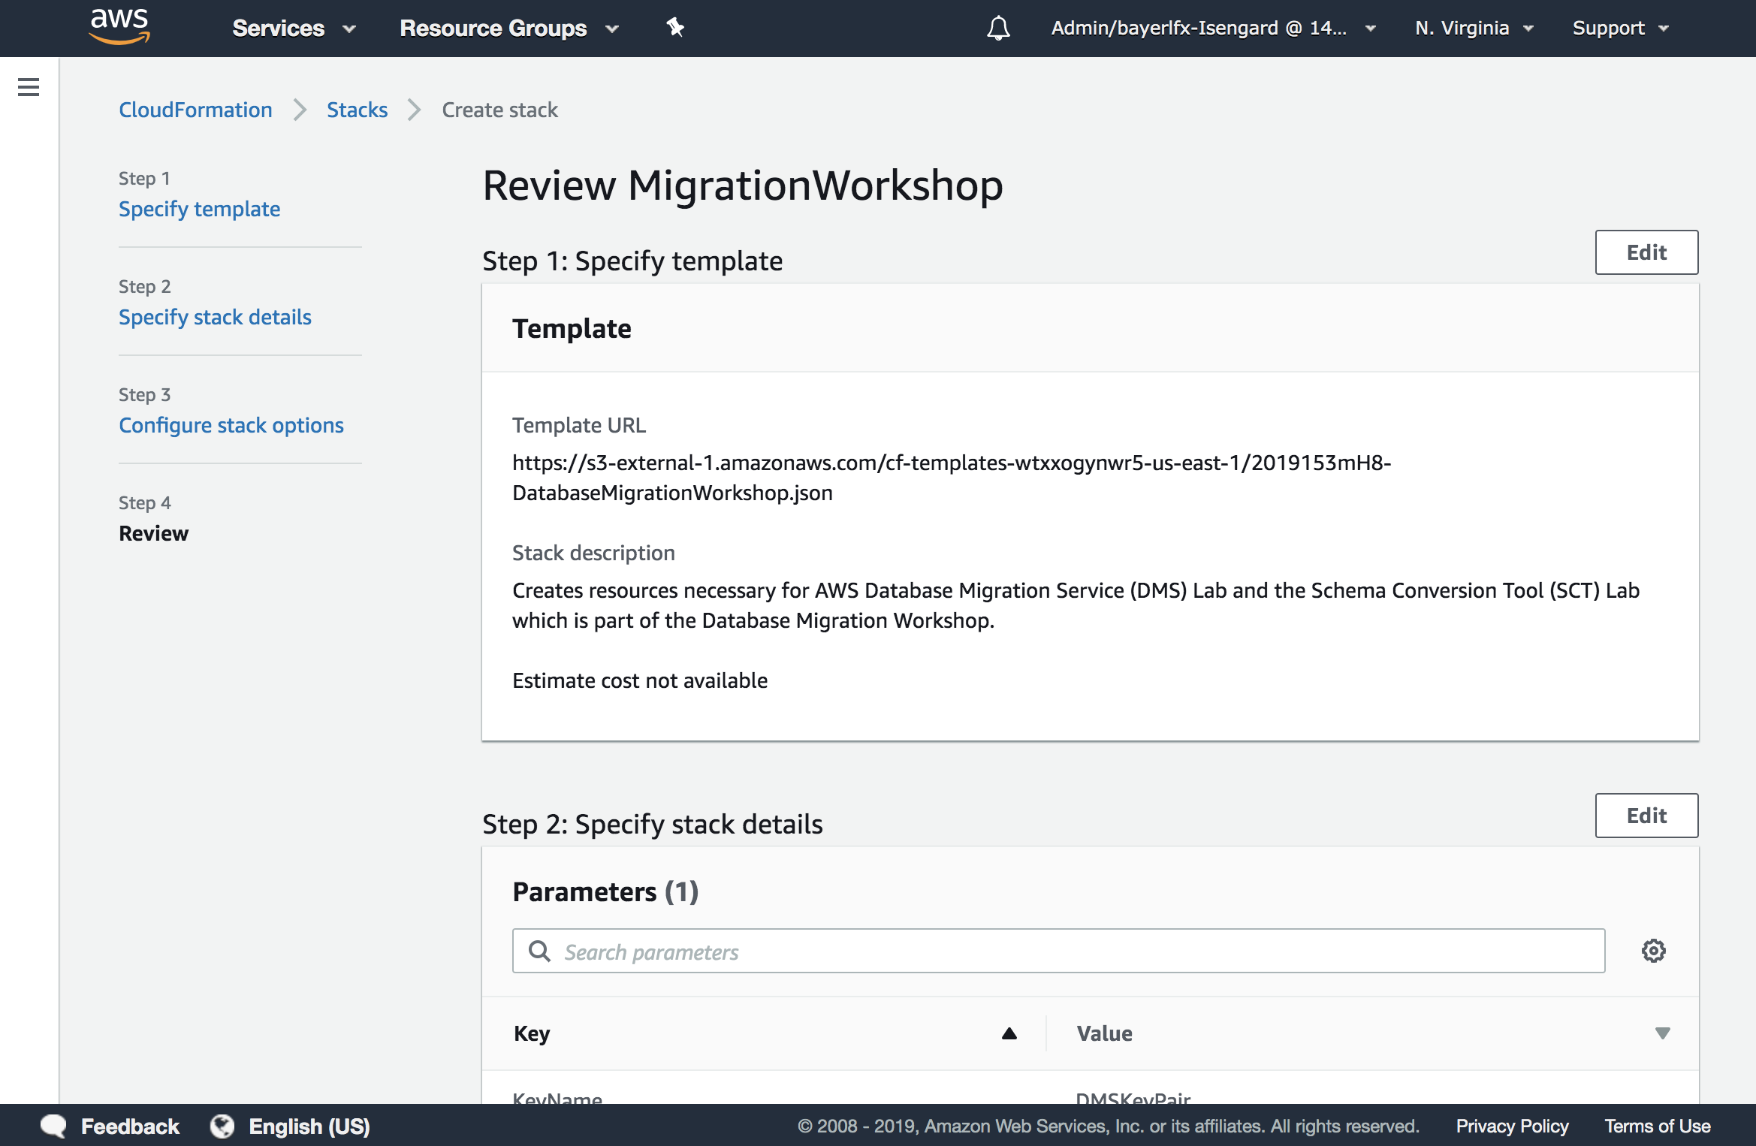

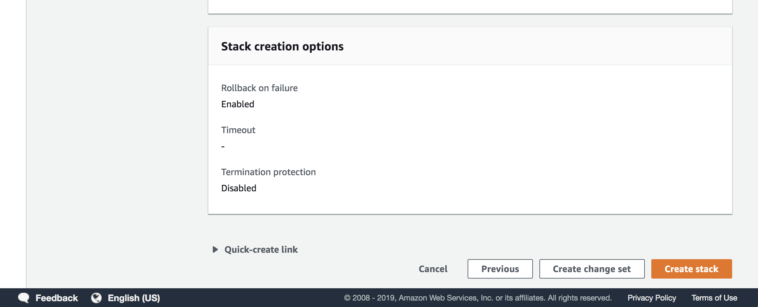

1. At this point, you will be directed back to the CloudFormation console and will see a status of “CREATE_IN_PROGRESS.” Please wait here until the status changes to “COMPLETE.”

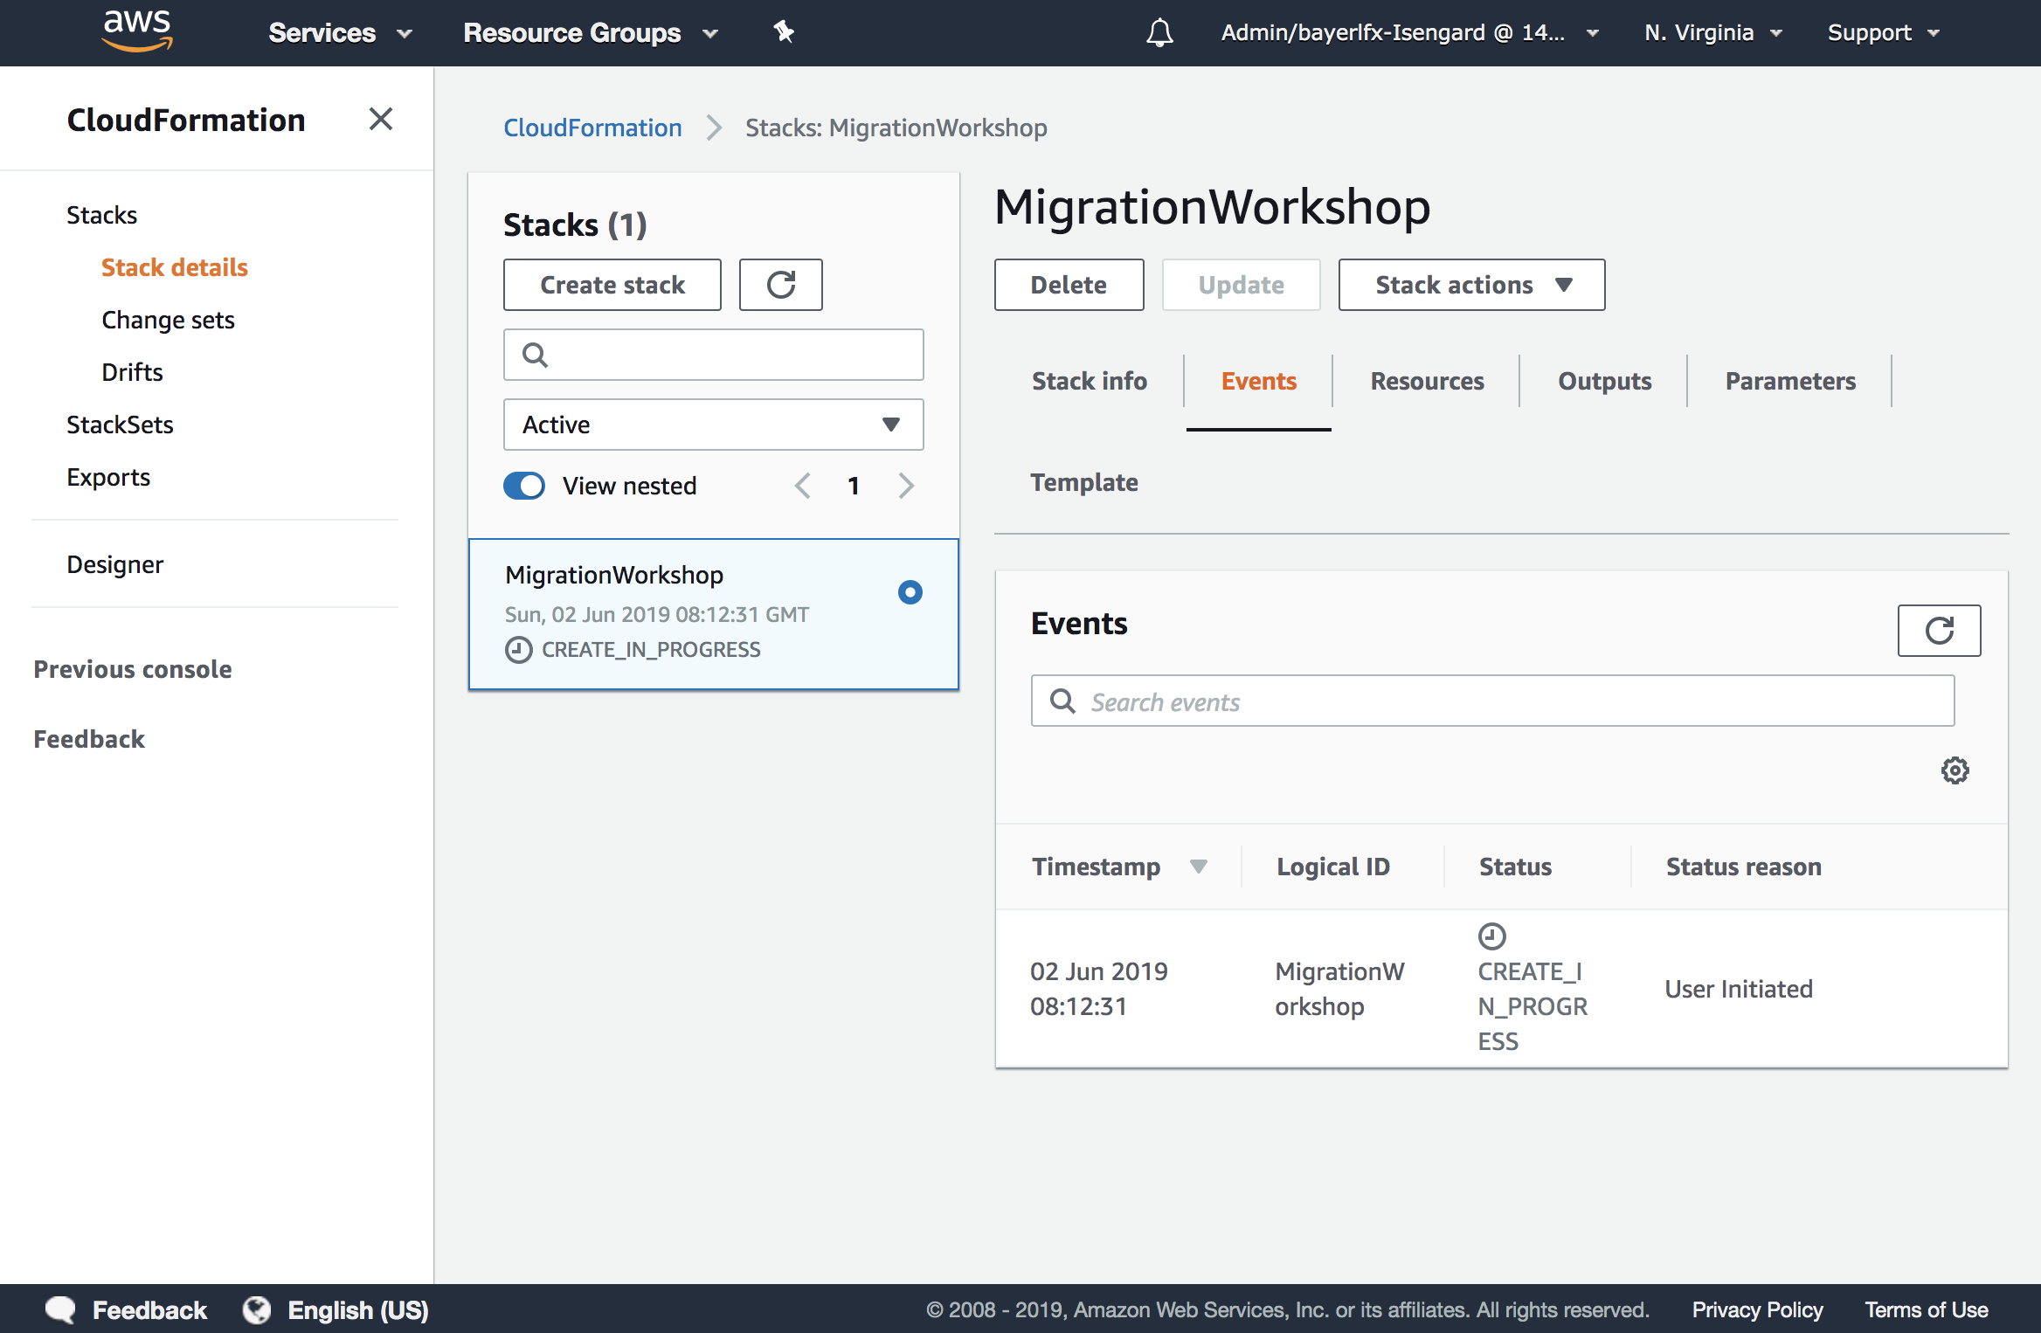

1. Once CloudFormation has completed building the stack, click on the ***name*** of your newly created stack.

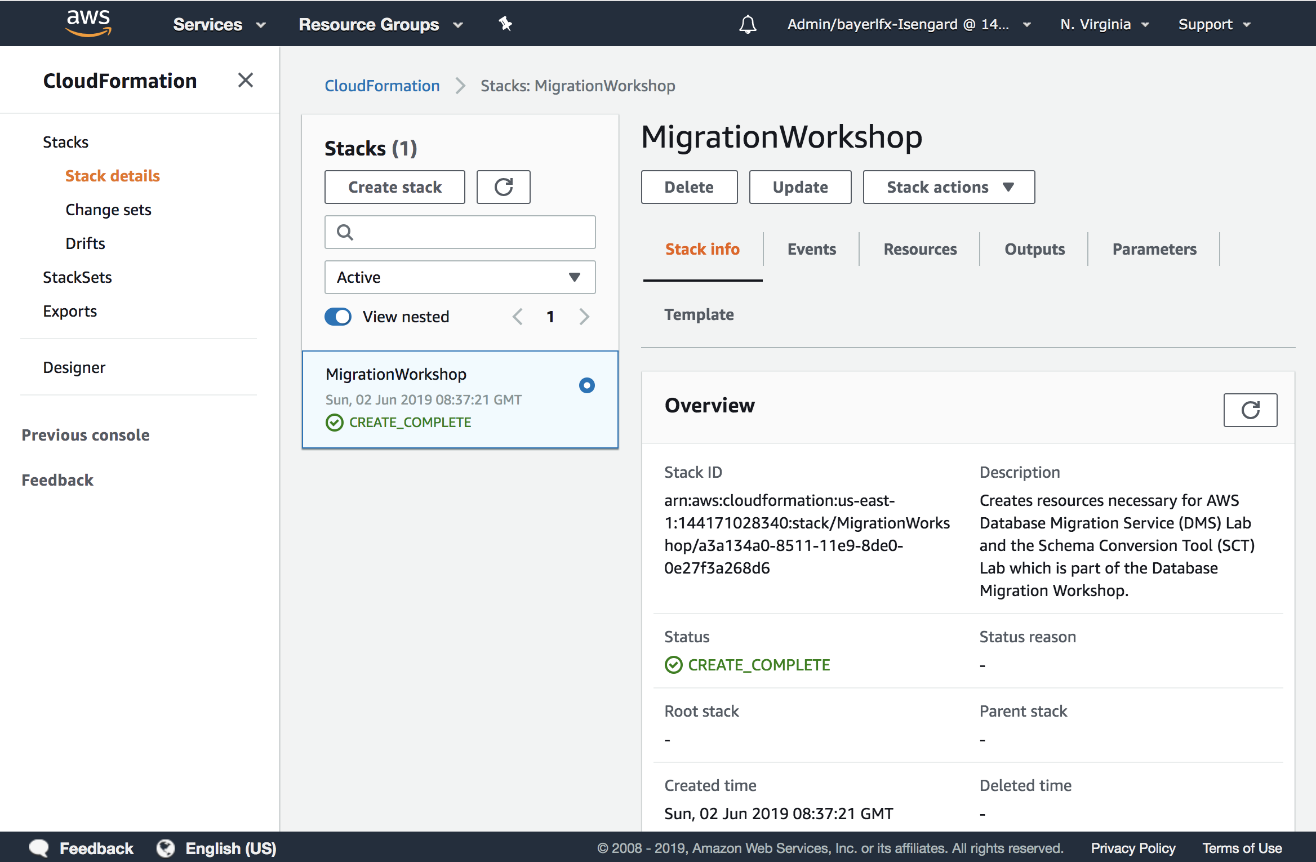

1. Click on the “Outputs” item.

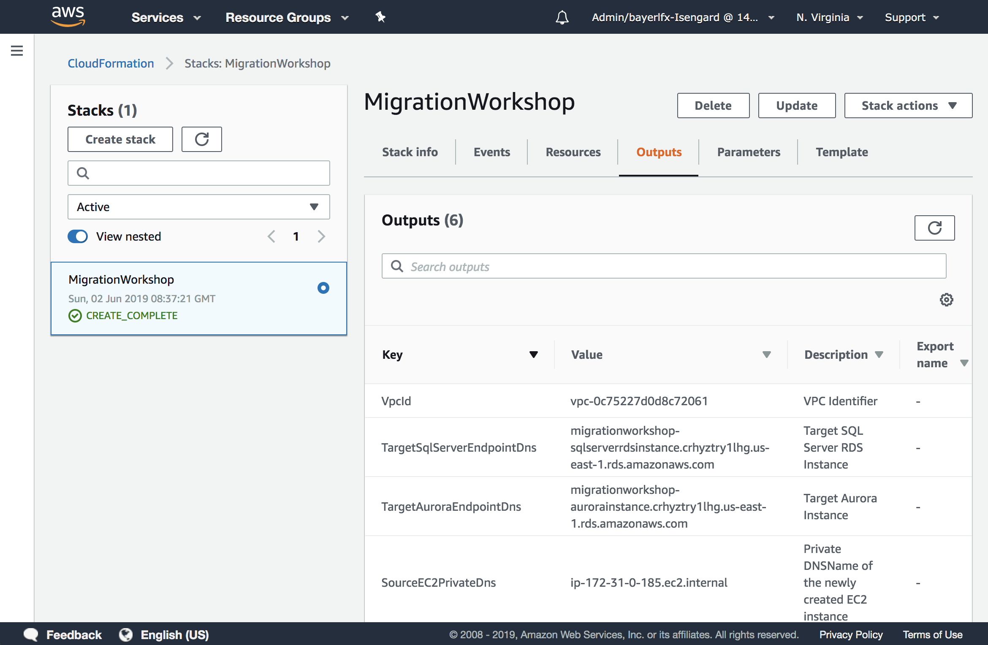

1. Take note of the following values as you will need them for the remainder of the lab:

* VpcId
* SourceEC2EndpointDns
* SourceEC2PrivateDns
* TargetAuroraEndpointDns
* TargetSqlServerEndpointDns
* EndpointApp

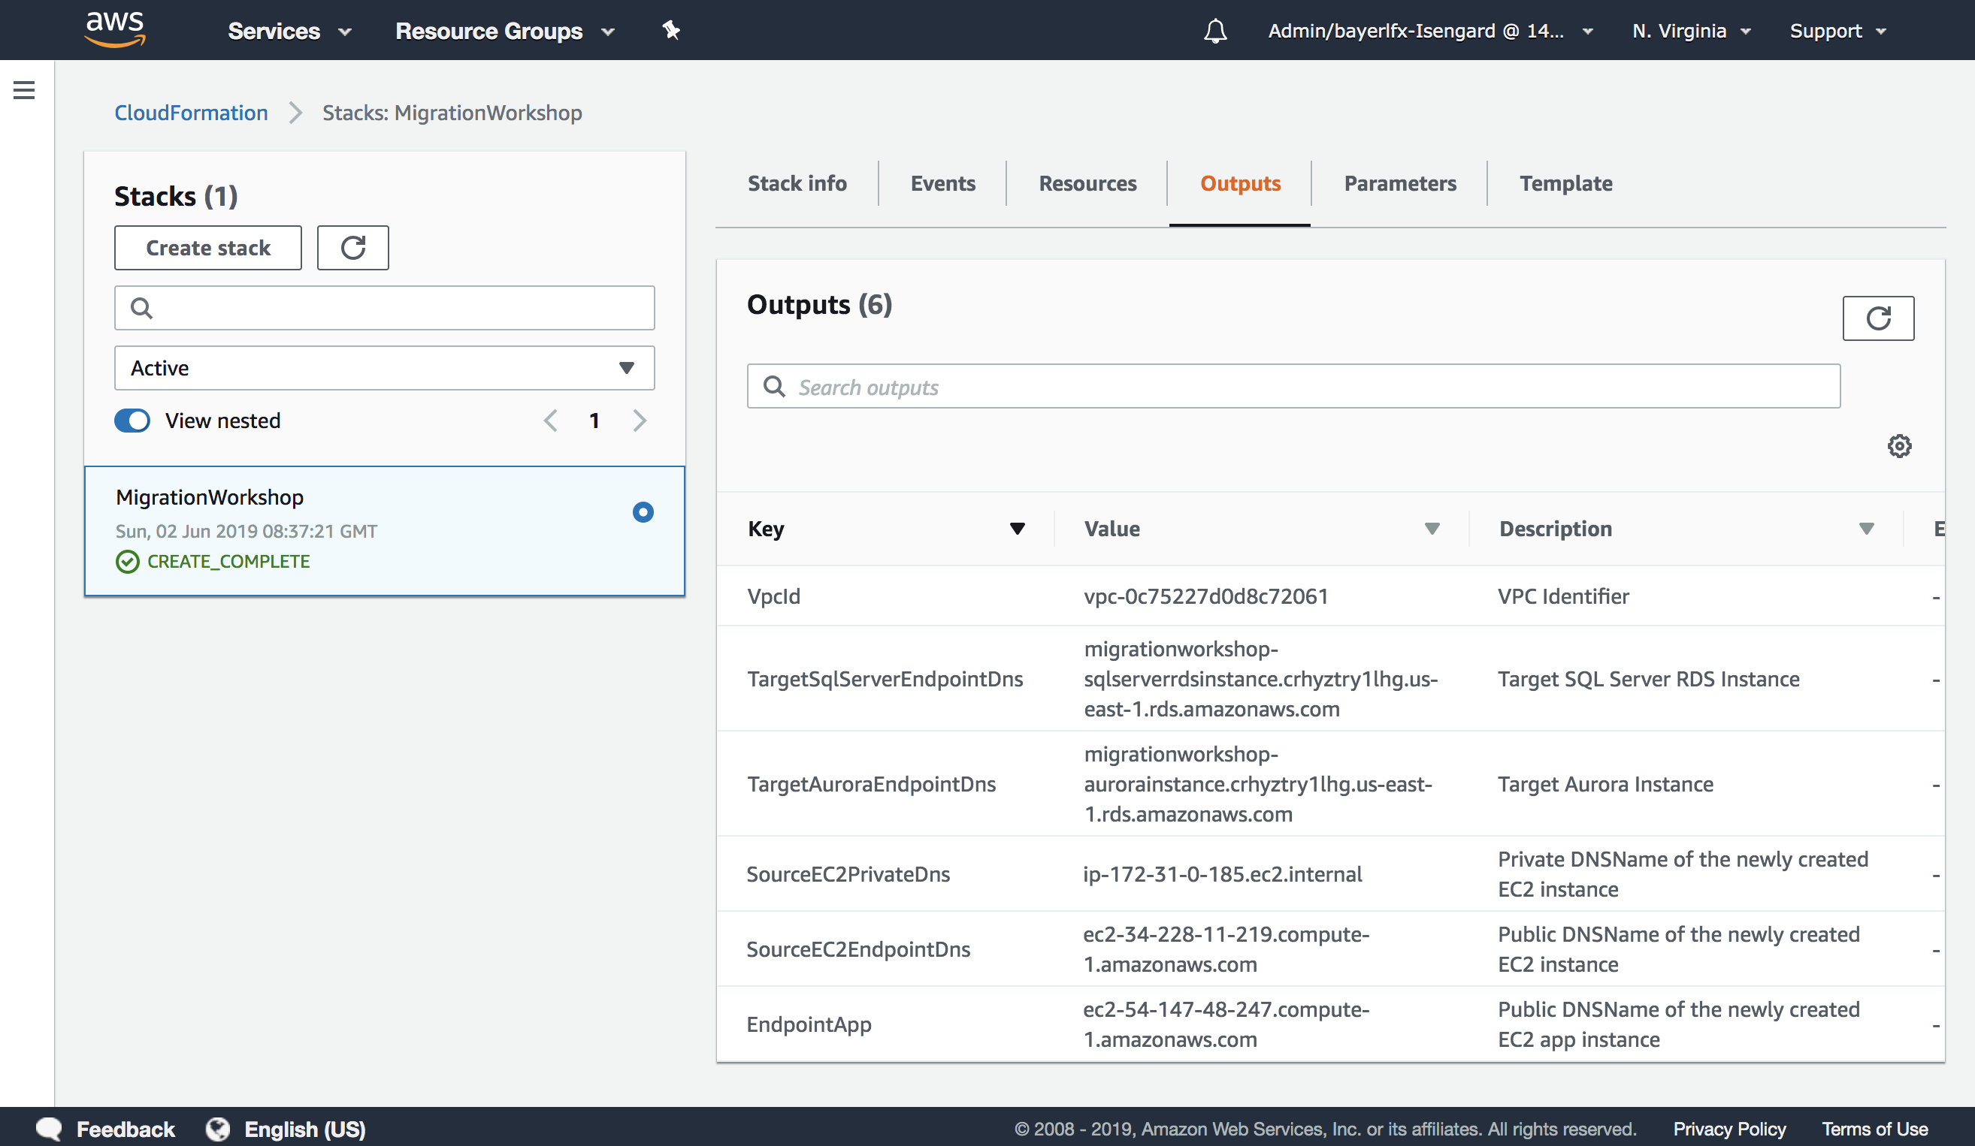

# Conclusion

You have completed the configuration of your environment for the Database Migration Workshop labs. Please make sure that you take note of the following values generated during this setup. You will need these values in order to successfully complete the lab.

1. The location of the key pair file named “DMSKeyPair.pem”
2. The VpcId value from CloudFormation
3. The SourceEC2EndpointDns value from CloudFormation
4. The SourceEC2PrivateDns value from CloudFormation
5. The TargetSqlServerEndpointDns value from CloudFormation
6. The TargetAuroraEndpointDns value from CloudFormation
7. The EndpointApp value from CloudFormation

***If you are missing any of the values listed above, please notify a lab assistant immediately for assistance.***