Solve the following puzzle and then write a program that moves you from “S” all the way to “F”. You can use any of the following commands to program:

* Move forward one space
* Turn left
* Turn right
* Repeat <#> times:

Once you are done, raise your hand so that one of us can check your work. Starting position facing downwards towards the wall.

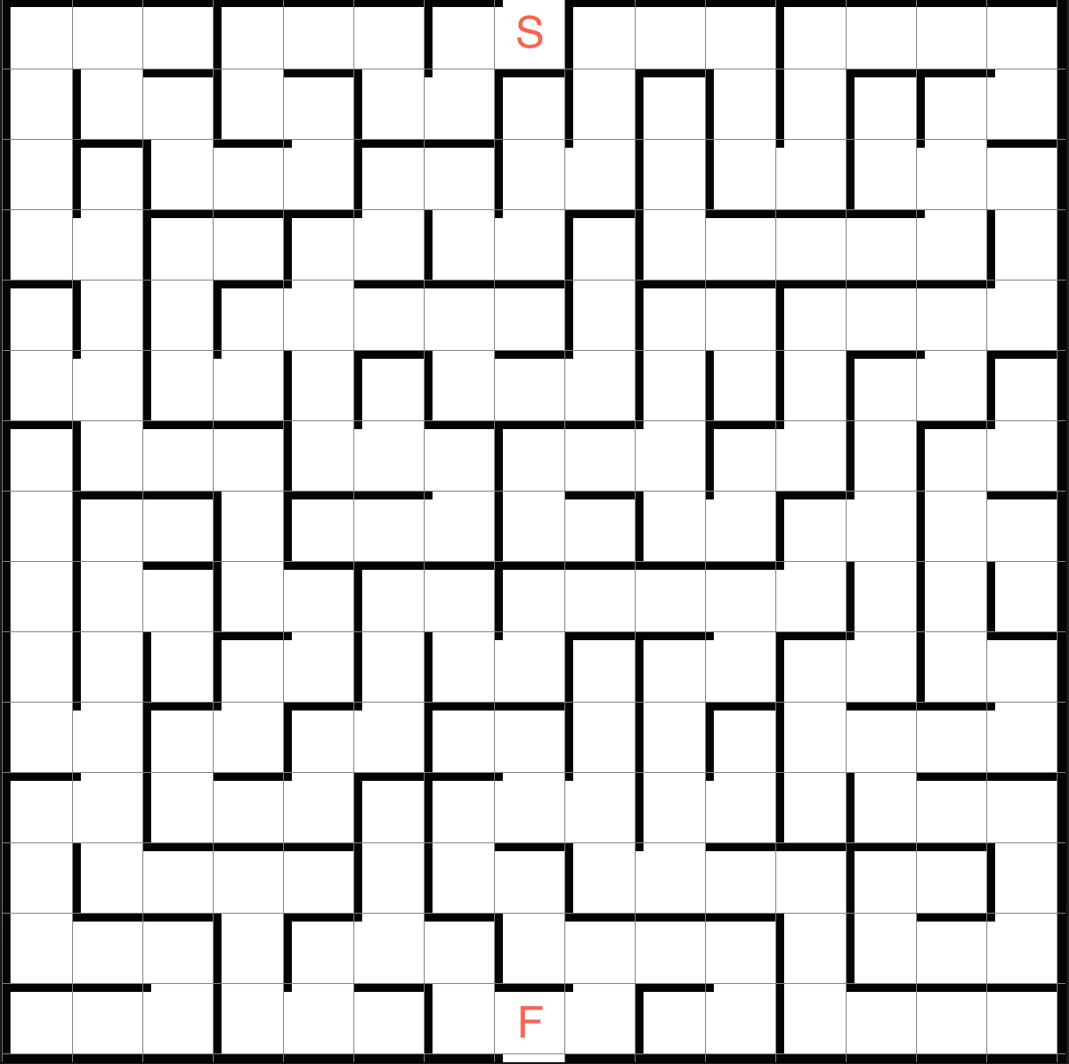

Solve the following puzzle and then write a program that moves you from “S” all the way to “F”. You can use any of the following commands to program:

* Move forward one space
* Turn left
* Turn right
* Repeat <#> times:

Once you are done, raise your hand so that one of us can check your work. Starting position facing downwards towards the wall.

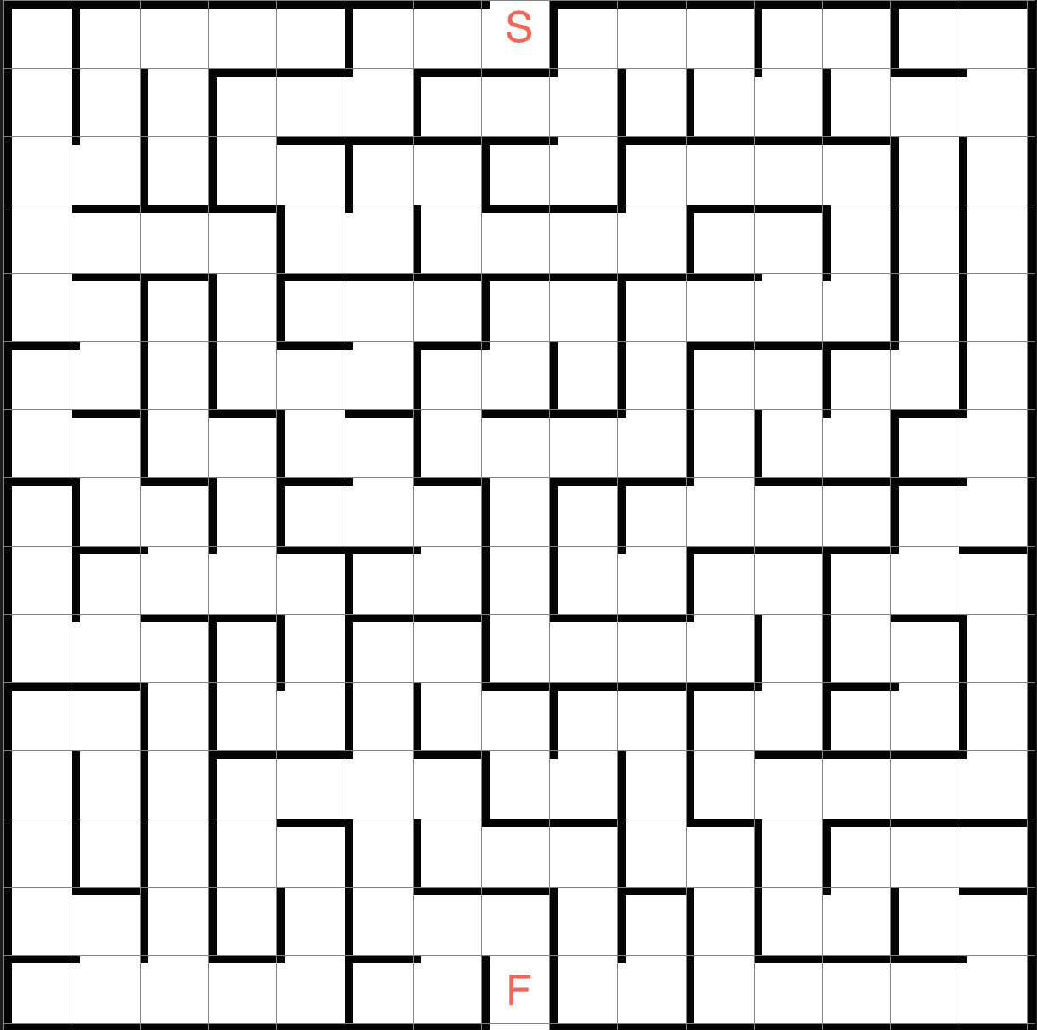

Solve the following puzzle and then write a program that moves you from “S” all the way to “F”. You can use any of the following commands to program:

* Move forward one space
* Turn left
* Turn right
* Repeat <#> times:

Once you are done, raise your hand so that one of us can check your work. Starting position facing downwards towards the wall.

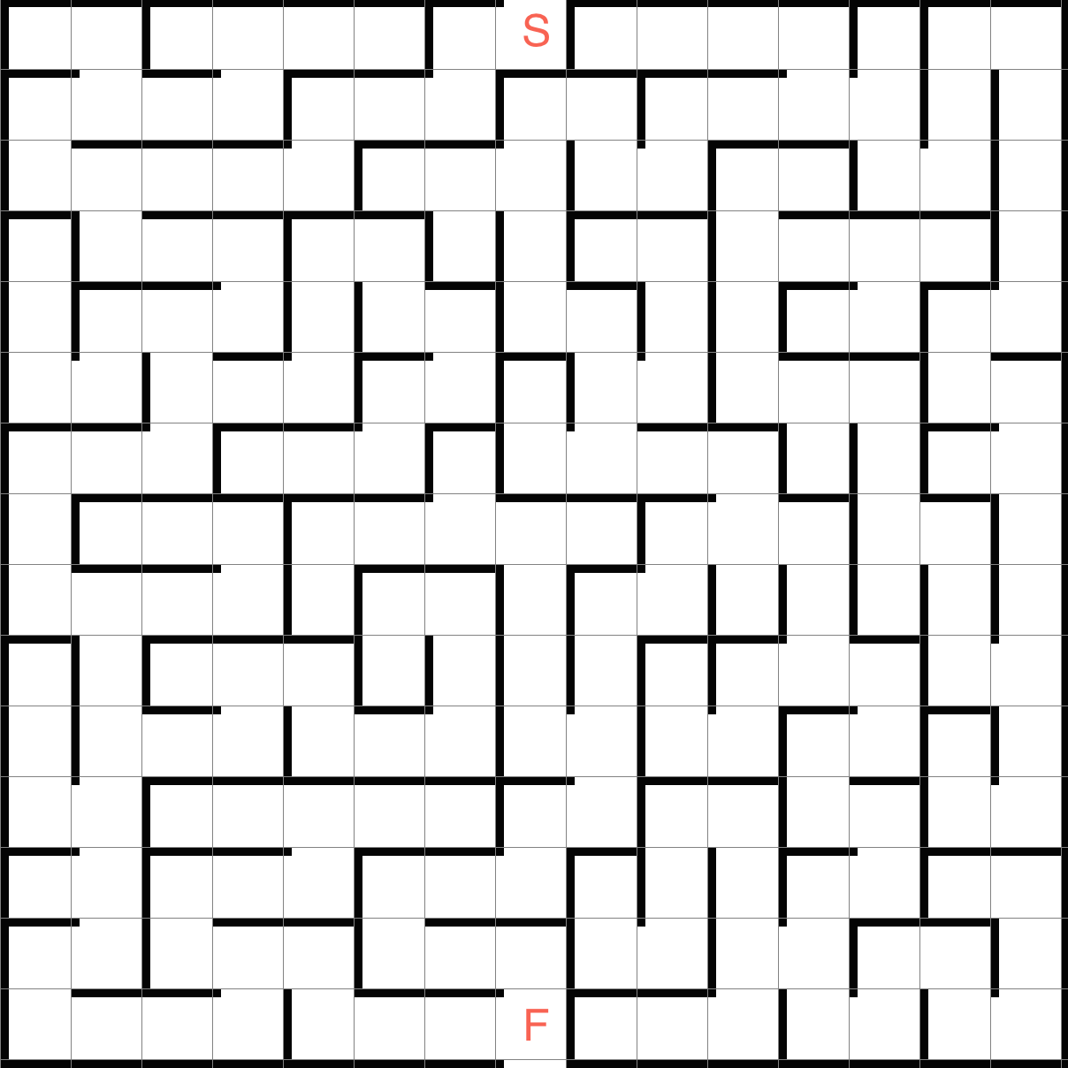

Solve the following puzzle and then write a program that moves you from “S” all the way to “F”. You can use any of the following commands to program:

* Move forward one space
* Turn left
* Turn right
* Repeat <#> times:

Once you are done, raise your hand so that one of us can check your work. Starting position facing downwards towards the opening.

