Program your partner using only 3 different types of commands in order to get them from the “S” to the “F”. Write down the commands you used get your friend to the end.

* Turn left
* Turn right
* Move forward one space

When you are done, raise your hand so that we can check your work and then switch roles and work on the other maze.

**Maze 1 (Start position facing downwards towards the wall):**

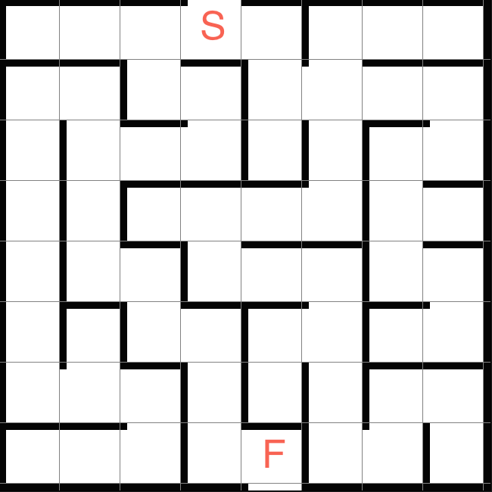

**Maze 2 (Starting position facing downwards against the wall):**

