Scratch!

Today we are going to be working on Scratch. Before we start, let’s sign in or create an account:

Go to <http://scratch.mit.edu/>

**I don’t have an account**

If you don’t have account do the following:

1. Click on the “Join Scratch”  
   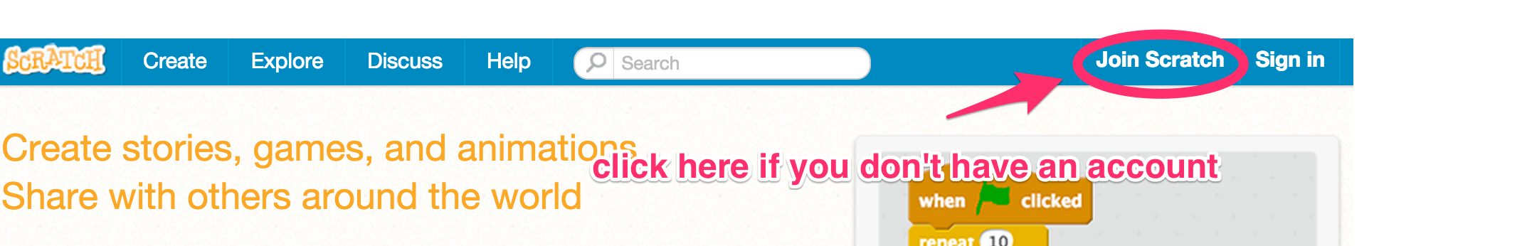
2. Pick a name and password  
   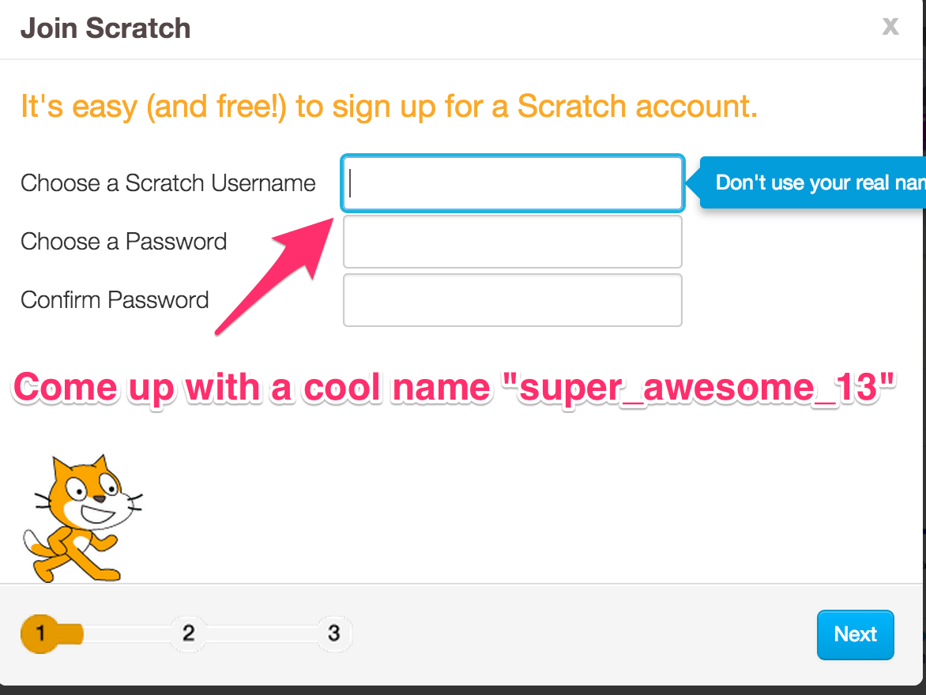
3. Fill out the rest of the form, and use [jstarker+missionbit@gmail.com](mailto:jstarker+missionbit@gmail.com) if you don’t have an email  
   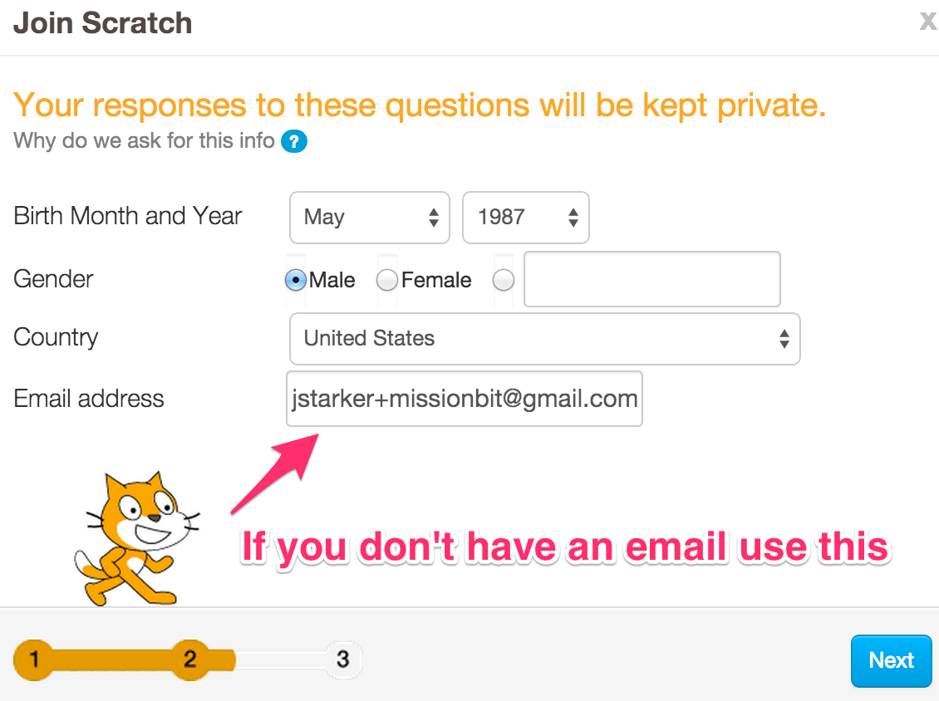
4. Click on the “Ok Let’s Go” when you are done.

**I have an account**

1. Go ahead and sign in by clicking on “Sign in” and fill out your username and password:  
   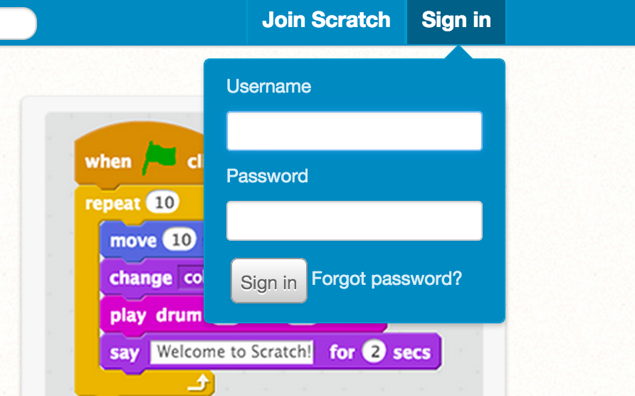

**The Activity:**

You are going to follow along with an activity to create a mini game. Do the following:

1. Open a new tab in your browser (press and hold “⌘” and then “T”)
2. Go the following address:
   * English: <http://goo.gl/YnKWiW>
   * Español: <http://goo.gl/D4yvaX>

Follow along with the instructions and let us know if you need any help!