21，Which of the following core areas will produce the smallest die size?
a) Nop-flipped and separated rows
b) Flipped and abutted rows
c) Flipped and separated rows
d) Non-flipped and abutted rows

22，Refer to layout A & B，which of the following is true:

A:W/L=2/0.5 B:W/L=4/0.25
a) B has the same area as A and double the drive.
b) B has double the area of A and half the drive.
c) B has the same area as A and the same drive.
d) B has 4X the area as A and the same drive.
e) B has 4X the drive as A and the same area.

23，which is correct?
a) Slack=Data arrival time － Data Required time
b) Slack=Data Required time － Data arrival time
c) Slack=Clock Arrival time － Data arrival time
d) Slack=Clock Required time － Data Required time

24，In the following figure, what is the total number of possible data arrival times for setup?
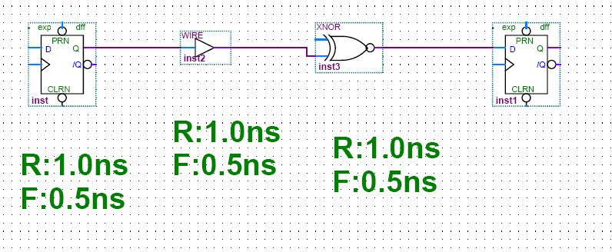
a) 1
b) 2
c) 3
d) 4

25，Which will always result in the worst slack for setup time?
a) The longest data arrival time.
b) The shortest data arrival time.
c) It is unclear as the slack is a function of data arrival time as well as data required time.

26，n-device is faster than p-device because Reduce Area
a) Hole mobility is greater than electron mobility.
b) Electron mobility is greater than hole mobility.
c) The P threshold is greater than N threshold.
d) The N threshold is greater than P threshold.
e) None of the above.

27，For a 25 MHz processor, what is the time taken by the instruction which needs 3 clock cycle
a) 120 nano secs
b) 120 micro secs
c) 75 nano secs
d) 75 micro secs

28，Which one is correct statement?
a) RTL models can be simulated only on cycle based simulator
b) Event driven simulators can simulate both synchronous and asynchronous designs
c) Multi clock designs can not be simulated with Event driven simulators
d) b and c

29，Formal analysis means:
a) Verifying designs with assertions using simulators
b) Verifying designs only with assertions statically
c) Analyzing functional coverage generated from the assertion IPs
d) a and c

30，Which language supports object oriented programming and good for RTL verification?
a) C++
b) Verilog with VPI
c) System Verilog
d) b and c

31.What is the difference between logic and bit types? (1%)
a) logic is 2 state, bit is 4 state
b) There is no difference
c) logic is 4 state, bit is 2 state
d) none of the above

32.How do you specify signal direction in a SystemVerilog interface? (1%)
a) through clocking blocks
b) Through cross module reference
c) Through modports
d) None of the above

33.How do I create a variable shared by all objects of a class, but not make a global? (1%)
a) declare it as automatic
b) declare it in the top scope
c) declare it as shared
d) declare it as static

34.How do I share code between classes? (1%)
a) Instantiate a class within another class
b) Inherit from one class to another (inheritance/derivation)
c) all of the above
d) None of the above

35.What is the final value of t1.data and t2.data in this code? (1%)
class Thing;
int data;
endclass
Thing t1, t2;
initial begin
t1 = new();
t1.data = 1;
t2.data = 2;
t2 = t1;
t1.data = 5;
end

a) t1.data = 5, t2.data = 5
b) t2 gets used before new() is called. Null object access!
c) t1.data = 5, t2.data =2;
d) None of the above

36. Write a constraint for the variable Q that picks a value of 0, for 75% of the time and 1~3 for the rest? (1%)
a) constraint c {Q dist {0 := 75, [1:3] := 25} ; }
b) constraint c { Q < 4; Q >= 0; }
c) constraint c { Q < 4; Q >= 0; Q%2 dist {0 := 75, 1:= 25}; }
d) constraint c { Q < 4; Q >= 0; Q%3 dist {0 := 25, 1:= 25, 2:=25, 3:= 75 }; }

37. What are the possible values that x and y will take when the following class is randomized (1%)

class E;
rand bit [15:0] x[10], y[10];
constraint size_cons {
foreach (x[i]){
x[i] > 0; x[i] < y[i];
foreach (y[i])
y[i] inside {[1:9]};
}}
endclass
a} x in [0,9], y in [0,9]
b) x in [1,9], y in [1,9]
c) x in [1,9], y in [2,10]
d) x in [1,8], y in [2,9]

38. What is the final value of t1.data and t2.data in this code? (1.0%)

class Thing;
int data;
endclass
Thing t1, t2;
initial begin
t1 = new();
t1.data = 1;
t2.data = 2;
t2 = t1;
t1.data = 5;
end

a) t1.data = 5, t2.data = 5
b) t2 gets used before new() is called.
Null object access!
c) t1.data = 5, t2.data =2;
d) None of the above

39. The new intern Smart Assert can not write simple assertions. He wrote:
( a ##1 (!b[*0:$] ##1 b)[*3:5] ## 1C )

While the assertion works correctly, can you help him write it in a simplified form? Please choose one correct answer from A), B), C) and D): (1.0%)

A)property abc_sequence_with_!b_random_space_between;
@(posedge clk) $rose(a)##1 b|-> b[*3:5] ##1c;
endproperty: abc_sequence_with_!b_random_space_between;

B)property abc_sequence_with_!b_random_space_between;
@(posedge clk) a##1 b[=3:5] ##1 c;
endproperty: abc_sequence_with_!b_random_space_between;

C)property abc_sequence_with_!b_random_space_between;
@(posedge clk) a##1 !b[*0:$] ##1 b[*3:5] ##1 c;
endproperty: abc_sequence_with_!b_random_space_between;

D)property abc_sequence_with_!b_random_space_between;
@(posedge clk) a##1 b[->3:5] ##1 c;
endproperty: acb_sequence_with_!b_random_space_between;

40. Consider a bus protocol that includes the property “a new bus cycle may not start for 2 clock cycles after an abort cycle occurs.” This property could be coded as below. Please choose one correct answer from A), B), C) and D). (1.0%)

A）property wait_after_abort;
@(posedge clk) wait（abort_cycle） ##2 !cycle_start;
endproperty: wait_after_abort ;

B）property wait_after_abort;
@(posedge clk) while (abort_cycle) ##2 Not(cycle_start) ;
endproperty: wait_after_abort

C）property wait_after_abort;
@(posedge clk) abort_cycle |=> !cycle_start[*2];
endproperty: wait_after_abort

D）property wait_after_abort;
@(posedge clk) abort_cycle |-> Not(##2 cycle_start);
endproperty: wait_after_abort

41. 考虑以下两个逻辑表达式 f 和 g,
Consider the following logic expressions for f and g :
ƒ = x₁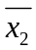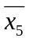₊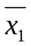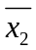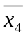₊x₁x₂x₄x₅₊x₃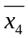₊ x₁x₃x₅ ₊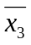x₄₊ x₁x₂x₃x₄
g =x₃₊₊ x₁x₃x₄₊ x₁x₄₊ x₁ x₃x₄x₅₊₊ x₁x₂x₄x₅
证明这两个表达式相等或者不相等。若用定理证明必须写出每个步骤和所用定理名，否则不给分数。（占10%）
Prove or disprove that ƒ = g. Steps of logic simplification must be provided with the name of theorems used, or else no marks will be given.

答案：当x₅＝0时，f=x₁ + + x₃ + x₄ +x₁ x₂x₃x₄ ；
当x₅＝1时，f=x₁ x₂x₄ ＋ x₃ ＋ x₁x₃；
当x₅＝0时，g=x₃ + + x₁x₃x₄ + x₁x₄ + ；
当x₅＝1时，g=x₃ + x₁x₃x₄ + x₁ x₂x₄；
f的卡诺图如下所示：
x₅＝0 |  | x₁ x₂
 |  | 00 | 01 | 11 | 10
x₃x₄ | 00 | 1 | 0 | 0 | 1
x₃x₄ | 01 | 1 | 0 | 0 | 1
x₃x₄ | 11 | 0 | 0 | 1 | 1
x₃x₄ | 10 | 1 | 0 | 0 | 1

x₅＝1 |  | x₁ x₂
 |  | 00 | 01 | 11 | 10
x₃x₄ | 00 | 0 | 0 | 0 | 0
x₃x₄ | 01 | 0 | 0 | 1 | 0
x₃x₄ | 11 | 0 | 0 | 1 | 1
x₃x₄ | 10 | 1 | 0 | 0 | 1
g的卡诺图如下所示：
x₅＝0 |  | x₁ x₂
 |  | 00 | 01 | 11 | 10
x₃x₄ | 00 | 1 | 0 | 0 | 1
x₃x₄ | 01 | 1 | 0 | 0 | 1
x₃x₄ | 11 | 0 | 0 | 1 | 1
x₃x₄ | 10 | 1 | 0 | 0 | 1

x₅＝1 |  | x₁ x₂
 |  | 00 | 01 | 11 | 10
x₃x₄ | 00 | 0 | 0 | 0 | 0
x₃x₄ | 01 | 0 | 0 | 1 | 0
x₃x₄ | 11 | 0 | 0 | 1 | 1
x₃x₄ | 10 | 1 | 0 | 0 | 1
根据表达式f和g的卡诺图得，f＝g。

42. 在标准单元技术中，电路是由一些实现简单逻辑功能的构件块（例如基本的逻辑门）互相连接组成的。 (In standard cell technology, circuits are built by interconnecting building-block cells that implement simple functions, like basic logic gates.) 有一种常用的标准单元叫做与或反向器（and-or-invert, 缩写为AOI），该AOI单元逻辑图如下图所示，(A commonly used type of standard cells is And-Or-Invert (AOI), which can be efficiently built as CMOS complex gates. Consider the AOI cell shown in the following Figure: )其逻辑表达式为：(This cell implements the function ) f =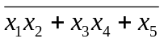.。 画出由CMOS三极管实现该单元逻辑功能的成本最低的电路。(Derive the CMOS complex gate that implement this cell.) （占10%）

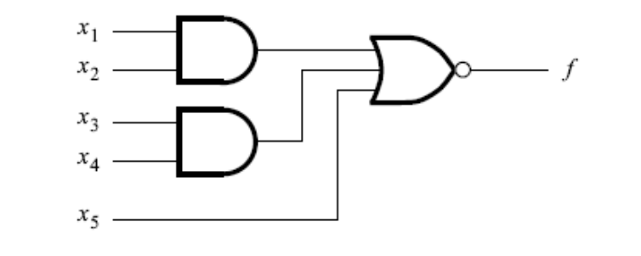
The AOI cell for question 2

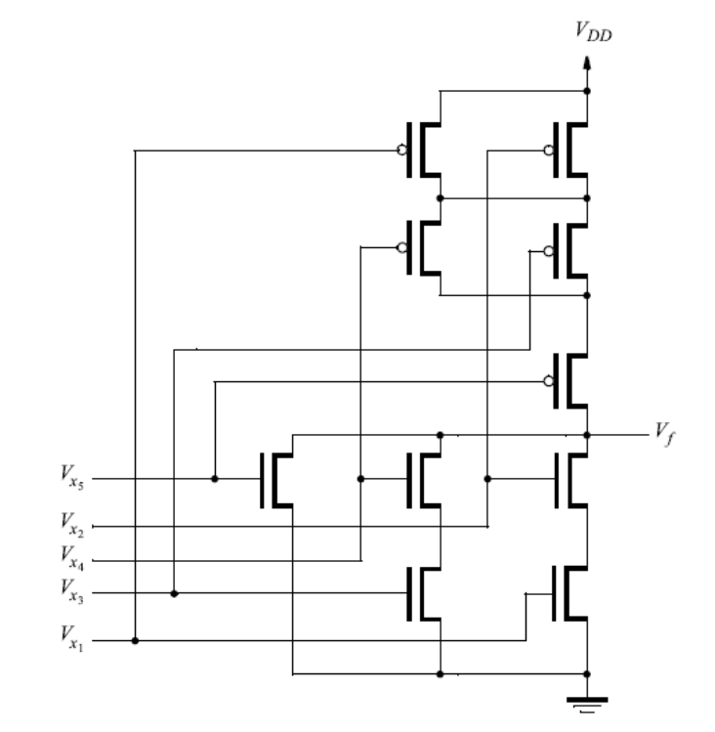
43. 设有以下逻辑函数 f :
Implement the following function:
f (w₁,w₂,w₃,w₄,w₅) = 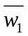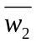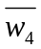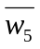 + w₁w₂ + w₁w₃ + w₁w₄ + w₃w₄w₅
假设输入信号w₁,w₂,w₃,w₄和w₅ 全都没有可用的反相信号，请用4选1多路器和尽可能少的门实现该逻辑函数。（占10%）
by using a 4-to-1 multiplexer and as few other gates as possible. Assume that only the
uncomplemented inputs w1, w2, w3,w4 and w5 are available.

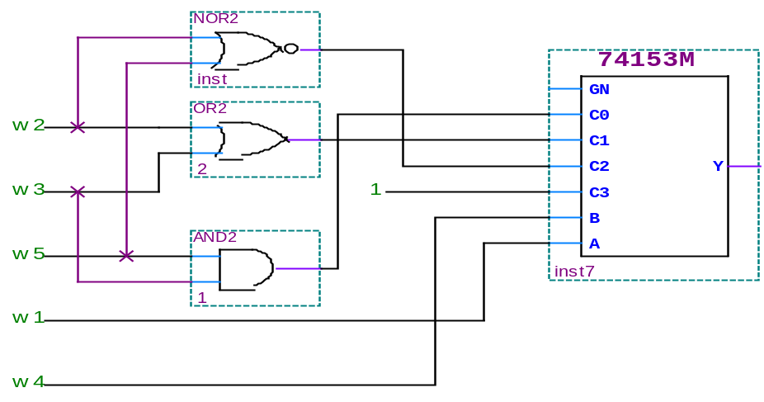

44. 某时序电路有两个输入w1 和 w2，一个输出z。其功能是将输入的两个序列进行比较。若在四个连续的时钟周期里 w1 = w2，则电路输出z = 1，否则z = 0。举例说明如下：(A sequential circuit has two inputs, w1 and w2, and an output , z .Its function is to compare the input sequences on the two inputs . If w1 = w2 during any four consecutive clock cycles, the circuit produces z = 1; otherwise , z = 0. For example
)
w1 : 0110111000110
w2 : 1110101000111
z : 0000100001110

推导出该电路。写出描述该电路有限状态机的Verilog或者VHDL代码。（占10%）
(Derive a suitable circuit . Write the Verilog or VHDL codes for the FSM which describes the circult.)

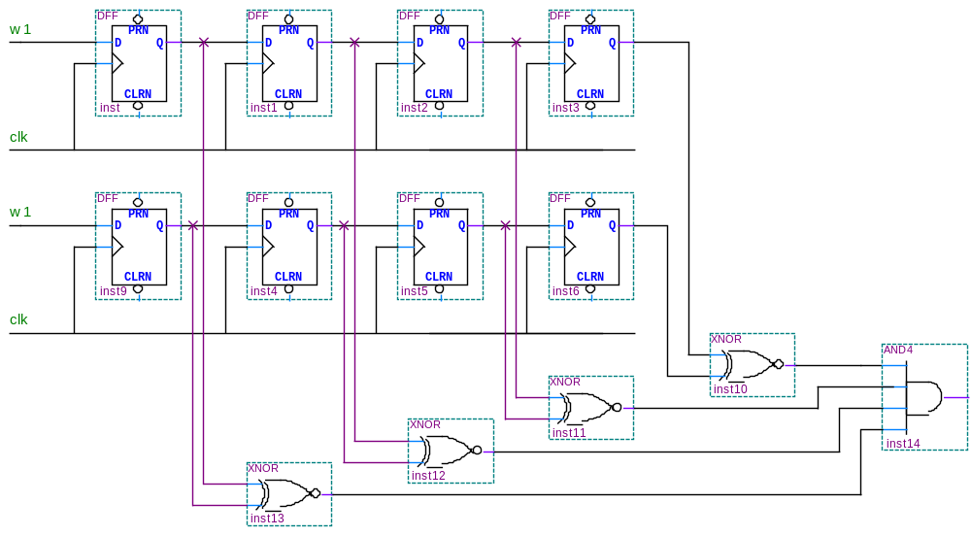
Verilog代码：
`timescale 1ns/1ns
module state( w1,
w2,
z
);
input clk;
input w1,w2;
output reg z;

reg[1:0] state；

always@(*)
case(state)
2'b00: begin if(w1==w2)
state<=2'b01;
else
state<=2'b00;
end

2'b01: begin if(w1==w2)
state<=2'b10;
else
state<=2'b00;
end

2'b10: begin if(w1==w2)
state<=2'b11;
else
state<=2'b00;
end

2'b11: begin if(w1==w2)
state<=2'b11;
else
state<=2'b00;
end

default: begin if(w1==w2)
state<=2'b01;
else
state<=2'b00;
end
endcase

always@(posedge clk)
if(state==2'b11 && w1==w2)
z<=1'b1;
else
z<=1'b0;

endmodule

45. 设被测试电路如下图所示，写出能检测出以下各个故障的测试：（占5%）
(For the circuit of Figure below, show the tests that can detect each of the faults:)
w₁/0, w₄/1, g/0, c/1.

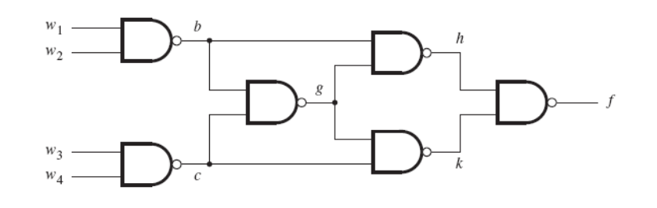

测试故障 | w1 | w2 | w3 | w4 | 正确输出 | 故障输出
w₁/0 | 1 | 1 | 1 | 1 | 0 | 1
w₄/1 | 1 | 1 | 1 | 0 | 1 | 0
g/0 | 1 | 0 | 1 | 1 | 1 | 0
c/1 | 1 | 1 | 1 | 1 | 0 | 1
测试g/0故障只要使b、c中一个为0，一个为1即可。

46. 某电路只有一个输入w 和一个输出 z。向输入端w 输入一系列脉冲。请画出组成该电路的逻辑门，使得输出端 z 的波形必须每隔两个脉冲才与输入端w的脉冲一致，具体波形见下图所示。（注意：不能用触发器）（占15%）
（A circuit has an input w and an output z. A sequence of pulses is applied on input w. The output has to replicate every third pulse, as illustrated in Figure low. Design a suitable circuit which is composed only by gates with delay, no flip-flops are allowed in the circuit.）
w
z

答案：
根据46题的图，可以得出六个状态，如下图所示：
w
z
S₁
S₂
S₄
S₃
S₆
S₅
S₁
S₂
S₃
S₄
S₅
S₆

根据这六个状态可以得出一个激励表：
Current state  y₁y₂y₃ | Next state Y₁Y₂Y₃ |  | Output  Z
Current state  y₁y₂y₃ | W=0 | W=1 | Output  Z
000(S₁) | 000 | 001 | 0
001(S₂) | 010 | 001 | 1
010(S₃) | 010 | 011 | 0
011(S₄) | 100 | 011 | 0
100(S₅) | 100 | 101 | 0
101(S₆) | 000 | 101 | 0
注：上表中粗体红色的为稳定状态。
根据上表中的稳定状态可得以下状态表达式和输出表达式：
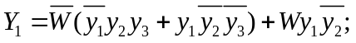
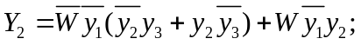
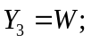
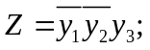
根据状态表达式和输出表达式可以得出如下电路图：
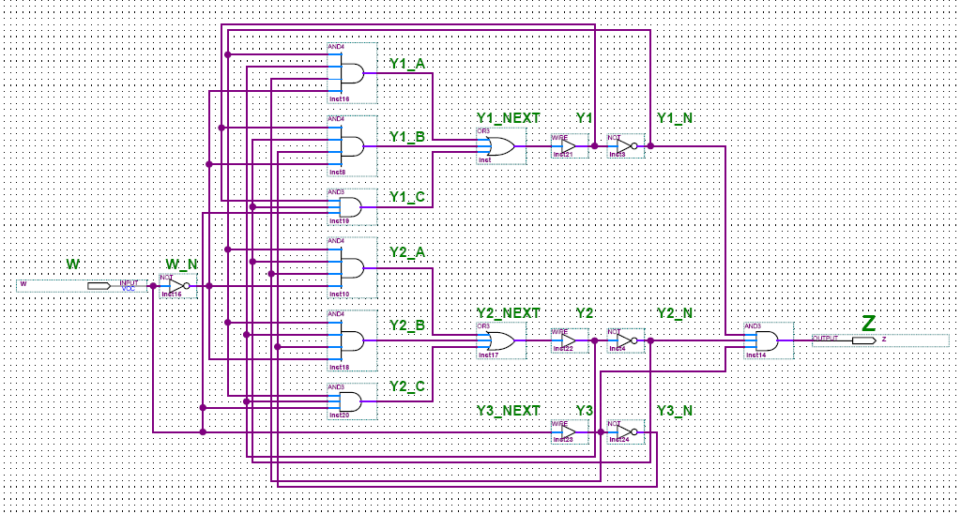
注：这只是解答此题答案中的一种，根据状态设置的不同可以得出不同的逻辑电路。（附件中有此题的Verilog代码和测试程序 The Verilog programs in the fold are used to verify the design. ）

47. 画出下面电路图的状态表。该电路能检测信号线w上输入的是什么序列？(占10%)
（Derive the state table for the circuit below. What sequence of input values on wire
w is detected by this circuit?）
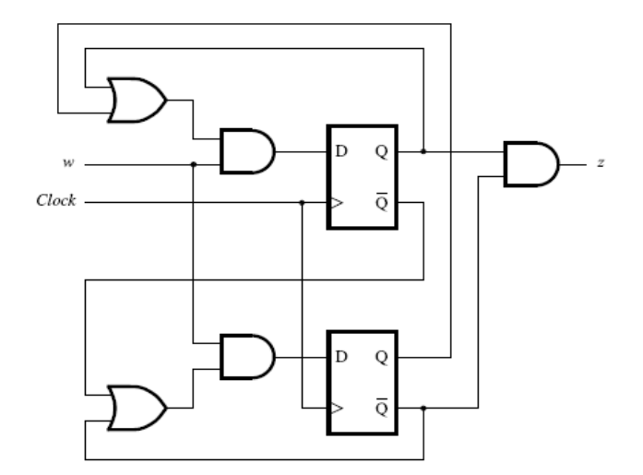

答案：
根据逻辑电路图得出状态表达式和输出表达式如下：
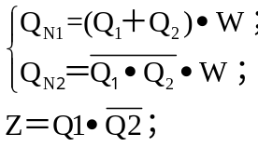

由此得出状态表如下：
Current state  Q₁Q₂ | Next state Q_{N1}Q_{N2} |  | Output  Z
Current state  Q₁Q₂ | W=0 | W=1 | Output  Z
00 | 00 | 01 | 0
01 | 00 | 11 | 0
10 | 00 | 11 | 1
11 | 00 | 10 | 0
根据状态表，W从0变1后经过三个时钟的上升沿才有输出1；当W从0变1后超过三个时钟，输出Z一直保持101010……这样交替变化。但是，当W从0变1后，维持少于或者等于两个时钟又变0，输出仍然为0。所以，改电路能检测信号线w上输入的脉冲宽度大于2的序列。

48. 写出表示下面逻辑电路行为的状态表达式和输出表达式，分析是否会产生冒险竞争，如果存在冒险竞争，你准备如何解决？(10%)
（Derive the expressions for states and an output for the circuit below. Are there any hazards in the circuit ? How do you plan to solve it?）
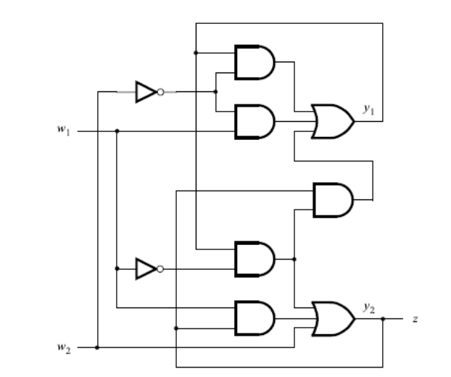
答案：
根据逻辑电路图得：
状态表达式：
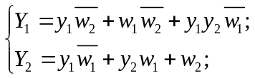
输出表达式：
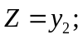

因此，可以写出Y₁和Y₂的卡诺图得：
Y₁ |  | w₁w₂
 |  | 00 | 01 | 11 | 10
y₁y₂ | 00 | 0 | 0 | 0 | 1
y₁y₂ | 01 | 0 | 0 | 0 | 1
y₁y₂ | 11 | 1 | 1 | 0 | 1
y₁y₂ | 10 | 1 | 0 | 0 | 1
Y₂ |  | w₁w₂
 |  | 00 | 01 | 11 | 10
y₁y₂ | 00 | 0 | 1 | 1 | 0
y₁y₂ | 01 | 0 | 1 | 1 | 1
y₁y₂ | 11 | 1 | 1 | 1 | 1
y₁y₂ | 10 | 1 | 1 | 1 | 0

因为在Y₂的卡诺图中有两项乘积项存在相切的情况（当w₂y₁y₂＝011时，w₁从1到0或者从0到1都可能发生冒险），所以必须加一个冗余项，如图红圈所示的y₁y₂。状态表达式修改如下：
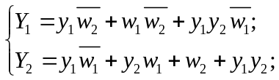
这样便可以消除电路中的冒险竞争。

49. 设某电路能将用下面协议表示的三位串行数据转换成8位独热码数据pdata[7:0]输出（即某条输出线电平为1，其余各条均为0 ）。 该协议规定：当信号sclk为高电平时，sdata 从高变为低表示sdata准备开始送数，先送最低位bit0，该位可以为1，也可以为0，但变化必须在sclk为低时进行。按照同样方式送出bit1 和bit2。当信号sclk为高电平时，sdata 从低变为高表示sdata信号送数结束。请参考如下波形理解协议。(不允许再添加任何其他输入信号) 写出描述以上电路行为的可综合的Verilog或者VHDL电路模型。(占15%)
（Assume a circuit that can convert the serial bit flow, sdata, into an output of one hot bit parallel data, pdata[7:0] . The protocol for the serial bit flow, sdata, is that LSB is sent first, and MSB last. That sdata changes from 1 to 0 when sclk is high, means that the sdata is ready to send. That sdata changes from 0 to1, when sclk is high, means that the sdata sending has been finished. And sdata bits can only change its 1/0 when sclk is low. See the waveform below. Write the synthesizable Verilog or VHDL model for the circult with the above behave. No other signals can be used ).

sclk
1/0
sdata
1/0
1/0
1/0

答案：
Verilog代码如下：
-------------------------------------------------------------
`timescale 1ns/1ns
module s2p(
input sclk,
input sdata,
output reg [7:0] pdata
);
//--------------------------local signals declarations------------
reg start_flag;
reg stop_flag;
reg sdata_shift_enable;
reg [3:0] sdata_shift;
//--------------------------module body---------------------------
//start_flag
always @(negedge sdata or negedge sclk) begin
if(!sclk)
start_flag <= 1'b0; //asynchronous reset
else
start_flag <= 1'b1;
end
//stop_flag
always @(posedge sdata or negedge sclk) begin
if(!sclk)
stop_flag <= 1'b0; //asynchronous reset
else
stop_flag <= 1'b1;
end
//sdata_shift_enable
always @(posedge sclk or posedge start_flag or posedge stop_flag) begin
if(start_flag)
sdata_shift_enable <= 1'b1; //asynchronous set
else if(stop_flag)
sdata_shift_enable <= 1'b0; //asynchronous reset
end
//sdata_shift
always @(posedge sclk) begin
if(sdata_shift_enable)
sdata_shift <= {sdata,sdata_shift[3:1]};
end
//pdata
always @(posedge sdata) begin
if(sclk)
case(sdata_shift[2:0])
3'd0 : pdata <= 8'b00000001;
3'd1 : pdata <= 8'b00000010;
3'd2 : pdata <= 8'b00000100;
3'd3 : pdata <= 8'b00001000;
3'd4 : pdata <= 8'b00010000;
3'd5 : pdata <= 8'b00100000;
3'd6 : pdata <= 8'b01000000;
3'd7 : pdata <= 8'b10000000;
default : pdata <= 8'b00000000;
endcase
end
endmodule

50. 用Verilog或者VHDL写出能全面测试以上电路的测试平台。
（Using Verilog or VHDL to write the test-bench for fully testing and verify the above ciucuit.）(占5%)

答案：
Verilog代码如下：
-------------------------------------------------------------------------------
`timescale 1ns/1ns
`define CYCLE 100
module testbench;
//--------------------------local signals declarations------------
reg sclk;
reg sdata;
wire [7:0] pdata;
event transfer;
reg processing;
reg [2:0] data;
//--------------------------modules instantiation-----------------
s2p s2p_inst(
.sclk(sclk),
.sdata(sdata),
.pdata(pdata)
);
//--------------------------module body---------------------------
//sclk
initial begin
sclk=0;
forever #(`CYCLE/2) sclk=~sclk;
end
//other signal
initial begin
sdata=1;
processing=0;
#500000 $stop;
end
//transfer
always @(posedge sclk) begin
#(`CYCLE/8)
#({$random}%(`CYCLE/4))
if(!processing)
-> transfer;
end
//transfer process
always @(transfer) begin
processing=1;
data={$random}%8;
$write("sdata:\t%3b\t",data);
sdata = 0; //start bit
#(`CYCLE/2) sdata = data[0];
#(`CYCLE) sdata = data[1];
#(`CYCLE) sdata = data[2];
#(`CYCLE) sdata = 0;
#(`CYCLE/2) sdata = 1; //stop bit
#1
$write("pdata:\t%8b\t",pdata);
if(pdata==1<<data)
$write("ok!\n");
else
$write("error!\n");
processing=0;
end
endmodule

------------------------------------------------------------------------------------------------------
以上答案由神州龙芯IC设计公司 甘伟 工程师提供，经 夏宇闻 老师核对正确无误。

若有错误欢迎指正，也欢迎同学们提出不同解决办法。建议在网上组织讨论，以提高同学们基础数字电路的设计能力。
----------------------------------------------------------------

