Q&A about
majoring in Computer Science or Computer Information Systems
at Meredith

WHAT STUDENTS SAY…
Why did you decide to major in CS or CIS?
"I like to know how things work."
"It's just so logical."
"It wasn't what everyone else was doing, I wanted to be different."
"I've always been good at solving ... puzzles."
What's your favorite thing about being a CS or CIS major?
"I enjoy the hands on experience. .... It's like trying to solve a puzzle."
"Getting to solve problems and create cool programs. I also like that there are so many different ways to solve a problem, so your answer doesn't have to be exactly like everyone else's."
Rebecca Fosdick's research involved building robots from Legos, then programming them to move and pick up things.
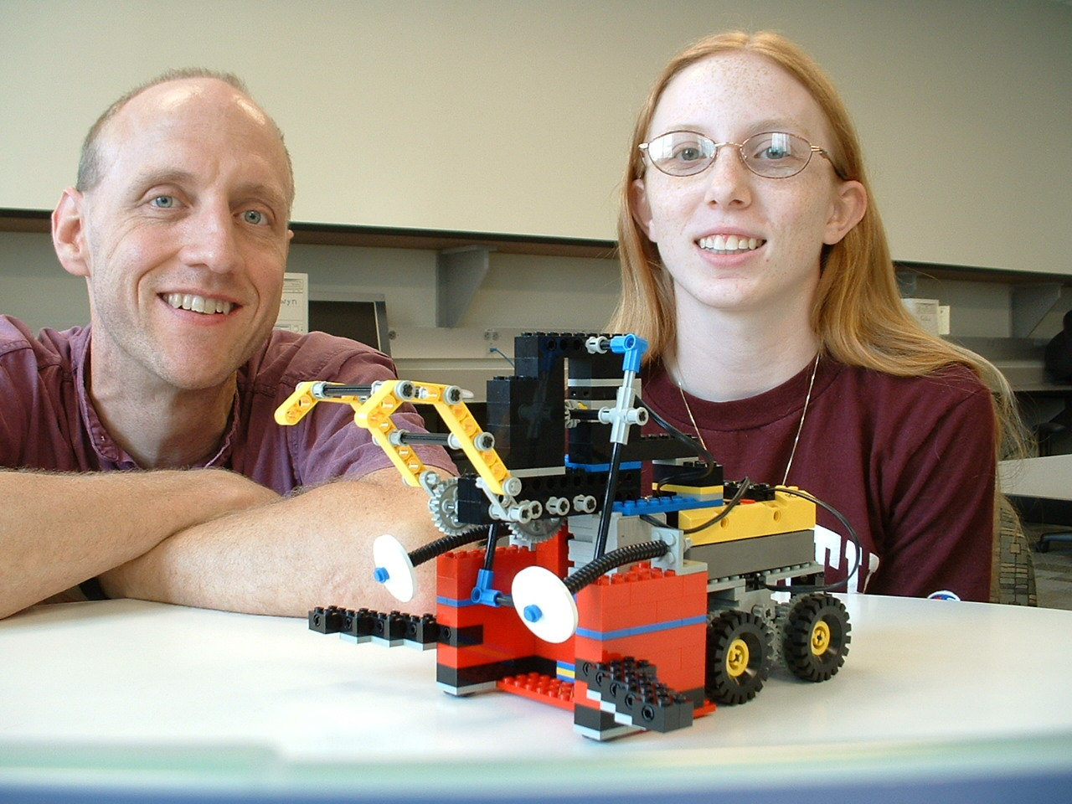
If you wanted to major in computers, why didn't you go to a big state school?
"I didn't want to be stuck in an auditorium with hundreds of other students. If I went to NC State, I wouldn't have gotten the experience of having my professors not only know my name, but also know me."

"The Faculty!!!!!"

"Because I liked the small, close-knit community that Meredith is… the classes are so small, it is so much easier to learn that way."
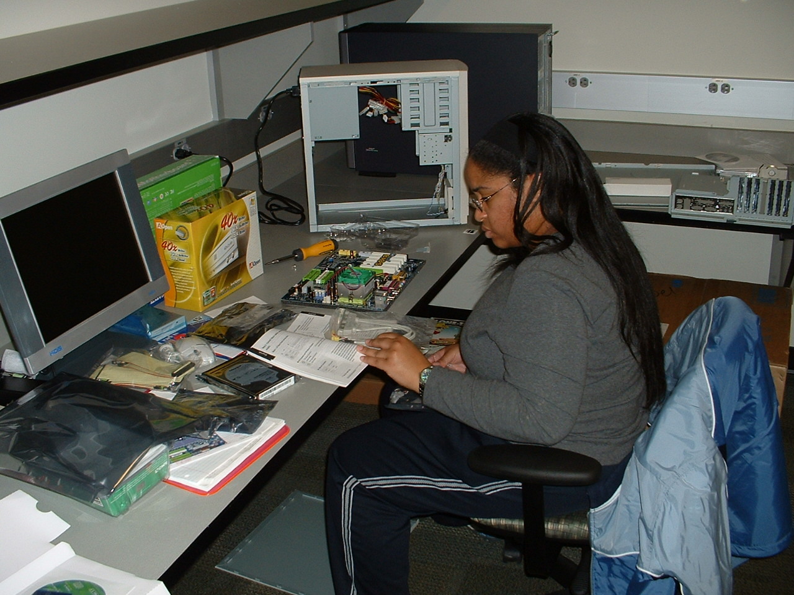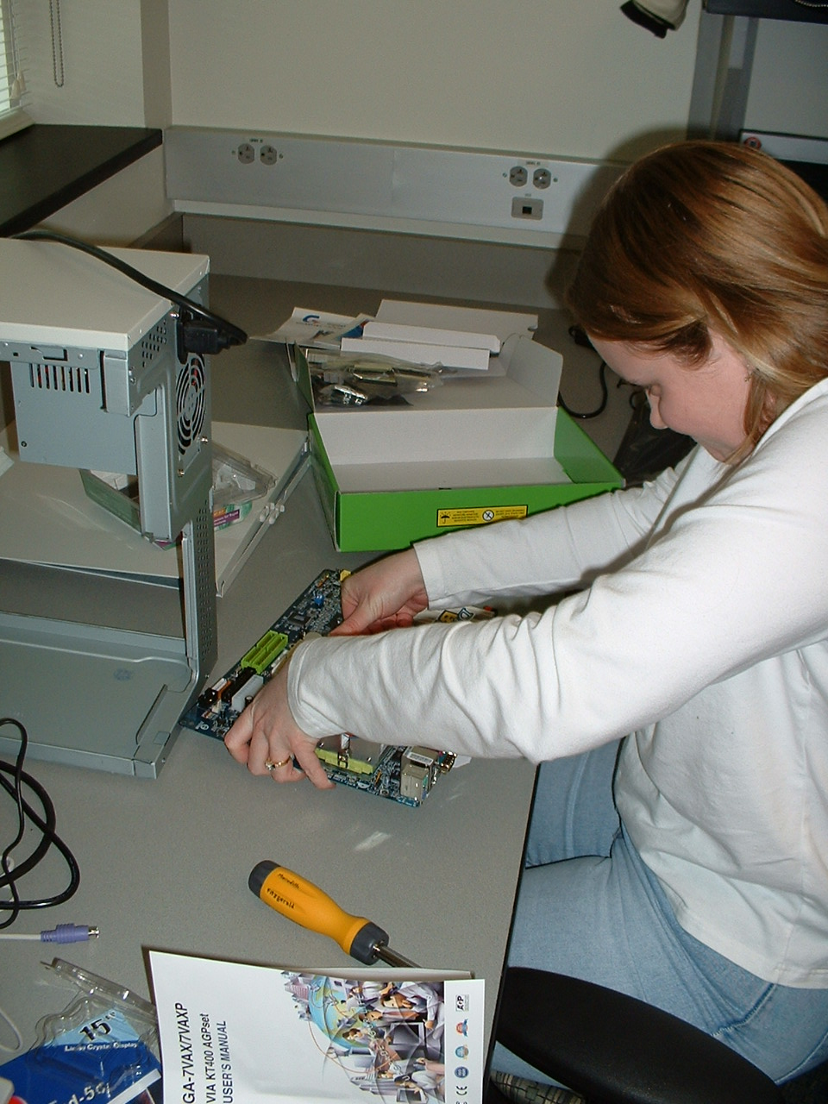
Meredith students learn about computer hardware
by building computers for the Bit Lab
"The faculty at Meredith have a really great attitude toward the students. There's not this 'sink or swim, I don't care' atmosphere… the material is just as challenging, but the professors want students to succeed and are available and willing to help."
"The combination of having small classes and having all women makes a much easier environment for building confidence through gaining skills. I wasn't 'into' computers growing up… I was starting from ground zero. Some guys can be a little chauvinistic when it comes to computers. I wanted a more cooperative atmosphere."
What do you think makes a person be "cut out" for CS or CIS?
"One who enjoys problem solving and refuses to give up."
"I believe that it starts with a basic interest in computers. I don't believe that you have to be a geek or a nerd if you want to learn about computers."
"Problem-solving, the ability to think on a detailed level, and being interested in how things work. You don't necessarily have to be a math type to be a good programmer or systems administrator (or a lot of other really good computer jobs out there)."

What is the biggest myth about computer majors?
"That 'computer people' just eat and breathe computers, that it's our whole life. In reality, we have tons of other interests and activities as well."
"I think that some people think that computer majors know everything that there is to know about computers. I don't know everything and I'm not trying to know everything."
"[That] we are geeks... well, we are geeks, but we are cool geeks "
"All we do is sit at the computer all day."
"… that you have to be really into computers and technology to enjoy programming. Anyone can program - anyone who understands logic."

WHAT FACULTY SAY…

What do you think makes a person be "cut out" for CS or CIS?
"For CS students, I look for attitude. CS people try stuff, have the confidence to break things."
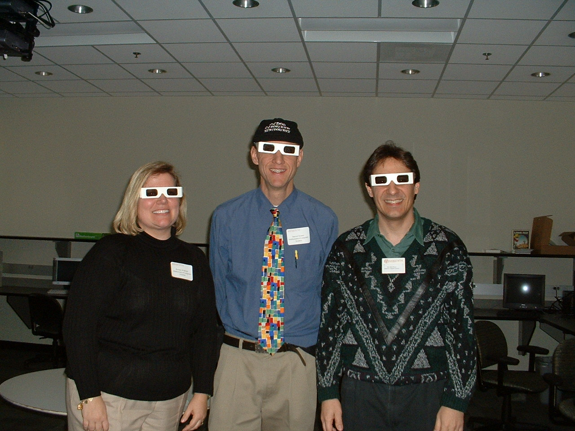
Meredith computer faculty, stylin' in the ever-so-fashionable 3D glasses. The Bit Lab is equipped with a stereo projector that allows viewing of 3D images.
"…interest in computers and how they work, enjoys or at least does not hate using computers, an appreciation for using reason and logic“
What is the difference between Computer Science and Computer Information Systems?
"CIS is more business and user oriented, and as such CIS people are … usually more into the mechanisms of PEOPLE with computers as helpers. CS people are more concerned about just the computer's functions, what we can make the machine do. CS tends to be more technical, mathy and sciencey."
What is the biggest myth about computer majors?
"[That] computer people are only interested in computers to the exclusion of everything else in the universe. "
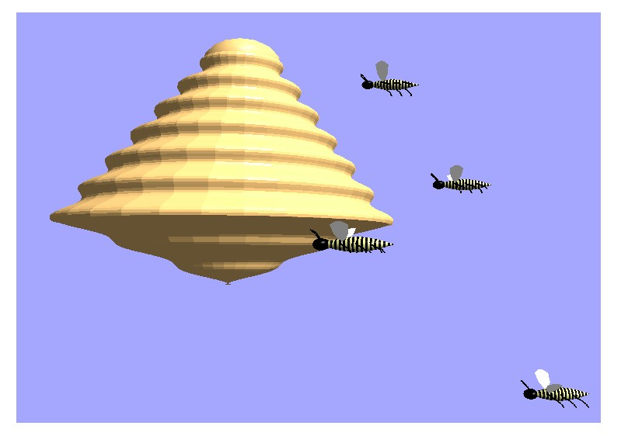
"The biggest myth about computer majors is that they are antisocial. I think it's promulgated by guys who don't want to be threatened…it's a punishment for a woman being smart…"
Students in a graphics course create 3D-stereo animated interactive scenes with technology available in the new Science and Math Building.

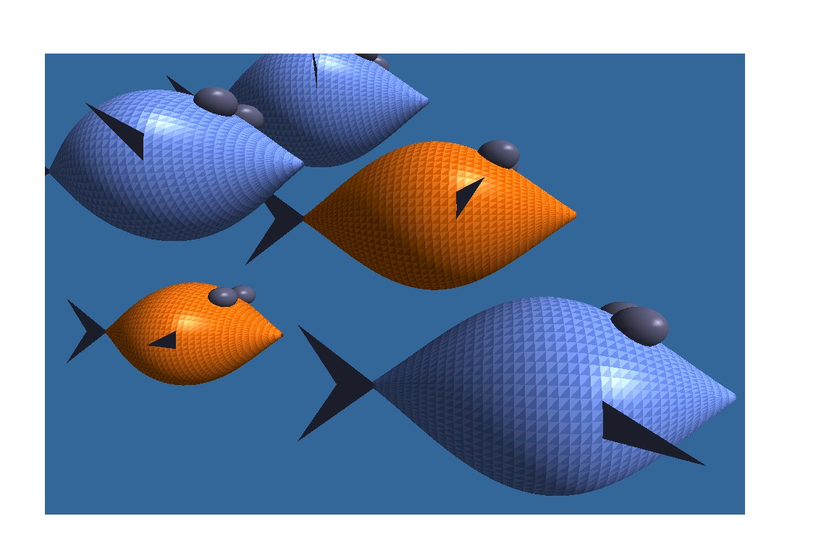
Spheres, cones, and sine waves become the raw materials for beehives, fish, and other animated figures.

WHAT ALUMNAE SAY…
"When I first came to Meredith, I never thought I would graduate with a computer science degree. Now I can not imagine doing anything else with my career!"
"Dr. Rosso made me a major because he believed in me and saw potential I overlooked!!!!"
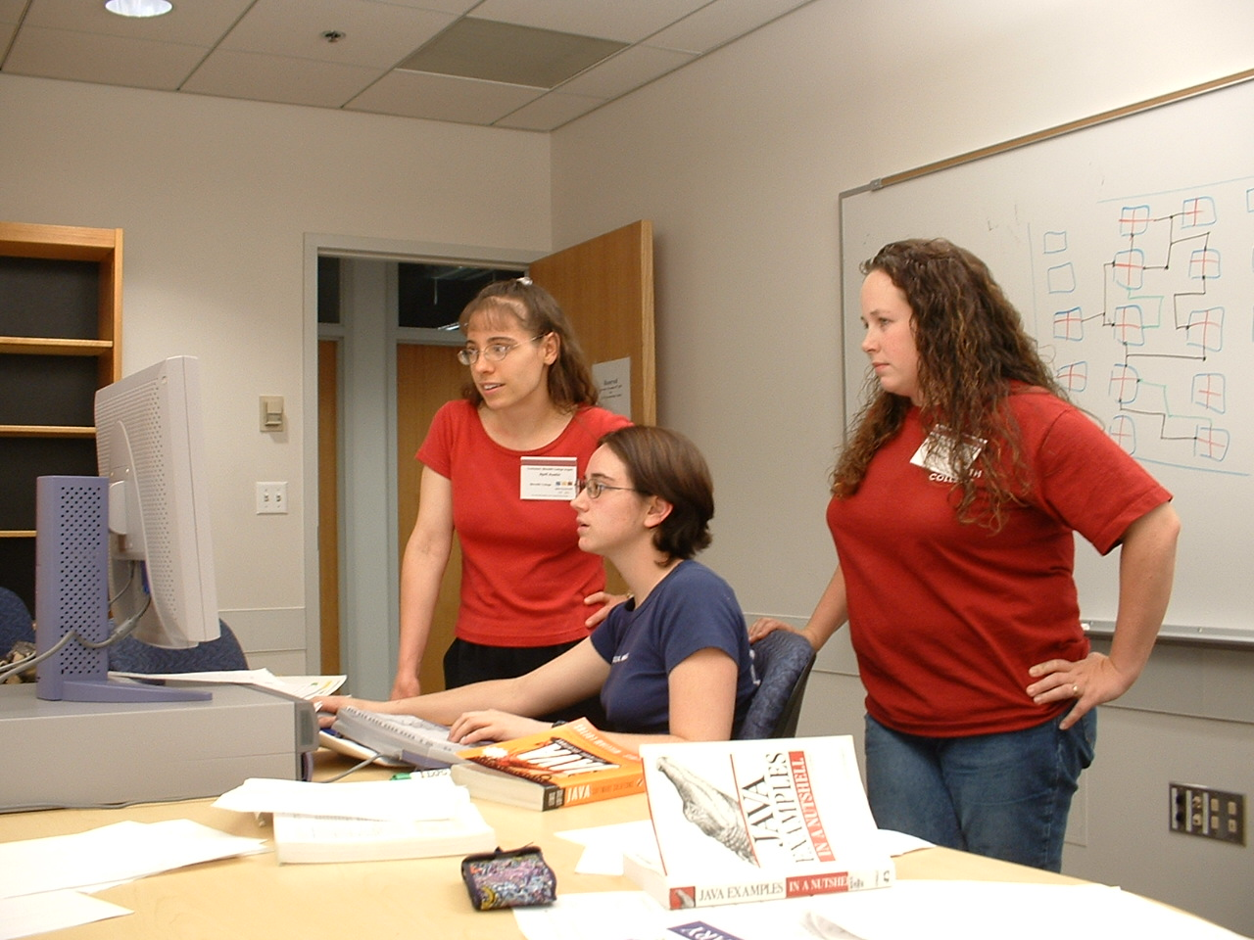
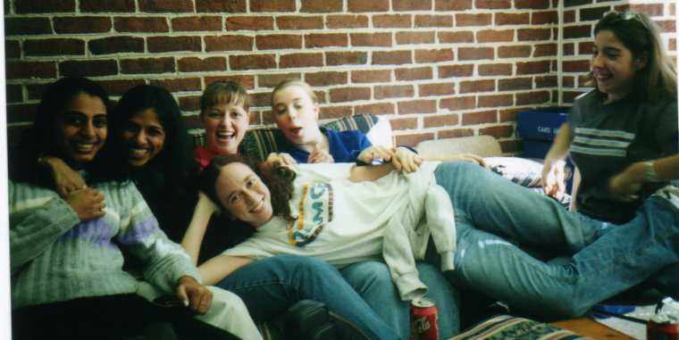
Each year, Meredith students compete in an international programming competition.

"CIS and CSC are challenging, but fun subjects. At Meredith you get a state-of-the-art facility and very personal attention with small class sizes. You get to know your professors and they know you and how you code. The large state schools with more popular computer programs have computers check your work, not a human. At Meredith you get real feedback and learn to write neater, better code."
"The CSC/CIS faculty [are] a huge reason to be a major! They are personable, knowledgeable, and quite a bit silly."
"My degree in computer science from Meredith more than adequately prepared me for my graduate work in computer science. In fact some of my graduate work was a review because the undergraduate studies had been so comprehensive."
"Computer science is not an easy field, but the program at Meredith is hands-on and the individual attention you receive goes a LONG way towards your understanding of the important concepts. I would never have chosen computer science as my major if I had not been at Meredith."
"The computer science program at Meredith laid a solid foundation for my career in computer science. I not only have the basic building blocks, but I also gained the ability to learn new concepts on my own and in a short amount of time. This skill is critical in the computer science field where technology is constantly changing."
"The hands-on experience in the computer labs at Meredith is very valuable to me."
"My undergrad in Computer Science from Meredith prepared me for my Masters in Computer Science at N.C. State. The Computer Science courses at Meredith created a very strong foundation for me."

For more information contact:
Dr. Barrett Koster
Dept. of Math and Computer Science
Meredith College
271 Science & Math Bldg.
3800 Hillsborough St.
Raleigh NC 27607-5298
919-760-2388
kosterb@meredith.edu
http://www.meredith.edu/math
http://www.bitlab.meredith.edu
revised 2005 Mar 24

Computer
Studies
at Meredith College

Could you be good at computers?
See what students, faculty and
alumnae say about
Computer Information Systems and Computer Science at Meredith.

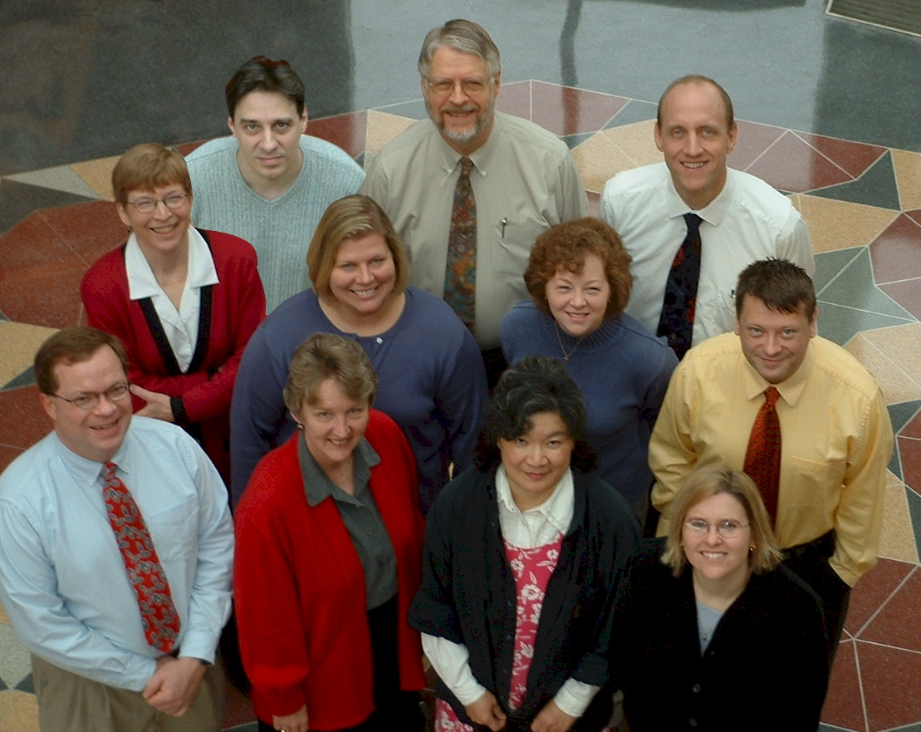

Math and Computer Science Faculty

