**Arena Z 3-15-2021 - Adding Chat & messaging.**

**1. Check the graphics. We’re going to put visual messaging or emoticons in the game.  
  
2. Create a table called player messages:**

**In it it should have:  
  
Game_id: ID of the game… <= this is not required. We might use the same table to send different forms of messaging.  
  
From_User_id: User_id  
  
To_User_id: User_id  
  
Message: 150 characters.   
  
Date/time:  
  
Seen: 1 or 0 <= if the To user has seen it yet, meaning we’ve loaded the message on his screen as an alert.  
  
2. In the game, as the game is going. Query this table for messages that have not been seen that are to the user, from the other player and show the appropriate animated emoticon to the left of the opponent.  
  
When user sends a message and the message from is created, show the animated emoticon immediately as if the user is feeling it..   
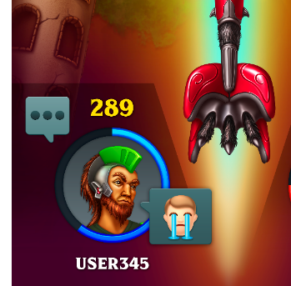  
  
  
When emoticons are hit, message submitted should be like  
  
[Cool]  
[Love]  
[Nervous]   
[Cry]  
[Surprised]  
[lmao]  
[Giggles]  
[Mad]  
[Sleep]  
  
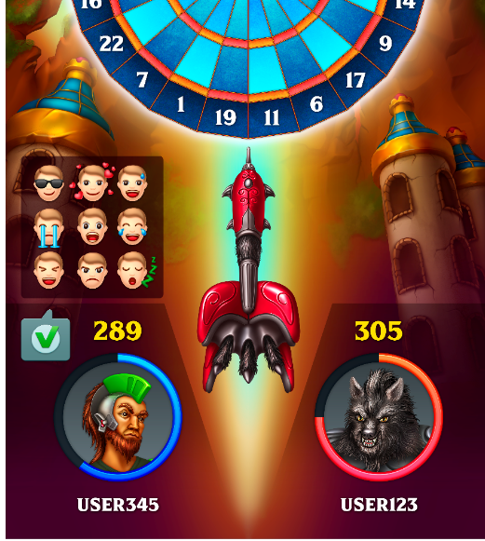  
  
3. If user has effex sound on use the mp3s included for each emoji. These are in order from Cool top left to sleep bottom right.  
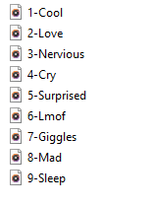**

**Either player hits it when it’s displaying play the sound.  
  
4. Make it so when player submits a message they cannot send another one for 2 seconds. There should be at least some gap so players can’t keep hitting the emoji button.**

**5. Test properly on multiple devices and make sure this is properly working.  
  
6. The graphics are highest quality please optimize them by making them proper size, without lowering their quality graphic.   
The sound and animated graphic should match properly.**