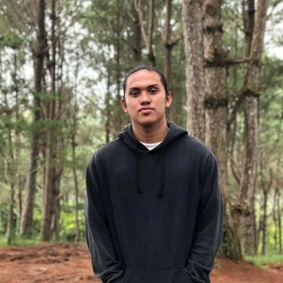
SKILLS
Programming & Software
Development (PHP, JavaScript, Node.js, Python)
Database Management & Networking
IT Support & Troubleshooting
UI/UX Design & Frontend Development
Teamwork & Collaboration Problem-Solving & Adaptability

EDUCATION

HOLY CROSS OF DAVAO COLLEGE
Bachelor of Science in
Information Technology (BSIT),
2021 – Present

MAMBAGO-B NATIONAL HIGH SCHOOL
Academic Strand: Information and Communications Technology, Graduated March
2021

PROJECTS
CSCoach: A Voice-Interactive
Reviewer Chatbot for the Civil
Service Exam Using
Conversational AI ,
Eleven 26 Pharmacy POS System

REFERENCE
Available upon request.
Jesseph Mariño
Aspiring IT Professional
+639632422368
Brgy. Mambago-B, Samal Island, Philippines bitinpasihany85@gmail.com

CAREER OBJECTIVE
Motivated and adaptable IT professional seeking opportunities to contribute to organizational success by applying strong
technical, interpersonal, and problem-solving skills. Committed to delivering efficient digital solutions, fostering teamwork, and supporting continuous growth and innovation.

WORK EXPERIENCE

OJT FULL STACK DEVELOPER – DMSF INC (FEB 2026 – MAY 2026)
Developed and maintained full-stack web applications to support internal systems and operational workflows during on-the-job training at DMSF INC

Collaborated with team members in designing responsive user interfaces, managing databases, and implementing backend functionalities to improve system efficiency and user experience.

Applied problem-solving, debugging, API integration, and database management skills while following professional development practices in a real-world environment.

