# Purpose

The website is an ecommerce site which its main product is selling air/oxygen to customers that need quality oxygen. The customers will be able register an account, from which they are able to have the ability to purchase products of their choosing by adding it to their personal shopping cart and checking out when they wish.

# Structure

The site structure will consist of 5 pages:

* Index/Home page: will the homepage of the website, and you can browse items here.
* Login: login to the website with your existing login details
* Registration: Create a new account.
* Update profile: change profile details.
* Cart: view your shopping cart and checkout if the user wishes.
* [https://www.fluidui.com/editor/live/preview/cF9xMDJ6bGJKU3BCZ3ZmTVBIbnlIa1JEV3BacDY2T05CbQ==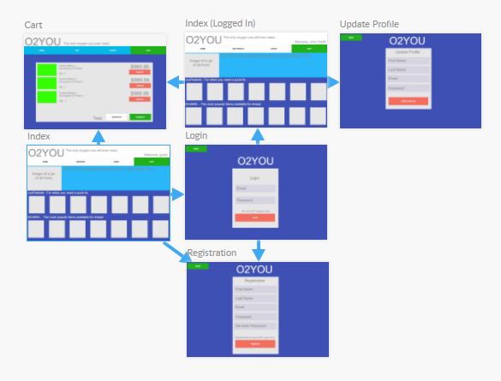](https://www.fluidui.com/editor/live/preview/cF9xMDJ6bGJKU3BCZ3ZmTVBIbnlIa1JEV3BacDY2T05CbQ==)

# Specifications

* The user will be able to navigate the page with a navigation bar at the top of the page, under the website header. Some of the buttons (such as the registration and edit profile buttons) will not display whether the user is logged in or not.
* The website will feature a flat style hierarchy, with the deepest level being a single page deep.
* Product pages will be a pop-up box when the product is clicked on in the index page, giving you the ability to view the product description, add to cart or to exit and choose another product.
* The product section in the index page will have categories listed horizontally across the page, with the ability to scroll horizontally through the products (like a carousel). For example, there will a section header for jars of oxygen, and underneath will feature a list of different kind of jars listed across the page.
* The overall design will be based on the material design by google.

# Development Roadmap

1. Create the basic header portion of the index page.
2. Set up the horizontal navigation bar on the index page and link to other (empty) pages of the website. This includes the navigation to the login, registration, home and cart.
3. Set up skeletons of the page design (create empty div areas on the page that will be filled with content later).
4. Set up initial CSS styling to the page for the header and navigation sections (colour, borders, padding, margins, and placeholder text). This will set up the navigation design which will be able to transfer to each of the pages that will use the navigation bar.
5. Set up the registration page. The input fields (first name, last name, email, password and re-enter password) will be created first, followed by the box design containing the input fields, and the colours will be added/adjusted afterwards. These fields will be inputted into a database containing all of the registered users later.
6. Set up the login page. The input fields will be created first, followed by the box design containing the input fields, and the colours will be added/adjusted afterwards. These input fields will read from the database containing all of the website’s users – the database will be added later.
7. Set up the edit profile page. The input fields will be created first, followed by the box design containing the input fields, and the colours will be added/adjusted afterwards.
8. Fill the big banner area in the index area with relevant content.
9. Create the rows that will contain the products
10. Create the products and place them in the appropriate empty skeleton area in the index page.
11. Set up the shopping cart page. The cart content box will be created first, followed by the design of the rest of the page.
12. Revisit the pages to adjust any page element issues.
13. Adjust the page to make it more “responsive” on different screen sizes.
14. Determine the correct colours to be used for the definitive version of the page.
15. Go through the test plan checklist.

# Software Selection

**Microsoft Word:** This word processor is a functional and reliable software that will be used to develop a test plan list, as well as the plans. It has many features that will improve the quality of the planning and writeups for the assessment. Features include: grammar and spelling checking, font styling, easily create checklists, screen clipping and images and more. This will allow me to complete the project easier and faster due to the simplicity of the software, and my familiarity with it.

**Github:** Github is an online git repository website, allowing the user to store their repositories over the cloud. It also displays every commit on the repository, which can act as a documentation/development log which displays the changes, additions and removal of code in files. It allows me to control the version history of the website via git by using a clean user interface. This means if I have messed up the website code, I can roll back to a previous state with git. This will prevent any problems that I can’t solve to ruin my project and set me back as I can easily revert to an earlier version.

**Sublime Text 3:** Sublime text is a beautiful, minimalistic text editor that is made for coding. It is lightweight and has syntax highlighting to ensure everything is being done correctly. It has libraries built in for many languages including html and css and additional libraries and features can be added via the package manager feature. It also has a folder view tab which allows me to see the folder structure (and files) of a folder on your system. This will boost my productivity with the project as it is extremely simple and fast to use, allowing me to efficiently write code for the website due to the features mentioned beforehand.

**Google Chrome:** Google Chrome is a fast browser that will be used to test run the website pages and code. It also has the inspect element tool that allows me to visually inspect the elements of the website including (but not limited to) margins, sizing, divs and more. It also the only browser on my device (other than Microsoft Edge (but I am not *familiar* with it)). It also has extensions that will boost my productivity and allow me to complete my work faster – such extensions include web colour picker (allows the user to use an eyedropper tool to identify the hex-code of a colour on a site).

**XAMPP:** XAMPP (Cross-platform, apache, mariadb, php and perl) is a free, opensource, cross platform and lightweight web server solution package by Apache that streamlines the process for developers to create a local web server for testing and deployment purposes.

**PHPMyAdmin:** phpMyAdmin is free, useful, graphical database administration tool for PHP. It can be used to create and manage mysql databases through a virtualised server hosted on the device. A local web user interface is available that greatly helps managing the administration side of the server, giving the user the ability to manage databases, tables, indexes, relations, users, permissions, queries and more while still giving the user to execute any sql statements.