T25 Manual testing script for ChatClientRunListener

1. Environment for testing
- The environment for testing is an instance of Jenkins running on the machine with the Chat Client plugin installed.
- For testing, Jenkins needs to have at least one project that it can try to build.

2. Test Case: When Jenkins builds a project unsuccessfully, the message that is printed to the console matches the status of the build that can be seen in Jenkins:
- Step one is to open Jenkins (default address is http://localhost:8080) and select a project. In this example, I have selected the project 427Test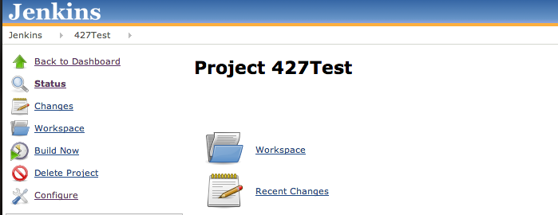
- Once the project page is loaded, Click on Build Now from the menu on the left hand side of the page. Once Jenkins finished building the project, click on the link to the build from the top of the Build History menu on the left hand side of the page.
- In this example, this project failed to build, and this is the page for the build: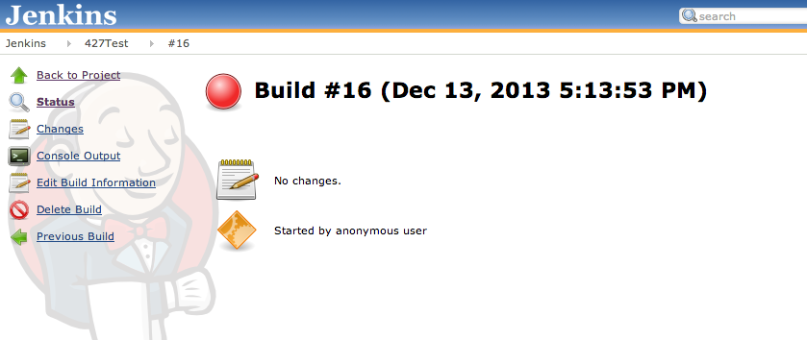
- Now that the build is completed, assert that the output that has been printed to the console matches the information from the build status page: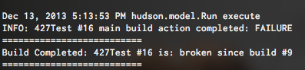
- In this example, the terminal output says that build #16 from the project 427Test is broken since build # 9 which matches what we see on the build status page.

3. Test Case: When Jenkins builds a project successfully, the message that is printed to the console matches the status of the build that can be seen in Jenkins:
- Step one is to open Jenkins (default address is http://localhost:8080) and select a project. In this example, I have selected the project test.
- Once the project page is loaded, Click on Build Now from the menu on the left hand side of the page. Once Jenkins finished building the project, click on the link to the build from the top of the Build History menu on the left hand side of the page.
- In this example, this project built successfully, and this is the page for the build: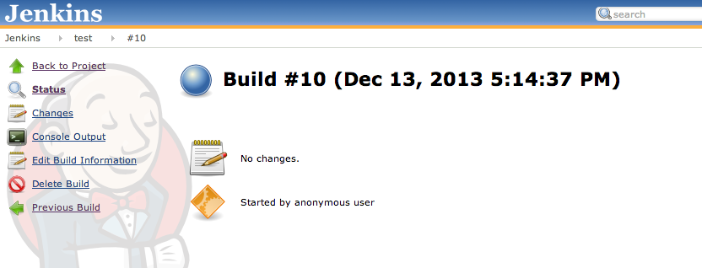
- Now that the build is completed, assert that the output that has been printed to the console matches the information from the build status page:
- In this example, the terminal output says that build #10 from the project test is stable which matches the information from the build page.
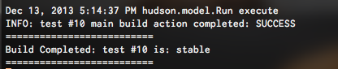

4. Test Case (Not implemented yet) : When Jenkins completes a build, the build status message is sent to all chat boxes that are part of the project group.
- Step one is to open Jenkins (default address is http://localhost:8080) and select a project. In this example, I have selected the project test.
- Once the project page is loaded, Click on Build Now from the menu on the left hand side of the page. Once Jenkins finished building the project, click on the link to the build from the top of the Build History menu on the left hand side of the page.
- Now that the build is completed, assert that a chat box below is displaying the correct build message according to the build status page: