TUTORIAL: Digital I/O
LED Toggle with Push-Button
Name: WonBitna ID: 22400462

I. Introduction
We will learn how to control digital I/O of GPIOs of the MCU board to turn on/off an LED with a push-button input. The LED should be turned on when the button is pressed.
The objectives of this lab are to learn how to
- Read and configure registers of digital GPIO of MCU
- Program firmware to control digital input/output pins
- Create your own functions for GPIOs

Hardware
NUCLEO -F411RE

Software
Keil uVision IDE, CMSIS, EC_HAL

Documentation
STM32 Reference Manual

II. Basics of GPIO IN

A. GPIO Digital Out Register
List GPIO registers for this LAB
Type | Register Name | Description
GPIO | MODER | Mode: Input
 | PUPDR | Pull-Up Pull-Down: No pull-up,down/Pull-up, Pull-down, Reserved
 | IDR | Input Data Register

Schematic
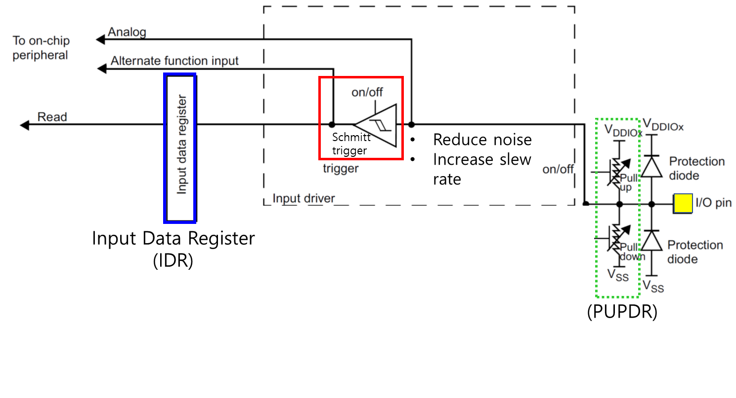

Process of GPIOx register initiation
0. Enable Peripheral Clock (AHB1ENR)
1. Configure as Digital Input (MODER)
2. Configure pull-up/down resistors (PUPDR)
3. Read Data (IDR)

III. Tutorial

A. Register Configuration

1. GPIO: Digital In - Pin Initialization & Read PushButton
Port C Pin 13 / Input // Pull-Up
use #define BUTTON_PIN 13

- MODER: Input (MODER13[1:0]=[0 0])
GPIOC ->MODER &= ~(3<<( BUTTON_PIN *2)); // clear bits at both [26] and [27]

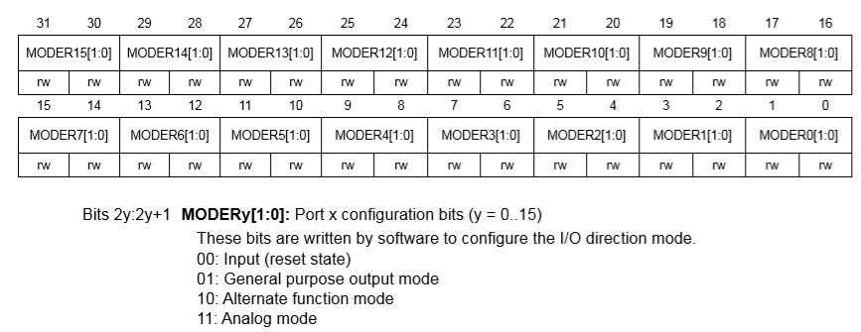

Register | 31 | 30 | 29 | 28 | 27 | 26 | 25 | 24 | 23 | 22 | 21 | 20 | 19 | 18 | 17 | 16 | 15 | 14 | 13 | 12 | 11 | 10 | 9 | 8 | 7 | 6 | 5 | 4 | 3 | 2 | 1 | 0
Initial | x | x | x | x | x | x | x | x | x | x | x | x | x | x | x | x | x | x | x | x | x | x | x | x | x | x | x | x | x | x | x | x
Logic | Bitwise AND
mask | 1 | 1 | 1 | 1 | 0 | 0 | 1 | 1 | 1 | 1 | 1 | 1 | 1 | 1 | 1 | 1 | 1 | 1 | 1 | 1 | 1 | 1 | 1 | 1 | 1 | 1 | 1 | 1 | 1 | 1 | 1 | 1
Value | x | x | x | x | 0 | 0 | x | x | x | x | x | x | x | x | x | x | x | x | x | x | x | x | x | x | x | x | x | x | x | x | x | x

- PUPDR: pull-up (PUPDR13[1:0]=01)
GPIOC->PUPDR &= ~(3<<( BUTTON_PIN *2));
GPIOC->PUPDR | = (1<<BUTTON_PIN*2);

Paste Register map from reference manual
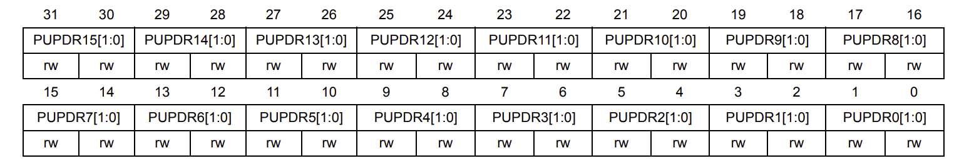
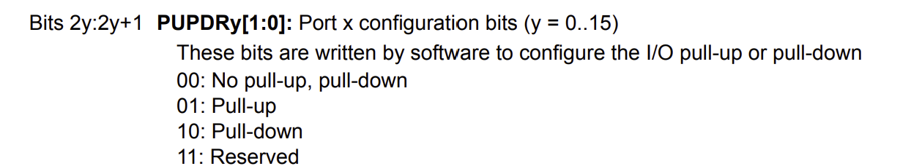

- IDR: Read Push-Button Value (IDR13=0or1)
btVal = (GPIOC->IDR) & (1<<BUTTON_PIN);

Paste Register map from reference manual
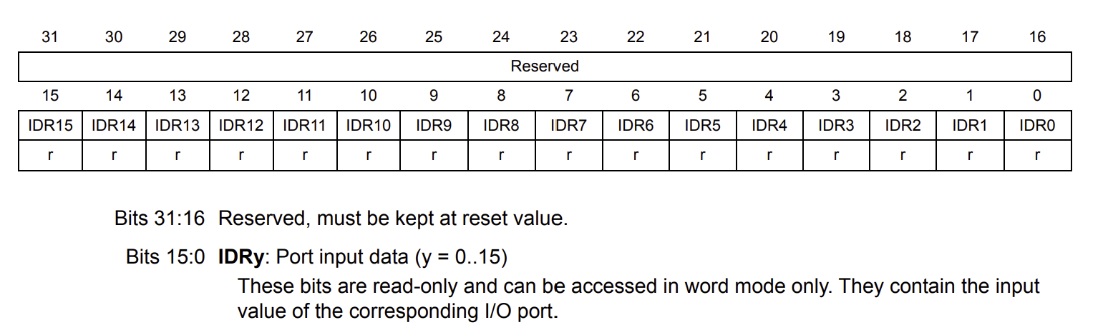

B. Programming
Preparation
  - Download ecRCC.h and ecRCC.c.
  - Save them in the library folder: “include\”
- You must have “ecPinNames.*, ecRCC.*” in include folder
  - Create a new item(file) as ‘\tutorial\TU_GPIO_Digital_InOut_Button’.c’
  - Copy and paste from the source code ‘TU_GPIO_Digital_InOut_LED_Button_student.c’.
  - Create a new environment : ‘TU_GPIO_Digital_InOut_Button’’.
(platformio.ini) : [env:TU_GPIO_Digital_InOut_Button]

[env:TU_GPIO_Digital_InOut_Button]
build_src_filter = +<tutorial/TU_GPIO_Digital_InOut_Button_student.c> +<include/*.c> -<include/ecSTM32_simple.c>

- Here, we have removed ecSTM32_simple.h for it can cause redundant errors
- You can also manually delete “ecSTM32_simple.*” files.

Exercise
Fill in the empty spaces in the code. Then, compile(F7) and flash(F8) the source code
on the MCU board.

/*----------------------------------------------------------------\
@ Embedded Controller by Young-Keun Kim - Handong Global University
Author : Won Bitna
Created : 05-03-2021
Modified : 09-13-2026
Language/ver : C++ in VS Code

Description : Tutorial Digital InOut
/----------------------------------------------------------------*/

// GPIO Mode : Input(00), Output(01), AlterFunc(10), Analog(11, reset)
// GPIO Speed : Low speed (00), Medium speed (01), Fast speed (10), High speed (11)
// GPIO Output Type : Output push-pull (0, reset), Output open drain (1)
// GPIO Push-Pull : No pull-up, pull-down (00), Pull-up (01), Pull-down (10), Reserved (11)

#include "stm32f411xe.h"
#include "ecRCC2.h"

#define LED_PIN 5 //LD2
#define BUTTON_PIN 13 // B1 Button

int main(void) {
/* Part 1. RCC GPIOA Register Setting */
RCC_HSI_init();
RCC_GPIOA_enable();
RCC_GPIOC_enable();

/*----------------------------------------------------------------
[EXERCISE]
---------------------------------------------------------------- */

/// Part 2. GPIO Register Setting for OUTPUT ///
// GPIO Mode Register MODE=OUTPUT
GPIOA->MODER &= ~(3UL<<(LED_PIN*2)); // Clear '00' for Pin 5
GPIOA->MODER |= (1UL<<(LED_PIN*2)); // Set '01' for Pin 5

/// Part 3. GPIO Register Setting for INPUT ///
// GPIO Mode Register MODE=INPUT
GPIOC->MODER &= ~(3UL<<(BUTTON_PIN*2)); // 00: Input

// GPIO Pull-Up/Pull-Down Register
GPIOC->PUPDR &= ~(3UL<<(BUTTON_PIN*2));
GPIOC->PUPDR |= (2UL<<(BUTTON_PIN*2)); // 10: Pull-down

/* Button Value Initialization */
unsigned int btVal=0;

/* Part 4. loop */
while(1){
//Read bit value of Button
btVal= (GPIOC->IDR) & (1UL << BUTTON_PIN);
if(btVal == 0)
GPIOA->ODR |= (1UL << LED_PIN);
else
GPIOA->ODR &= ~(1UL << LED_PIN);
}
}

Solution
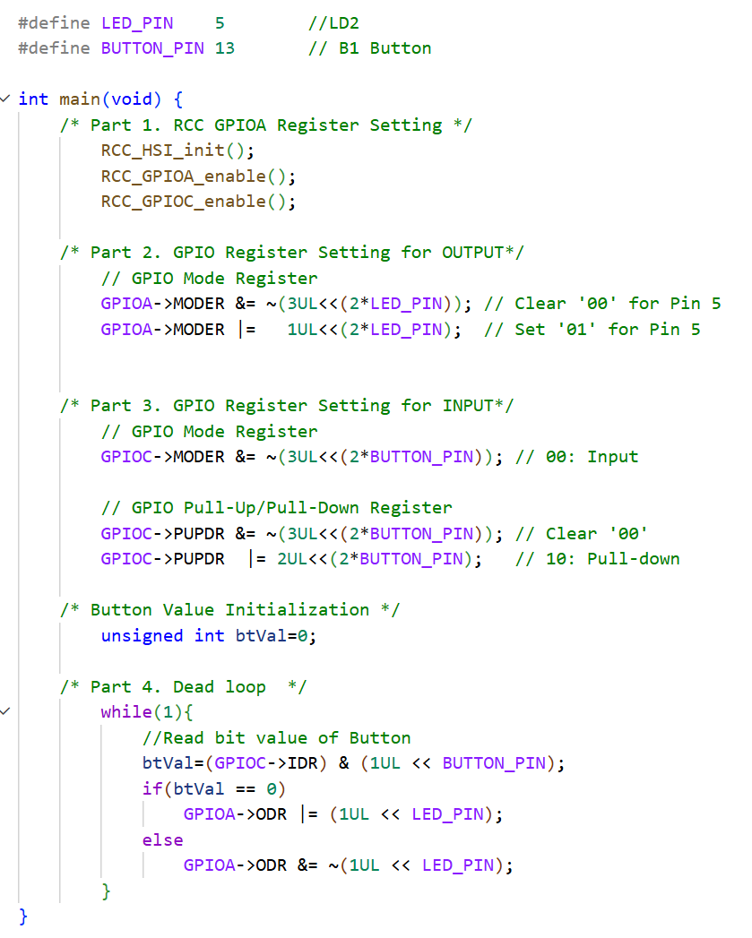

Appendix
See here for MCU resources
- Pin Configuration of NUCLE-F401RE
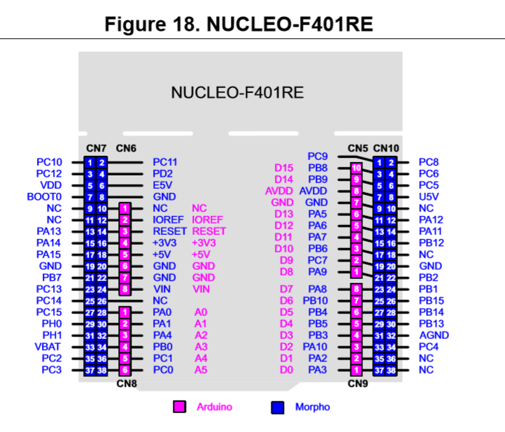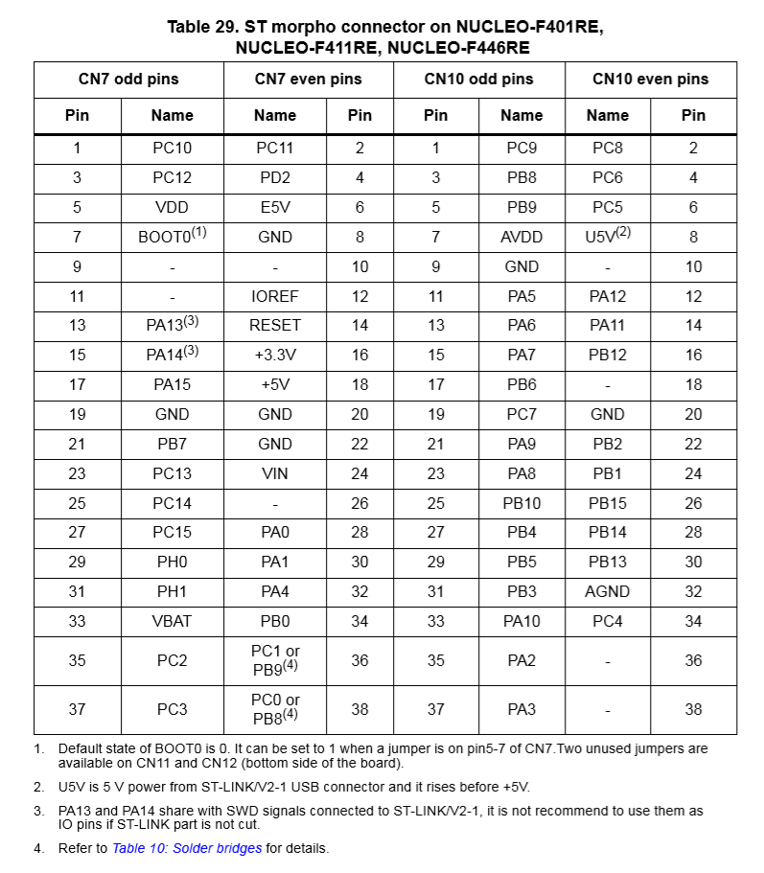

- LED/Button Circuit Diagram
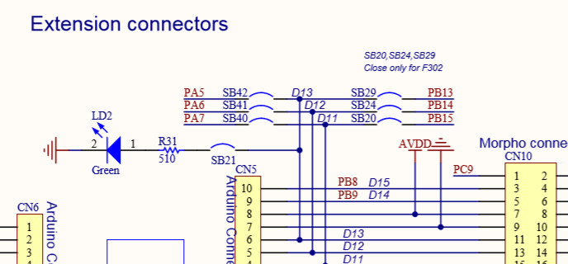

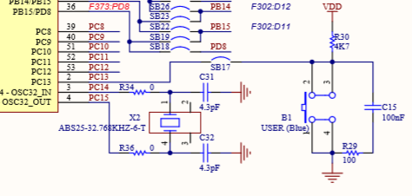
이거 지터 방지를 위해 소프트웨어/하드웨어적으로 어떤걸 할수있냐... 이런게 시험인가 퀴즈에 나왔었다...

