TUTORIAL: Digital Out
Name: WonBitna ID: 22400462

I. Introduction
In this lab, we will learn how to control the Digital Output of GPIOs of the MCU board to turn on/off an LED.
The objectives of this lab are to learn how to
- Read and configure registers of digital GPIO of MCU
- Program firmware to control digital input/output pins

Hardware
NUCLEO -F411RE

Software
Keil uVision IDE, CMSIS, EC_HAL

Documentation
STM32 Reference Manual

II. Basics of GPIO Out

A. Bit Operation
Fill in the blanks. You should write the answer in both hexa-decimal and binary number.
 | Bit operation | Description | Answer
 | 0xA & 0x2 | AND | 0x2, b10
 | 0x3 | 0xC | OR | 0xF, b1111
 | ~0x7 | NOT | 0x8, b1000
 | 0xF ^ 0x5 | XOR(Toggle) | 0xA, b1010
 | 0x1 << 3 | Shift left | 0x8, b1000
 | 0xC >> 2 | Shift right | 0x3, b11
 | 0x11 |= 1<<3 | Set bit | 0x19, b11001
 | 0xFF &= ~1<<4 | Clear bit | 0xEF, b11101111
 | val=0x0F>>3 & 1 | Read bit | 0x01, b1

B. GPIO Digital Out Register
List GPIO registers for this LAB
Type | Register Name | Description
GPIO | GPIOx_MODER | Mode: Output/Input/Analog/Alternate function
 | GPIOx_OTYPER | Output Type: Opendrain/Push-Pull
 | GPIOx_OSPEEDR | Output Speed: LOW/Medium/Fast/High
 | GPIOx_PUPDR | Pull-Up Pull-Down: No pull-up,down/Pull-up, Pull-down, Reserved
 | GPIOx_ODR | Output Data Register

Schematic
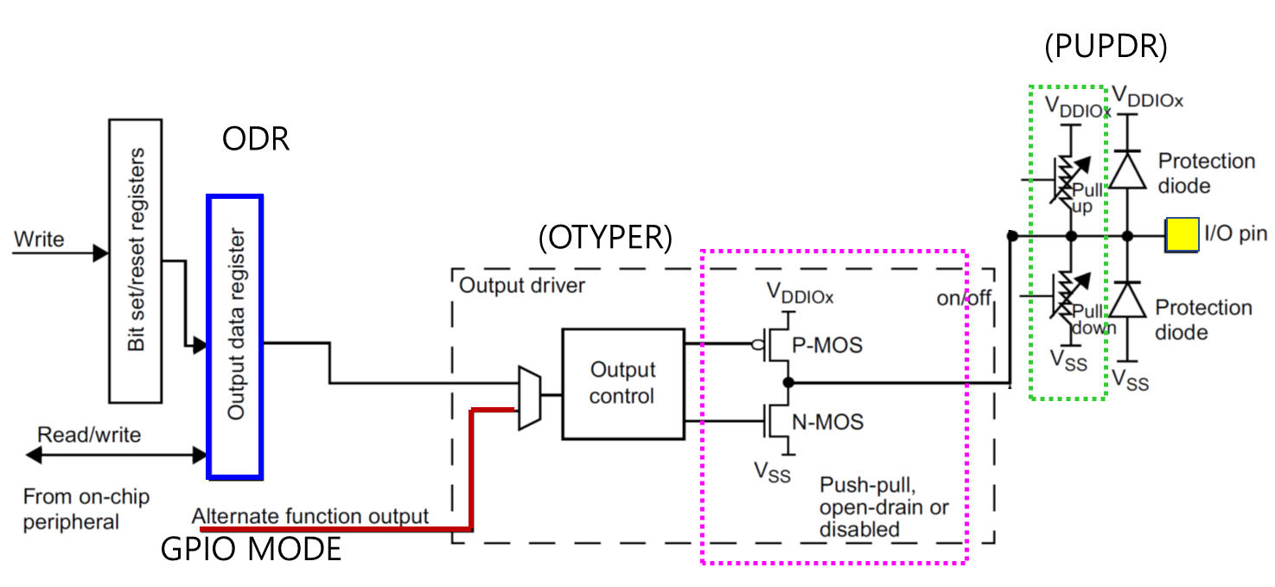

Process of GPIOx register initiation
0. Enable Peripheral Clock (AHB1ENR)
1. Configure as Digital Output (MODER)
2. Configure pull-up/down resistors (PUPDR)
3. For Output: Configure Output Type (OTYPE)
4. For Output: Configure Output Speed (OSPEEDR)
5. Output Data (ODR)

III. Tutorial

A. Register Configuration

1. GPIO: Digital Out - Pin Initialization & Set LED
Port A Pin 5 / Output / Push-Pull / No Pull-Up Pull-Down / Default Speed
use #define LED_PIN 5

- MODER: Output (MODER5[1:0]=01)
GPIOA->MODER & = ~(3<<( LED_PIN *2)); // clear bits at both [10] and [11]
GPIOA->MODER | = 1<<(LED_PIN *2); // set bit at [10]

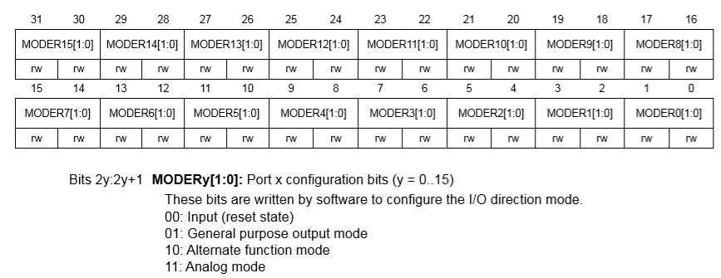

Register | 31 | 30 | 29 | 28 | 27 | 26 | 25 | 24 | 23 | 22 | 21 | 20 | 19 | 18 | 17 | 16 | 15 | 14 | 13 | 12 | 11 | 10 | 9 | 8 | 7 | 6 | 5 | 4 | 3 | 2 | 1 | 0
Initial | x | x | x | x | x | x | x | x | x | x | x | x | x | x | x | x | x | x | x | x | x | x | x | x | x | x | x | x | x | x | x | x
Logic | Bitwise OR
mask | 0 | 0 | 0 | 0 | 0 | 0 | 0 | 0 | 0 | 0 | 0 | 0 | 0 | 0 | 0 | 0 | 0 | 0 | 0 | 0 | 0 | 1 | 0 | 0 | 0 | 0 | 0 | 0 | 0 | 0 | 0 | 0
Value | x | x | x | x | x | x | x | x | x | x | x | x | x | x | x | x | x | x | x | x | 0 | 1 | x | x | x | x | x | x | x | x | x | x

- OTYPER: Push-Pull (OT5=0)
GPIOA->OTYPER &= ~(1<< LED_PIN);

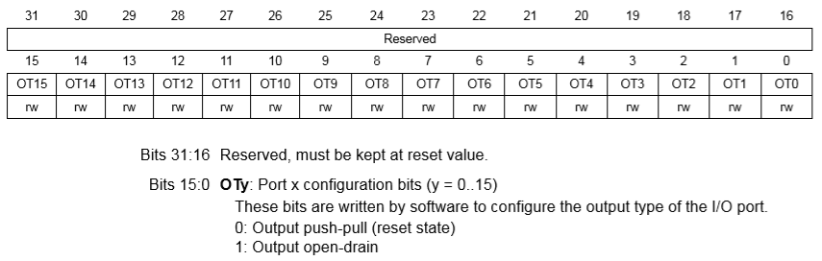

Register | 31 | 30 | 29 | 28 | 27 | 26 | 25 | 24 | 23 | 22 | 21 | 20 | 19 | 18 | 17 | 16 | 15 | 14 | 13 | 12 | 11 | 10 | 9 | 8 | 7 | 6 | 5 | 4 | 3 | 2 | 1 | 0
Initial |  |  |  |  |  |  |  |  |  |  |  |  |  |  |  |  | x | x | x | x | x | x | x | x | x | x | x | x | x | x | x | x
Logic | Bitwise AND
mask | 1 | 1 | 1 | 1 | 1 | 1 | 1 | 1 | 1 | 1 | 1 | 1 | 1 | 1 | 1 | 1 | 1 | 1 | 1 | 1 | 1 | 1 | 1 | 1 | 1 | 1 | 0 | 1 | 1 | 1 | 1 | 1
Value | x | x | x | x | x | x | x | x | x | x | x | x | x | x | x | x | x | x | x | x | x | x | x | x | x | x | 0 | x | x | x | x | x

- PUPDR: no pull-up pull-down (PUPDR5[1:0]=00)
GPIOA->PUPDR &= ~(3<<( LED_PIN *2)); // clear
GPIOA->PUPDR |= (0UL<<(LED_PIN*2)); //set

Paste Register map from reference manual
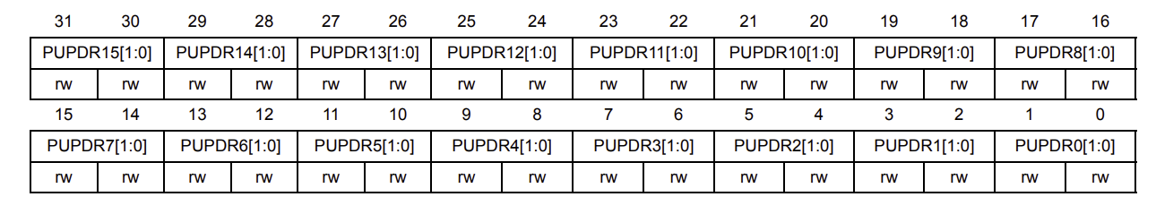
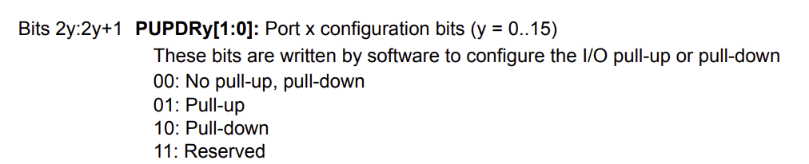

- ODR: Set LED (ODR5=1)
GPIOA->ODR |= (1UL<<LED_PIN);

Paste Register map from reference manual
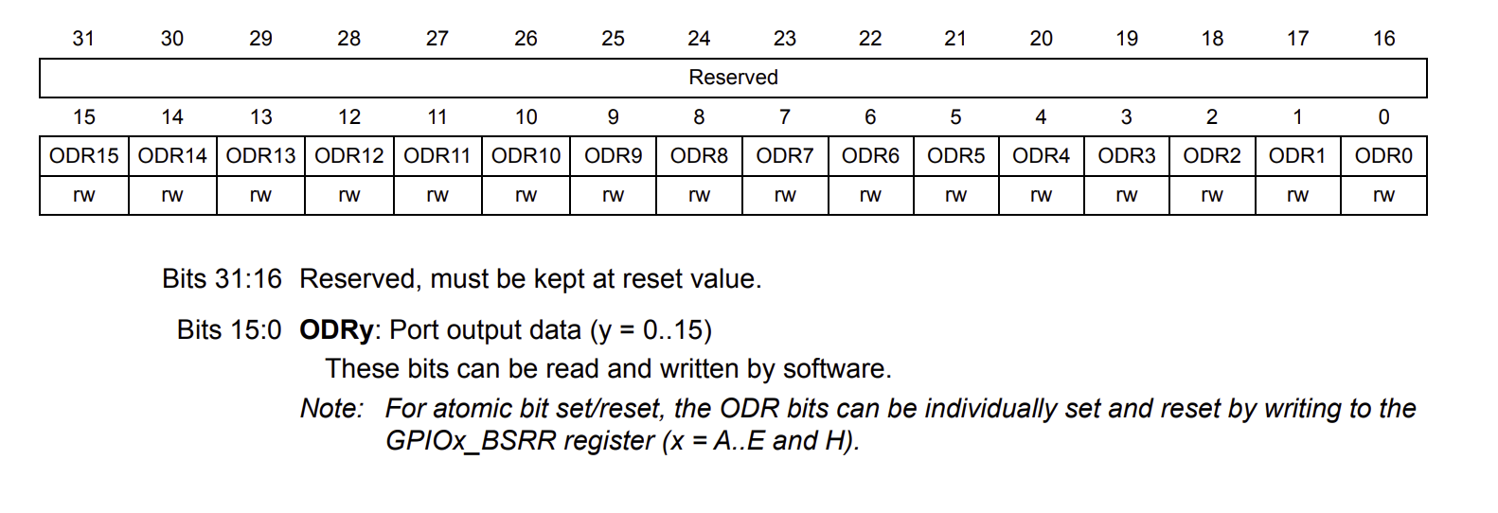

B. Programming
Preparation
  - Download ecRCC.h and ecRCC.c.
  - Save them in the library folder: “include\”
- You must have “ecPinNames.*, ecRCC.*” in include folder
  - Create a new item(file) as ‘\tutorial\TU_GPIO_Digital_Out_LED.c’
  - Copy and paste from the source code ‘TU_GPIO_Digital_Out_LED_student.c’.
  - Create a new environment : ‘TU_GPIO_Digital_Out_LED’.
(platformio.ini) : [env:TU_GPIO_Digital_Out_LED]

[env:TU_GPIO_Digital_Out_LED]
build_src_filter = +<tutorial/TU_GPIO_Digital_Out_LED.c> +<include/*.c> -<include/ecSTM32_simple.c> (not needed since it was already deleted!)

- Here, we have removed ecSTM32_simple.h for it can cause redundant errors
- You can also manually delete “ecSTM32_simple.*” files.

Exercise
This is an example code of turning ON LED without button input. Do not worry if you do not understand what this code means yet. You will learn one by one in the following few weeks.
Fill in the empty spaces in the code.
Then, compile and flash the source code onto the MCU board.
Verify the program by checking if the LED is turned ON.

Solution
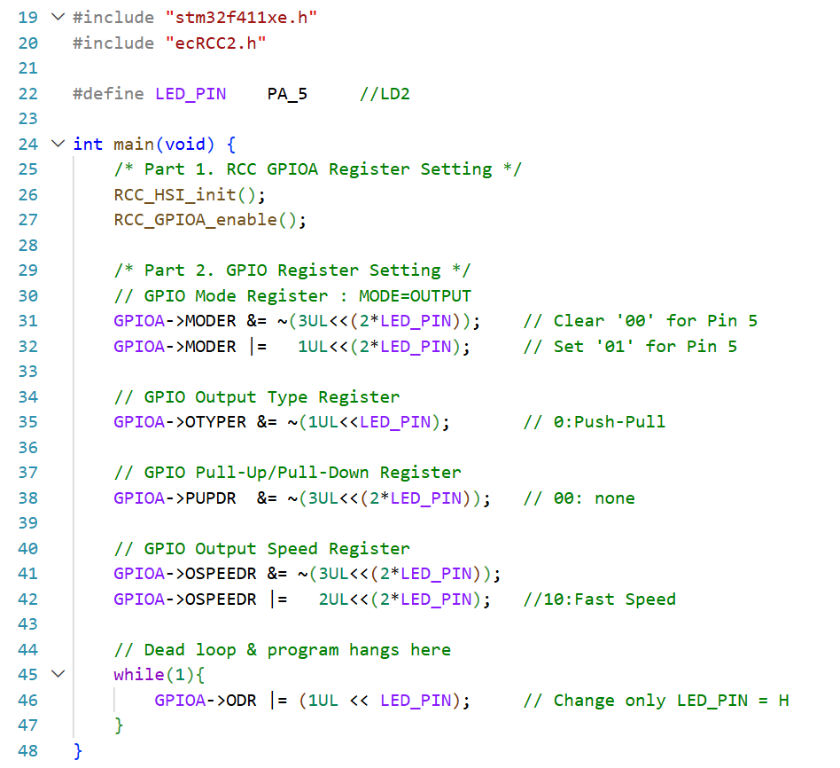

Appendix
See here for MCU resources

- Pin Configuration of NUCLE-F401RE
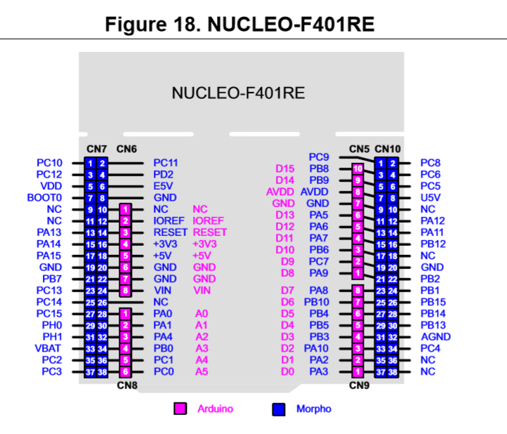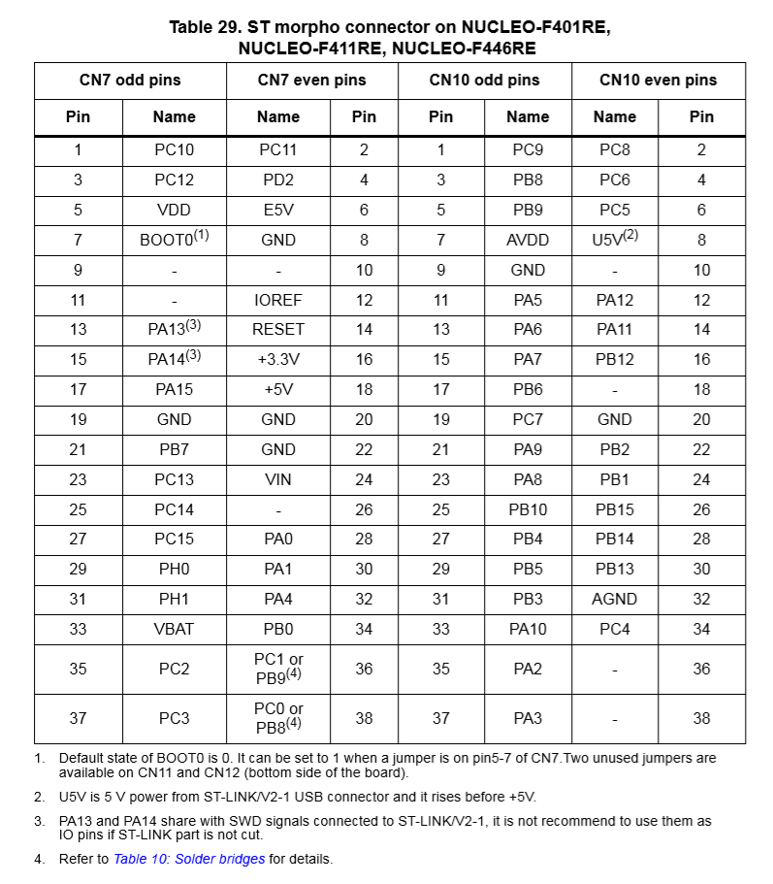

- LED/Button Circuit Diagram


