MyDesign Portfolio
Element H Initial Template

Element H: Prototype Testing and Data Collection Plan

Testing Details (H1, H2, H3, H4)
 | requirement | testing setup and procedure | test cases and number of trials | expected range of results | pass/fail criteria, goal
1 | functionally coded detection system | - Code and have assembled Arduino for having function of a audible buzzer and visible LED  - Place on a flat surface where no ulterior forces can affect the outcome  - Hold the heat source (in our case, a lighter) near the censor for roughly 5 seconds.  - Observe and note visible changes. | Hold flame close to the Arduino sensor (7 trials) | The Arduino may:  - Visually lack or no change at all  - Emit light that is intense  - Emit light that is lacking | Fail: Remain with a turned off LED  Pass: LED emits bright, obvious light  Goal: All parts of the detection system are functionally coded and working.
2 | functionally coded notification system | - Take balloon and fill up with water till approximately 4.5 inches in diameter and knot closed  - Preform over, ideally, a sink  - Suspend balloon over the sink by pinching the knotted end  - Safely and supervised, take a flame (lighter in our case) and place at the most ~1 in away from the bottom of the balloon    - Observe any changes | Holding flame close till water balloon pops (7 trials) | The water balloon may:  - Not emit a pop and burst open  - Emit a pop and burst open | Fail: The water balloon does not burst open and emit a audible pop  Pass: The water balloon bursts open and an audible pop is heard  Goal: The balloon popping is startlingly heard, thus being a successful notification system.
3 | Working suppression system using balloons | - Fill 4 balloons till approximately 4.5 inches in diameter and knot closed  - Taking our water-filled balloons, tie onto wooden sticks with tight knots, 1 balloon per stick  - Preform over, ideally, a sink  - Pick up the stick from each end till the bottom of the balloons are a confident 7 in+ off of a flat surface  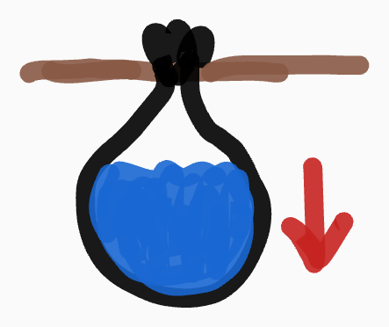  - Observe if any changes occur  - Subject the balloons to stress by bounce the stick up and down gently (~1 in motions up and down)  - Do for 10 seconds  - Observe if any changes occur | Suspending bouncing of the water-balloons (7 trials) | The attempts may result in:  - Water-filled-balloons being successfully supported  - Sticks breaking apart  - Balloons ripping | Fail: Suspended water balloons rip or stick supports break as a result of the weight of the balloons.  Pass: The sticks keep the water balloons suspended without breaking apart.  Goal: Water filled balloons are successfully supported by sticks and the suppression system is made able to be implemented.
4 | sufficient amount of materials to construct our project | 1) The following is completed by following the provided Burn Day instructions of constructing the frame of the final house, using the appropriate steel beams, bolts, and nuts, 12x12 floor piece, and 5 appropriately sized wall pieces (some vary).  2) Assemble the frame with the steel pipes provided doing as our instructions to create a 18in x 12in x 12in structure.  3) Using an electric jig saw, the instructed L-shaped measurements are cut in each corner of 4 of the walls (specifically those that will be directly inserted between beams).  4) Using an electric drill with a drill-bit as suggested in the instructions, we drilled holes in the new corners of each wall, certain cms away from the edges as the instructions suggested.  5) Use the provided nuts and bolts to put the beams into place, measured precisely appropriately away from the ends of each beam (as per the instructions).  6) Using the appropriate sized Allen Key (or any suitable screw) to tighten these into place till seemingly tight enough.  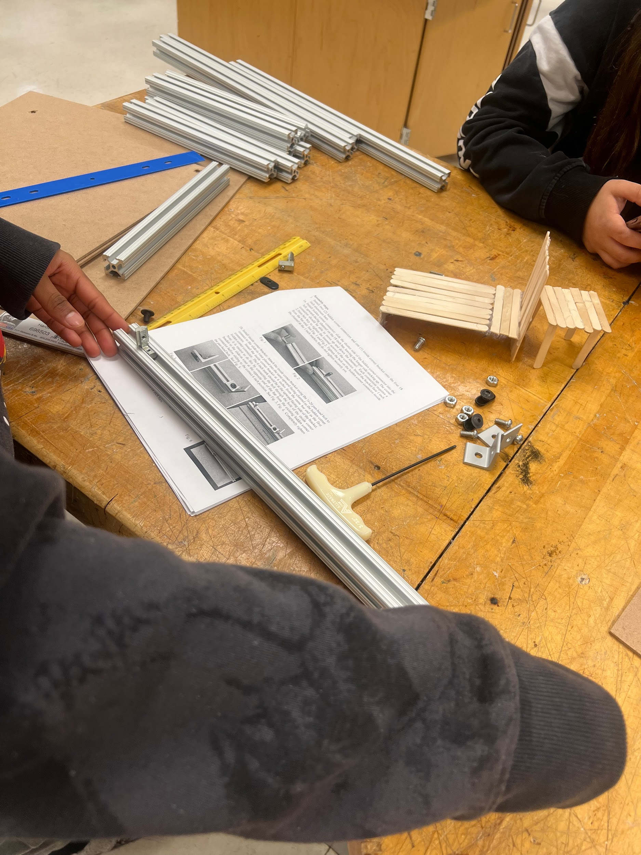  7) insert wooden walls and floor as seen fit.  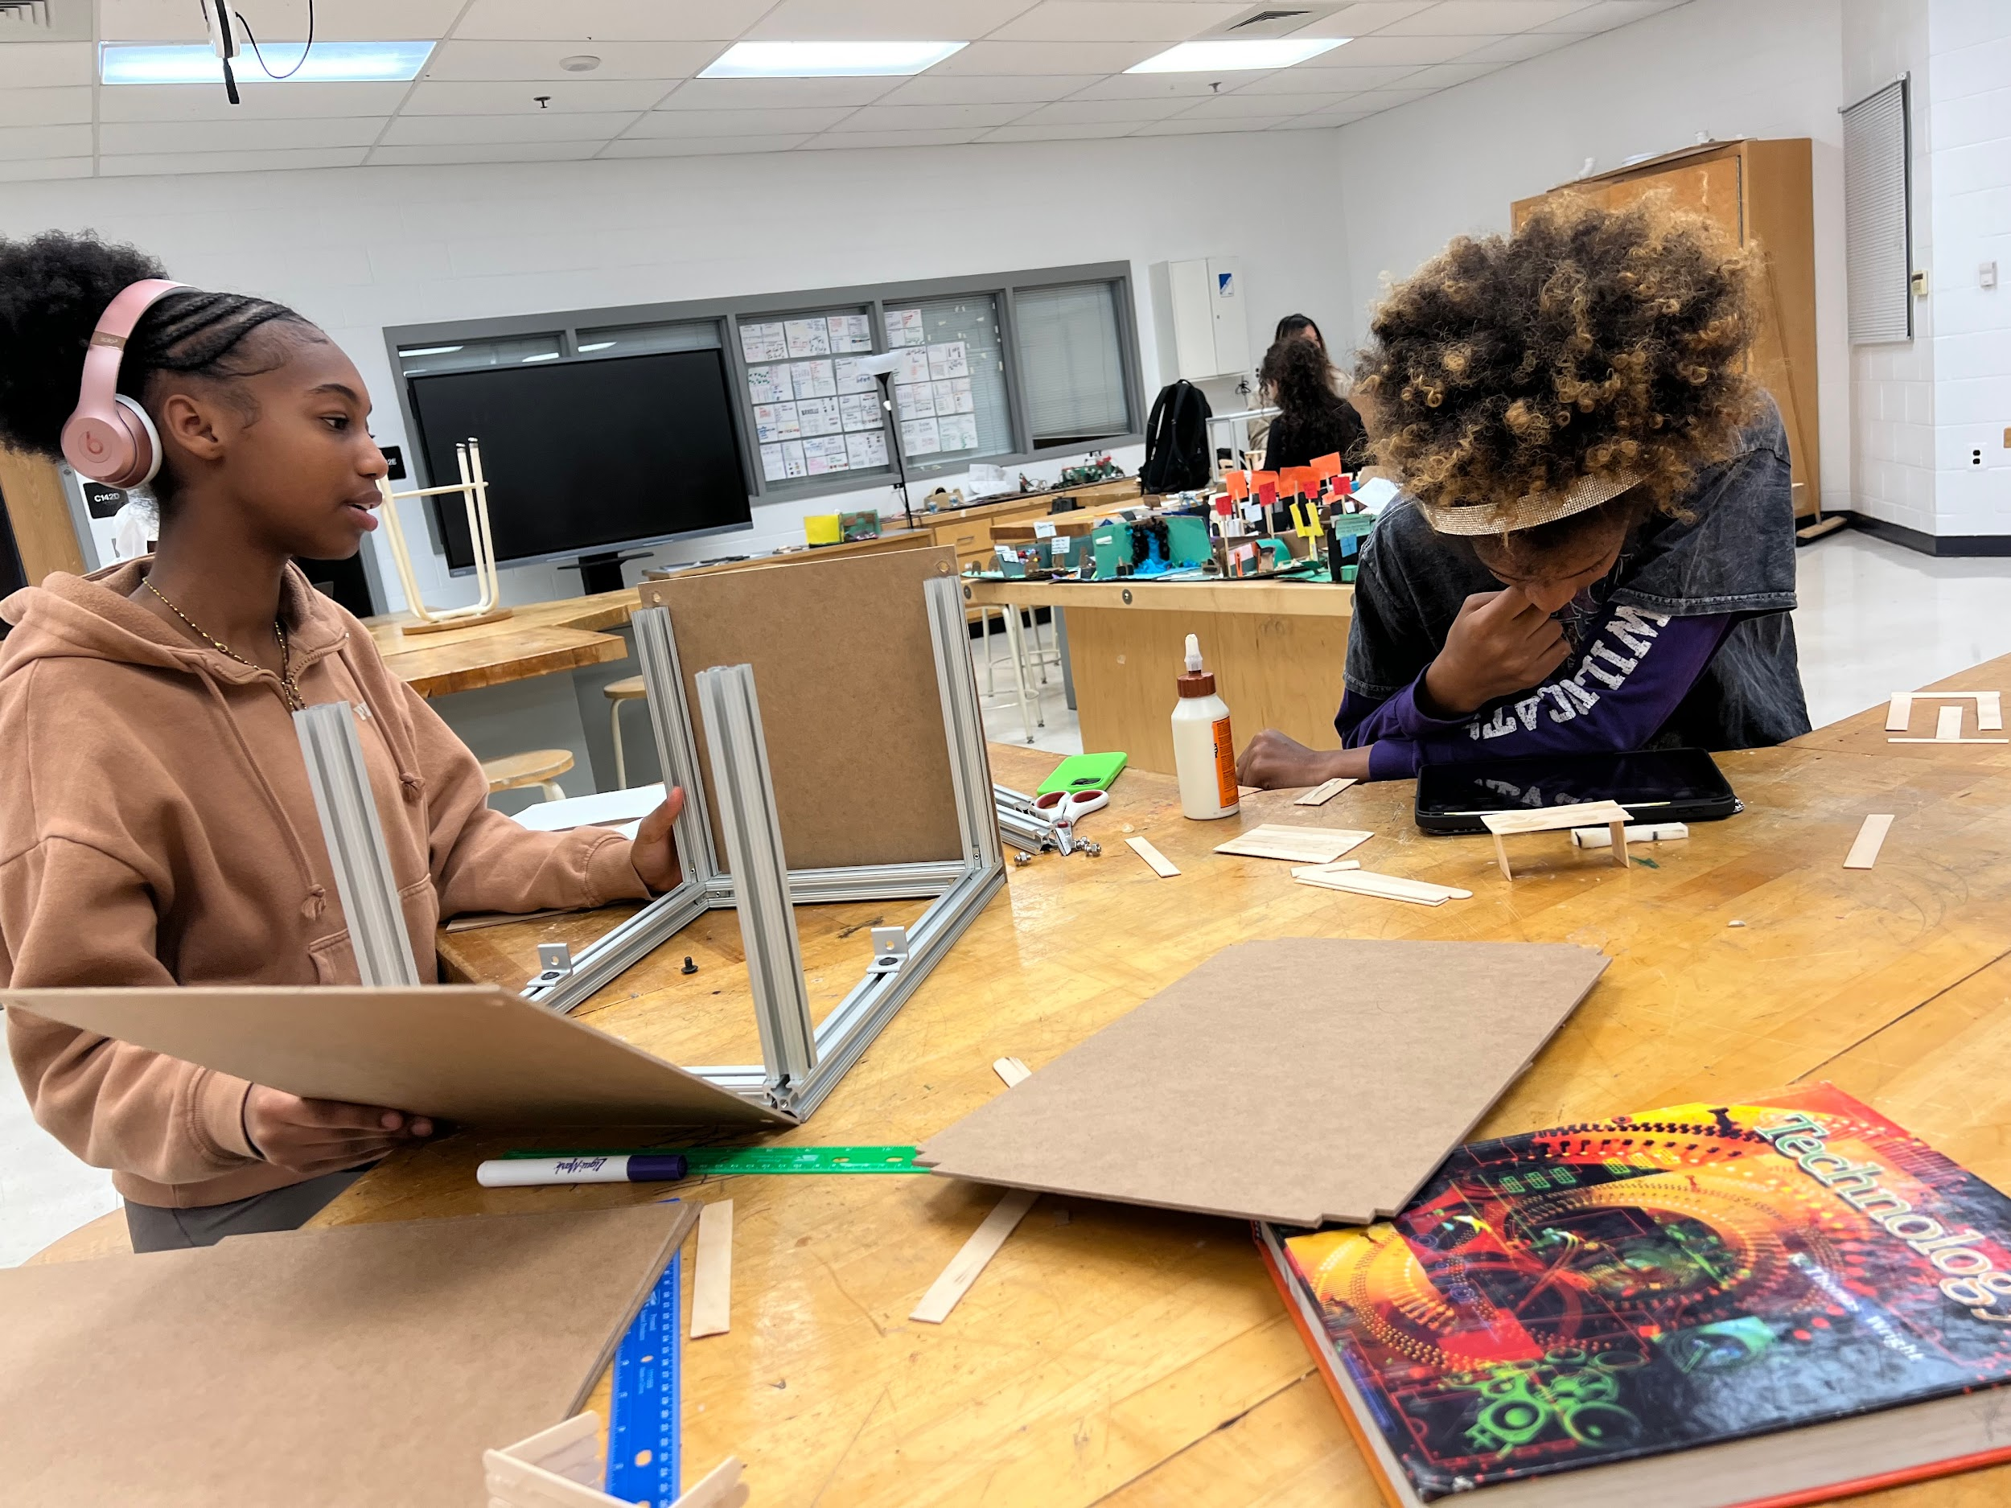  8) Continue this process till the structure is completed and can be successfully held with no loss of materials, signifying all pieces fit as instructed and nothing is amiss. | Test cases: N/A  Get through the assembly with no left over/missing pieces and a flawlessly accurate structure. | Parts may not completely fit or at all:  - Due to missing parts, parts may detach resulting in an improper frame  - Wall boards and or floorboard do not fit properly  - Inaccurate measurements hindering how things fit  Parts fit perfectly like puzzle pieces to assemble sturdy 18in x 12in structures. | Fail: one or more parts of the structure doesn’t fit (typically resulting in the rest of the pieces not fitting).  Pass: zero parts of the structure have difficulty fitting/fit awkwardly.  Goal: all parts of the structure remain sturdy and intact as instructions intended.

Feedback From Field Experts (H5)
Name of your field expert:
Deshawn Anderson
Why are they a field expert?
He is an engineering teacher in Montgomery County Public Schools with 25 years worth of teaching experience under his belt, currently guiding us in our Making For Engineers A/B course at James H. Blake High School. He provided us with all the required material to assemble our prototype and final project, provided us with an uncoded Arduino to allow us to create our notification and detection systems, and guided us in designing a proper suppression system to go within our project.

What did they say to you about the tests you are proposing?
The main concerns he had concerning our suppression system was that our initial brainstormed solution was lacking enough water and lacked aspects of realism. This project is meant to be a small-scale, realistic solution to house fires, which take a lot of water to extinguish so our project has to meet those standards.

Name of your field expert:
Christina Ward
Why are they a field expert?
She is an engineering teacher in Montgomery County Public Schools, currently another teacher leading the Making For Engineers A/B course at James H. Blake high School. Like Mr. Anderson, she provides all the required material to assemble prototypes and final projects, provides uncoded Arduinos to allow notification and detection systems to be created, and guides people in designing proper suppression systems to go within their projects.

What did they say to you about the tests you are proposing?
Similarly to Deshawn Anderson’s critiques, she had also proposed that we go with a more realistic suppression system, one that didn’t rely on the balloons’ pop to serve as a notification system.

Revised Testing Details That Incorporate Field Expert Feedback (H5)
As per the suggestions from our field experts, we created a realistic fire alarm and increased the numbers of total water balloons being used as part of our suppression system to increase the amount of water being used to suppress a fire.

Element H: REVISED Prototype Testing and Data Collection Plan

REVISED Testing Details (H1, H2, H3, H4)
 | requirement | testing setup and procedure | test cases and number of trials | expected range of results | pass/fail criteria, goal
1 | functionally coded detection system | - Code and have assembled Arduino for having function of a audible buzzer and visible LED  - Place on a flat surface where no ulterior forces can affect the outcome  - Hold the heat source (in our case, a lighter) near the censor for roughly 5 seconds.  - Observe and note visible changes. | Hold flame close to the Arduino sensor (7 trials) | The Arduino may:  - Visually lack or no change at all  - Emit light that is intense  - Emit light that is lacking | Fail: Remain with a turned off LED  Pass: LED emits bright, obvious light  Goal: All parts of the detection system are functionally coded and working.
2 | functionally coded notification system | - Code and have assembled Arduino for having function of a audible buzzer and visible LED  - Place on a flat surface where no ulterior forces can affect the outcome  - Hold the heat source (in our case, a lighter) near the censor for roughly 5 seconds.  - Observe and note audible changes. | Hold flame close to the Arduino sensor (7 trials) | The Arduino may:  - Remain silent  - Emit a constant beeping  - Emit a buzzing too quiet  - Emit an unpredictable beeping | Fail: buzzing is lacking or non-existent.  Pass: clear, constant buzzing can be heard.  Goal: All parts of the notification system are functionally coded and working.
3 | Working suppression system using balloons | - Fill 6 balloons with water till approximately 4.5 inches in diameter and knot closed  - Taking our water-filled balloons, tie onto wooden sticks with tight knots, 2 per stick and evenly spread out by length  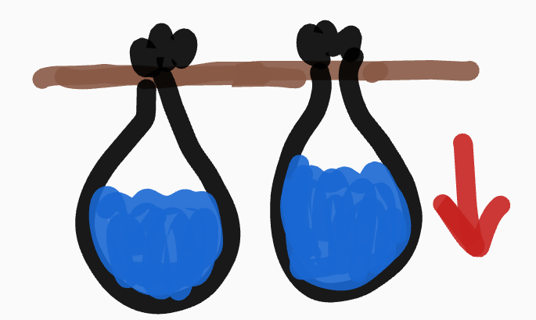  - Preform over, ideally, a sink  - Pick up the stick from each end till the bottom of the balloons are a confident 7 in+ off of a flat surface  - Observe if any changes occur  - Subject the balloons to stress by bounce the stick up and down gently (~1 in motions up and down)  - Do for 10 seconds  - Observe if any changes occur | Suspending bouncing of the water-balloons (7 trials) | The attempts may result in:  - Water-filled-balloons being successfully supported  - Sticks breaking apart  - Balloons ripping | Fail: Suspended water balloons rip or stick supports break as a result of the weight of the balloons.  Pass: The sticks keep the water balloons suspended without breaking apart.  Goal: Water filled balloons are successfully supported by sticks and the suppression system is made able to be implemented.
4 | sufficient amount of materials to construct our project | 1) The following is completed by following the provided Burn Day instructions of constructing the frame of the final house, using the appropriate steel beams, bolts, and nuts, 12x12 floor piece, and 5 appropriately sized wall pieces (some vary).  2) Assemble the frame with the steel pipes provided doing as our instructions to create a 18in x 12in x 12in structure.  3) Using an electric jig saw, the instructed L-shaped measurements are cut in each corner of 4 of the walls (specifically those that will be directly inserted between beams).  4) Using an electric drill with a drill-bit as suggested in the instructions, we drilled holes in the new corners of each wall, certain cms away from the edges as the instructions suggested.  5) Use the provided nuts and bolts to put the beams into place, measured precisely appropriately away from the ends of each beam (as per the instructions).  6) Using the appropriate sized Allen Key (or any suitable screw) to tighten these into place till seemingly tight enough.    7) insert wooden walls and floor as seen fit.    8) Continue this process till the structure is completed and can be successfully held with no loss of materials, signifying all pieces fit as instructed and nothing is amiss. | Test cases: N/A  Get through the assembly with no left over/missing pieces and a flawlessly accurate structure. | Parts may not completely fit or at all:  - Due to missing parts, parts may detach resulting in an improper frame  - Wall boards and or floorboard do not fit properly  - Inaccurate measurements hindering how things fit  Parts fit perfectly like puzzle pieces to assemble sturdy 18in x 12in structures. | Fail: one or more parts of the structure doesn’t fit (typically resulting in the rest of the pieces not fitting).  Pass: zero parts of the structure have difficulty fitting/fit awkwardly.  Goal: all parts of the structure remain sturdy and intact as instructions intended.

Element H: Prototype Testing and Data Collection Plan
 | 5 | 4 | 3 | 2 | 1 | 0
1. Addressing Requirements. The final prototype Testing Plan addresses _____________ of the high priority design requirements. | all or nearly all | many | some | a few | one | none - or is missing altogether
2. Conduct of Tests. The Testing Plan _____________ in describing the conduct of tests (through physical and/or mathematical modeling). | is effective | is generally effective | is only adequate | is partially effective | is at least minimally effective | is void
3. Quantity of Tests Planned. The Testing Plan defines _____________________ of all design requirements based on the instructional context. | sufficient quantity to feasibly test 100% | sufficient quantity to feasibly test 80% | sufficient quantity to feasibly test 60% | sufficient quantity to feasibly test 40% | sufficient quantity to feasibly test 20% | no feasible test
4. Logic of the Plan. The Testing Plan provides _____________________. | a logical and well -developed explanation | a logical and generally developed explanation | a generally logical and adequately developed explanation | a somewhat logical and partially-developed explanation | at least a generally logical and/or partially -developed explanation | no explanation
5. Use of Field Experts. The Testing Plan is confirmed by ____________ . | more than two field experts with feedback provided and incorporated | two field experts with feedback provided and incorporated | one field expert with feedback provided and incorporated | one field expert with feedback provided | one field expert but no response was documented | Field expertise is not mentioned or addressed and field experts are not consulted.

