The Athletic Commons at GPS needs backpack organization because the backpacks cause safety issues, as well as creating a choke point which slows down everyone trying to use the athletic commons after school.

Requirement 1: Collapsibility
We 3D printed multiple different designs of hinges to test how each of them works. From there we had to choose the best design to make sure that the plexiglass panels are sturdy when put together. When we tested the designs, there were hinges that would not bend at all due to faulty design. There were also hinges that were so loose that the prototype fell completely apart. For our final design, we are going to redesign the hinges again so that there is a bolt that screws onto the nut. This edit will make the prototype extremely sturdy and able to withstand stronger testing.

Requirement 2: Quickly Accessible
We designed the front of our prototype for easy access. It has a large open front similar to a bookshelf or other standard cubicle. We designed it with the measurements of a large, overstuffed backpack, so there is more room than needed for an average backpack. We plan to test this design by timing how long it takes for multiple different people with different sized backpacks to put the bag into the cubby and take it out. From there, if the time is slower than we need it be, we will make adjustments to the size of the front of the prototype.

Requirement 3: Holds 50+ backpacks
The largest space we are working with is by the pool window that is 23 feet long (276 inches). This space is able to hold 18 stacks of cubbies that have 2 cubbies in each stack. Therefore this space can hold 36 cubbies for backpacks. The other spaces in the athletic commons are a bit smaller, but are able to hold cubicles for our design as well. By the Bow, our school store, there is a space that is 42 inches wide, which can have 2 cubbies wide and up to
6 cubicles tall. This adds another 12 places for backpacks to be placed.

Requirement 4: Affordability (See figure 1)
There was no need for testing on this requirement and a budget because we are using leftover plexiglass shields from Covid. So far we have only used 10 shields out of the 525 available, so our supply is not endless, but pretty substantial. All of the material is from GPS and is in a storage close here, so our final design and repairs that need to be made to it are super feasible. The laser cutter is in the library, so if repairs are needed, they can be done in house. This is super important to the cost once our design is put into place because there is no additional cost to service it.
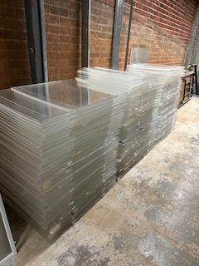
Figure 1

