MyDesign Portfolio
Element H Initial Template
How to use this template
Teachers: You may customize this document before providing it to students.
Students: The template below is one way to structure your testing plan, but the specific assignment given by your instructor may require a different structure or dictate different details. If you make a copy of this template to edit for your own testing plan, be sure to delete the instructions and delete the examples given in the template table.
Guidance before filling out the table on the next page:
Enter all of the high-priority design requirements you listed in Element C into the table below.
Determine an appropriate testing method for each requirement. For example, the test may involve measurement, inspection, physical actions, or mathematical modeling.
As you plan, use your scientific method best practices, e.g. creating experimental controls, defining independent and dependent variables, only changing one variable at a time and changing it in increments to find a trend, state your prediction, etc.
Your testing plan for a given requirement must include enough detail so that a person who is not on the design team could fully replicate the test. Include photos and/or diagrams to add clarity. Each test should include the following details:
how the test will be set up
what needs to happen during the test
test cases (if applicable)
number of trials of the test expected (aim for 7 or more trials)
the expected range of results that could be recorded, including units
the criteria for passing or failing the associated design requirement, including any permissible range for error and/or minimal thresholds
any goals your team has set beyond the passing result
Element H: Prototype Testing and Data Collection Plan
Testing Details (H1, H2, H3, H4)

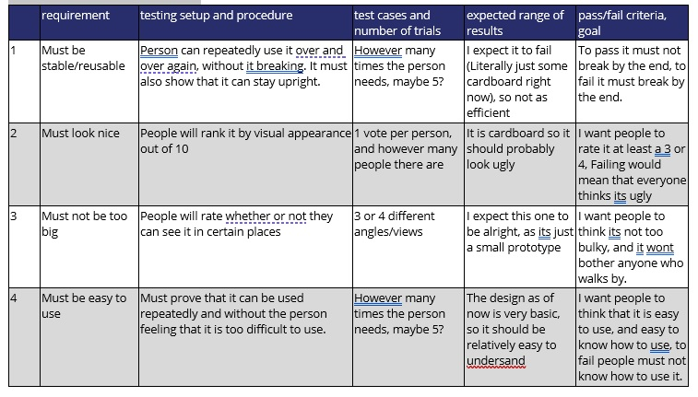

Feedback From Field Experts (H5)
Guidance to students about this section of Element H.
"Field experts" are professionals who spend at least a portion of their time working in a field directly related to your project. These field experts are not permitted to double count as stakeholders.
You must provide evidence in this section that your testing plan has been reviewed by 2-3 field experts.
Do not incorporate their feedback in the table above. Rather, make a copy of the table in the section above, paste it into the section below, and make all revisions only in the table below. This provides evidence that you incorporated the feedback and shows your testing plan’s progression.
Revised Testing Details That Incorporate Field Expert Feedback (H5)
-Wanted us to think outside the box, wants us to consider ability to actually work, such as torque above the visual appearance.

