Element G
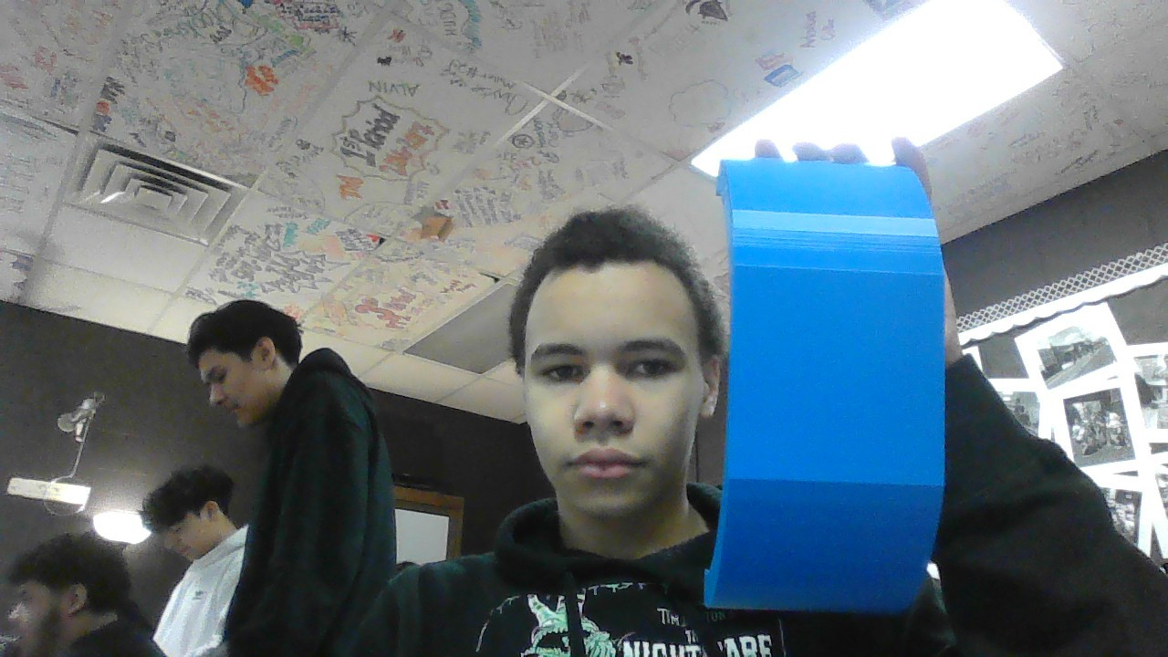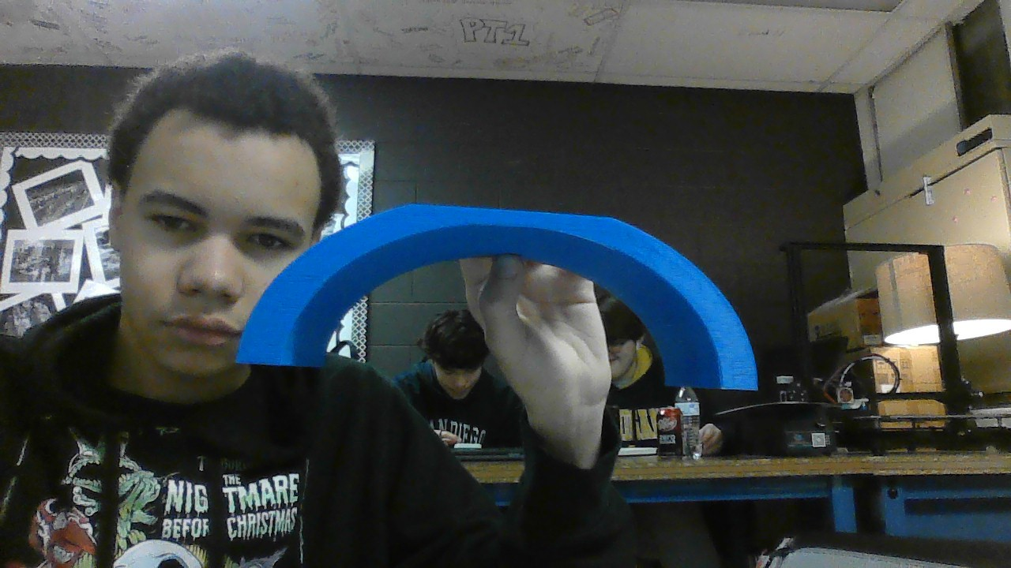
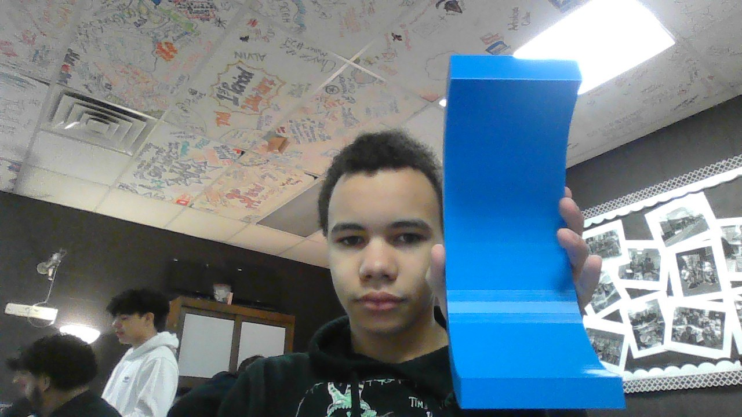
We have ensured to take photos from each angle to show our full prototype in size and length.

Detailing
Step 1: for the first step in any process is to plan out what needs to happen as such if in a group assign which group member will do what as this is a very important process for everyone to know what to do such as build, design, or program in cases its always the most important step first to plan out what is coming.
Step 2: the step that comes next and is also just as important would be researching and gathering information, this is a very vital step in any process to gather research and information on what is the idea of what’s to come for the group on what to do and how to do it.
Step 3: The next step should be using the information gathered to collect resources for the next steps and for the construction and building process while making sure the materials are up to proper standards ad fit all the necessary means.
Step 4: The next step for this process is to use these materials to build the visualized prototype and put it into perspective for the prototype will be the first design to go on and get feedback off.
Step 5: test the prototype in its aspects to see what needs to be improved or what can be improved such as height, length, width, or just materials in general its always important to test and find flaws.
Step 6: after using and testing your prototype then ensure a design for the new prototype or finished product then proceed to test this and the same ways to find flaws or if none you have almost finished.
Step 7: spend time and resources on the final product and finish the product to all means as such making the product the best you can make it to that point and once you have the product you set your sights on you have your product ready.

Step 1: with are designed first protype it was a complete mess with nothing of what was needed or what to make happen as such it was more or less just a curved wall with nothing special.
Step 2: our next design was more in terms of what was needed for the design, and we came to make the design more curved, yet it was better then the last as it was smoother on the texture but still had what it needed.
Step 3: after testing our last prototype the next was still curved but was flat to the top for the ability to hold objects on top as to hold the heat press it was intended to.
Step 4: out final product was almost exactly similar to the last except for detailing in the side and the angles as it was thicker and denser for a weight to it while the product had also been made for more sturdiness and the ability to hold something with a decent weight
th a decent weight

