Element H
Spinning Base:
As we were trying to find a decent size to match our design, we found one but had to be made bigger and had to make it able to spin. Our client want flexibility and for it to be able to turn
Shape Design:
Our testers made use do some good iterations as we did many diverse types of designs to see what would suit the client and what design would look best. Our final design was spinning bottom with a cup holder and 2 rows of cubbies with pulled string doors.
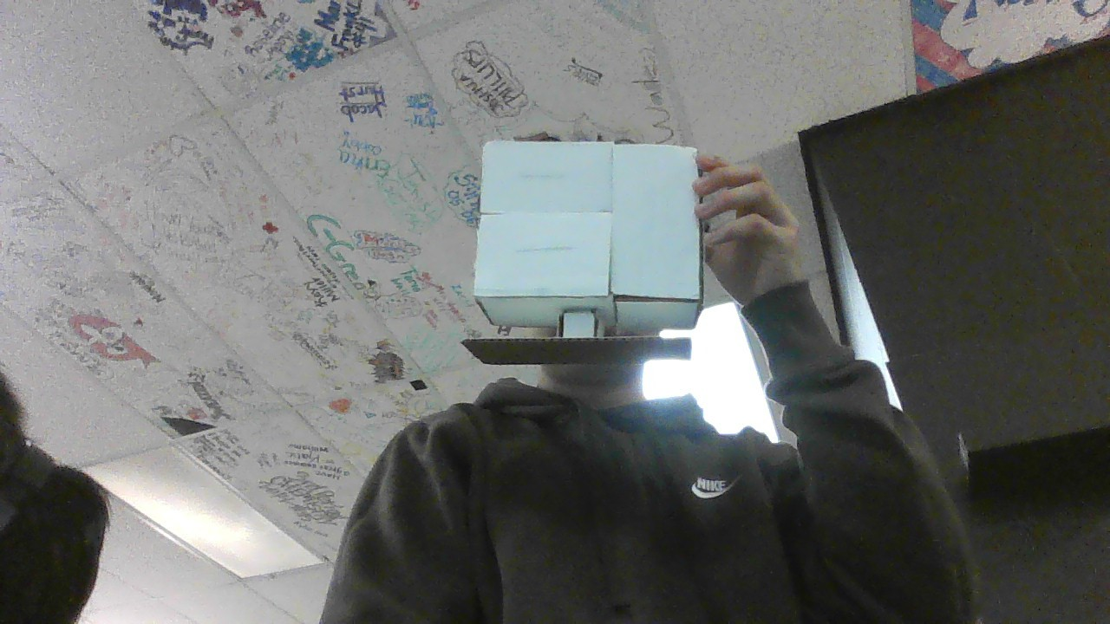
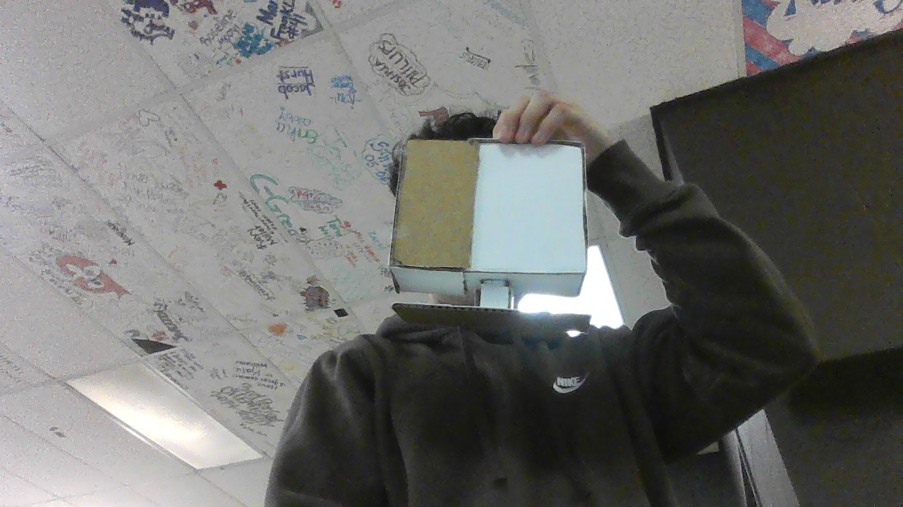
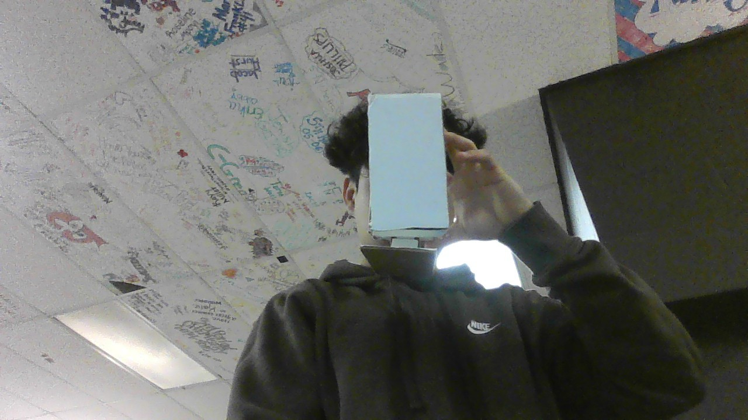
Our feedback from the experts from one of them was a very good idea and it would probably be a better design, which is to make cubbies in the main area instead of a pull box to make it easier to open. Another very good idea was to attach a little open box at the back to be able to hold more things and easily access whatever it is that you need.

