Section A: Presentation and Justification of the Problem

We are trying to solve the problems caused by swiveling desks in DCI. DCI students need to be able to lock these desks so that they can prevent them from being a disruption in class. These desks can be a distraction because of their unreliable nature. Many students can encounter difficulties during class time due to these desks. Swiveling desks can be beneficial in many ways, but cause problems when our peers expect a sturdy table and find their materials falling often. For example, a student might place a water bottle on the table, and any small bump may push the desk away quickly and cause the bottle to fall. While this may seem like a small issue to most, class time is critical, and it would be helpful to prevent distractions such as this one. Additionally, these desks can be a source of injuries for those unaware and not expecting moving desks. These problems can happen in any class where the desks are present.
The stakeholders in our project are both the students, teachers, and administration at DCI. Our project will make class time efficient, benefiting the teachers and students of DCI. There aren’t many possible unintended consequences, unless, of course, students wanted to unlock and relock desks but couldn’t figure out how our creation works. This could cause a few problems and perhaps cause a greater disruption than the original desks. However, it’s not a likely possibility, since our project will be simple, so our peers will be able to use it.
Our primary stakeholders are DCI students. Any student who has to use swivel desks should be interested in our solution because it would increase focus, allowing you to do better in your classes. Parents/guardians should also be interested in our solution because it will help their children to succeed as well as the faculty. After all, they will be able to teach in a more focused environment and see their students thrive. In addition, teachers, administration, and other DCI staff will be interested in our solution because they want DCI students to succeed. These additional stakeholders will also be in support of our project, as it will benefit them as well.
There is a lot of evidence supporting the fact that swivel desks can be a problem in schools. For starters, according to a study performed at the University of North Carolina in Chapel Hill where swivel desks were tested in various classrooms, “two instructors and 16% of the students surveyed said that the swivel desks had been a distraction at times. They were most likely to mention “moving too much” while in the seats or items falling off the desks.” Additionally, in the same study, 25% of professors mentioned that the swivel desks caused students to have more side conversations and be distracted by their peers (Henshaw et al.). This demonstrates how swivel desks are not only a problem at DCI but in classrooms across the country. It also shows how there are mixed feelings about the desks, which makes our solution ideal. A study was also performed at various universities across the US, which shows that unstable chairs are less likely to be comfortable or liked (Kulka et al.). Due to the swivel, the desks we have here at DCI are unstable, meaning that, according to the data from this study, not only are they less comfortable, but they are also worse for students’ posture and overall health. We also polled DCI students to get their opinions on the desks. Out of the 38 responses, 32 people (84.2%) said that they find the swivel desks annoying (Duncan et al.). This clearly demonstrates how this is a major problem at DCI and that these desks inconvenience the majority of students.
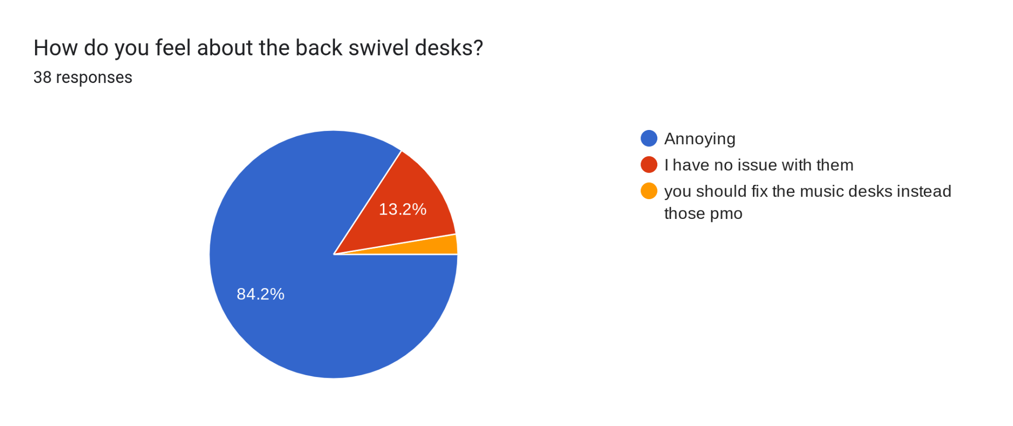
In summary, the black swivel desks are a major problem at DCI, inconveniencing, annoying, distracting, and harming students. Thus, it is vital that we solve this issue in order to create a better learning environment at DCI.

Bibliography:
Duncan, Elspeth, et al. “Are the Black Swivel Desks a Problem?” 12 Feb. 2025, https://docs.google.com/spreadsheets/d/15aM2MSSWKZr6hWi8-6dFZcdspzPZsZ5q-Cj1THbGCTA/edit?gid=0#gid=0
Henshaw, Robert G., et al. “Use of Swivel Desks and Aisle Space to Promote Interaction in Mid-Sized College Classrooms.” Journal of Learning Spaces, vol. 1, no. 1, 1 Dec. 2011, libjournal.uncg.edu/jls/article/view/277/166.
Kulka, Joseph, et al. “The University Desk Chair: Examining the Impact on Learner Comfort and Ability to Focus.” Journal of Learning Spaces, vol. 11, files.eric.ed.gov/fulltext/EJ1372450.pdf.

