Element B:
Prior Design Attempt #1
Name/Source: Kong Stuffin- https://healthypetaustin.com/
Image:
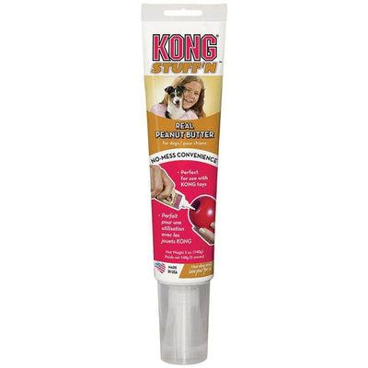
Details: All you must do is push pressure on the top and it comes out in one direction
Analysis: Yes, it is a promising idea the bad thing is, is that you would have to buy this product repeatedly to be used properly as it would run out
Prior Design Attempt #2
Name/Source: Kong easy treat- https://vetapprovedrx.pharmacy/kong-stuff-n-paste.html
Image:
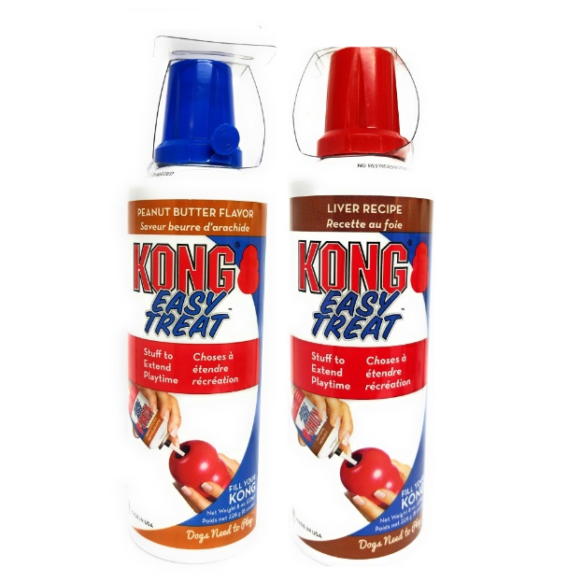
Details: Like whip cream cans just apply pressure to the tip and it will come out from a small like shown in the picture
Analysis: Like the previous design it fails to recognize that you would have to repurchase the product repeatedly
Prior Design Attempt #3
Name/Source: Kong Stuff'N Toy Stuffing- https://shop.howlinhampden.com/kong-stuffn-all-natural-pb-bacon-banana.html
Image:
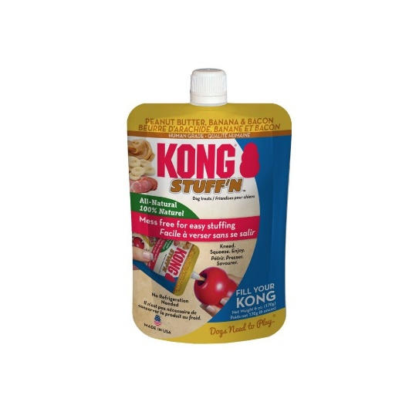
Details: Push the soft pouch and it will push through the tip
Analysis: Like previous designs it fails to realize the consumer would have to buy it many times and this one would just be dirtier as there is a higher chance of this exploding everywhere if introduced to the wrong environment
Prior Design Attempt #4
Name/Source: https://www.petsupermarket.com/dog/treats/soft-chewy-treats/kong-peanut-butter-bliss/PSI04616.html
Image:
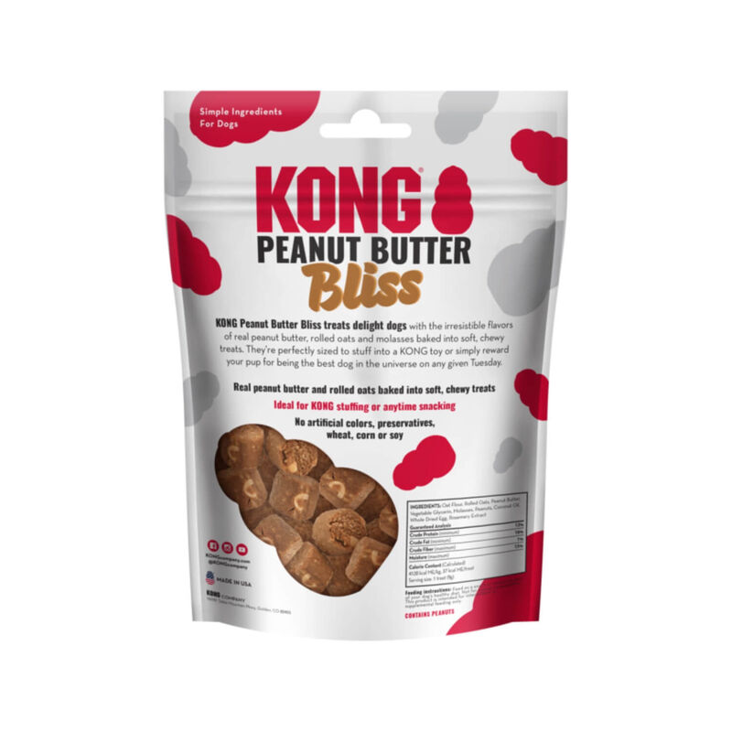
Details: little disks that are supposed to fit right in the Kong with ease
Analysis: This one is a clever design as you grab the treats and put them in and let the dog enjoy its treat. But we need to make an invention not a type of food, but we could take some inspiration from this.
Prior Design Attempt #5
Name/Source: https://orchardcountrystore.com/products/kong-stuffn-snacks-peanut-butter-recipe-dog-treats
Image:
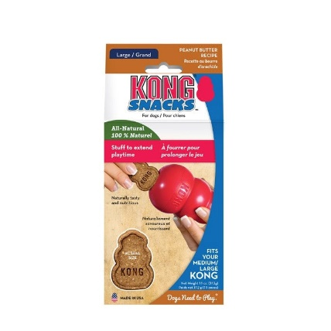

Details: Peanut butter Kong shaped snacks that easily fit in the Kong supposedly
Analysis: Again, like the other, it gets the job done of just putting in the treat instead of putting the work into it. But like wise it is not an invention but a reliable source to work off

