MyDesign Portfolio

Element B: Documentation and Analysis of Prior Design Attempts

Prior Design Attempt #1 - “Long Tennis Racket”

Source
Mrs. Hopkins, 2024
Image
Include at least one image of this prior design attempt. Make sure to cite all images.

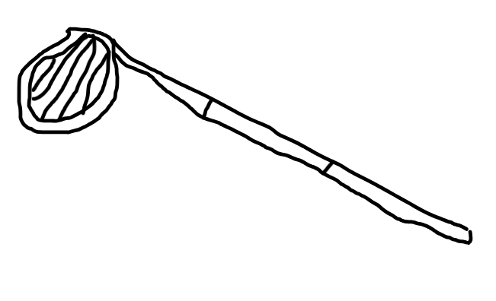
Replica of Mrs. Hopkins’s “Long Tennis Racket”, drawn by me, 2024.
Details
This is just the head of a tennis racket attached to a long stick. It is meant to help you reach high areas to retrieve the birdies. Although it is helpful to retrieve birdies and tennis balls from basketball hoops and backboards, and on some other walls, many birdies end up getting stuck too high for the stick to reach.

Prior Design Attempt #2 - Ladder

Source
Google (year unknown)
Image
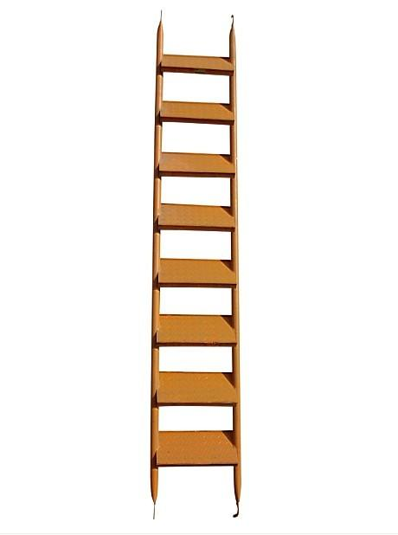
Include at least one image of this prior design attempt. Make sure to cite all images.
A ladder
Details
Mrs. Hopkins could have used a ladder to get to higher places easier. However, the birdies and tennis balls were particularly high, and many ladders would not be to reach such heights, but this and attempt #1 together (standing on the ladder while using the tennis racket) would work, but it would be very dangerous to do.

Prior Design Attempt #3 - Fishing Rod

Source
Google (year unknown)
Image
Include at least one image of this prior design attempt. Make sure to cite all images.
A fishing rod, Google (year unknown)
Details
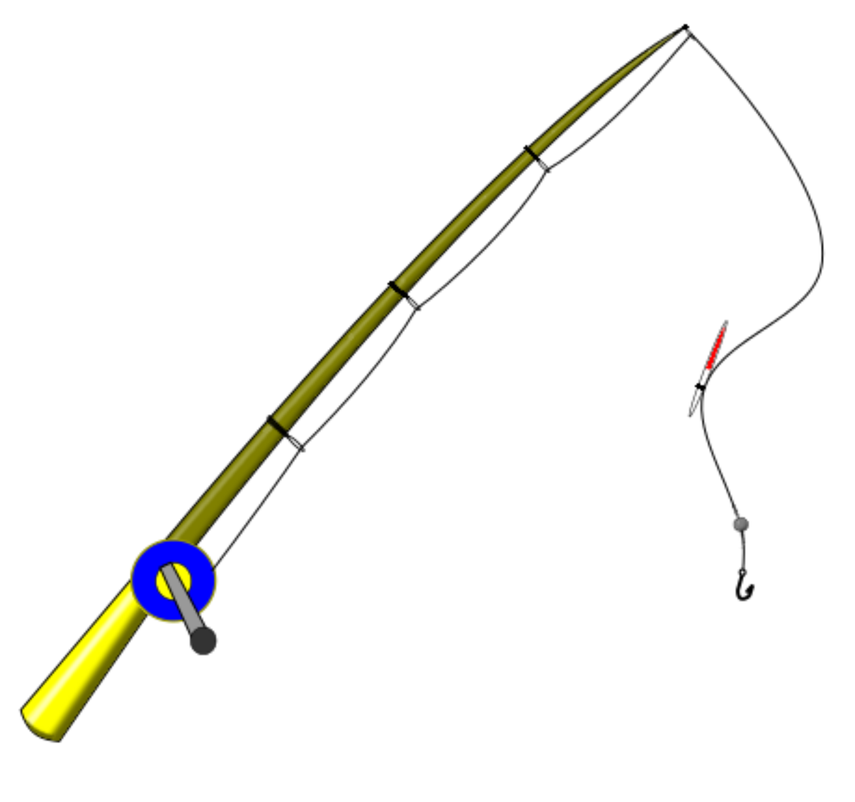
Source
Google (year unknown)

Mrs. Hopkins could use a fishing rod to hook the birdies and tennis balls to bring them down. However, this might be very challenging to do, and the sharp hook might damage the equipment.

Prior Design Attempt #4 - Drone

Source
Google (year unknown)
Image
Include at least one image of this prior design attempt. Make sure to cite all images.
A drone, Google (year unknown)
Details

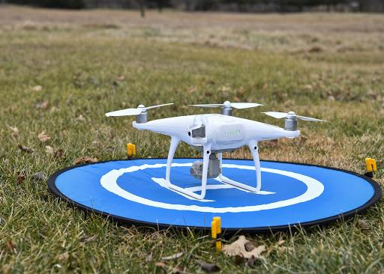
Source
Google (year unknown)

Mrs. Hopkins could use a drone to pick up the birdies/tennis balls from the high locations and retrieve them, but this will be challenging because it will be difficult to predict the exact location of the drone when it drops down to pick up something. The drone could also run out of battery at a location and get stuck, as well.

Analysis

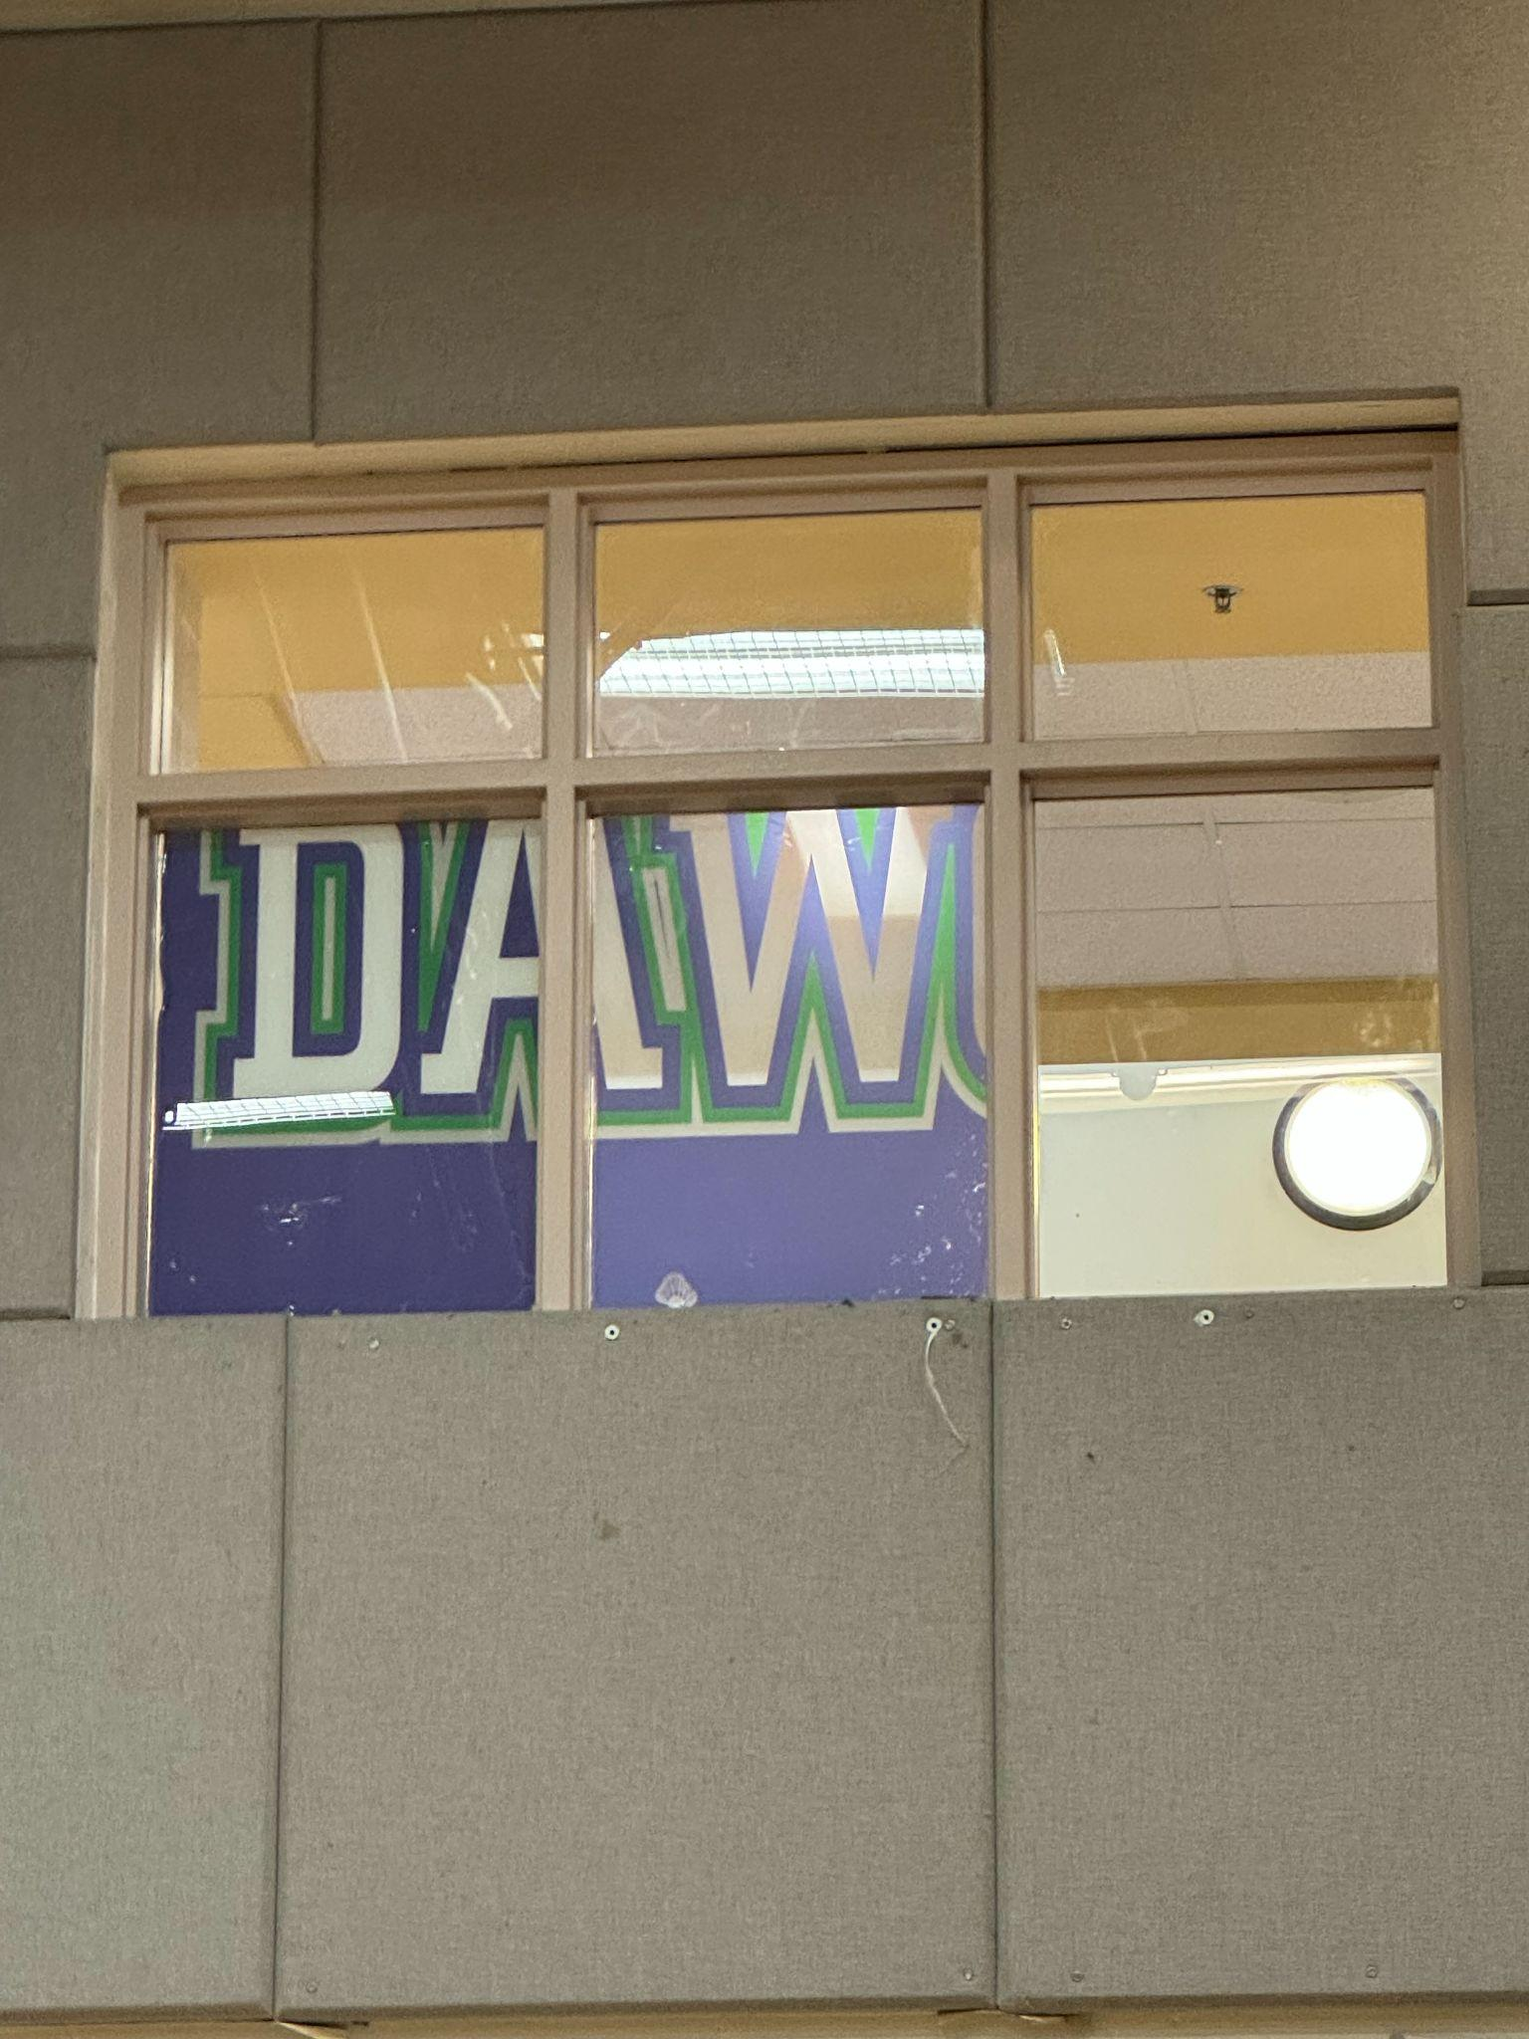
This windowsill is the prime example of the problem. It is on the second floor of the school, and it is way too high for anyone with the stick to reach it. If the stick is extended too long, it becomes too unstable and falls apart.
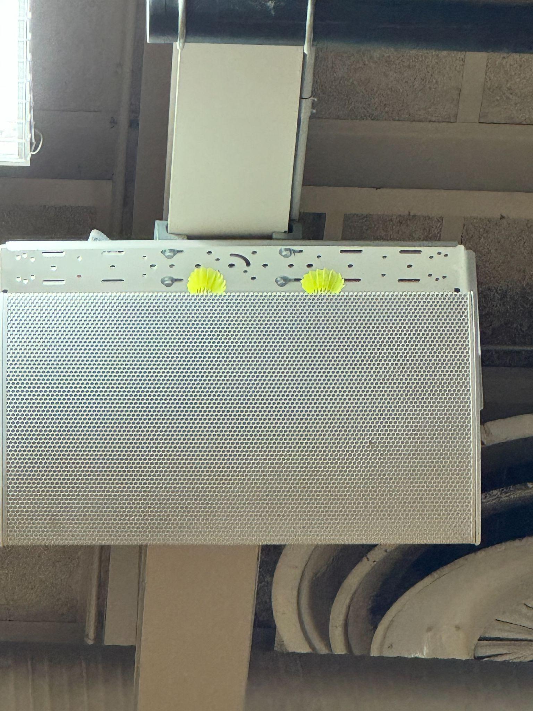
This is another example of birdies ending up too high. The speaker is near the high ceiling of the gymnasium, making retrieval near impossible.

Rubric
Element B: Documentation and Analysis of Prior Design Attempts
B1. Documentation of plausible prior attempts to solve the problem and/or related problems is drawn from  (2) Only two sources.  The only official attempt that was made to solve the problem was the “Long Tennis Racket”, and so far, that was mostly ineffective. The last three attempts are all theoretical and it was never officially tested. |  | score = 5 | score = 4 | score = 3 | score = 2 | score = 1 | score = 0
 |  | a wide array of clearly-identified and consistently-credible sources | a variety of clearly-identified and consistently-credible sources | several—but not necessarily varied—clearly-identified and generally-credible sources | a limited number of sources, some of which may not be clearly identified and/or credible | only one or two sources that may not be clearly identified and/or credible | missing or minimal (a single source that is not clearly identified and/or credible)
B2. The analysis of past and current attempts to solve the problem — including both strengths and shortcomings —  (3) Is generally clear and contains some detail and supporting data that is recent and relevant to the problem. |  | score = 5 | score = 4 | score = 3 | score = 2 | score = 1 | score = 0
 |  | is consistently clear, detailed, and supported by relevant data | is clear, generally detailed, and supported by relevant data | is generally clear and contains some detail and relevant supporting data | is overly general and contains little detail and/or relevant supporting data | is vague and is missing any relevant details and/or relevant supporting data | cannot be inferred from information intended as analysis of past and/or current attempts to solve the problem

