Element B 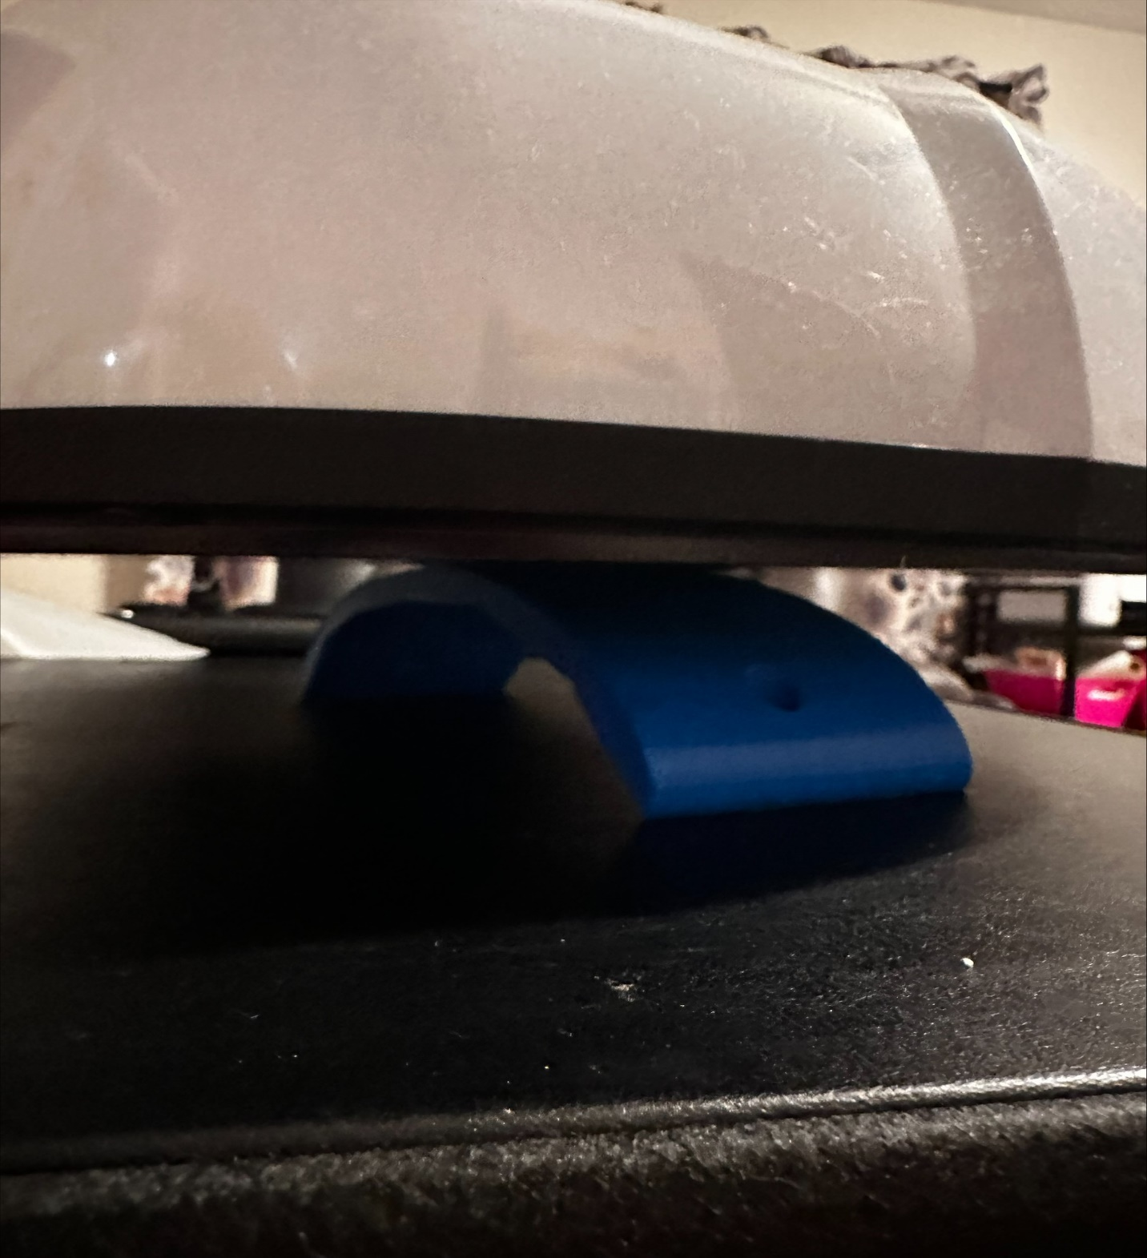
Design attempt 1
This was our first printed out prototype which held to its purpose but wasn’t quite fit enough for the job as it tended to be too small and too light which was a big issue for our group meaning we had to redesign.
Its purpose was served as it was able to hold the heat press and was small for storage, but it was too small which was the contributing factor leading to redesign, but it was sturdy and lightweight as well as small which were good but also bad things for the project.
For the analysis our prototype for the project was as successful as it wasn’t as it met requirements it needed while those requirements were not meeting the other requirements which led to the redesign to make the project bigger and sturdier as well with keeping the light weight to a factor
This was provided and constructed during class periods in the technology classroom with the help of a trustworthy supervisor Amanda Jones
Design attempt 2
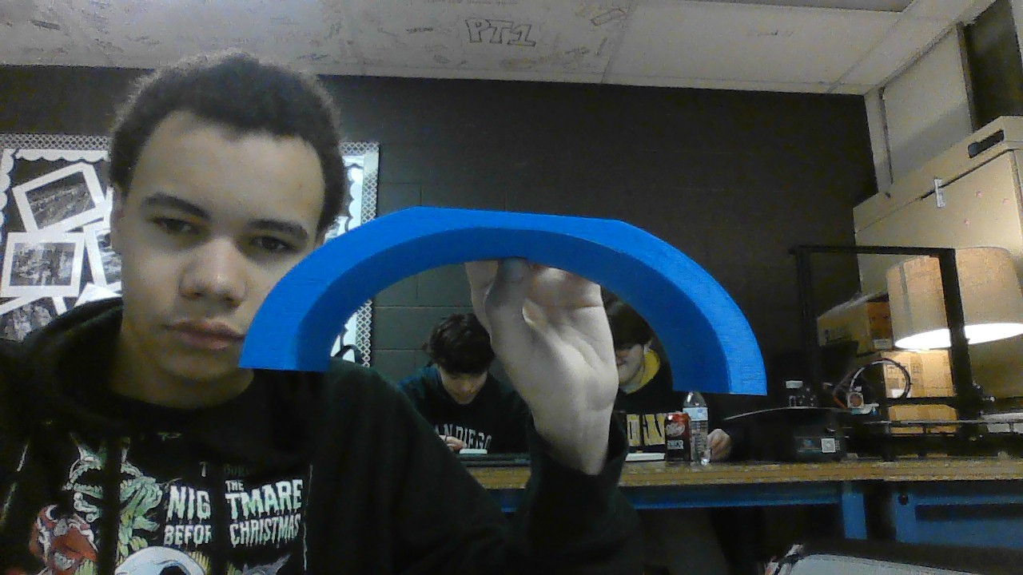
This was the second attempt for our final product which unlike the prototype was made much more carefully as the product is larger to hold the heat press easier as well as it was made much sturdier then the first which tends to the high temperature and making it a great holder for the heat press.
For the analysis the product is everything it needs to be along with its counterpart the second piece, the product is sturdy, has a decent weight and has a good resistance to heat which is required.
This was provided and constructed during class periods in the technology classroom with the help of a trustworthy supervisor Amanda Jones

Design 0
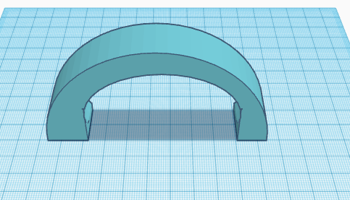
This was the very first design for the prototype which pales in comparison to the newer models, but this was the first attempt at a design which made the way for our achievements in making the newer and better projects while this would have had sturdiness and decent weight it would not have served the intended purpose all that well while it does share attributes with the other projects it simply is a lesser model
This project of a prototype was constructed during class hours of technology and engineering under the watch of the supervisor Amanda Jones

