Documentation and Analysis of prior attempts Part B

Prior Design Attempt #1 - <original metal can>
Source
https://www.webstaurantstore.com/documents/specsheets/179b254.pdf
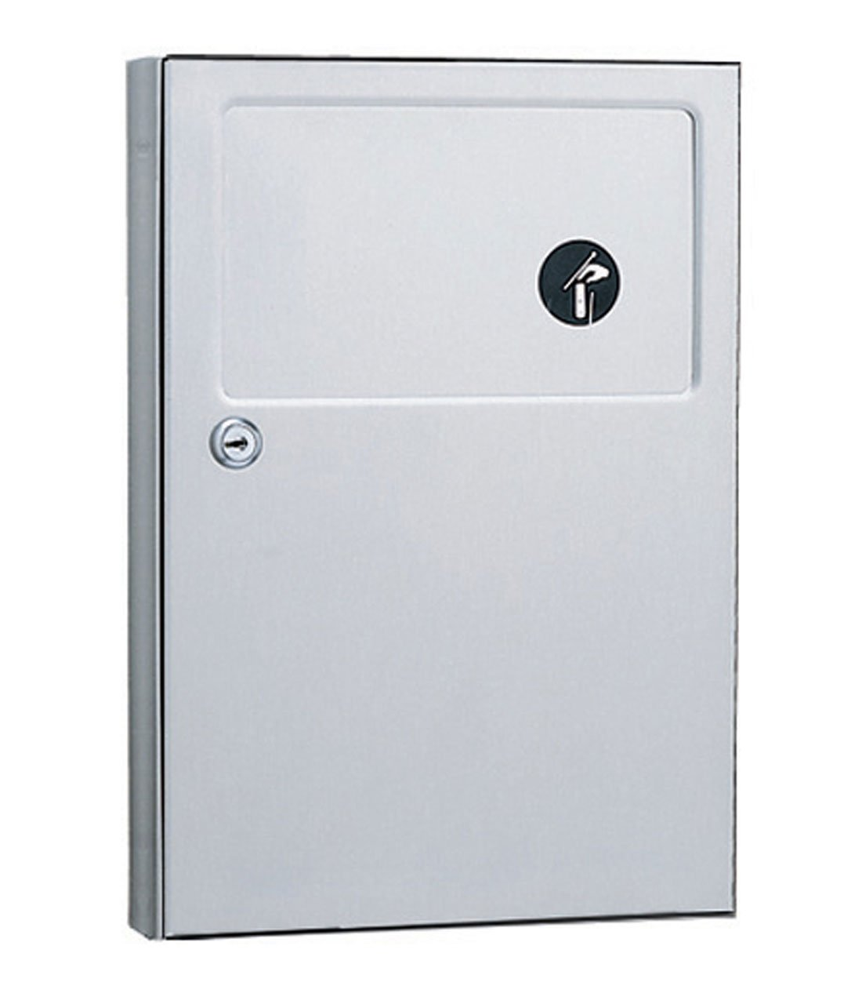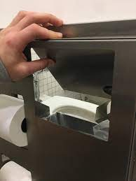

Details
- Metal trash can
- Push in swinging door
- Connected through stall wall
- Shared trash can for both stalls
Analysis
The metal surface harbors bacteria, and the swinging door requires contact for the trash can to be used. This is extremely unsanitary, especially considering the contents of which are being disposed of. Additionally, the trash can is shared between stalls. This becomes a privacy issue as the user in stall 1 can easily view the user in stall 2 through the opening.

Prior Design Attempt #2 - <plastic can>
https://www.webstaurantstore.com/lavex-janitorial-white-plastic-wall-mount-sanitary-napkin-receptacle-imp-1102/2721102.html?utm_source=google&utm_medium=cpc&utm_campaign=GoogleShopping&gclid=CjwKCAiAu9yqBhBmEiwAHTx5p4VL5_4ifyyQTbR-_5Vklpf9HkbWyCevX62lbKHX8HEe6yjqEaMNDxoC-8QQAvD_BwE
Journal/newspaper about feminine product trashcans and dispensers page 2 https://nsuworks.nova.edu/cgi/viewcontent.cgi?article=1556&context=nsudigital_newspaper/
https://www.5gyres.org/plastic-period-care
Info about use of plastic period product
https://www.googleadservices.com/pagead/aclk?sa=L&ai=DChcSEwjL1ob0zMuCAxWBNtQBHUkrB70YABARGgJvYQ&ase=2&gclid=CjwKCAiAu9yqBhBmEiwAHTx5p2QiFVV1y8xpkhjuk5bN70SS8q3qL8Q5MlvsV-VB9EfpdxpVOYXMmhoCERsQAvD_BwE&ohost=www.google.com&cid=CAESVuD2-qn6O7zUfggP63Y8haWa32UpV1ewmmpFDXQWP6h9pBdudeQTe6Dr5yQQZtowJatqaJEbF8KNdvjn2ti2QuwxYaAZAoqau8TdrOn6-oFWgk924gLR&sig=AOD64_0ku2PvOyLg98fOgiZ_YO21LKJjMA&q&nis=4&adurl&ved=2ahUKEwjdyfnzzMuCAxXXrmoFHatwAk4Q0Qx6BAgMEAE
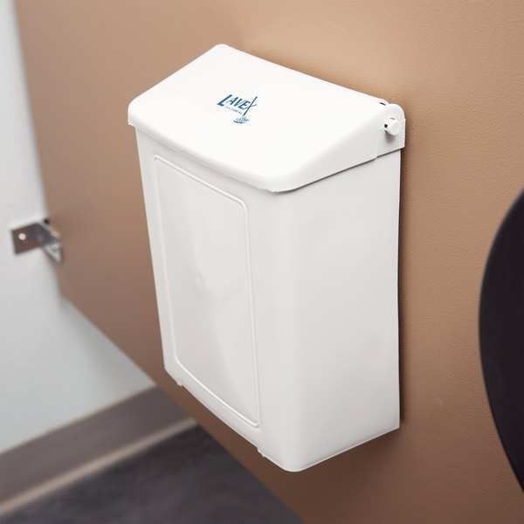

Include main details about this prior design attempt
The design attaches to a stall in a bathroom in a public setting. There is a simple lid that opens to a wax trash bag where they can put their products. This simply screws into the wall and is made out of plastic for easy cleaning.
Provide evidence and explain what parts of this prior design attempt were unsuccessful at solving the defined problem and why based on design requirements.
What is successful about this design is that it is easy for staff members of the school to change out the bag and clean it. What we think could be improved is that the cleanliness is not there. Every person must touch the lid to allow the disposal of their products. We believe there should be a different way to do it. Although this is accessible, there is room for improvement. The door is also not spring-loaded which means the person will have to touch the thing many times

