MyDesign Portfolio
Element D Initial Template
Students: The template below is one way to present your design ideas, but the specific assignment given by your instructor may require a different structure or dictate different details. If you make a copy of this template to edit for your own design ideas, be sure to delete the instructions.

Guidance before filling out the template on the next page:
Because you will iterate on your design multiple times, you will need to create multiple copies of these sections. Think of Element D as a diary that you will date and keep adding to throughout your work until your final iteration. It’s critical that iteration shines through in this Element.
You should begin with many design ideas that reflect the individual ideas of your group members and then the group ideas. Number these ideas and include a date, description, drawing, and details for each.
After you have created an initial set of ideas, document your decision making on which design to include, ideally with a design matrix. Create a plan of work, ideally using a Gantt chart that may be housed in this document or in a different day-to-day document. Generate a design blueprint with enough details that someone else not familiar with your project could also build your design.
You will then proceed forward to build and test this design, returning to Element D afterwards when you are ready to create more design ideas. Fill out each of these steps again.

Element D: Design Concept Generation, Analysis, and Selection

Design Idea Generation (D1)
This section focuses on the process of generating solutions. The initial rounds should include every idea you come up with but the subsequent rounds of ideation should lead to viable options. Each idea should include not only words, but also a picture. Use as many copies of this sub-template as needed.
Design Idea #1: Pullee System
Date: 2/10/24
Description: There is a string or pullee thing that pulls the sneeze guard up and down.
Drawing that includes distinguishing information such as scale, dimensions, and materials:
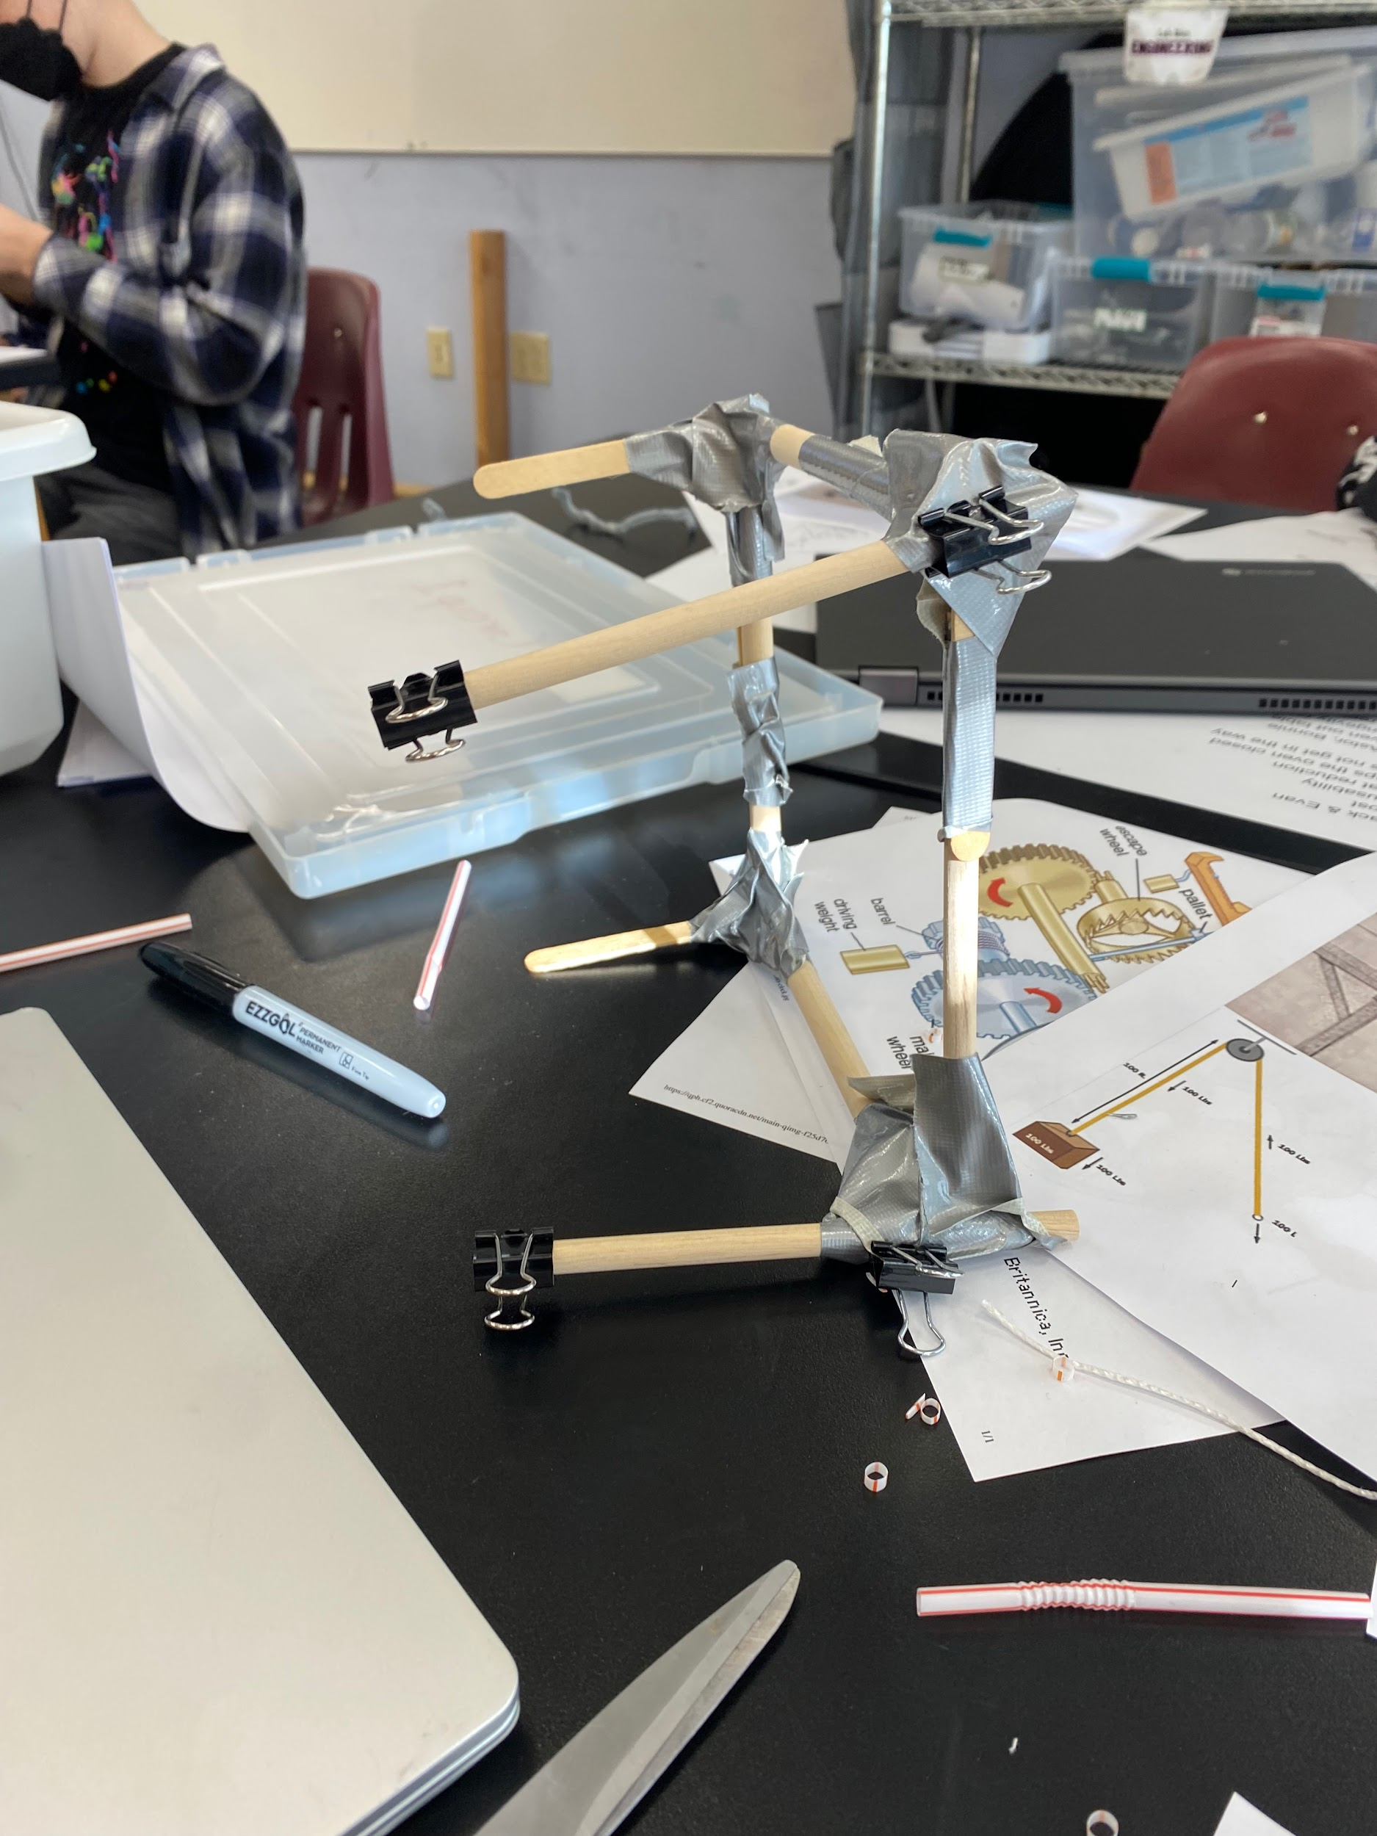
Design Idea #2: Handle Idea
Date:2/10/24
Description: The handle will lift the sneeze guard up and down
Drawing that includes distinguishing information such as scale, dimensions, and materials:
Design Idea #3 Door knob thing
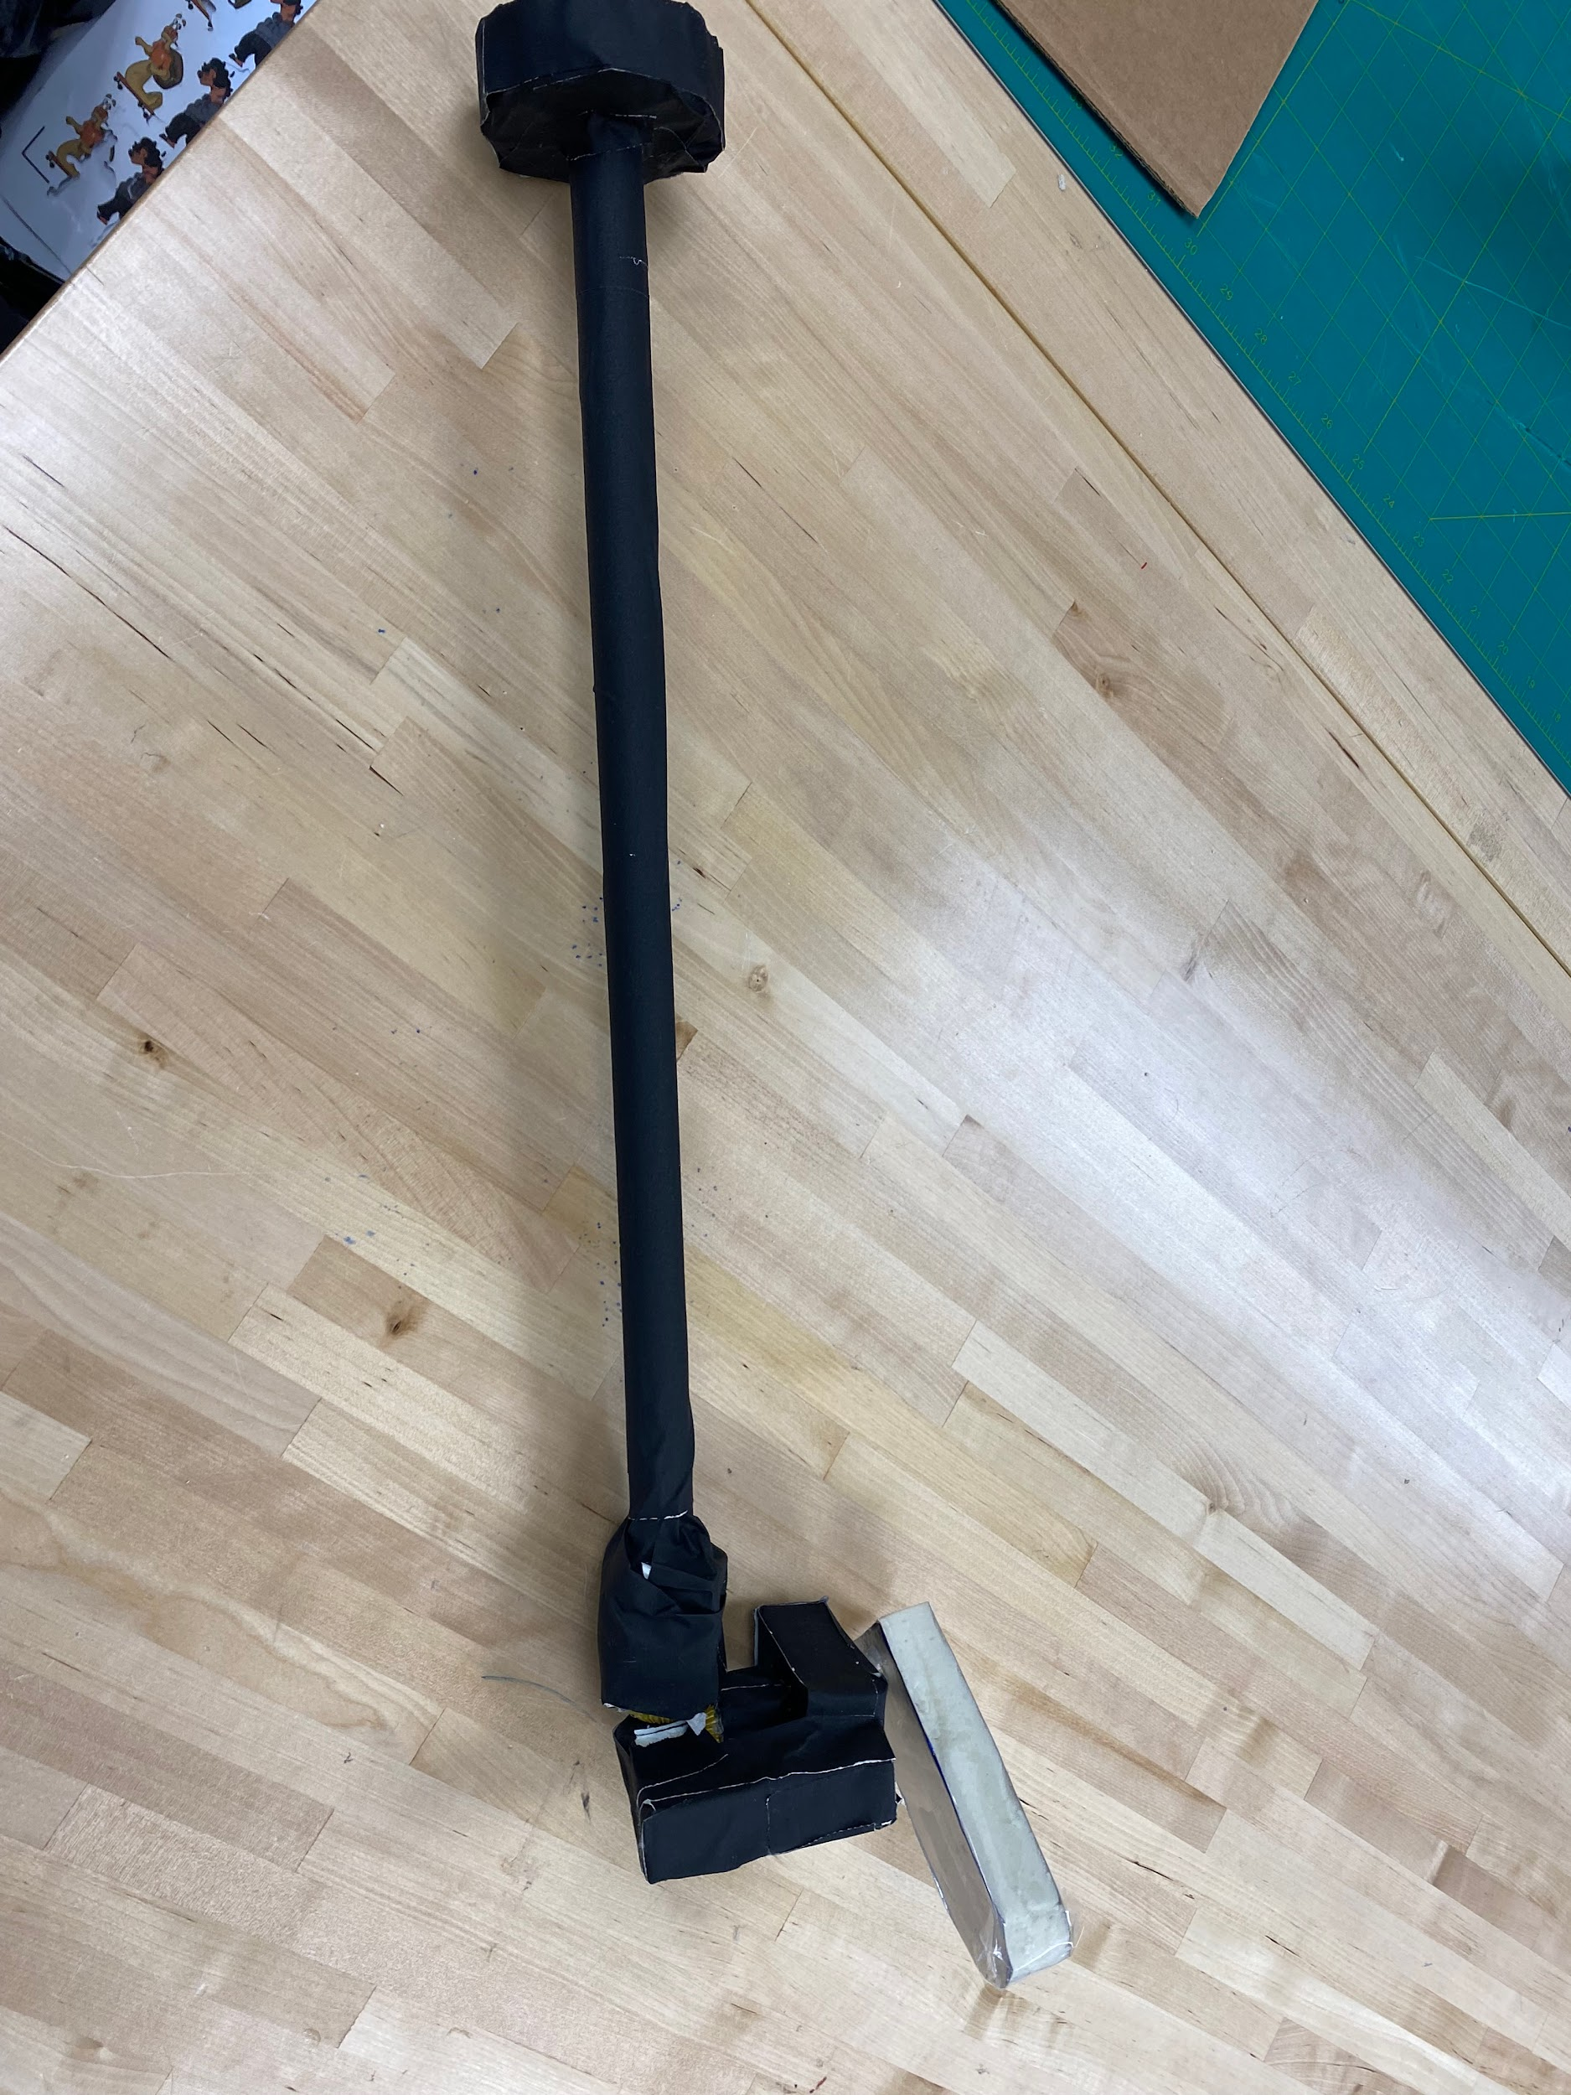
Date:2/12/24
Description: The door knob idea will turn the sneeze guard so it isnt in the way. As you turn the knob, some bevel gears will turn causing the little pole to rotate left and right. As it turns to the left, the pole will slide up, causing the sneezguard to lift up. As it turns to the right, it will drop the sneezguard.

Design Idea Comparison and Selection (D1, D2)
When you’ve finished generating ideas, you must compare your design options according to all your design requirements. Incorporate the priority of those requirements when comparing design options. A decision matrix (perhaps a Pugh Matrix) is encouraged since it allows for systematic, weighted comparisons. If using weights in a decision matrix, be sure to explain and justify the weighting based on your design requirements. You may use the weighted design matrix template below, inserting your criteria and design options.

 | weight | Handle | Pullee | Nothing | Robe hold thing
Size of solution | 25% | 2 | 4 | 5 | 3
Speed of use | 20% | 5 | 5 | 2 | 5
Ease of use | 20% | 4 | 5 | 1 | 5
Weight of solution | 30% | 2 | 3 | 5 | 3
Visual appearance | 5% | 1 | 4 | 1 | 4
 | 100% | 14 | 21 | 14 | 20
score | 100% | 14 | 21 | 14 | 20

Design Blueprint (D4)
Describe all of your design's details such that someone unfamiliar with your project could build your prototype. Include sketches, dimensions, CAD (if taught in your class), manufacturing methods, material choices, supply lists, and costs.
Design Blueprint #1
Date: 2/12/2024
Manufacturing Methods:
Step 1:
Step 2:
Step 3:
Supply List and Costs:
Item | Cost each | # needed | Total
rope/string |  | WE HAVE EVERYTHING MOST LIKELY
pullee
3d printed parts
Total Cost

Plan of Action (D3)
A Gantt chart is encouraged to lay out the primary steps expected on a visual timeline. Larger tasks from the Gantt chart should be broken down further into detailed sub-tasks, which may be housed in a different day-to-day document. Discrete tasks should include enough detail such that others could replicate the efforts, such as procedures, materials, tools, status, etc.

