Element D

Design concept generation, analysis, and selection
 | Idea #1 | Idea #2 | Idea #3
Date | 1/26/24 | 1/26/24 | 1/26/24
Description | Suction cups are attached to the handle that attaches to the iron press. | Have a comfortable handle that is easy to hold that could be screwed in. | 3-d printed handle that can be screwed into the iron press.
Picture | 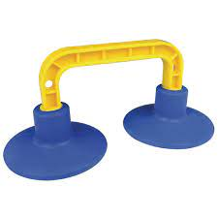 | 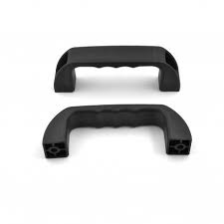 | 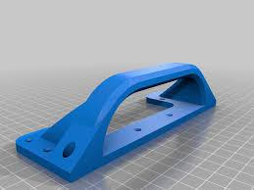
Design idea comparison and selection

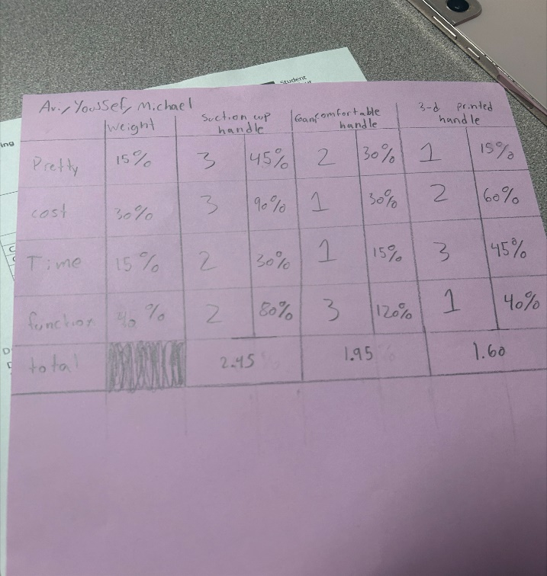
We decided to select the 3-d printed handle because it functions well, doesn't take a lot of time, and doesn't cost much. It also had the lowest total on the chart. It could also look pretty if we design it pretty.

Design Blueprint #1
1/30/24
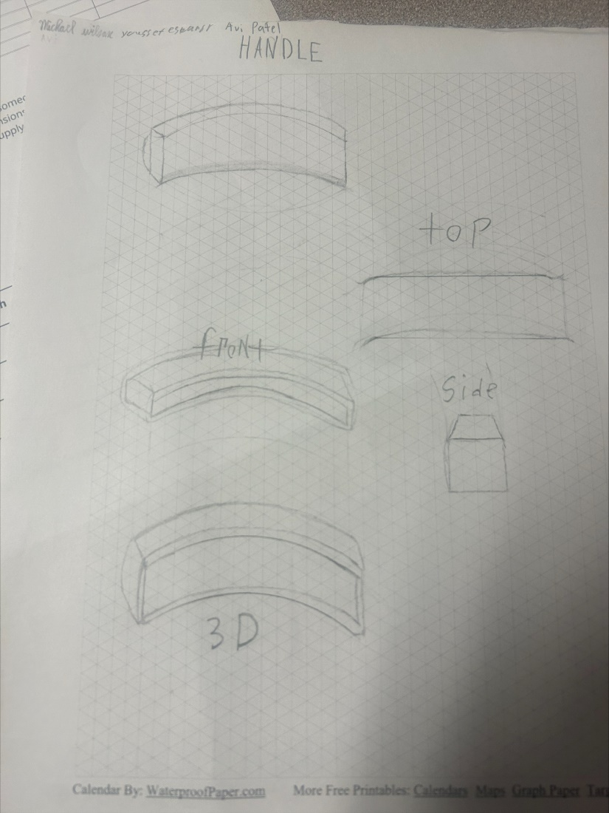
Step 1: make ideas
Step 2: choose an idea
Step 3: sketch the idea
Step 4: tinker cad
Step 5: make the prototype
item | Cost each | # needed | total
screws | $7.50 | 1 pack | $ 7.50
Plastic for 3-d printer | $21 | 1 pack | $21
sandpaper | $7 | 1 pack | $7

