Design Concept Generation, Analysis, and Selection Part D

Design Idea Generation (D1)
This section focuses on the process of generating solutions. The initial rounds should include every idea you come up with but the subsequent rounds of ideation should lead to viable options. Each idea should include not only words, but also a picture. Use as many copies of this sub-template as needed.
Our first step was drawing out our ideas for possible prototypes. We then researched materials as well as what is currently on the market. After this, we put together a very rough cardboard prototype and took it to Mr. Glass for official prototype planning. Over the next few weeks we worked closely with him to laser cut and assemble pieces of plexiglass to create the final prototype.

Design Idea #1
Date:
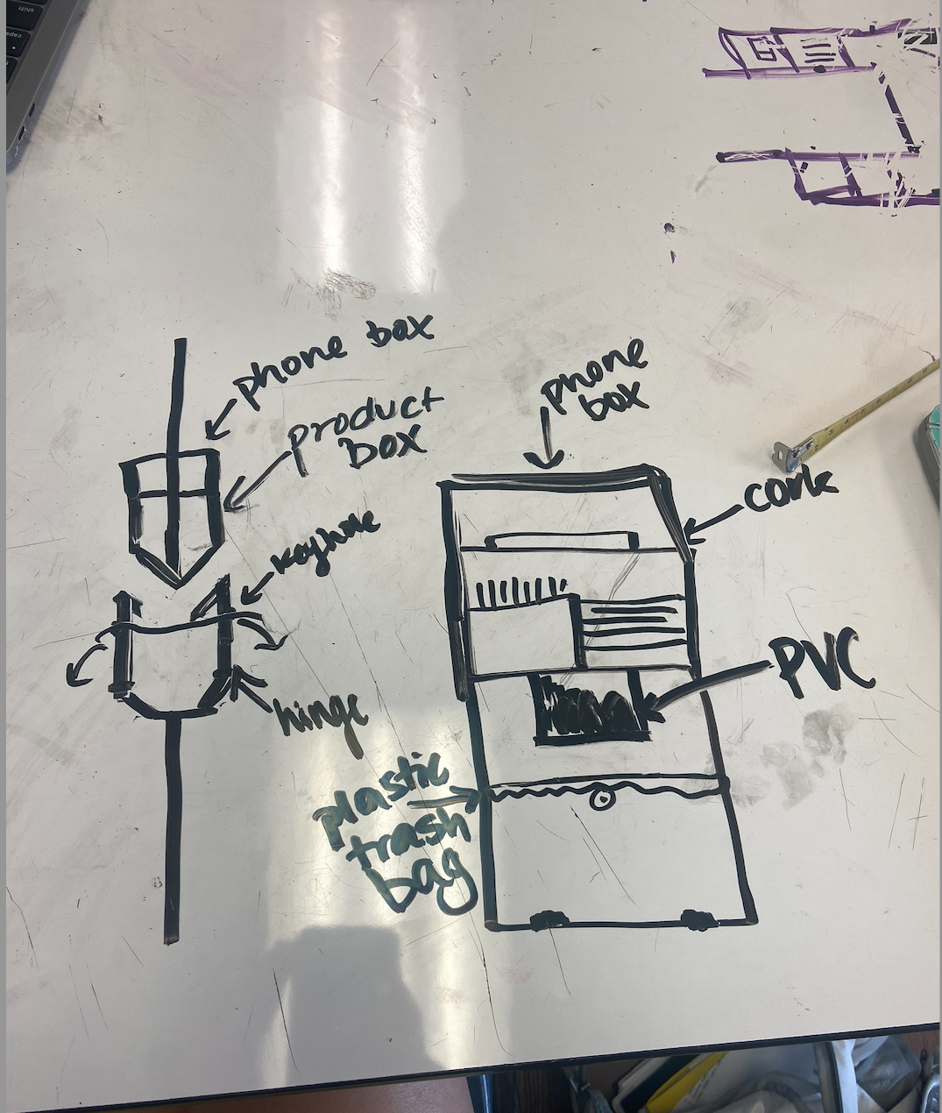
Design Idea #2
Date: 2/28/24
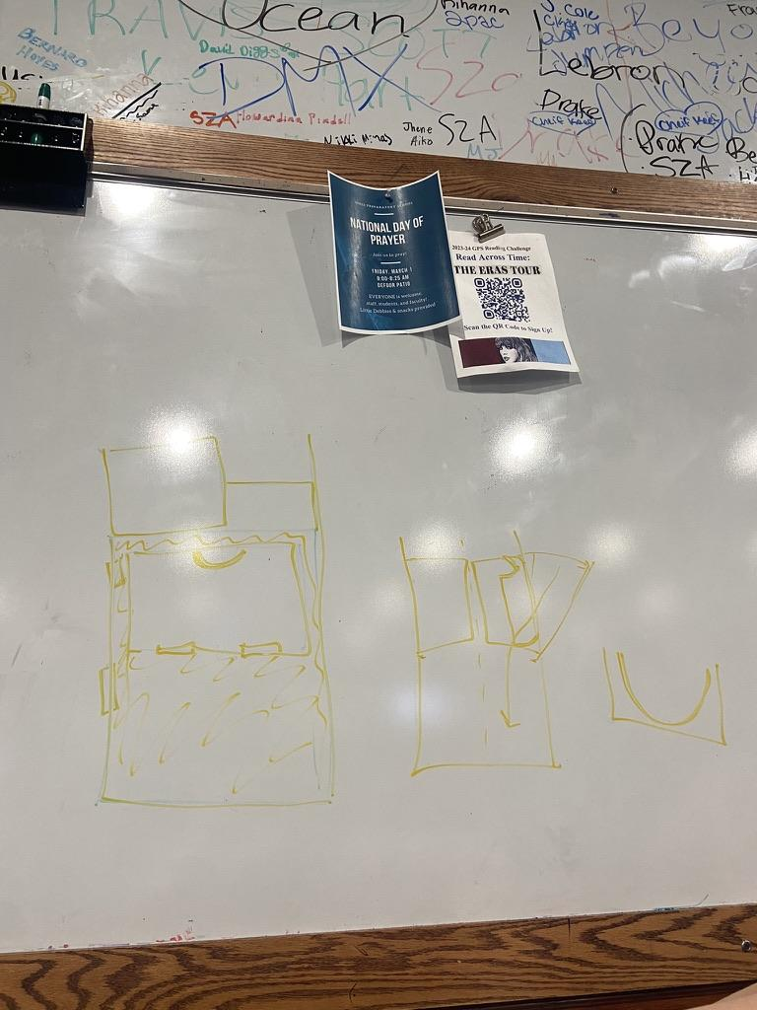

Design Idea #3
Date: 3/4/24
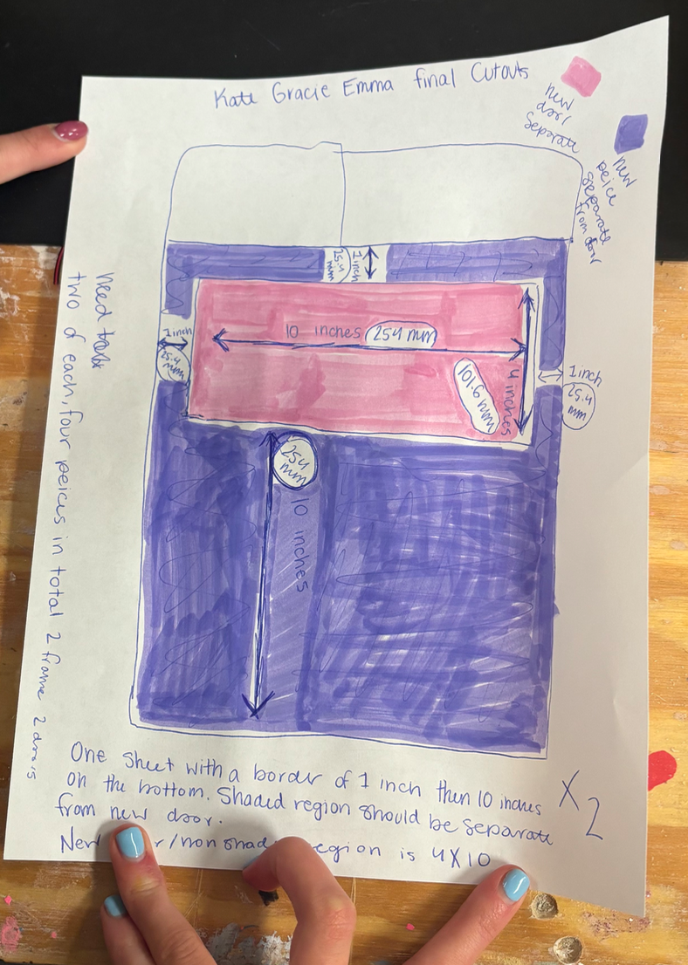

Design Blueprint (D4)
Describe all of your design's details such that someone unfamiliar with your project could build your prototype. Include sketches, dimensions, CAD (if taught in your class), manufacturing methods, material choices, supply lists, and costs.
Design Blueprint #1
Manufacturing Methods:
Step 1: Laser cut pieces of plexiglass & paint them
Step 2: Use adhesive/tape to assemble the pieces
Step 3: Apply cork to the bottom of the shelving
Item | Cost each | # needed | Total
Plexiglass | Free (recycled) | 2 sheets | $0
Cork sheets | About $0.75 | 4 sheets | $3
PVC Pipe | $9 | 0.5 of a whole pipe | $4.50
Total Cost |  |  | >$9

