Element D:
Design Idea #1
Date:1/26/24
Description: Customized straw that could pass peanut butter into Kong
Drawing:
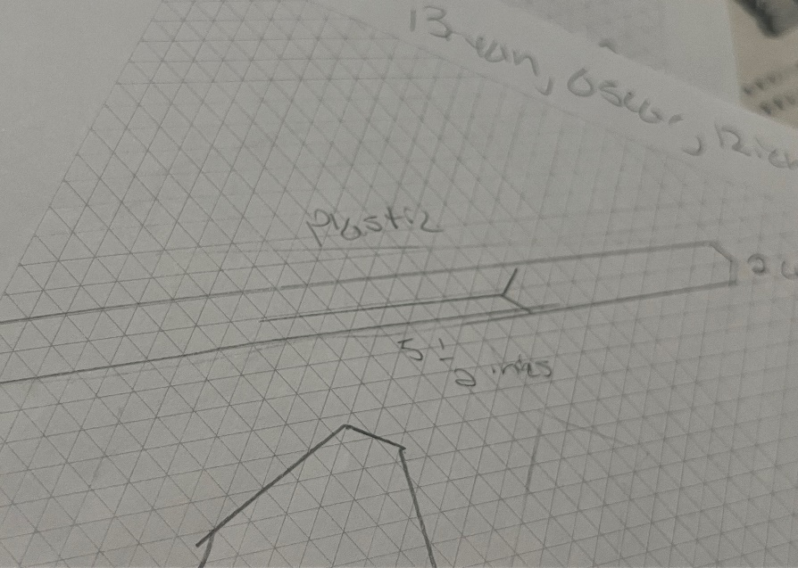
Design Idea #2
Date:1/26/24
Description: Ice cream like spoon that can grab peanut butter and push it out with the handle at the back
Drawing:
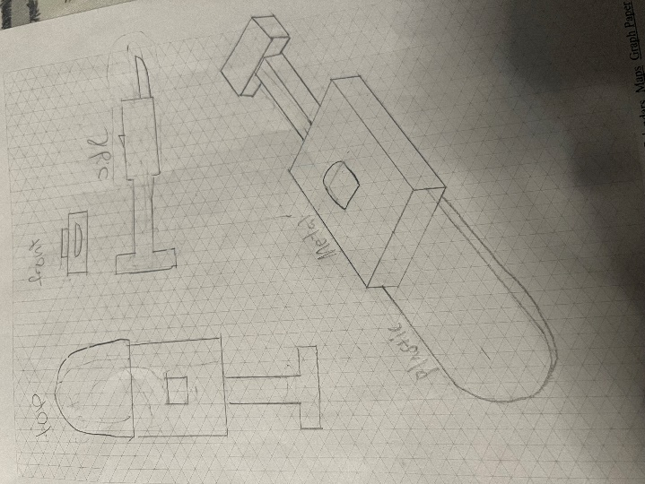
Design Idea #3
Date:1/26/24
Description: Suction object to absorb and release peanut butter into Kong
Drawing:
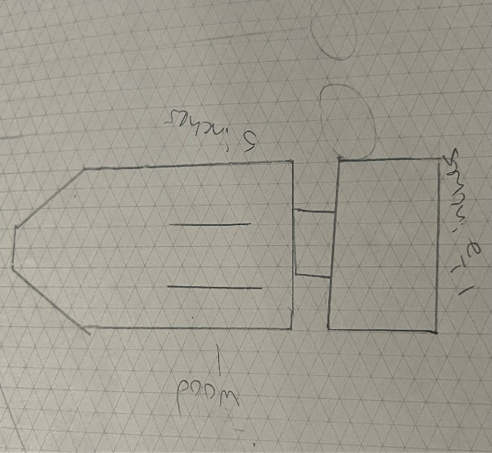
 | Weight | Ice cream scoop like spoon.  Rank Score | Suction object to absorb and release into Kong.  Rank Score | Customized straw that could pass peanut butter into Kong.  Rank Score
Pretty | 10% | 1 .10 | 2 .30 | 3 .30
Cost | 30% | 1 .30 | 2 .40 | 3 .60
Time | 20% | 1 .20 | 3 .60 | 2 .40
Function | 40% | 2 .80 | 1 .40 | 3 1.20
Total |  | 1.4 | 1.6 | 2.5

Design Blueprint #1
Date:2/8/24
Sketch
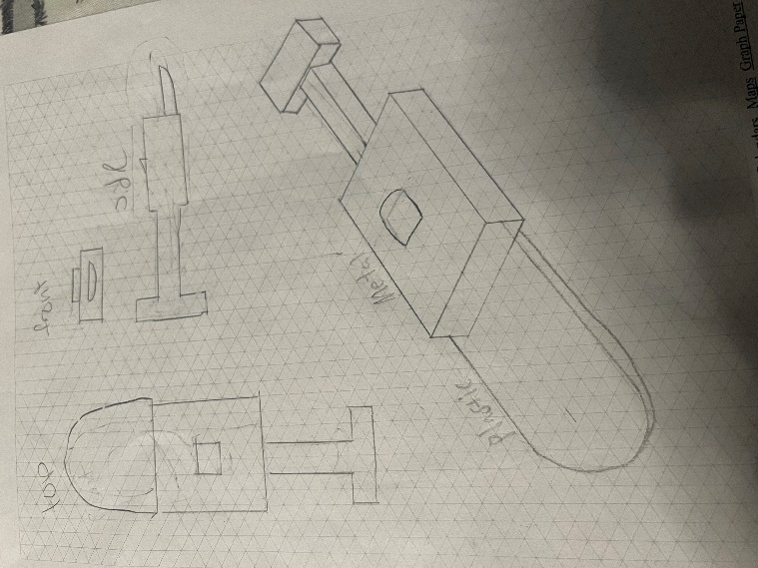
Manufacturing Methods:
Step 1: Make the base of the design along with the push object.
Step 2: Make the part where it can go in and out and lock.
Step 3: Make the spoon effective and support weight.
Supply list and costs:
Item | Cost each | # Needed | Total
Plastic spoon | Three dollars | 1 | 3
Sheet of plastic | Eight dollars | 1 | 8
Metal sheet | Thirteen dollars | 1 | 13
Total cost |  |  | 24

