D
Design Idea #1: Gps dress altered to a shirt, with the option to be worn with shorts or pants.
Date: November 2023
Description: uniform with shirt and pants or shorts.
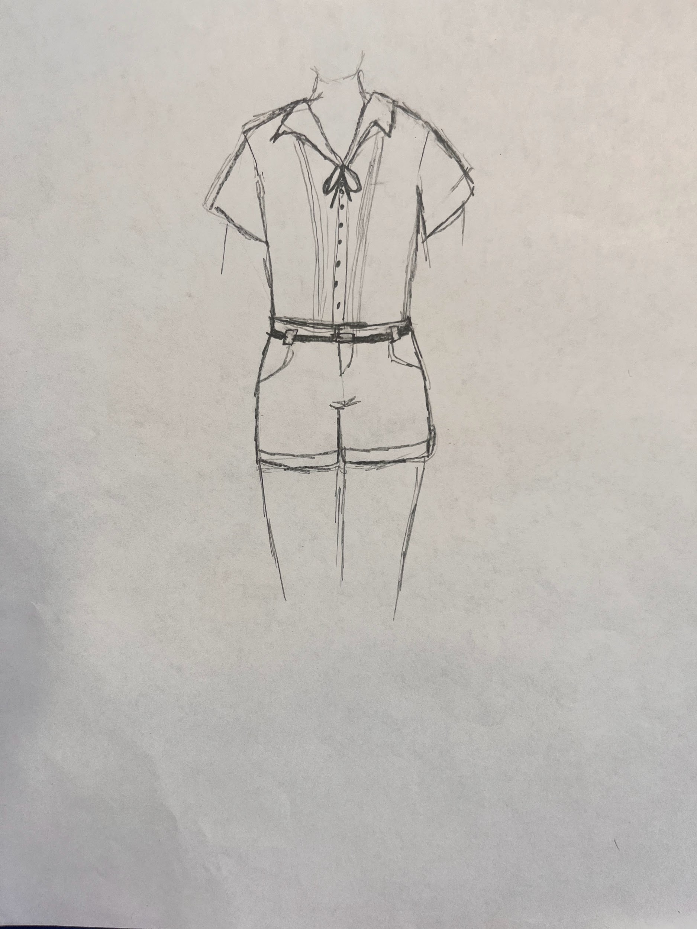
Design Idea #2 GPS dress altered the same way as Design Idea #1, with an addition of the traditional pocket moved to the chest.
Description: Uniform with shirt and pants or shorts with traditional pocket.
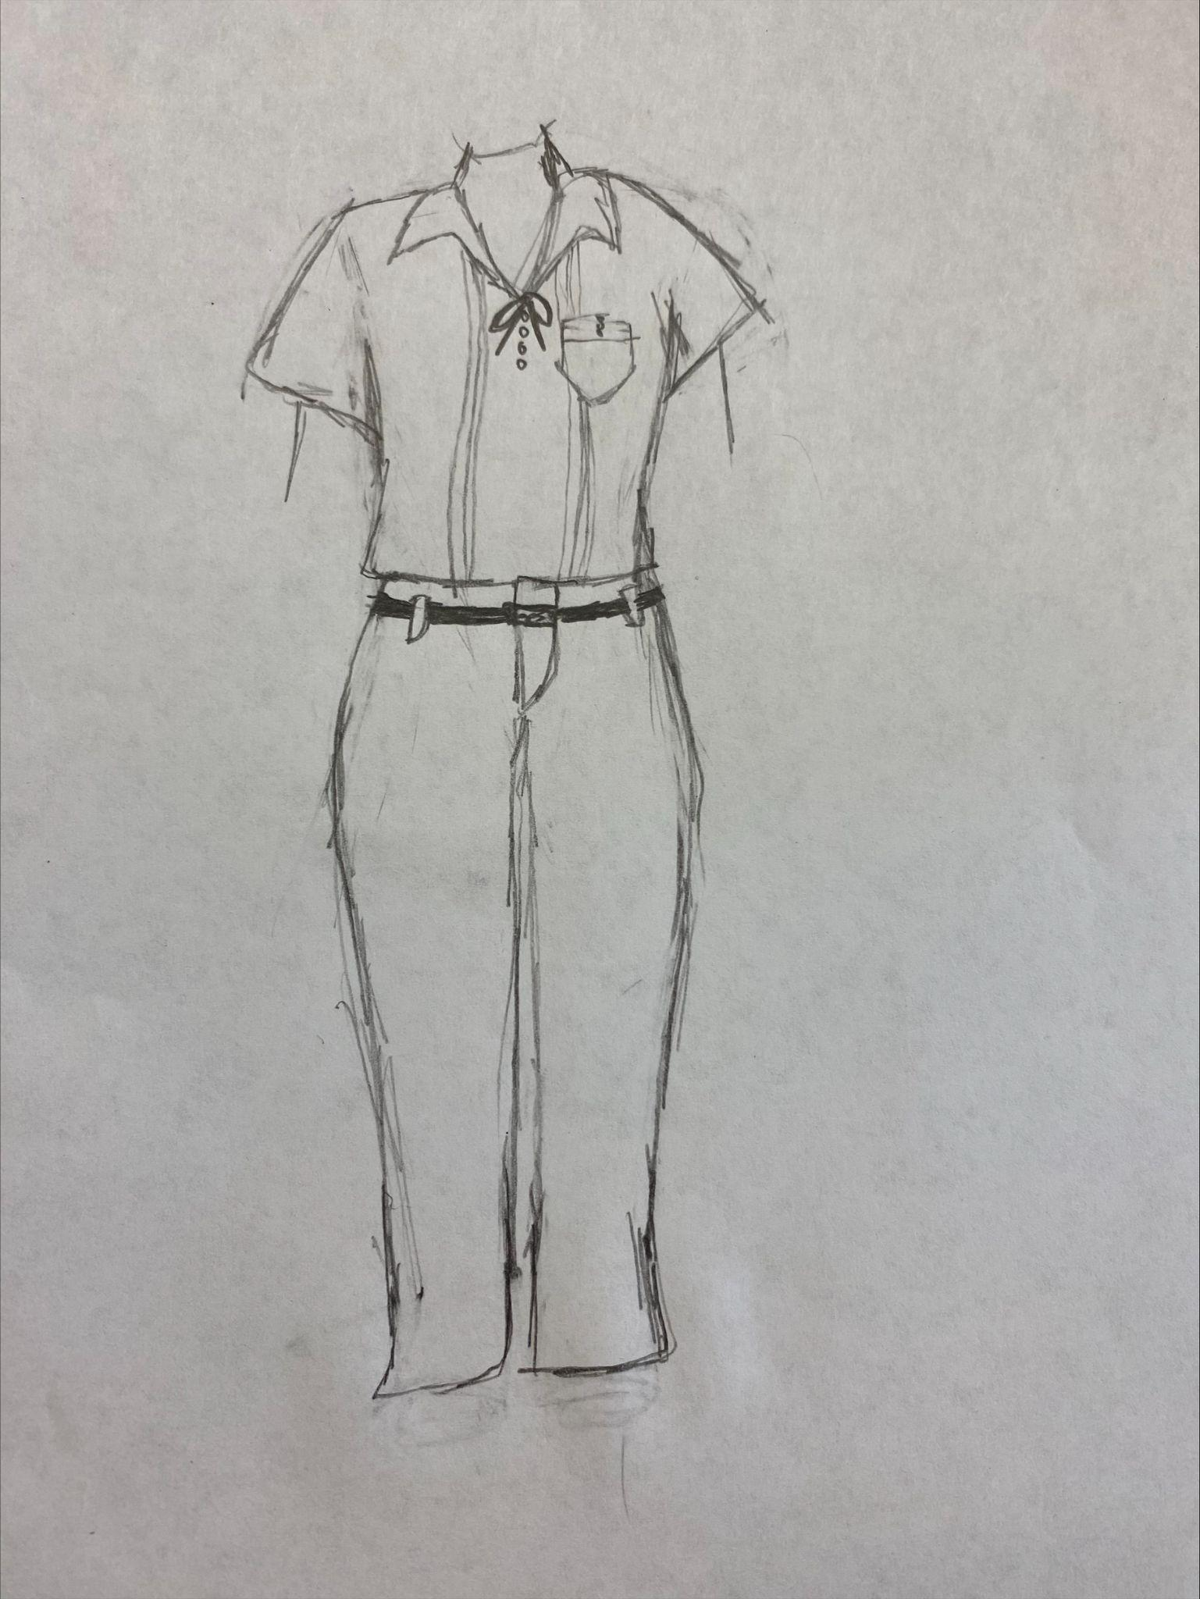
Design Blueprint (D4)
Date: November 2023
Manufacturing Methods:
1: Kameels
2: Homemade
Supply List and Costs:
Item | Cost each | # needed | Total
Dress | Approximately $30-$100 | 1 dress per uniform, or 3 yards per dress. | $30-$100
Sewing Thread | Approximately $1 | 1 or 2 | $2
Total Cost |  |  | $32-102

Plan of Action (D3)
- Design the uniform: draw outline and dimensions of your preferred size of uniform
- Cut the dress: cut a straight hem line right below the original pockets or just as long as it tucks into a pair of khakis.
- Sew the shirts: you want to hem the end of the bottom of the shirt twice so the hem stays. If you want pockets similar to a button up shirt, remove the original dress pockets and sew one of the pockets to the chest of the new shirt.
- Uniform assembly: you want to put on your new shirt then tuck it into a pair of khaki pants or shorts, then you want to put the belt around your waist.

