Element D - Document 6365

Portfolio ID: de8620d6f6d8
Document ID: 6365
Project Name: Unit 7 Personal Project
Date Submitted: 2024-05-22 01:45 GMT
Scorer: Carly Brown

SCORING TABLE - ELEMENT D

D1: 4
D2: 5
D3: 3
D4: 4

SCORER COMMENTS:
D1: There are multiple possible design solutions that are presented. Materials and dimensions are included.
D2: The design solution is chosen through a decision matrix that aligns with the design requirements. In the decision matrix. The weighting decisions could be more clear.
D3: There is a short plan of action included, and then another linked. I didn't have access to the linked plan, so scored just based on the plan of action included in this element.
D4: The design blueprint is generally pretty detailed. There could be a bit more detail around how the jibbet and Velcro interact.

STUDENT SUBMISSION:

Page 1
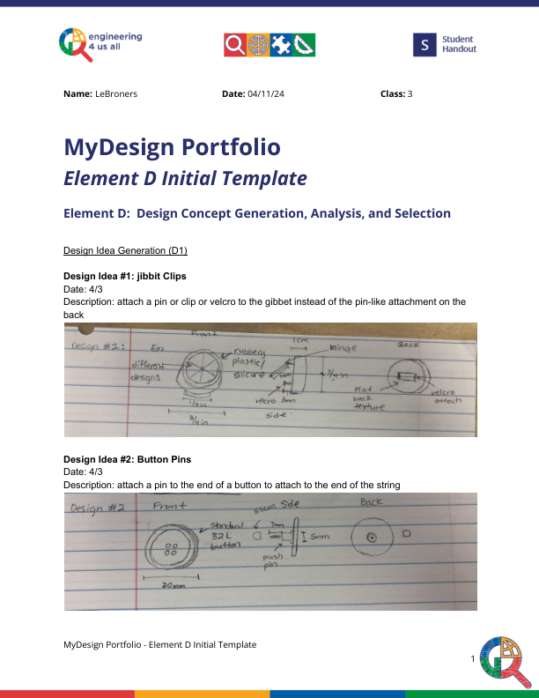
Page 2
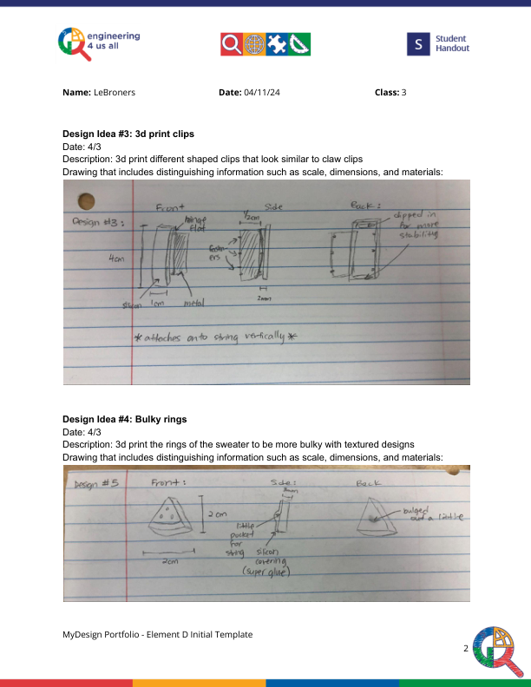
Page 3
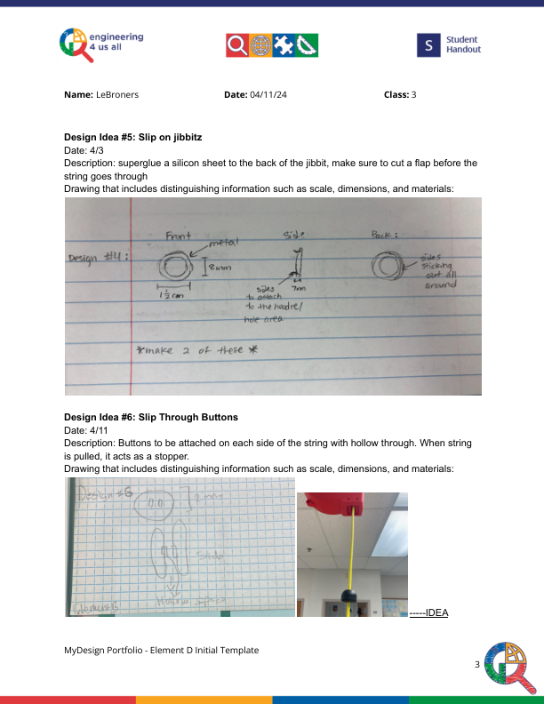
Page 4
