Element D - Document 7728

Portfolio ID: efae4f0e8aaa
Document ID: 7728
Project Name: Unit 3 - Community Project
Date Submitted: 2024-06-05 05:31 GMT
Scorer: Carly Brown

SCORING TABLE - ELEMENT D

D1: 5
D2: 3
D3: 0
D4: 0

SCORER COMMENTS:
D1: All four plans had general materials, dimensions, and were different!
D2: It seems like in this section, the design requirements were consolidated a bit more. It is tricky to say that ALL design requirements were included in the decision matrix, but in this section, the number of design requirements is more reasonable. The decision matrix clearly outlines a design solution choice. To improve in this area, explain and justify the weighting based on the design requirements.
D3: No plan of action was included.
D4: No design blueprint was included.

STUDENT SUBMISSION:

Page 1
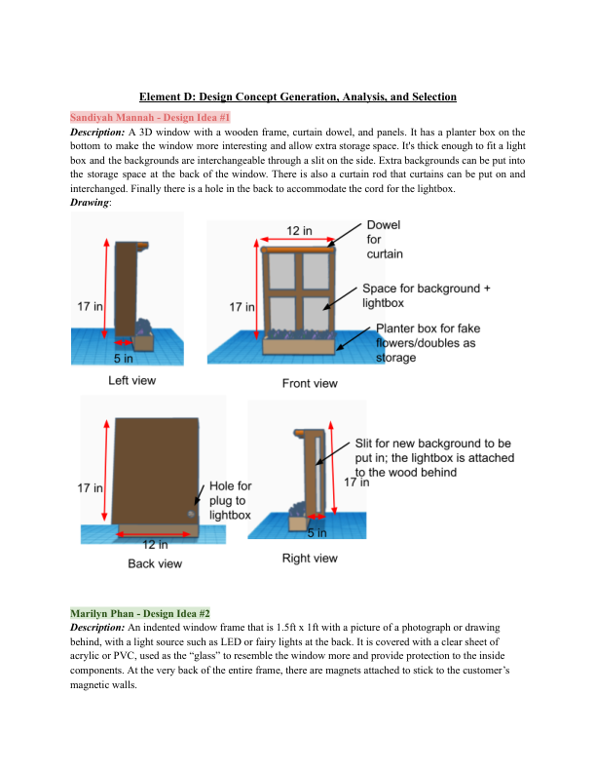
Page 2
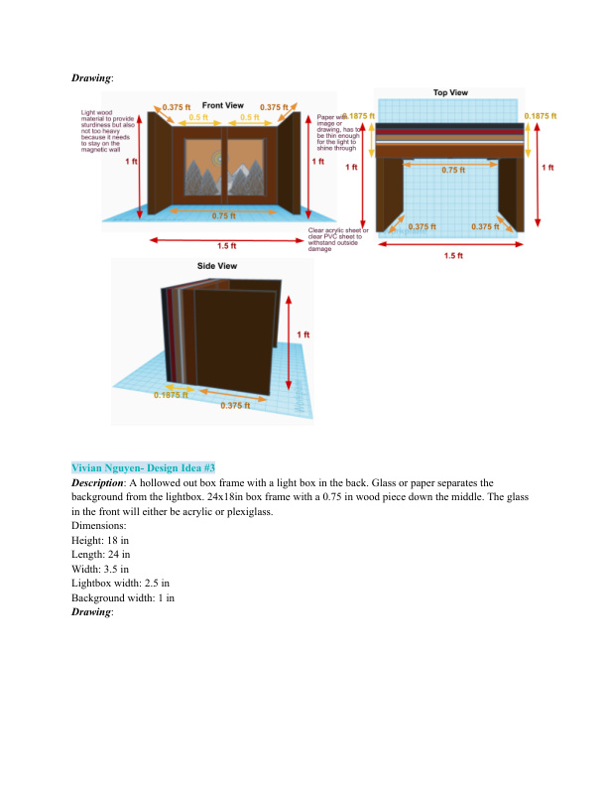
Page 3
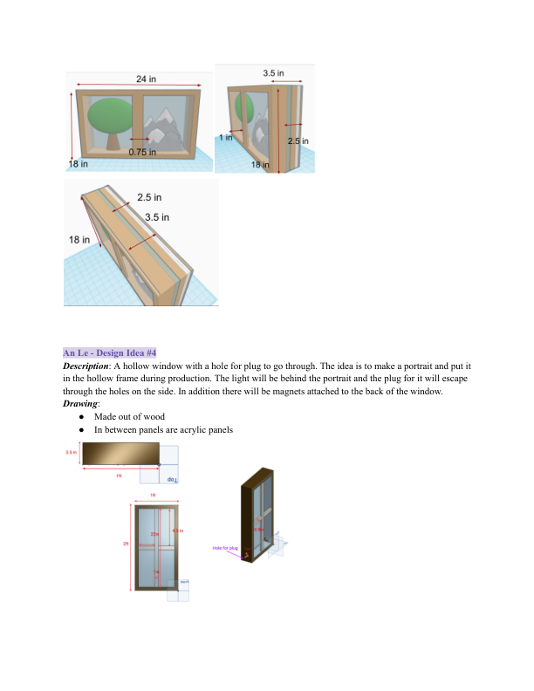
Page 4
