Element D - Document 5842

Portfolio ID: 99375d105f3c
Document ID: 5842
Project Name: Unit 3-4
Date Submitted: 2024-04-02 11:42 GMT
Scorer: Abigail Bergman

SCORING TABLE - ELEMENT D

D1: 5
D2: 3
D3: 5
D4: 5

SCORER COMMENTS:
D1. The spirit of iteration is reflected within each of the four design ideas presented. For each idea, students presented a rough sketch that they further developed into a detailed CAD drawing with complete scale and dimension information. The written descriptions for each idea include materials and construction steps.
D2. Students used a decision matrix to select a solution. The matrix included ratings on four of the five high-priority requirements identified in element C: 1) presentability, 2) reproducibility, 3) durability, and 4) replaceability. The written explanation is not sufficient to understand their selection process: their use of the matrix table, including the matrix weights.
D3. Plan of action is extremely detailed; the major tasks are broken down into subtasks and each are laid out on a timeline. It provides other engineers with all the necessary information to replicate their process and is likely to lead to at least one (but potentially multiple) viable solution.
D4. Design blueprint includes all the necessary schematics, construction steps, and supplies.

STUDENT SUBMISSION:

Page 1
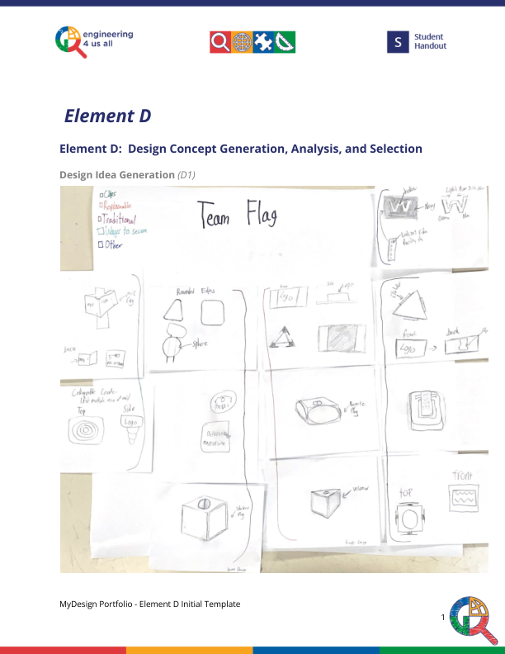
Page 2
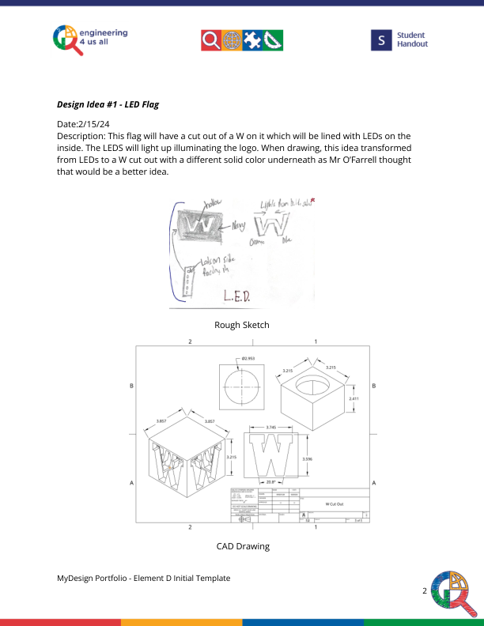
Page 3
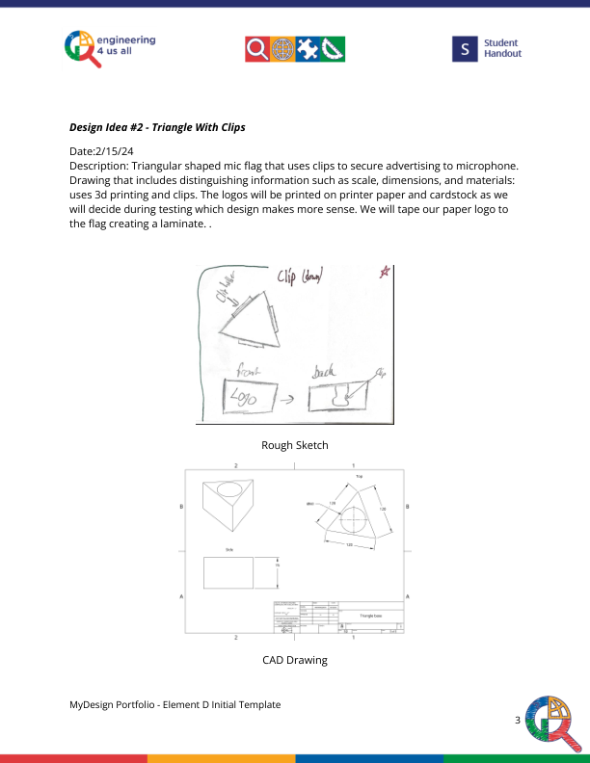
Page 4
