Element D - Document 6668

Portfolio ID: a89ac6dba6e6
Document ID: 6668
Project Name: Community Project
Date Submitted: 2024-05-29 13:19 GMT
Scorer: Heather Morley

SCORING TABLE - ELEMENT D

D1: 1
D2: 0
D3: 0
D4: 0

SCORER COMMENTS:
Your decision matrix is confusing. Was one side supposed to be a list of possible projects?

STUDENT SUBMISSION:

Page 1
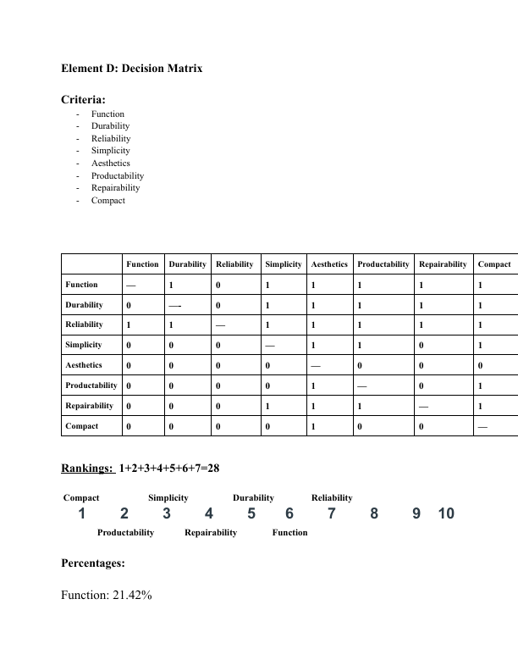
Page 2
