Element D - Document 6668

Portfolio ID: a89ac6dba6e6
Document ID: 6668
Project Name: Community Project
Date Submitted: 2024-05-29 13:19 GMT
Scorer: Alison Kay

SCORING TABLE - ELEMENT D

D1: 0
D2: 0
D3: 0
D4: 0

SCORER COMMENTS:
There is no evidence that there has been an iterative process undertaken to come up with a design solution. A decision matrix has been provided which seems to prioritize design requirements, however this is not explained or elaborated upon.

STUDENT SUBMISSION:

Page 1
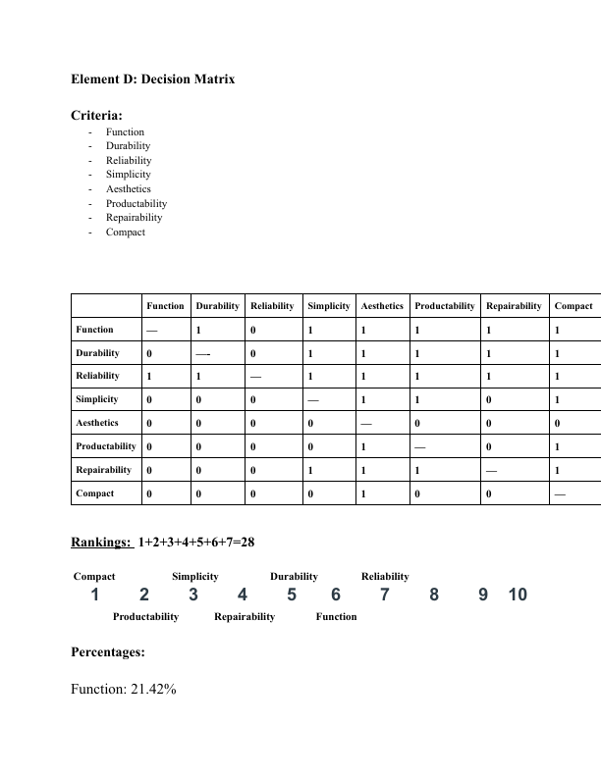
Page 2
