Element D - Document 6503

Portfolio ID: 24f107cc724d
Document ID: 6503
Project Name: Humidity Proof Container for Art Supplies
Date Submitted: 2024-05-24 16:32 GMT
Scorer: Heather Morley

SCORING TABLE - ELEMENT D

D1: 1
D2: 2
D3: 1
D4: 0

SCORER COMMENTS:
No blueprints or sketches were offered to support the project. Further, details are lacking for the final design

STUDENT SUBMISSION:

Page 1
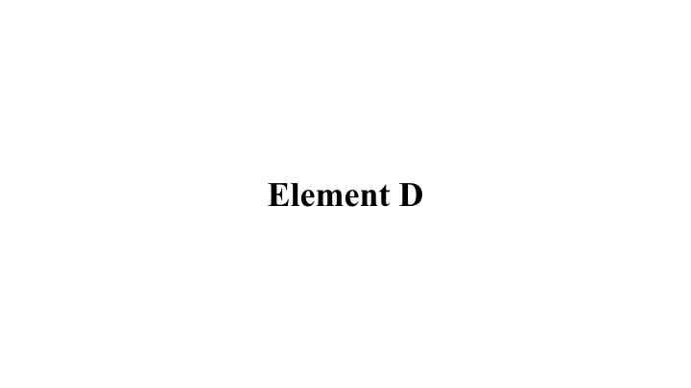
Page 2
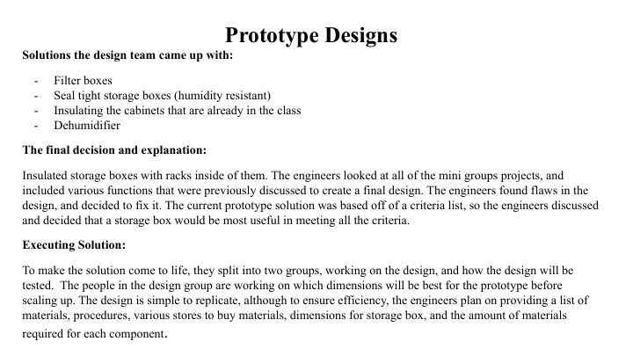
Page 3


