Element D - Document 8207

Portfolio ID: 3bda6523de22
Document ID: 8207
Project Name: Units 3 & 4
Date Submitted: 2024-06-13 18:07 GMT
Scorer: Jeannie Chipps

SCORING TABLE - ELEMENT D

D1: 1
D2: 2
D3: 2
D4: 1

SCORER COMMENTS:
No additional comments provided.

STUDENT SUBMISSION:

Page 1
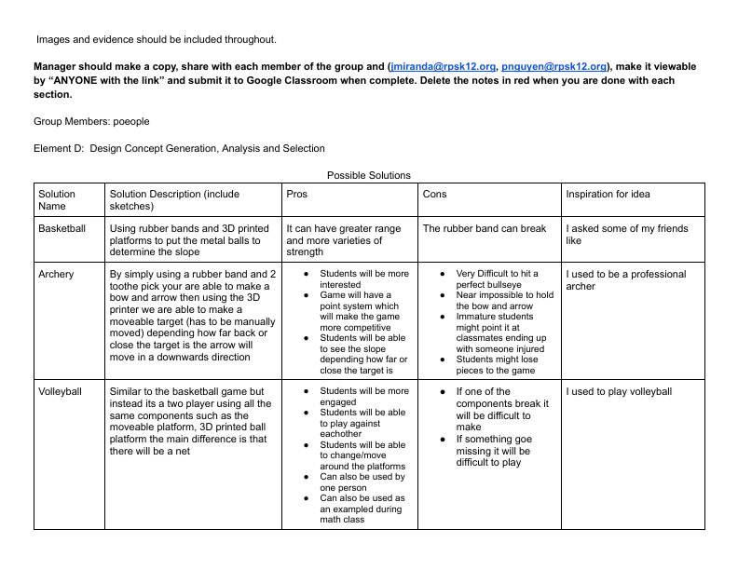
Page 2
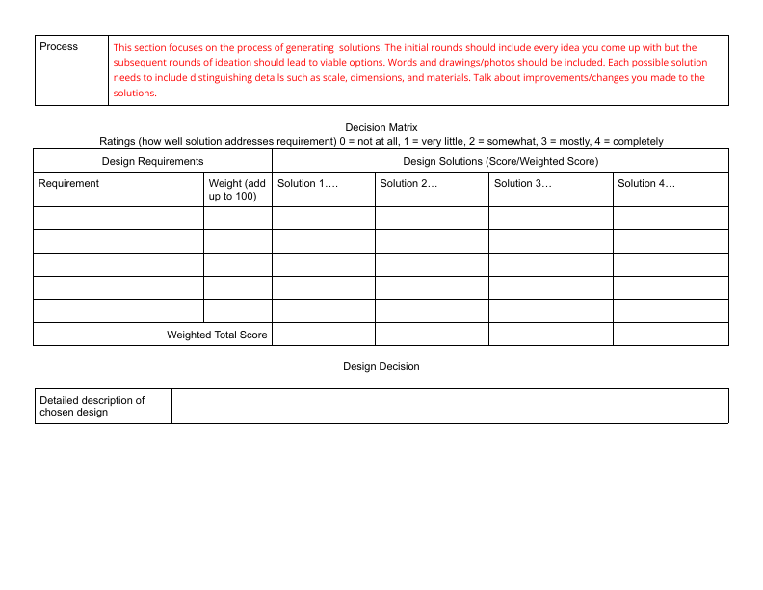
Page 3
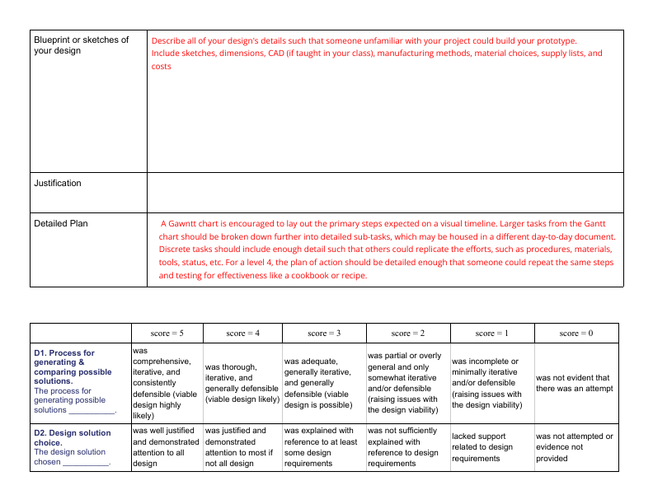
Page 4
