Element D - Document 5943

Portfolio ID: e9adc7a01d5f
Document ID: 5943
Project Name: Engineering is Personal
Date Submitted: 2024-04-19 16:41 GMT
Scorer: Alison Kay

SCORING TABLE - ELEMENT D

D1: 2
D2: 2
D3: 0
D4: 0

SCORER COMMENTS:
You did not explain your solution in relation to your design requirements or detail how you came to the final decision.

STUDENT SUBMISSION:

Page 1
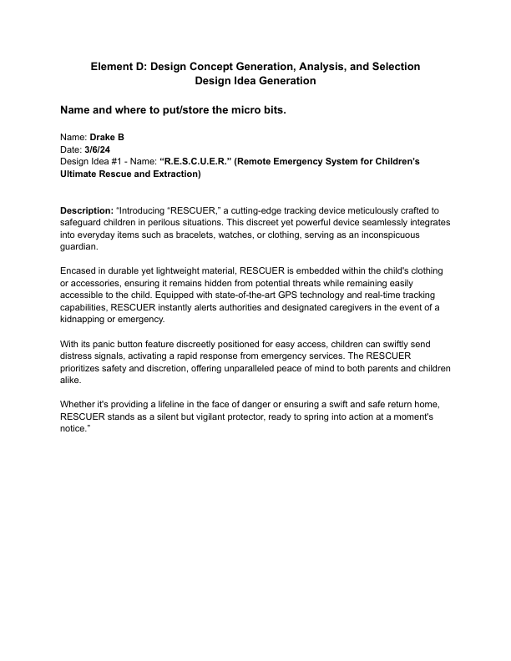
Page 2
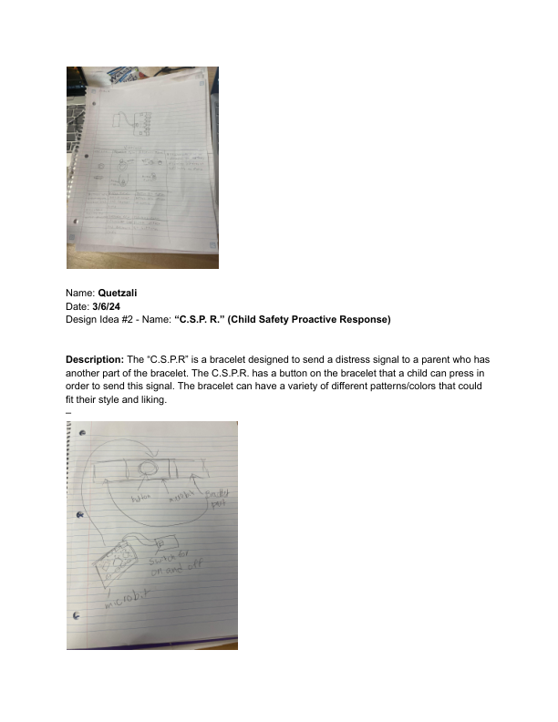
Page 3
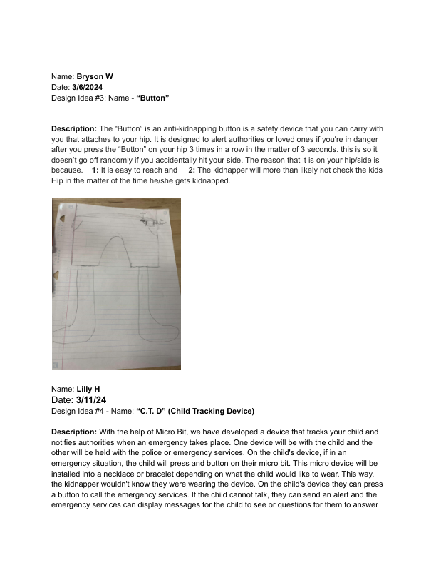
Page 4
