Element D - Document 6503

Portfolio ID: 24f107cc724d
Document ID: 6503
Project Name: Humidity Proof Container for Art Supplies
Date Submitted: 2024-05-24 16:32 GMT
Scorer: Carly Brown

SCORING TABLE - ELEMENT D

D1: 2
D2: 3
D3: 3
D4: 1

SCORER COMMENTS:
D1: There was a general name given to each of the iterations in the design generation. To improve in this section, include drawings and descriptions that can give an understanding of design, scale, measurements, and materials.
D2: The design solution choice was explained. It would be interesting to know what flaws were found in the other design options, and why this solution was the chosen solution.
D3: There is a general plan of action. To improve this section, add more details around tasks so that someone could replicate the efforts of this project.
D4: The solution is generally described, but is missing manufacturing methods, material choices, costs, etc.

STUDENT SUBMISSION:

Page 1
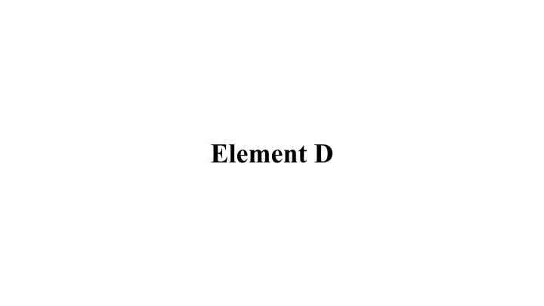
Page 2
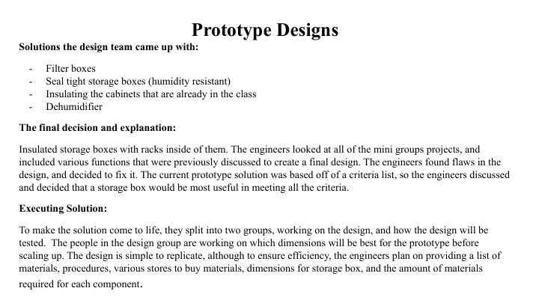
Page 3


